

**Senior Design Project**

**Design of An Automated Drink Dispensing System**

ENGE476 Senior Design Project I

Department of Engineering and Aviation Sciences

University of Maryland, Eastern Shore

Nathan Bane

Chris Blanks

Project Advisor, Dr. Lei Zhang

Submitted

May 13th, 2019

List of Contents

1. Introduction 8

1.1. Backgound/Motivation 8

1.2. Objective 10

1.3. Design Requirements 10

1.4. Design Constraints 10

1.5. Design Methods 10

2. Project Description 11

2.1. System Description 11

2.2. System Diagram 12

2.3. System Functions 13

3. Implementation Plan 14

3.1. Tasks 14

3.2. Team Organization 15

3.2.1. Responsibility of Nathan. 15

3.2.2. Responsibility of Chris. 15

3.3. Timeline/Milestones/Delivery Plan 15

4. Implementation 17

4.1. Implementation of Task 1. 17

4.2. Implementation of Task 2 25

4.3. Implementation of Task 3 34

4.4. Implementation of Task 4. 37

4.5. Implementation of Task 5. 54

4.6. Implementation of Task 6 61

5. Conclusion 66

Appendix 68

A. Component Specs 68

1. Specs of the Raspberry Pi 3 Model B 68

2. Specs of the Embedded Board 69

B. Industry Standards 69

C. Source Code. 70

1. Source Code of the Desktop Application 70

2. Source Code of the Phone Application 155

References 185

List of Figures

Fig. 1. Embedded System Diagram: Main Computer, Hardware Controller 12

Fig. 2. Full-System Finite State Machine 13

Fig. 3. Fluid Control Microcontroller 17

Fig. 4. High-Side Switch (ON Semiconductor, 2014) 18

Fig. 5. Schematic for High-Side Switch 19

Fig. 6. High-Side Switch Simulation 19

Fig. 7. Full H Bridge Typography (Texas Instruments, 2016) 20

Fig. 8. Motor Driver Logic Table (Texas Instruments, 2016) 20

Fig. 9. Motor Driver Schematic 21

Fig. 10. I2C GPIO Expander and 5V Regulator 22

Fig. 11. I2C Thermometer 23

Fig. 12. I2C Input Current Sensor 23

Fig. 13. PCB Layer Stack-Up (Altium, 2017) 24

Fig. 14. STM32Cube Power Calculations 27

Fig. 15. SPX3819 3.3V Linear Regulator Layout 27

Fig. 16. 5 Pin JTAG Connector 28

Fig. 17. Pinout of the STM32L4 Microcontroller 28

Fig. 18. FFC Connector Pinout 28

Fig. 19. Switches and Leds 29

Fig. 20. PCB Layout of Embedded Micrcontroller Board 30

Fig. 21. Main Loop Block Diagram 31

Fig. 22. Make Drink Function 32

Fig. 23. Fill Recipe Data Function 33

Fig. 24. I2C Communication with the MCP23018 33

Fig. 25. Open Drain Pin Configuration 34

Fig. 26. Equation for PWM Frequency 34

Fig. 27. Fluid Ounce to Pump Time Conversion Expression 35

Fig. 28. I2C Communication Scheme 36

Fig. 29. Grid Geometry Example 37

Fig. 30. MVC Pattern 37

Fig. 31. Class Diagram of Desktop Application 38

Fig. 32. Root Window with Mode Selection Buttons 38

Fig. 33. Main Window of Customer Window 39

Fig. 34. Order Page for Customer 39

Fig. 35. Order Confirmation box 40

Fig. 36. Login Window 41

Fig. 37. Admin Options Menu Bar 41

Fig. 38. CRUD Principle 42

Fig. 39. DrinkProfileManager Window 42

Fig. 40. Drink Editor Window 43

Fig. 41. Inventory Manager 44

Fig. 42. Log Manager 44

Fig. 43. ApplicationUserEditor Window 45

Fig. 44. “Add a User” Window 45

Fig. 45. “Delete a User” Window 46

Fig. 46. Background Color Picker 46

Fig. 47. IP Address Window 47

Fig. 48. URL Window 48

Fig. 49. “Help” Menu Bar Options 48

Fig. 50. How to Operate Instructions Window for Customer 48

Fig. 51. Contributors Window 49

Fig. 52. Parent and Child Directories 49

Fig. 53. Example of the Text File Format of Each Drink Profile 50

Fig. 54. Shared Data File Format 51

Fig. 55. PeripheralDevice Inheritance Diagram 52

Fig. 56. MEI Bill Acceptor 52

Fig. 57. MEI Bill Acceptor Interface Schematic 53

Fig. 58. 3D Printed Picamera holder 53

Fig. 59. Flowchart for the Drink Ordering Process 54

Fig. 60. Phone app Icon with Notification Bubble 55

Fig. 61. Login Page of Phone App 56

Fig. 62. Tabbed View of Main Menu 57

Fig. 63. URL Settings Options 58

Fig. 64. URL Editor Layout 58

Fig. 65. Inventory Fragment View 59

Fig. 66. ADDS Phone App Notification 60

Fig. 67. Sales Fragement View 60

Fig. 68. System Status Fragment View 61

Fig. 69. Bunny Ears Filter 62

Fig. 70. Bunny Ears Math 62

Fig. 71. Rainbow Mask Filter 63

Fig. 72. Rainbow Glasses Filter 63

Fig. 73. Rainbow Glasses Algorithm 64

Fig. 74. Desktop Application Package on PYPI 65

Fig. 75. Raspberry Pi 3 Model B Specifications 68

Fig. 76. Raspberry Pi 3 Model B General Purpose Input & Output Pins 68

List of Tables

Table 1. Project Timeline and Delivery Plan 14

Table 2. Project Timeline and Delivery Plan (Continued) 15

Abstract

With the advent of touchscreen appliances, businesses have been integrating new technology into their establishments in order to increase the productivity of their workers, reduce costly long-term expenses, and stay competitive with other businesses who are adopting other modern technologies. Within the current drink making appliances market, there is a growing need for this kind of technology. This paper proposes a solution for addressing the issue of long wait times for service and delivery of beverages in establishments that serve alcohol. Herein the design of an embedded system at the hardware and software level is proposed in order to solve this issue in a cost effective and efficient manner.

**Keywords**— Automation, Embedded, Electronics, Software, Image Processing, I2C, Motors, Dispensing

1. Introduction

Over the course of the project the team will detail the development of an automated drink making machine that will alleviate wait times in bars, allow users to pick complicated drinks, and facilitate a good buying experience for the customers.

* 1. Backgound/Motivation

In most popular bars, there is always the issue of long lines of customers and overworked bartenders. Why does this usually occur? The ratio of bartenders to customers is usually very small, so there is more demand than supply. This issue can cause a few problems for the bartenders and customers. If the bartenders rush to meet the demand of the customers then that will liken the chance of errors being made in the drink making process, which will lower the quality of the drinks and cause customers to become unsatisfied with the service. If the bartenders are too slow to meet the demand, then some customers will become irritated due to the long wait time. When wait times get too long, customers tend to migrate to other bars that are not as busy. This is very disadvantageous for the bar owner and bartender because that means less revenue. Limiting the number of customers in one period or space is an option, but that does not maximize on the potential profit.

One solution that some bar owners take is to just hire more staff members, but this is not always feasible due to limited budgets and lack of space. Additionally, you cannot always predict when a large wave of people will come to the bar, so it is better to have a more flexible solution that takes up a very small amount of space, does not cost thousands of dollars, and can be reliable at any moment. The perfect solution to help bar owners and bartenders is an automated machine that meets the previously listed criteria. This machine would be able to work at any moment of the day and make bartenders more productive.

After doing some market research on the usefulness of an automated drink making machine, the machine must be easily customizable and intuitive to use. When the machine is easily customizable, a bar owner can make more use of the machine and cater to multiple groups of people. For example, if the bar owner can add or exchange the drinks in the machine easily then the owner can meet the needs of the customers a lot faster and enhance their experiences. An intuitive interface is a very important feature of any product. When it is simple to use, it will be used a lot more than if it was convoluted. In addition, if the bar employees have a hard time trying to figure out how to use the machine then that makes them less productive, which means less revenue. Ideally, any bar owner would want a machine that would augment the abilities of their workers.

A couple other considerations for an automated drinking machine are the payment process and the issue of people that have had too many drinks. Traditionally, most customers to bars will either pay upfront for their drinks or will ask the bartender to open a tab until they are done. Sometimes customers drink too much, so they are cut off from buying any more drinks. This is a task that is usually left to the bartender’s discretion. An automated machine can help with these two common tasks. The automated machine could handle cash, credit cards, and electronic payments (e.g. PayPal, Venmo, Bitcoin). This could potentially allow more money to be spent at the bar. With the automated machine handling drinks, the drink making process would be objective and customers would get exactly what they bought. The issue of preventing customers from drinking too much is also an achievable task for an automated machine. The machine could incorporate a system for detecting when a customer is past an acceptable level of drunkenness. This could be done with the use of a facial recognition camera that monitors the facial expressions of recurring customers over the night and decides whether they should have another drink within a certain time frame. Another option is using an infrared camera to do a similar job as the facial recognition camera. Regardless of the method, the maker of an automated drink making machine must take these two issues into consideration.

There a few solutions on the market already for automating the drink making process. The first solution used the layout of a 2-D plotter to design their automated drink making machine. The alcoholic beverages are fastened in their own slots and with their bottoms upward. The alcohol is dispensed by utilizing 25 ml Beaumont Taps. A servo actuates these taps and dispenses the alcohol into a cup that is attached to a linear actuator. The cup is then moved to the next drink dispensing location for the next ingredient for a mixture. Once the mixture has been finished, the patron picks up the cup from the machine. There are also lights that are integrated into the design that make their drink making process more entertaining. The user interface is just an array of buttons and a Liquid Crystal Display (LCD) screen.

The second solution utilizes two industrial robotic arms to mix a wide range of drinks. The robotic arms are located on a platform about the height of a counter, and the drinks are suspended above the robot platform. It uses the common utensils that a standard bartender uses. This allows the robot to make any drink that a bartender can make. The robot arms are also capable muddling, stirring, shaking, and straining actions, which are common for drink making. This is a very extendable design because the robots are dexterous enough to perform many actions, so this solution can make a lot of drinks. It can make two drinks per minute, which yields around 1,000 drinks per day.

Both solutions can create alcoholic drinks and allow patrons easy access to drinks. However, the first solution has a slow drink making process. Each pour the machine makes is a pre-calibrated pour that cannot be changed. As a result, it can only mix imprecise volumes. In addition, the machine’s unwieldy size is not suitable for most bar applications. The electronics and mechanism are open to the patrons allowing them to potentially damage the machine. Another con is that it could expose drinks to impurities before the customer gets the drink. The machine also doesn’t dispense ice or other ingredients, so only basic drinks can be made. The second solution would be very expensive and too large for most bar owners. It also requires a lot of overhead to operate. The industrial robot arms are heavy pieces of equipment which will require special structures to support. It will also have high power requirements necessitating the need for a specific electric service that is not always available. These specific needs require a huge investment to install. This puts it out of reach for most bar owners.

The designing and building of an efficient automated drink making machine is no easy task due to all the considerations to keep in mind. It requires keeping the bar owner, bartender, and customer happy with the product. It requires a flexible and extensible design, so that it can be appealing to large groups of people. It is a suitable engineering challenge to undertake.

* 1. Objective

Design an automated drink making machine that will offer a more economical solution to reduce wait times for drinks, create drinks, and reduce the human error in the drink making process.

* 1. Design Requirements

1. The machine will fit in a 3’ x 2’ x 3’ (L x W x H) space.
2. The dry weight, the machine without ice or fluids, of the machine will be less than 50 lbs.
3. The machine will be able to serve at least 10 different drinks due to the combinations of 4 liquors, 1 liqueur, and 7 flavoring additives.
4. The machine will feature an easy to use graphical user interface allowing the patrons to select various drinks for purchase.
5. The machine will be able to be powered from 120/220 V outlets.
6. The machine will be capable of operating without the main computer.
7. The phone application will allow store managers to remotely monitor the machine and view drink analytics.
8. Shared data will be updated every minute via a HTTP server.
9. This machine must securely store profits and information from users.
   1. Design Constraints
10. The machine must be on a raised, supporting platform in order to make the touchscreen close to the eye level of users.
11. The machine must conform to a common set of food equipment safety rules, especially if the machine was to become a commercial product.
    1. Design Methods

The first step is to design the board for the embedded system section. The second step is to design a computer application for the main computer. The third step is to write code to interface all the peripherals with the main computer and embedded board. The fourth step is to design a phone application that can pull system data from the main computer. The fifth step is to identify a power supply that will support the whole machine. The sixth step is to implement image recognition using the camera and main computer. The final step is to use a Field Programmable Gate Array to create extra features for the machine. After these steps are completed, our project will be done.

1. Project Description
   1. System Description

This system is composed of three main systems: the embedded electronics, the desktop application, and the phone application.

The embedded electronics can be broken down into two sections: the hardware controller board and the main computer. The hardware controller board will use a microcontroller to control fluid flow throughout the system via controlling valves, dc brushed motors, and peristaltic pumps. An additional motor controller will be used to dispense ice from the ice container. An onboard sensor module will be used to gather data regarding the operation of the machine. The main computer will host the touchscreen application that customers will use in order to select and purchase drinks from the system. The main computer will also interface with the payment collector, Field Programmable Gate Array (FPGA), and camera. The payment collector will send signals to the main computer when payment has been received. The FPGA will control extra features (e.g. LED light show, security). The camera can potentially be used to check driver licenses and apply amusing filters to the customer’s face (for entertainment).

The desktop application will control the states of the system (e.g. wait, dispensing, cleaning) through a series of commands sent to peripheral devices. It will be an application made with the Python 3 programming language and its supporting libraries. The app will have a graphical user interface (GUI) that will contain buttons, images, and dropdown menus. The customer will interact with the application through the touchscreen. Information regarding the inventory, purchases/sales, and customers will be stored in the local file system of the main computer.

The phone application will be used for remote monitoring and configuring of the system. The app will be created in Android Studio using the Java programming language and will be available for any android phone. The application will consist of a main menu, buttons, dropdowns, graphical displays, and images. For the app to acquire and display data about the whole system, it will have to use the HyperText Transfer Protocol (HTTP) to gain access to the file system of the main computer. In addition, the app will be able to change system configuration settings by editing a special file in the main computer.

* 1. System Diagram

The **Embedded System Overview** is divided into two sections the **Main Computer** and the **Hardware Controller**. The main computer provides and interface between the customer using a touchscreen and the hardware such as pumps, valves, and sensors. The main computer is a Raspberry Pi 3 a 1.2 GHz Linux capable computer. The customer’s order is placed on the tough screen and executed by sending I2C Commands to the hardware controller. It enables the two sections to accomplish different tasks at the same time.

The hardware controller completes the interface between the main computer using a STM32 microcontroller and the hardware. The onboard microcontroller receives its commands through the I2C Bus. Using clever programming, it will command its various subassemblies to actuate the motors, valves, and other hardware. The hardware controller has three main sections the **Sensor Module** which senses important data such as the security of the system through tamper alarms, the **Fluid Microcontroller** controls flow of fluid through the system, and the **Motor Control** section will oversee any additional motor control that is needed.

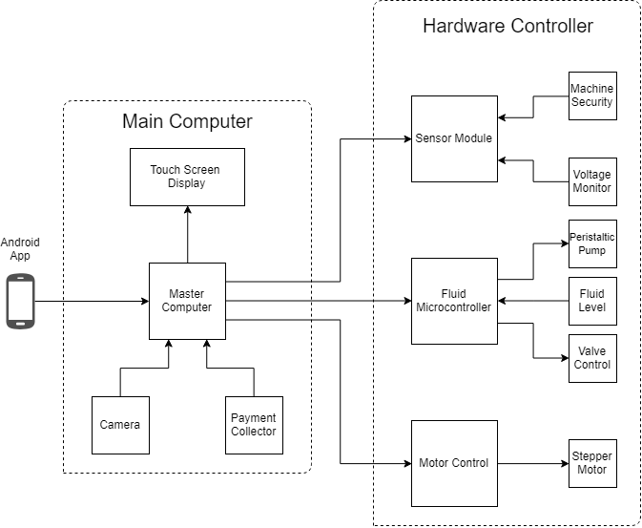

1. Embedded System Diagram: Main Computer, Hardware Controller
   1. System Functions

The full system will operate as a simple finite state machine. It will exist in the following states: idle, maintenance, ordering, drink making, and delivering. The following steps are how it will proceed through a successful drink making/delivery cycle:

1. The system will start in an idle state until a user selects a drink.
2. After a drink is selected, the system will migrate to the ordering state.
3. When the payment for the drink is received, the system will migrate to the drink making state.
4. When the drink finishes, the system will migrate to the delivery state.
5. After the drink is picked up by the user, the system will finish the cycle by migrating back to the idle state.

The system will also migrate to previous states for inverse actions performed by the user. For example, if the user deselects a drink while in the ordering state then the system will go back to the idle state. Also, the system will loop in the same state if certain actions are not performed. An example would be if the user does not pick up his or her drink while in the delivering state then the system will stay in the delivering state until the drink is picked up. Of course, these kinds of stalls will have to be handled in some fashion because stalls will be disadvantageous for the customer and owner of the machine. In addition, the system will offer a maintenance state that will allow the user to perform maintenance duties on the system and check the status of each device in the machine. Exiting the maintenance state will bring the system back to the idle mode.

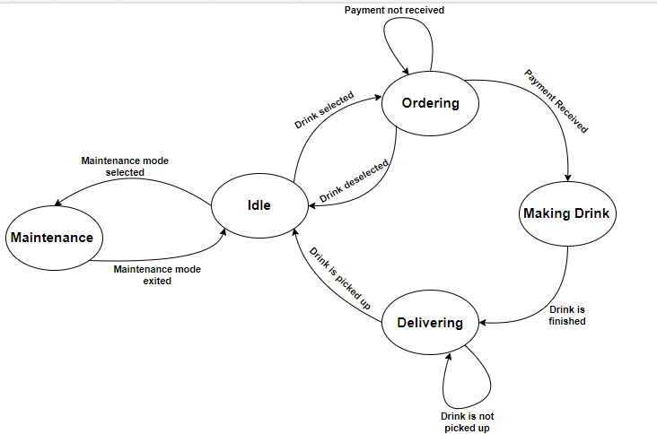

1. Full-System Finite State Machine
2. Implementation Plan
   1. Tasks
3. **Design sub-assemblies for the embedded board**
   1. Design a High-Side Switch
   2. Design a Motor Driver
   3. Design a I2C GPIO Expander and Supporting Circuitry
   4. Design a I2C Thermometer and Supporting Circuitry
   5. Design an I2C Input Power Current Sensor
   6. Design a Printed Circuit Board
   7. Create a Bill of Materials, Order Components and Printed Circuit Board
   8. Assemble Components onto Printed Circuit Board
   9. Develop Test Code for the Printed Circuit Board to Test Assembly
4. **Select/Integrate Microcontroller**

Subtask 1. Select microcontroller and develop supporting circuitry for microcontroller.

Subtask 2. Select and design supporting circuitry for I2C EEPROM

Subtask 3. Develop circuitry to interface with a resistive touch screen

Subtask 4. Interface switches with microcontroller to manipulate modes of microcontroller

Subtask 5. Layout printed circuit board

Subtask 6. Assemble components onto printed circuit board

Subtask 7. Code Microcontroller to receive commands through the serial data line

1. **Develop a communication protocol between the main computer, and the embedded development board.**
2. **Create a main computer application**
   1. Design a GUI using Python’s Tkinter Library that the customers will use
   2. Develop an efficient way to organize monitoring/drink information in the file storage system
   3. Add in capabilities for serial communication between the main computer and peripheral devices.
   4. Interface the main computer with the embedded boards and peripherals.
3. **Create a phone application**
   1. Design the user interface of the phone app with Android Studio’s SDK
   2. Allow the user to update system information (e.g. drinks currently stored)
   3. Allow the phone app to access the system information stored on the main computer and acquire relevant data for use within the app
4. **Add extra capabilities and entertaining features**
   1. Incorporate facial recognition into the main application
   2. Adapt desktop application for compatibility with the Python Package index
   3. Team Organization
      1. Responsibility of Nathan.

Task 1, Task 2, Task 3

* + 1. Responsibility of Chris.

Task 3, Task 4, Task 5, Task 6

* 1. Timeline/Milestones/Delivery Plan

1. Project Timeline and Delivery Plan

|  |  |  |  |
| --- | --- | --- | --- |
| Time | Task | Comments | Responsible Personnel |
| Fall 2018 Semester | | |  |
| Week 1-4 | N/A | Project proposal and planning | Nathan Bane |
| Week 4-  Week 7 | Task 1 (subtask 1.1,1.2) | Design and draw up a schematic for a high-side switch. Develop circuitry to control a brushed DC Motor . |
| Week 8-  Week 10 | Task 1(subtask 1.3-1.5) | Design and layout circuitry to support an I2C Thermometer, Current Sense Circuitry, and I2C GPIO Expander |
| Week 11- Week 13 | Task 1(subtask 1.6-1.7) | Layout the components on the Printed Circuit Board and order Printed Circuit Board with parts |
| Week 13 - End of Semester | Task 1(subtask 1.8-1.9) | Solder components onto the printed circuit board and develop code to test the printed circuit board |
| Spring 2019 Semester | | |  |
| Week 1-4 | Task 2 (subtask 2.1-2.4), Task 3 | Choose a suitable microcontroller and develop supporting circuitry.  Develop communication protocol | Nathan Bane & Christopher Blanks |
| Week 5-  Week 8 | Task 2(subtask2.5-2.6) | Layout printed circuit board, order components , and assemble components onto printed circuit board | Nathan Bane |
| Week 9  -End of the semester | Task 2(subtask 2.4 ) | Develop Code for Embedded |

1. Project Timeline and Delivery Plan (Continued)

|  |  |  |  |
| --- | --- | --- | --- |
| Time | Task | Comments | Responsible Personnel |
| Fall 2018 Semester | | |  |
| Week 1-5 | N/A | Project proposal and planning | Chris Blanks |
| Week 6-  Week 11 | Task 4  (subtask 4.1,4.2, 4.3) | Design and create the main application. Test the inputs and outputs of the system, so that it will interface correctly with the embedded boards and other peripherals. |
| Week 12-  End of the semester | Task 5  (subtask 5.1, 5.2, 5.3) | Design and create the phone application. |
| Spring 2019 Semester | | |
| Week 1-2 | Task 6  (subtask 6.2) | Restructure desktop application software for compliance and compatibility with the Python Package Index |
| Week 3-  Week 10 | Task 4 (subtask 4.4), Task 6  (subtask 6.1 ) | Finish interfacing and testing the main computer/application with the other systems. Incorporate facial recognition into the main application. |
| Week 11- End of the semester | N/A | Documentation. Testing and updating source code. |  |

1. Implementation
   1. Implementation of Task 1.

#### Design a Valve and Pump Control Board

The purpose of the valve and pump control board is to facilitate control of the hardware necessary to manipulate the flow of fluid through-out the system. It receives commands from the control microcontroller PCB through the I2C Bus and translates those commands into actions through various subassemblies. There are 5 main sub-assemblies: high-side switch, dc brushed motor driver, I2C GPIO expander, I2C thermometer, and input power current sensor. The high-side switch controls the valves directing the flow of fluid. Each subassembly plays an important role in the overall function of the system.

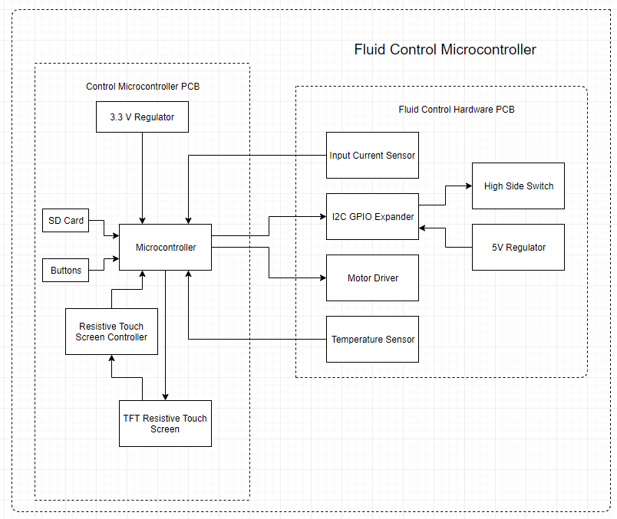

1. Fluid Control Microcontroller

#### Subtask 1: High-Side Switch

The high-side switch will control the valves which directs the flow of liquid through the system. The high-side switch will enable the system to turn on and off specific valves. There will be three banks of 5 valves in the system. Four of the valves will be used to select which fluid will be pumped and the fifth valve will be used as a main on and off valve to cut off flow to that section of the system.

There are two main topographies of load switches that are used in modern circuitry: the high-side switch which utilizes a PMOS transistor to switch the load on and off and the low-side switch which utilizes the NMOS transistor to switch the load on and off. These switches control the flow of power through the system. They are often used in battery powered systems to turn off less used sections of the system to conserve power and then turn power on when that section is needed.

Utilizing the high-side switch has an advantage over the low-side switch. The high-side switch utilizing the PMOS power transistor facilitates the use of a simpler control block (ON Semiconductor, 2014). The control block involves shorting the gate of the PMOS power transistor to ground. It can be accomplished through the use of a logic level NMOS transistor whose gate is connected to the pin of a microcontroller.

The circuit topography of the high-side switch dictates that the switch is a normally open switch. A normal open switch requires power to close the switch connecting the power rail to the load. The control block of our circuit utilizes a microcontroller to output a logic level high to the gate of the NMOS transistor. The NMOS transistor conducts power shorting the gate of the PMOS power transistor to ground putting it a closed switch configuration connecting the power rail to the load.

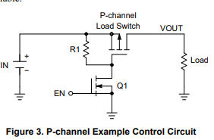

1. High-Side Switch (ON Semiconductor, 2014)

The high-side switch does have a disadvantage in comparison to the low-side switch. The low-side switch uses an NMOS power transistor to connect the power rail to the load. A determining factor in the power loss of a MOSFET is the internal resistance of the transistor when conducting power. Due to the construction of the NMOS transistor it has a naturally lower resistance. The lower resistance reduces the power lost due to high current flowing through the device. The high-side switch will have higher power loses in comparison to a similarly specified low-side switch (ON Semiconductor, 2014).

The requirements for our high-side switch was determined by the solenoid valve chosen to control the flow of liquid through the system. We chose values 150% of current requirements which means that the PMOS power transistor can handle current of up to .75 amps and 24V. The requirements allow the circuit to support any manufacturing imperfection in the resistance of the coil of the solenoid and reduce the chance that a random current spike could damage the components of the high-side switch.

After much research a load switch was chosen for this application. The International Rectifier IRF9953PBF is a dual packaged PMOS power transistor in a small outline integrated circuit (SOIC) package that can handle -30 VDSS, 1.8 A, -20 VGS, and -1 VTH (International Rectifier, 2004). The dual PMOS package was chosen in order to reduce the number of components needed to solder to the printed circuit board and save on space thus reducing the amount of board area needed for the components. It will reduce the number from 16 individual pass transistor into 8 dual package transistors.

When the IRF9953PBF was originally chosen the voltage requirements of the system were only 12 V. The -20 volts maximum between the gate and the source (VGS) did not pose a significant problem. However, when it was determined that the voltage requirements would need to be raised to 24 V in order to reduce the current flowing through the board the maximum VGS became a problem. In order to prevent the voltage from exceeding the max VGS it was determined that a Zener diode would need to be placed in series with the control transistor. The Zener diode was reversed biased to raise the voltage from ground to the avalanche voltage of the Zener diode. The avalanche voltage chosen for this project was 6.2 V because it will protect VGS when it is 24 V and allow the pass transistor to operate when the power applied to the system is 12 V.

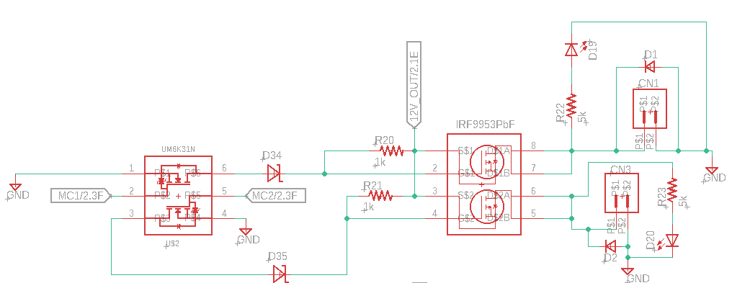

1. Schematic for High-Side Switch

Two methods were used to confirm the design of the system, hand calculations and computer simulations. In order to analyze the system by hand it was necessary to separate the high-side switch into its two main component the power transistor block and the control block. It enables us to simplify the analysis of the circuit because it eliminates unnecessary calculations. The power transistor has two modes open switch and closed switch. In open switch mode the gate of the power transistor is connected to the power rail and in closed switch mode the gate is connect to ground through the Zener diode. The control block is simply an NMOS transistor operating in switch mode.

The computer simulation was conducted in LTSpice an open source circuit simulation program. LTSpice did not have the components that we needed to simulate so similar specified components were chosen to substitute for the missing components. The circuit was created in LTSpice and simulated to determine the overall function of circuit. The simulation node V(n004) is VGS of the MOSFET which can be seen does not exceed a difference of -20 V. The logic voltage V(n002) switches the pass transistor and current flows through I(R1) which is the load.

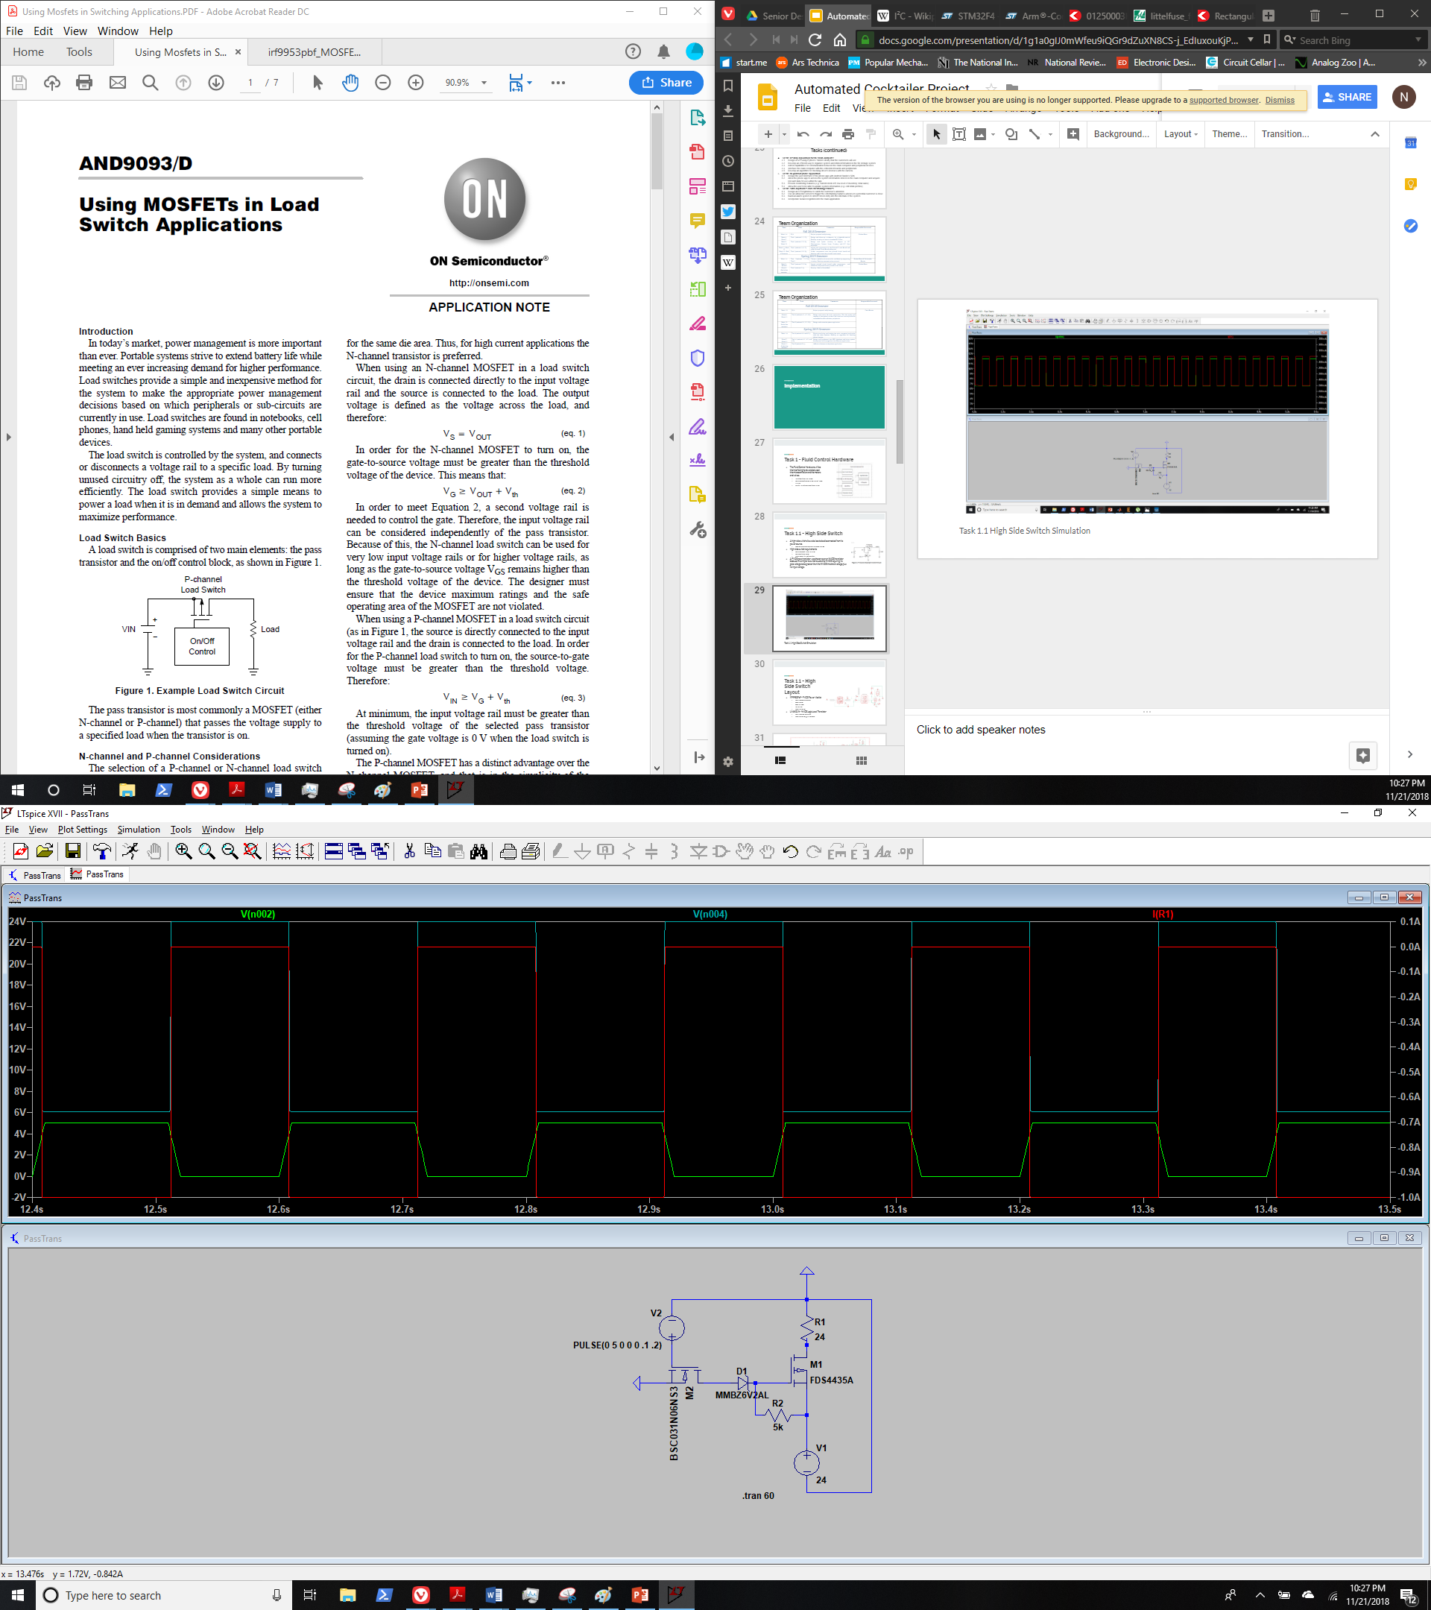

1. High-Side Switch Simulation

#### Subtask 2: Motor Driver

A motor driver is needed to control the DC brushed motor peristaltic pump. It will control the volume and flow rate of the fluid going to the dispensing location. The basic theory behind a motor driver is a full h bridge and the necessary control circuitry. A full h bridge motor driver consists of 2 NMOS transistors which are in series connecting VCC to GND in parallel with two additional NMOS transistors which themselves are is series connecting VCC to Gnd. One lead of the motor is connected in between the 2 NMOS transistor in series.

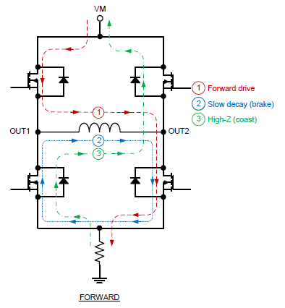

4

3

2

1

1. Full H Bridge Typography (Texas Instruments, 2016)

To select the direction of the motor the control circuitry chooses either NMOS transistors 1 and 4 or NMOS transistors 2 and 3. The pairs of NMOS transistors allow the control lines to be reduced from four pins to two pins. Sending a pulse width modulation (PWM) signal to the NMOS transistors will not only control the direction of rotation of the motor but also speed of rotation of the motor. The average voltage of the signal corresponds to the average voltage out to the motor thus setting the speed of rotation of the motor. The motor driver datasheet has logic table which corresponds with the expected outcomes of various inputs to the control pins on the motor driver.

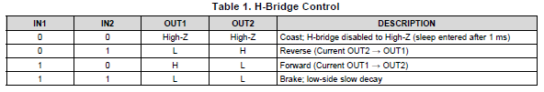

1. Motor Driver Logic Table (Texas Instruments, 2016)

The requirements for motor driver were set by the requirements of the pump 24 V and 1.5 A. We set the requirements of the motor driver to 200% of the current requirements to give headroom for current draw of the motor. Therefore, the motor driver chosen was the Texas Instruments DRV8871 motor driver which supports voltages of up to 45 V and 3.6 A (Texas Instruments, 2016). The DRV8871 has several important features that protect the integrated circuit: overcurrent protection and thermal shutdown. The overcurrent protection is set by a resistor connecting the pin ILIM to ground. The resistor value is determined by the equation $ITrip=\frac{64 (kV)}{RILM (kΩ)}$ the desired trip current of 3 A. The calculated resistor value was 21 kilo-ohm (Texas Instruments, 2016).

In order to protect against rapid voltage changes due to the power supply needing to catch up to the power requirements of the circuit large capacitors were chosen to intervene in these instances. The values chosen were determined by the DRV8871 datasheet which was 47 uF.

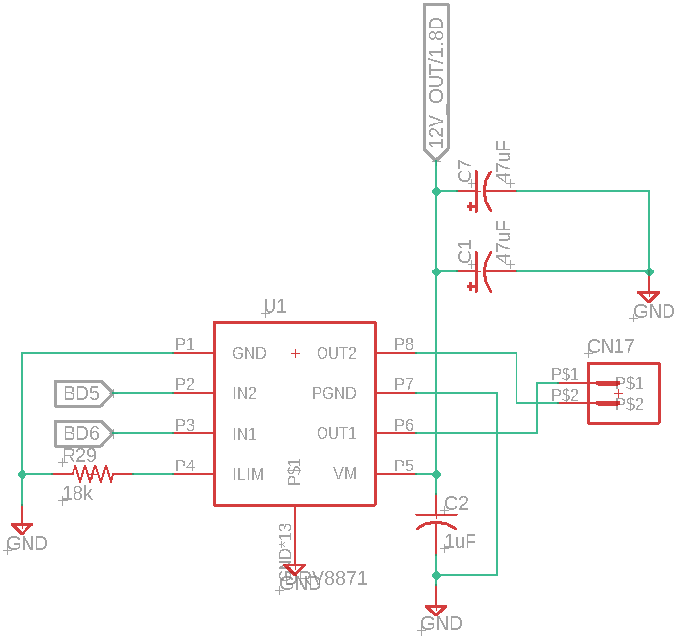

1. Motor Driver Schematic

The design of the system requires three motor drivers to reduce the time spent delivering fluid to the cup. The purpose of the project is to reduce wait times as much as possible. The pumps selected for the system can deliver a maximum flow rate of 1000 ml/min. A simple 16-ounce cup will require 473.5 ml of fluid to fill the cup. Simple math demonstrates that it will take nearly 30 seconds to fill a cup. We wished to reduce that time to under 10 seconds. This requirement will require 3 pumps to deliver the necessary volume in the specified time frame.

#### Subtask 4: Design a I2C GPIO Expander and Supporting Circuitry

An I2C GPIO Expander is used to extend the capability of microcontroller through the use of the I2C bus. In our case the GPIO Expander reduces the pin count on the microcontroller needed to control the valves from 16 different pin to 2. It enables the designers to reduce the number of wires coming to and from the board significantly. It also allows the board to be used by a variety of devices such as Arduinos, Raspberry Pi, and various other embedded boards.

The I2C GPIO Expander was chosen using the various parameters given to the project namely the need to control 16 valves. The students conducted a parametric search on Digi-Key to find the desired part. The device chosen was the Microchip MCP23018 16 Bit I2C GPIO Expander. It is capable of delivering 25 mA per pin for a total of 400 mA (Microchip Technology Inc., 2008). Allowing for communications speeds of up 3.4 MHz enabling it for very high-speed communication. These specifications allow it to drive a variety of devices making it useful for our project.

Included during the design and selection of the GPIO Expander the student also selected a suitable 5V linear regulator to support all 5V devices on the PCB. The regulator needed to be able to convert 12-24V into a steady 5V output. After conducting a parametric search on Digi-Key the Richtek RT9058-50GV 5V 100 mA linear regulator was selected. The datasheet specified that the linear regulator required a 1 uF smoothing input capacitor and an additional .5 uF smoothing output capacitor (Richtek Technology Corporation, 2016).

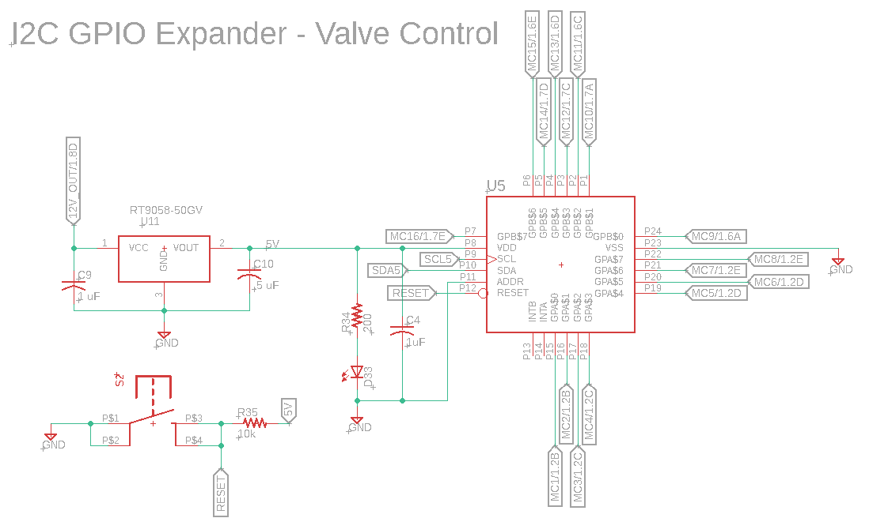

1. I2C GPIO Expander and 5V Regulator

#### Subtask 5: Design a I2C Thermometer and Supporting Circuitry

It is important to be able to monitor board temperatures to make sure the devices on the printed circuit board do not exceeded the maximums designated by the designer. The most common reason for failure among electrical components is due to overheating. It is important to recognize issues before they occur as a result it was decided that it would be important to include a thermometer to monitor the overall health of the system.

A simple parametric was conducted on Digi-Key to look for a component that was capable of I2C communication. The I2C thermometer chosen for this project is the Texas Instruments TCN75A. The device is a little limited in communication speed to 400 kHz and has a resolution that is selectable between 0.5 - 0.0625 degrees Celsius (Microchip Technology Inc., 2010). These devices will get very precise information of the printed circuit board.

Each I2C device has a 7-bit address to be referenced by the microcontroller. In the case of the temperatures sensor the manufacturer has selected the devices first 4 bits of the address while the user has the ability to select the last 3-bits of the address through the use of jumpers and 0-ohm resistors. When the pin is connected to 5V the that bit of the address will be a 1 and it is just the opposite when the pin is connected to ground. It gives the user the ability to change an address if two devices share the same address (Microchip Technology Inc., 2010).

The resistor is placed in series with the 5V power rail to form a low pass filter with the capacitor. It will filter out any noise coming from the power supply. Filtering the noise from the power supply is important because it could create an error in the measurement thus giving the microcontroller an incorrect view of the overall status of the machine.

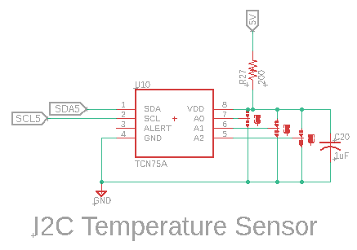

1. I2C Thermometer

#### Subtask 6: I2C Input Current Sensor

Monitoring the current draw of the system is an important feature of the design. It enables the system to determine whether a device has failed or determine whether a pump is pumping a fluid. The basic theory behind the I2C current sensor is measuring the voltage drop across a known resistor value and using Ohm’s Law $\frac{V}{R}=I$ to determine the current flowing through the resistor. The position of the resistor in the circuit allow for us to monitor the current flowing through the whole circuit. In order to measure the voltage drop across the current sense resistor the input voltage to the resistor and the output voltage from the resistor is fed to an operational amplifier. The operational amplifier amplifies the change in voltage between the two inputs allowing it to measure by an analog to digital converter.

In order to select the right current sense resistor some math was necessary to determine its value. The current sense operational amplifier’s gain is 20 and the max voltage of the operational amplifier is set by the input voltage to the operational amplifier which is 5V. Therefore, the divide the max voltage by the gain of the operation amplifier to determine the max voltage drop across the resistor which is $\frac{5 V}{20}= .25 V$. The max calculated current draw of the device is 12.5 A therefore the fuse selected for the device is 15 A. Using ohms law, the calculated resistor value is: $\frac{.25 V}{15 A}=16.7 mΩ$. However, according to analog to digital converter the max voltage that can be measured by the device is set by the voltage reference which is 4.096 V. The resistor value chosen for the current sense resistor is 10 mΩ. It is also necessary to determine the power rating of the resistor needed using the equations $P=I^{2}R={15}^{2}\left(.01\right)=2.25 W$. In order to give plenty of headroom a 7W .01 Ohm resistor was chosen.

The components chosen for the input current sensor: Operational Amplifier – Analog Devices AD8418A; Analog to Digital Converter – Maxim MAX11644; and 4.096 V Voltage Reference – Microchip MCP1501T. The components selected allow the system to see current draws as little as 10 mA and as much as 15 A.

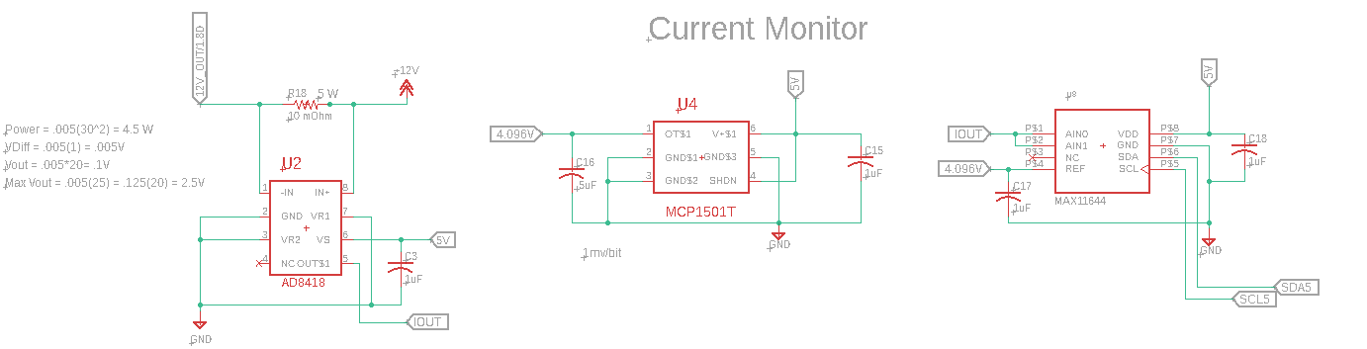

1. I2C Input Current Sensor

The analog to digital converter selected for this project is the MAX11644 which is a 12-bit I2C capable ADC. Although there is an ADC on the microcontroller selected for this project it was decided to separate the task away from the microcontroller to protect the microcontroller from voltage spikes, allow for higher ranges due to the ability to use 5 volts analog inputs instead of the microcontroller ADC’s 3.3 V analog input, and the possibility to use a voltage reference. The ADC will use the 4.096 V reference and the 12 bit resolution to enable the ADC to read as little as a millivolt plus or minus a millivolt.

#### Subtask 7: Design of Printed Circuit Board

The printed circuit board (PCB) is an important part of any modern electrical assembly. The PCB enable all the components to be connected without the use of wire or other methods such as perfboard. The PCB consists of two main materials the copper plain in which all electrical power is carried and the insulation material which is usually FR4. These layers can be stacked in multiples of 2 (i.e. 2,4,6, 8, etc.) as high as the designer specifies.

Through an etching process the copper can be removed leaving behind thin section of copper called signal wires. The signal wires are what connect the electrical components on the same sheet of copper. To connect different sheets of copper a via is used. A via is a copper plated hole that will allow electricity to flow through it connecting two different planes of copper. These vias are what enable the multilayer boards that are so common today.

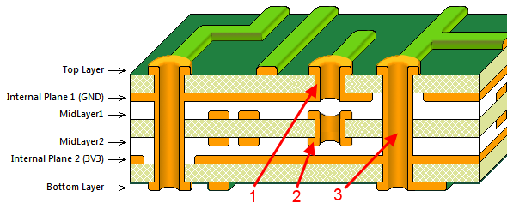

1. PCB Layer Stack-Up (Altium, 2017)

We designed our PCB using a software called Autodesk Eagle. The design process for the printed circuit board starts with the components. The user must first draw up the component in accordance with its datasheet. Each datasheet has a pinout and footprint for the components. The pinout shows what each pin of the component does and the footprint shows the size and location of pads that the pins will be soldered to. In Eagle this is done with component editor. The component editor allows the user to draw up the pinout for the part and the foot print of the part.

The second step that must be completed to design a printed circuit board is laying out the schematic of the circuit. Each component and electrical connection between components is specified in the schematic. The electrical connection between pins of components is created by using the net command in Eagle. The net command also allows the user to specify trace width of the signal wires in the printed circuit board. It is important to specify the trace width to allow the desired current to flow. If the trace is too small for the specified current than the trace has the potential to destroy itself.

The third and final step occurs after the schematic has been completed. The layout of the PCB. The layout begins with the specifications from the desired printed circuit board manufacturer. Each manufacturer has limits on the what can be performed such as limits on the minimum trace width or how close each trace can be to each other. These specifications were entered the software so that it knows what can be done.

During the third step it must also be specified how many layers the designer wishes to use for his design. We chose to use a four-layer board for a few reasons. The first reason is that it is important to keep the ground and power wires to be as large and clear of obstructions as possible. It helps improve the flow electricity through the board because it can take the shortest path to the load. To meet these requirements, we chose to have separate power and ground planes each using a layer of copper. The second reason is that it enables the signal wires to be isolated from high current areas of the board. Improving signal integrity. The four layers are: signal, power, ground, and signal.

The components are place in their desired location. It is important to keep the signal wires as short as is physically possible. As a result, components are placed close together. A general rule is that the components are generally oriented in the same direction. Now this rule doesn’t have to be strictly adhered to but it does help during the hand soldering process allowing the technician to keep a steady procession during the soldering process.

#### Subtask 8: Create a Bill of Materials, Order Components and Printed Circuit Board

Creating a bill of materials is relatively easy by using Digi-Key’s bill of material manager. Eagle allows the user to print out a bill of materials with component values and names of components. We took the generated list and enter each component into Digi-Key and selected the desired quantity of the components. If a component could not be found on Digi-Key, we used a different distributer, Mouser. Using these two distributers we were able to find all the components and buy them.

The process of ordering a printed circuit board is a little more complicated. First in Eagle the user most generate a set of Gerber files. The Gerber files tell the manufactures were the copper needs to be removed and where drill holes need to be placed. A Gerber file is needed for each layer of the board and a separate drill and silkscreen layer. The Gerber files are generated using the CAM Function in Eagle. It allows the user to select which layers go with each layer of the printed circuit board.

The manufacturer we chose for this project is JLC-PCB. The offer ten 4-layer board for $91.00 per meter square. It is one of the cheapest manufacturers of printed circuit boards available. Once the Gerber files are generated it is simple to upload them to JLC’s website and order them.

* 1. Implementation of Task 2

An embedded microcontroller board is needed to operate the valve control board. The microcontroller board will have several tasks: take the commands from the Raspberry Pi 3 through an I2C bus, interpret those commands, and send the control signals to the valve control board.

#### Subtask 1: Selecting a Microcontroller and Developing the Supporting Circuitry

The embedded microcontroller board has many specifications that will need to meet in order to accomplish the control of the valve control board:

* + 1. The microcontroller needs to have 12 different pulse width modulation (PWM) channels to have full control over 6 different motors. The 12 PWM channels will enable the microcontroller to control the direction of the fluid and to stop the fluid.
    2. The microcontroller needs to have 3 I2C buses to enable communication with 2 I2C buses being used for the valve control boards and 1 I2C bus being used for communication with the Raspberry Pi 3.
    3. The microcontroller needs at least 5 general purpose input/output channels to enable basic control on the code.

These basic requirements will inform the microcontroller chosen for the embedded board. The microcontroller will require at least 23 different pins to have full operability of the system. A microcontroller has several pins reserved for specific purposes such as programming, power, and clock inputs. These required pins increase the number of pins that the microcontroller will need to accomplish its assigned task.

Two different types of microcontroller architecture were considered for this project: AVR architecture and ARM architecture. The AVR architecture is a very robust 8-bit architecture developed by Microchip Technology. The AVR is based off the Harvard architecture which means its code and data are held in separate regions of the program memory. It also has a huge range of peripherals that can be used such I2C, EEPROM, and PWM. These peripherals are chosen by the model of AVR microcontroller selected.

The AVR has an extensive resource cloud available to the user such as books and code that can be used to develop the code for a project. It makes the AVR an extremely easy to use microcontroller. An additional advantage of the AVR is its deep roots in the Arduino ecosystem. The Arduino ecosystem is a hardware abstraction layer that allows for even the most inexperienced users to generate useable code to control hardware such as a led, I2C buses, PWM channels, and the other peripherals on a microcontroller.

The ARM architecture is widespread in the microcontroller industry it can be found in devices ranging from the latest iPhone to the last generation toaster. Having knowledge of the ARM architecture makes a student immediately useful in the microcontroller industry. The ARM architecture is based off the reduced instruction set computing just like the AVR. Unlike the AVR its memory layout can be the Harvard architecture or the Von Neumann architecture in which the code and data are stored in the same memory space. The differences in memory layout is chosen by manufacturer of the microcontroller. The ARM microcontrollers also have a huge range of peripherals that can be chosen based on the application. An application specific design will inform which ARM microcontroller will be chosen to control the project.

A limiting factor in using the ARM architecture is its limited resources available for a user of the platform to understand and implement. Limited resources are largely due to the wide variety of ARM processors available from 20 different manufacturers. Each manufacturer has a slightly different implementation of the ARM architecture which makes knowledge of these systems very specific. ARM tries to remedy this using the Cortex Microcontroller Software Interface Standard (CMSIS) a hardware abstraction layer that reduces “the learning curve for microcontroller developers, and the time to market for new devices” (ARM, 2019). However, CMSIS has an extremely steep learning curve which can require years of experience to become a successful developer.

STMicroelectronics (STMicro) implemented their own hardware abstraction layer called STM32-HAL code base. The STM32 is a ARM microcontroller that allows for an easy interface with the STM32-HAL library. It has several resources that make it an ideal entry point into the ARM ecosystem such as a book written by Carmine Noviello named “Mastering STM32”,STM32-Cube Software that is used to initialize the pin on the microcontroller, STMicro STM32 datasheets which identifies each use case of the pins, and the extensive write up by STMicro of the STM32HAL instruction set. STM32-HAL much like the Arduino ecosystem lowers the bar required for entry into the ARM ecosystem.

However, one of the biggest factors in choosing the STM32 ecosystem for this project was largely driven out of interest in the ARM microcontrollers, and a desire to be different from the other projects in the senior design class. Most project in the class use an Arduino which makes projects extremely easy to get running without any understanding. We wanted to raise the bar in the class, so we chose the STM32 microcontroller to be our embedded microcontroller.

STMicro has a large range of ARM microcontrollers that are available in the M0, M3, and M4 range. Each device has a specific use case. The specific STM32 microcontroller we chose was the STM32L476RGT6 a 64-pin microcontroller. It has 1MB of flash memory, 3 I2C buses, 51 general purpose input/output pins, and 16 timers that can be use to control 16 different PWM outputs. These peripherals make it an ideal microcontroller for the embedded microcontroller board.

The microcontroller has several specific needs such as 4-48 MHz high-speed external crystal or ceramic resonator clock input and a 32.768 kHz low-speed external crystal for a clock input. Each crystal has parasitic capacitance that has to be counteracted through the use of two capacitors placed across the crystal. The crystal chosen is based off the STM32-Nucleo development boards which have a 8 MHz 16 pF crystal on pins OSC-In and OSC_OUT and a 32.768 kHz 6 pF crystal on the pins PC14 and PC15. So, the design was copied onto our design of the embedded microcontroller board.

The second need for the microcontroller is power. The STM32 Cube is used to calculate the current requirements of the device based on the clock speed of the device and the selected peripherals. The STM32 Cube calculated that the microcontroller would require 29.2 mA when every peripheral is used.

1. 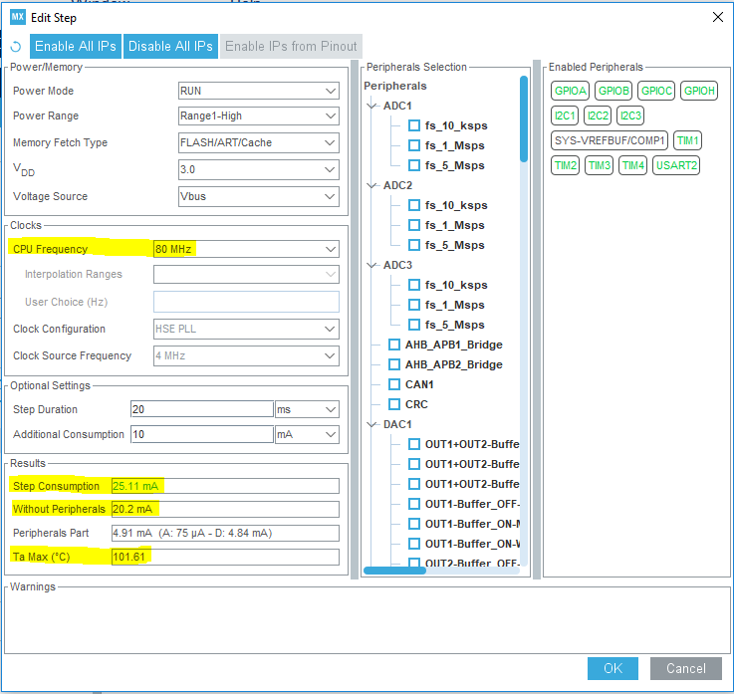 STM32Cube Power Calculations

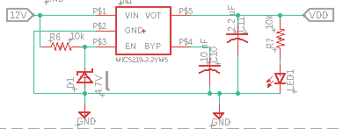Providing for any additional power requirements a MaxLinear SPX3819M5-L-3-3/TR 3.3 V 500 mA linear regulator was chosen to provide stepdown and regulate the voltage for the microcontroller. Its low cost, high availability, and specifications make it an ideal linear regulator for the microcontroller. It has 16 V maximum input which means it can be supplied from the 12 V power supply that the rest of the system uses to power the devices. It also has an enable pin which could be used to turn on or off the regulator supplying power to the microcontroller. The enable pin can be tied directly to the input of the linear regulator which makes it extremely easy to use. However, to further protect the pin I placed a current limiting resistor and a zener diode to drop the voltage to transistor logic levels (5V).

1. SPX3819 3.3V Linear Regulator Layout

The third need of the STM32 is it ability to be programmed through the use of the programming pins on the microcontroller. The programming interface that will be used is the 5 PIN Joint Test Action Group (JTAG) programming mode. The JTAG programming mode needs 5 pins: Test Data In (TDI), Test Clock (TCK), Test Mode Select (TMS), Test Reset (NRST), and Serial Wire Out (SWO) to enable successful communication between the programmer and microcontroller. The programmer we elected to use was a JLink Mini EDU programmer. The JLink programming cable has a 2x5 .05-inch female pin header that is use to connect it to devices under test. A suitable surface mount solderable 2x5 .05-inch male header was chosen to enable the interface for programming.

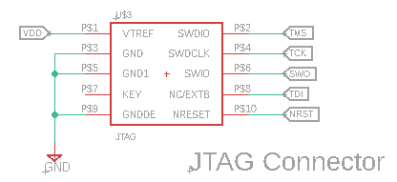

1. 5 Pin JTAG Connector

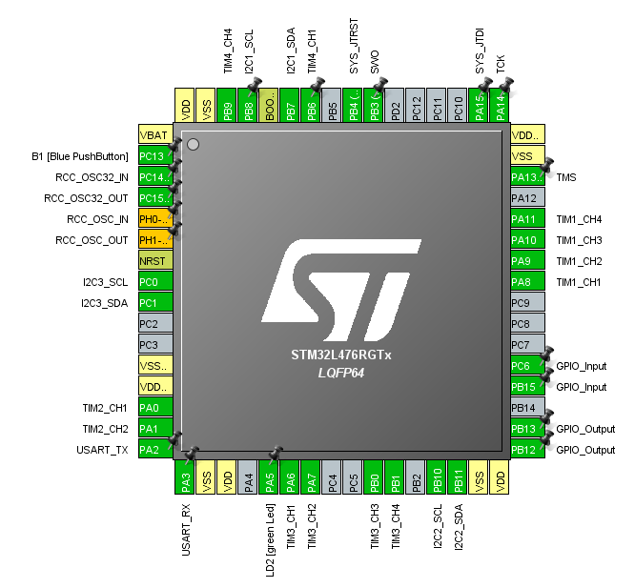The fourth need of the STM32 microcontroller is the need to interface with valve control board. The interface is done through the use of a flat flex cable (FFC) connector. These types of connectors make it extremely easy to connect devices together. The board will need two connectors in order to control two different valve control boards. The pins connected from the microcontroller to the FFC connector is largely determined by two things such as the design of the valve control board and the mode of operations each pin is capable of performing.

1. 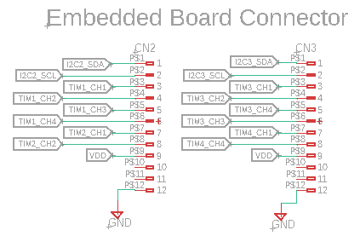Pinout of the STM32L4 Microcontroller
2. FFC Connector Pinout

#### Subtask 2: Interface of Switches with Microcontroller to Manipulate Modes of Microcontroller

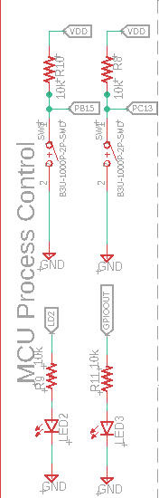The code needs to be able to be controlled using switches. The microcontroller needs to be able to communicate with the outside world through the use of LEDs. These two simple but easy to implement methods will allow for user to control the flow of the code of the microcontroller and have an understanding of where the microcontroller is at in its tasks. The embedded board as originally discussed was expected to have three control modes: a standalone mode in which the microcontroller would run its own stored recipes at the behest of user, a maintenance mode in which the pumps and valves can be run individually to determine if hardware has gone bad, and a slave mode in which it receives both the recipes and the drinks to be ordered from a master computer. However, the standalone mode had to be scrapped because the design lacked a touchscreen to control the microcontroller. In this version of the design one two modes are implemented: the slave mode and maintenance mode. The switches will be used to place the microcontroller into maintenance mode or slave mode.

The circuitry of the switches is easy to implement. by connecting a momentary SPST switch through a resistor to VDD. Sensing the change in voltage when the switch is pressed is done by connecting a sense pin from the microcontroller to a trace in between the resistor and the SPST switch. The sense pin has two states high and low when a pin changes states it will inform the microcontroller which mode the microcontroller it needs to be in.

1. Switches and Leds

The led is connected to a GPIO pin on the microcontroller through a resistor to ground. It will be used to determine the status of the microcontroller. A specific use case of the led is to let the user know which control state the microcontroller is in the maintenance or slave state.

#### Subtask 3: Layout of Printed Circuit Board

The layout of the embedded microcontroller board is much simpler in comparison to the valve control board. The embedded microcontroller board has 41 devices on the board most of them are resistors and capacitors. This allows for the board to be a two-layer board with the dimensions of 47 mm x 48 mm. The design rule check specifications are the same for this board as the valve control board. Each of the design rules are spacified by the manufacturer due their manufacturing limitations of the vias, wires, and dimensions of the board. The design rules are available on the manufacture’s websites.

The footprints of the STM32L4 was from a library found on the internet. Finding footprints of components on the internet makes building printed circuit boards much easier. The STM32L4 has 64 individual pins with specific dimensions requiring a huge amount of time to develop. The other components footprints are much simpler to design. The footprint dimensions are available in the datasheet of the component. This step of the design is conducted when designing the component in Eagle for the schematic. It makes it much easier to layout a board with all the footprints populated.

The embedded microcontroller PCB is a two-layer board. It is important to separate the VDD and ground plane to lower the noise of the PCB. A microcontroller is sensitive to noise so it is important to lower the noise floor as much as possible. The first layer of the board contains the VDD plane and most of the signal wires. The second layer of the board contains the ground plane and signal wires that could not be routed on the first layer of board. Most of the signal wires are 5 mil thickness due to the low current 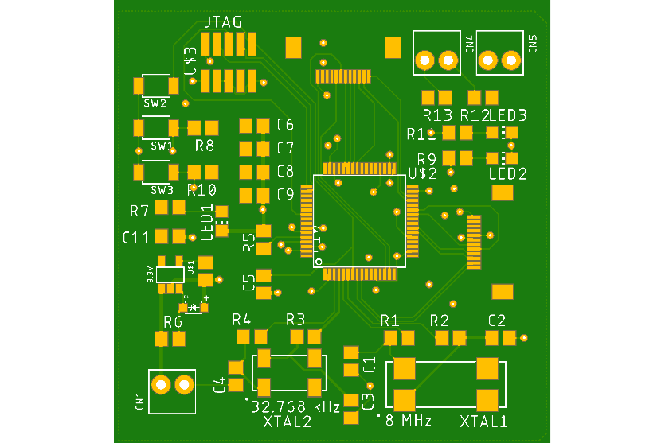requirements of the signals.

1. PCB Layout of Embedded Micrcontroller Board

#### Subtask 4: Assembling Components onto the Printed Circuit Board

Soldering of the components onto the embedded microcontroller PCB ended up being semi-difficult to complete. The microcontroller was the hardest device to solder due to its footprint. We ordered two microcontrollers to make two PCBs. However, we ended up destroying one microcontroller by messing the pins up on the microcontroller while using a pencil soldering iron. Soldering was also exasperated by choice of 0805 component. These components would be easy to solder if we were a manufacturer with access to reflow ovens. The reflow ovens heat up the PCB to the melting temperature of the solder paste melting it to the components and PCB.

The assembly of the PCB took several hours over the course of about two days. If another student decides to solder similar components, I would strongly advise them to have access to a hot-air soldering station. The hot-air soldering station allows the heating of multiple pads at the same time. It also prevents the lifting of pads from the printed circuit board by generating a more even heating. The component that did not respond well to hot-air soldering is the FFC connector. The FFC connector melted under the heat of the hot-air soldering gun. It is best to use a soldering pencil and heating up the large connector pads on the FFC connector and using the hot-air soldering gun on the small pins of the FFC connector.

#### Subtask 5: Code Microcontroller

The design of the hardware is only one portion of the design of an embedded system. An embedded system needs code to make all it work. The microcontroller takes the code and outputs various signals to manipulate the analog components on the PCB. It also gathers information on the status of the system by polling devices on the PCB. The advantage of using the STMicro ecosystem for the STM32 devices make the coding portion of the design of an embedded system straightforward. The process will go through several different pieces of software: STM32CubeMX and Keil uVision5.

STM32CubeMX has several roles in the coding process. The first role is to assign pin to their specific tasks. The software allows the user to pick from any of the devices available from STMicro and build a system around the device. In our case the device is a STM32L476GT6 it has 64 individual pins that must be assigned. Each pin on the device can serve in multiple roles. Some pins can be GPIO pins, Timer pins, SPI pins, I2C pins, etc., so each pin must be assigned a specific role by using the STM32CubeMX Graphical User Interface.

The second role that it plays is setting up the clock configuration of the device. The STM32L476 has many timers that must be set. Setting them the traditional way would require a complete understanding of the device but the STM32CubeMX makes it much simpler. The software takes the input clock frequency from the HSE clock or LSE clock and calculates the resulting frequencies of the cascading clocks. The frequencies of the cascading clocks also have specific frequencies requirements that must be met. Balancing these frequencies will require careful manipulation of the software to get the desired result.

The third role the STM32CubeMX software plays it the code generation. The software takes all of the configuration of the pins and clocks and translate that into C code. The code contains everything that is needed to start the project. It makes the process of coding the microcontroller significantly easier than what would otherwise be the case.

Over the course of the remainder of this section, the code will be explained from a high level of abstraction to a low level of abstraction. We will first discuss the organization of the code. It is important to understand the layout because it will inform us on the methods used during the processes taking place. The second thing to be discussed is the how the main loop functions. All the code developed, runs in the main loop. The third item to be discussed is how commands from the I2C bus are processed and implemented. The final discussion will be over the low-level control of the hardware on the valve control board.

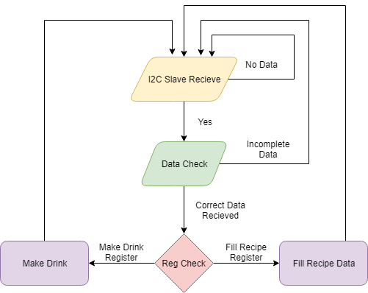 The code is organized into multiple files using header files and c files. This allows for the code to be easily changed and it allows for code to be more understandable. The main file contains all of the pin, clock configurations, and main loop. The main loop is where the main program runs. The main loop will function as the block diagram shows below.

1. Main Loop Block Diagram

The main loop checks the I2C bus to see if the correct address is being sent and data is present on the bus. The I2C bus sends various commands and data necessary for the overall function of Fluid Microcontroller Board. It is discussed in depth in the “Implementation of Task 3” of this paper. If data is present on the bus it will check to see if the correct amount of data was sent. An error will occur if the data is incomplete sending it back to the main loop checking the I2C bus. If the correct amount of data is sent it will check the first byte of the data to determine which data path it needs to follow. If the first byte of data corresponds to the make drink register. It will proceed in making a drink. If the first byte of data corresponds to filling the data struct then that process will be completed. After either one of those processes are completed it will send it back to the main loop checking the I2C bus.

Each process has a specific function it must carry out. The Fill Recipe Data function is a relatively simple function. The data is stored in a struct array. A struct is a C data type in which the data of different data types can be stored together in under one unique identifier. A struct keeps the data organized and distinguished. When the data is sent over the I2C bus it is sent with the unique identifier so that following data can be mapped to that struct.

1. 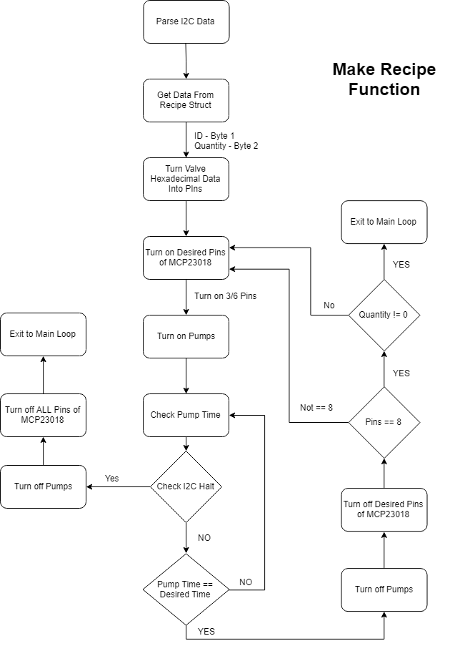Make Drink Function

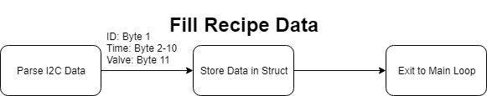The Fill Recipe Data function parses the data sent and places it in its desired location. The first byte of data identifies where the following data needs to be stored and which recipe it is associated with. The second through tenth bytes of data is used to determine the amount of time each pump will be on for a specific ingredient. The final data byte is related to which of the valves needs to be turned on. The function places this data into their respective locations within the struct. The data is stored in RAM which means that loss of power will result in the loss of the information stored. Each time the Fluid Microcontroller Board is powered on the data will need to be repopulated.

1. Fill Recipe Data Function

The Make Drink function is used to take the recipe data and output a drink using the recipe. The I2C bus sends 11 bytes of data. The first byte of data ID of the drink to be made and the second byte of data is quantity of the drink to be made. An important quark of the software is that the remaining data bytes are ignored. The ID of the drink informs which struct the valve and timing data is stored in. The function will fetch the data from the struct and make the drink based on the data. It will repeat this step until if finishes making all of the drinks.

Making a drink is a multistep process in which each valve is iterated over and the corresponding pump is triggered on. Each pump has 4 valves allocated to it. For instance, if valves 1-4 are connected to pump 1 and the valve data indicates that valves 1 and 3 need to be turned on. The loop will turn valve 1 on for the specified time and repeat for valve 3 during the next iteration of the loop. The make drink loop can turn on 6 valves at once corresponding to their 6 pumps. It will allow the drink making process to be much quicker than if only one pump and valve could be turned on at a time.

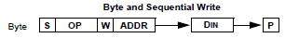The Make Drink function has two smaller subfunctions: valve control function and pump control function. On the valve control board each valve is controlled by the MCP23018 16 pin GPIO Expander. The MCP23018 is an I2C device, which means it will be controlled by the Fluid Microcontroller board. The device has a device specific 7-bit address that must be sent in order to start communication with the device. The address is sent along with a read/write bit. In our use case we only care about writing to the device so we will send a zero indicating that we wish to write to the device. Following the address and write bit is an acknowledge bit indicating that the device acknowledges the address and the write bit.

1. I2C Communication with the MCP23018 (Microchip Technology Inc., 2008)

The MCP23018 has 22 different register address that can be written to. Each register address has a specific role it plays in the overall function of the device. The valve control function uses 3 registers on the MCP23018. The first register used is the IODIRx (Input/output Direction) register. The IODIRx register controls whether we are reading the status of the pin on the device or whether we are outputting a signal from a pin of the device. The second register we will use is the GPPUx (GPIO Pull-up Resistor) register. An important feature of the MCP23018 is that the pins of the device are open drain outputs. The output of the device is not supplying the current through a transistor. A pull up resistor must be connected to the drain of the MOSFET allowing the pin to supply voltage and current to the device connected to it. The GPPUx register must be set to 1 to enable the pull up resistor. The third register that is important is the GPIOx (General Purpose Input/Output) register. It controls whether the pin is in an on or off state (i.e. whether pin is logic high or logic low). In startup each of these registers must be initialized. The registers do not retain the information in them when the device is 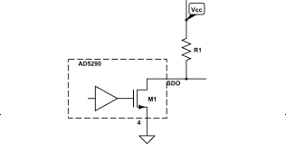powered off.

1. Open Drain Pin Configuration (Electronics - Stack Exchange, 2013)

The valve control function handles the translation between the valve data held in the struct call “pinList” and manipulates the GPPUx register turning valves on and off at the behest of the Make Drink function. The MCP23018 has two GPPUx registers: one for pins 1 through 8 and the other register for pins 9 through 16. The function must keep track of the changes being made to those registers since we are not reading the status of the register on the device itself. Whenever a change needs to occur the stored register data is changed and written to the MCP23018. The valve control function must also determine which register needs to be changed based on the pin it receives.

The pump control subfunction is a much simpler function in comparison to the valve control subfunction. In the configuration of the pins of the timers, it is necessary to choose both a pre-scaler and a period. These parameters allow a PWM frequency to be chosen - 480 Hz.

$$PWM \left(Hz\right)= \frac{Main_Clk_Freq}{\left(Prescaler+1\right)(Period+1)}=\frac{80 MHz}{(650+1)(255+1)}= 480.03 Hz$$

1. Equation for PWM Frequency

In our use case we chose to keep the duty cycle set by the timer compare register constant but for future expansion it will be nice to vary the speed of the pumps. The pump control subfunction takes the pump data from the struct and turns on or off the pumps according to the data.

The combination of all these functions allow for the control of the pumps and valves in an orderly method to make the various drinks required of the device. The code makes this a complete project.

* 1. Implementation of Task 3

In order to complete task 3, a custom communication scheme had to be developed between the Master Computer and the Fluid Microcontroller PCB. Due to software issues with the Fluid Microcontroller board, software-interrupt based communication could not be used, so a new way had to be developed to control the interactions between each board. General Purpose Input/Output (GPIO) pins were connected between each board in order to control whether the one board could send data to the other board. The Fluid Microcontroller would set their GPIO pin low (i.e. bringing the pin to the board’s GND voltage level) when communication could be carried out, and a high GPIO pin (3.3 Volts) would mean that the Fluid Microcontroller was busy with another task and could not receive data. When the GPIO pin was low, the I2C protocol was used to transfer data packets between each computer. The Master Computer acted as the master device on the I2C bus line, and the Fluid Microcontroller acted as a slave device on the same line. The “Polling” technique is being used for checking the GPIO pin and reading transferred data into a buffer.

The reason that communication was needed between each board is because the Master Computer and Fluid Microcontroller must have matching sets of data for making drinks. The Fluid Microcontroller does not use persistent storage for drink recipes or inventory placement, so this information must be transferred to the Fluid Microcontroller on startup of the Master Computer’s software. Until this information is transferred, the Fluid Microcontroller will be in an idle state. Because the Fluid Controller is in an idle state waiting for recipe data, the GPIO pin for controlling communication will be held low. When the Master Computer polls this GPIO pin, it should immediately begin the process of packing together the drink recipes into a drink menu data structure, which will be unpacked into an expected format before transferring to the Fluid Microcontroller. Once the microcontroller receives this data, it will store it in RAM for later use. While the microcontroller is processing and storing the recipe data, its GPIO pin will be brought high in order to prevent the Master Computer from sending any more data while it is busy. Eventually, the GPIO on the Fluid Controller will be brought low when it is done. This allows the Master Computer to send drink order commands to the Fluid Controller, which will also cause the GPIO state to change in order to control the communication.

The storage of the recipes for the master computer will be in Master Computer’s main memory as a text file. On startup of the desktop application software, the application will read this file and display its contents in an organized fashion for viewing by the user of the system. When changes are made to the recipes, the text file containing the recipes will be edited in order to keep the information being shared with the Fluid Microcontroller accurate. In addition, the information about the inventory items for the full system was stored in the main memory as well, so that the desktop application could transfer inventory item positions (i.e. valve numbers) to the Fluid Controller board. If changes occur in the offered inventory items, then these changes would require that the recipes be updated too.

The ingredients used in each recipe will have a specific number of ounces used. The number of ounces will be converted to uptime for the pumps. Each pump has a specific rate at which fluid can be passed through it in a minute, and it is defined to be milliliters per minute. The ounce value must be converted to milliliters, so the fluid ounce to milliliter conversion factor was multiplied to it. The max uptime for the pump was set to be 30 seconds. The bit resolution for pump time was 8 bits, which allows for 256 different values to be represented. By dividing the max uptime by the bit resolution, the smallest time unit that can activate the pump was decided. When the smallest time unit is multiplied by the pump rate, the quantity of milliliters that leave the pump in that unit time can be ascertained. By dividing the converted number of milliliters by the unit quantity of milliliters leaving the pump in unit time, the pump time is then calculated, reduced to the nearest integer value, and stored with its respective drink recipe. The Python expression for converting ounces to pump time can be seen in the following figure.

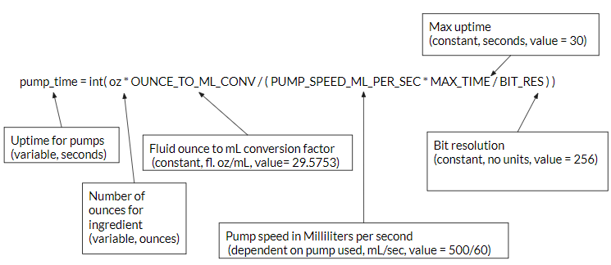

1. Fluid Ounce to Pump Time Conversion Expression

Each inventory item will correspond to a valve in the system (these are controlled by an onboard register on the Fluid Controller), so the recipe pump times are ordered by the id of the inventory items. The order in which recipes are transferred over to the Fluid Controller determines the id number of the recipe. When order commands are sent to the Fluid Controller, the Fluid Controller will expect a recipe id number and quantity of drinks that need to be made. These orders will be sent to the Fluid Controller via the I2C protocol. This will require Serial Clock line (SCL) and Serial Data line (SDA) of each board to be connected. The implementation of the I2C data transfer can be seen in the following figure.

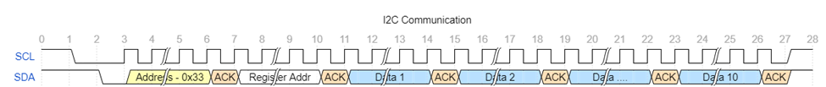

1. I2C Communication Scheme
   1. Implementation of Task 4.

#### Subtask 1. Design A GUI using Python’s Tkinter Library

This subtask dealt with designing a Graphical User Interface (GUI) using the Python programming language and its Tkinter library. Python is a high-level scripting language that is used for general purpose programming. Its Tkinter library comes with the initial installation of the Python toolkit, and it offers common GUI components/widgets (e.g. buttons, labels, scrollbars). The Tkinter library directly interfaces with the Tk widget toolkit, which is open source, native to various operating systems, and cross-platform. By using Python and Tkinter for the main application, this allows for easy extendibility and portability. For organizing GUI elements/widgets, there are usually three options: Place geometry, Grid geometry, and Pack geometry. The Place geometry option places elements at certain pixel coordinates. The Grid geometry splits a window into a grid and requires placements of elements within ordered cells. The Pack geometry fills in specified zones of a window with the use of keywords (e.g. TOP, BOTTOM, FILL, STICKY). The geometry that was picked for this project with Grid geometry because it is the simplest to use and maintain. The following figure shows what Grid geometry looks like.

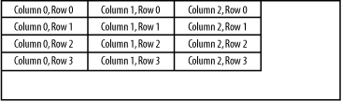

1. Grid Geometry Example

For most GUI applications, the structure of the GUI is separated into different parts. This is usually done for two reasons: the work can be split between different people and there can potentially be more code reuse if the complexity is reduced. These parts are usually the model, view, and control. The model directly manages the data, logic, and rules of the application. The view is any output representation of information. The control accepts input and converts it into commands. This project’s GUI follows this design pattern (also known as MVC).

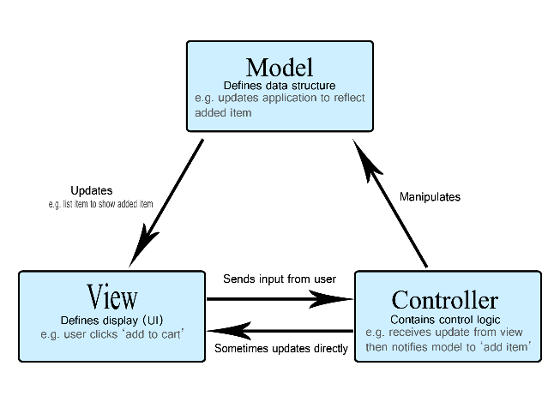

1. MVC Pattern

The model would be the MainApp class, which controls the file management of the whole system and directly adds/updates system information. The view is defined completely in the AppWindow, CustomerWindow, EmployeeWindow, and LoginWindow classes. The control is defined in a few different classes because every window needs to report information back to the MainApp object that acts as the central hub. The class structure is shown in a Unified Modeling Language (UML) diagram in the next figure.

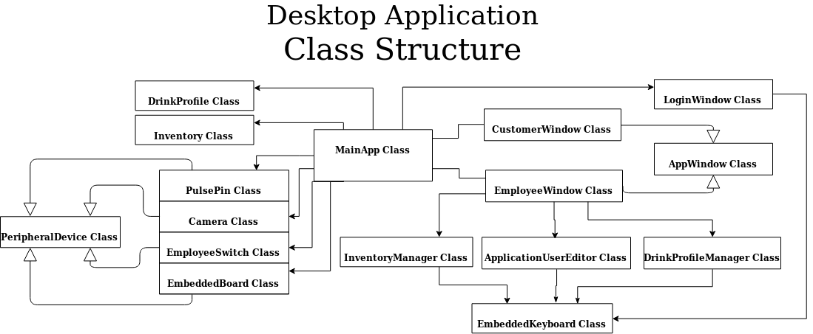

1. Class Diagram of Desktop Application

The classes that were made for this project each focus only on a few features. By splitting up the offered features in multiple classes, there is higher readability and lower coupling. These two results encourage reusability of code. For example, the CustomerWindow and EmployeeWindow classes are two classes that could have been merged within one file. The benefit of splitting them up is that they can be customized for a specific user if they exist on their own. Inheritance was used to give the same base functionality to the CustomerWindow and EmployeeWindow classes. The two classes could inherit methods that were useful for both, but still specialize.

Before getting to the customer or employee window, the user of the application must select the mode to operate in for the session. This will be triggered by a physical switch in the future, but the current code makes the user enter a “1” in the shell in order to get into the employee mode or any other number to enter the customer mode. The user is also given the chance to select a button in the root window that will redirect them to one of the two windows. This root window is shown in the following figure.

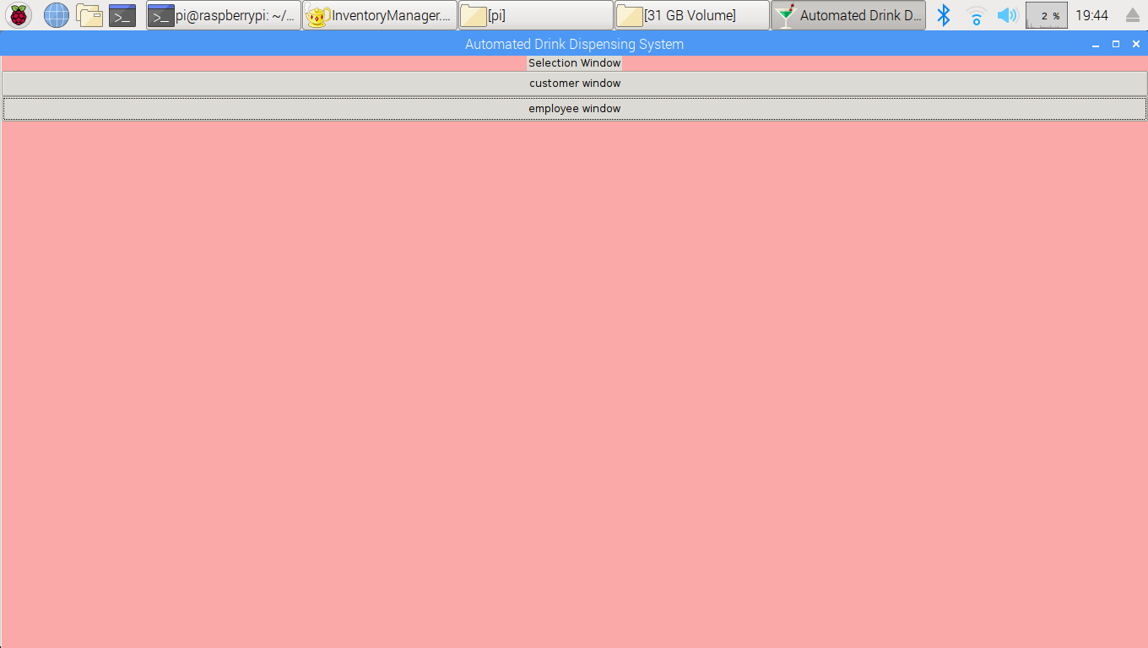

1. Root Window with Mode Selection Buttons

If the user selects either window, then the root window will be withdrawn, and the selected window will be displayed. The employee window requires login credentials to use, but the customer window does not require them. The customer window will launch in full screen mode and prevent the user from minimizing, moving, or exiting the window. Ideally, the customer should only have privileges for viewing and ordering desired drinks, so that’s why the window for customers is limited. A “Help” menu was also added that gives a user information about how to operate the machine and contact information for the creators of the machine. This window is shown in the following figure, and it is the main screen for the customer window.

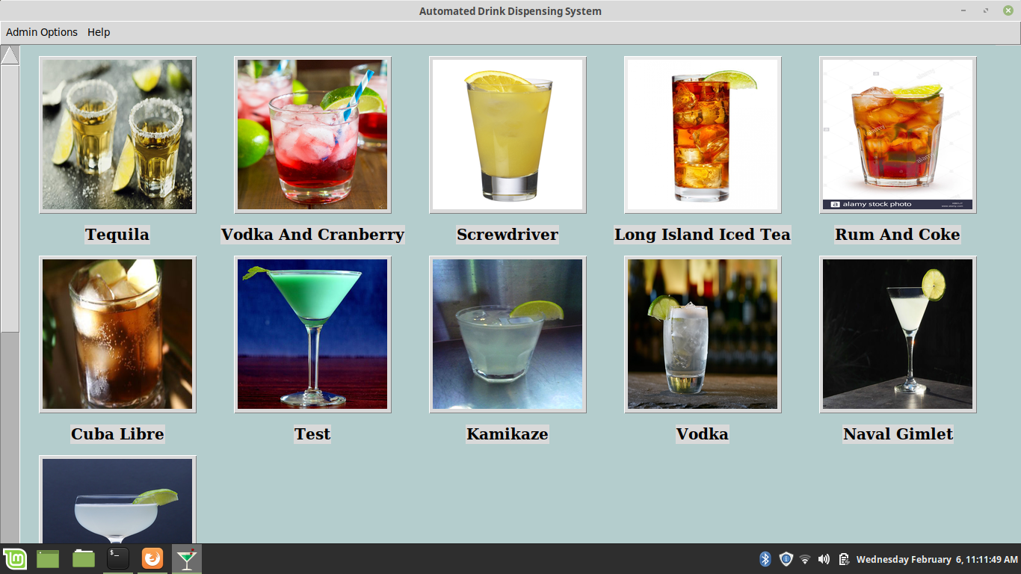

1. Main Window of Customer Window

The CustomerWindow class uses methods from the AppWindow class in order to display each active drink that is stored in the local file system. Active drinks are drinks that are currently capable of being served by the system, and the employee users are the ones that determine whether a drink is active. Within the main screen of the customer window, an active drink will be represented by three widgets: a label showing the drink’s name, a button for selecting the drink’s ordering page, and an image of the drink that is retrieved from the local storage system. Each set of widgets have vertical and horizontal padding in order to utilize all the space within the window. With the current code, only five widget sets can exist within each row. A variable number of active drinks can be loaded into the desktop application, so the main screen will eventually need to be vertically scrollable in order to display all the options. If the customer presses any one of the buttons, then the order page for the selected drink will be displayed. The following figure shows what the order page generally looks like for the customer mode.

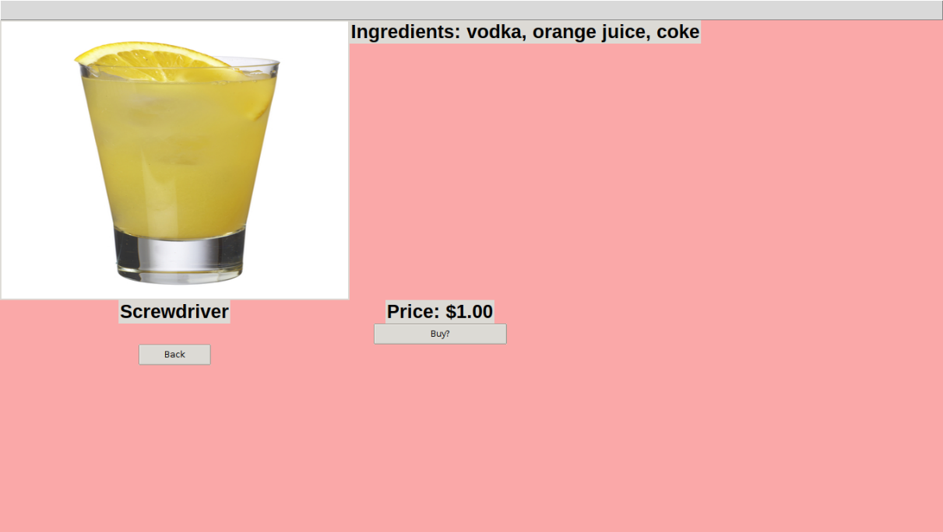

1. Order Page for Customer

The order page for the customer displays some of the information stored in each drink profile from the local file system. An enlarged picture of the drink is inside a label widget, and it is shown in the top left. The ingredients are stored inside a label widget, and the label is placed in a grid adjacent to the picture. The name of the drink is stored in a label widget directly below the picture. A “back” button widget is placed in the row under the drink name label. The price is stored in a label widget, and it is shown in the column to the right of the first column. The “buy” button is shown below the price label widget, and it initiates the ordering process. If the user clicks on the button, then a confirmation box is displayed. This feature can be seen in the following figure. Eventually, a pop-up window will be displayed to show whether the customer has paid yet.

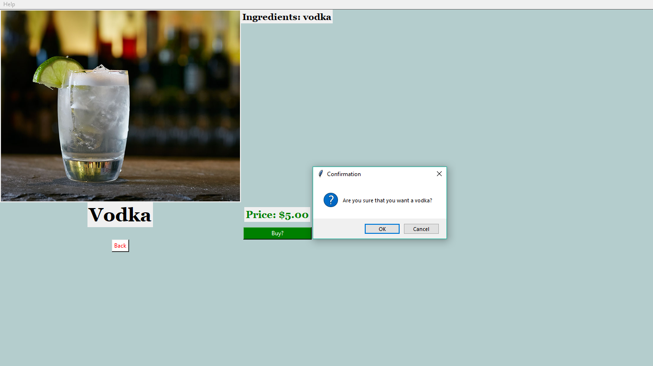

1. Order Confirmation box

Although the employee mode uses a similar format for the main menu and the ordering pages for each drink, there are a lot more features for that mode. If the user decides to enter employee mode, then the login window will appear and require the user to provide valid credentials before proceeding. The Login window is defined in the LoginWindow class. This class is responsible for the following features: providing an interface for the user to login, attempting to match the user’s login credentials with what’s stored in the local file system, denying entry if the user exceeds the max number of failed attempts, and decrypting/encrypting user login credentials. A login window instance will have the following widgets existing in adjacent grids: a username label, a password label, a username entry field, a password entry field, a canvas that will hold the embedded keyboard, and a login button. The login window instance will also determine whether a registered user is either a regular employee or an admin employee. Admin employees have more privileges than regular employees, so different options will be displayed when the employee window appears. The maximum number of failed attempts per session is three, and if that number is exceeded then the application will automatically bring up the customer mode window. All the registered users of the system will have their username and password stored in a single file. This file will be encrypted using Python’s cryptography library in order to keep entry into the employee mode secure.

Because this desktop application is meant to be a touchscreen application as well, an on-screen keyboard is embedded into the login window. The embedded keyboard is defined in the EmbeddedKeyboard class. It is a collection of button widgets that execute a certain command depending on the character that is displayed in the button. The special keys of the keyboard are the spacebar, backspace, and shift keys. These keys perform the same function as they do on a regular keyboard. The other keys on the embedded keyboard just directly output a letter to the current entry field. In addition, the embedded keyboard can pass input to at least 6 different entry fields, and each entry field that is associated with the embedded keyboard instance will touch bind, which basically makes the entry field active if the user touches the entry field. This embedded keyboard offers all lowercase and uppercase alphanumeric characters. The uppercase characters can be accessed by pressing the shift key. The login window and embedded keyboard can be seen in the following figure.

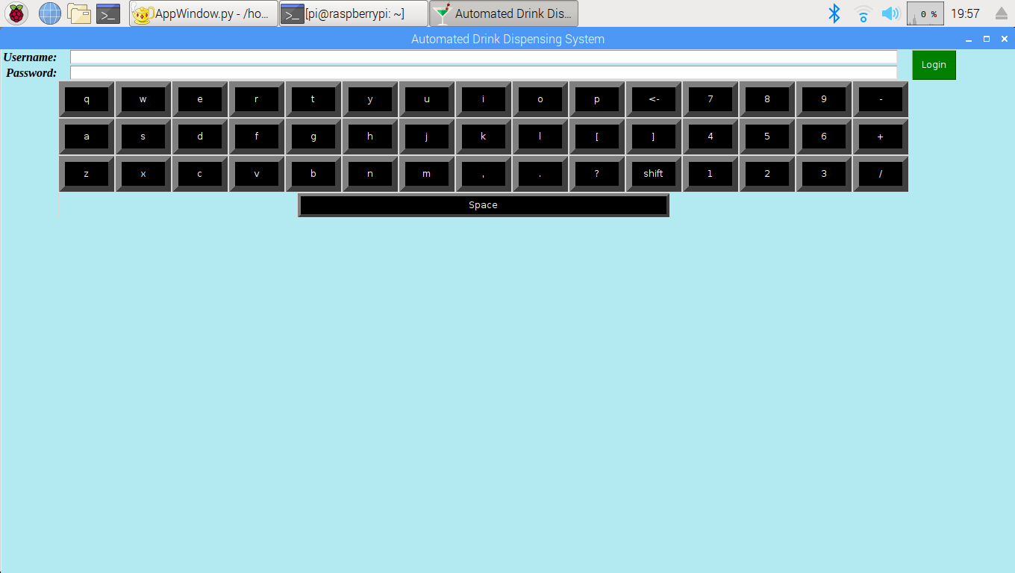

1. Login Window

When valid login credentials are provided, the login window is replaced by the employee window. The only difference between the main screen of the employee and customer windows is that the employee window will have an extra menu bar. If the user is a regular employee, then the menu bar will be the “Employee Options” bar. If the user is an admin user, then the menu bar will be the “Admin Options” bar. These two bars are similar, but the “Admin Options” bar has more options available. Currently, the “Employee Options” only has the “Launch Drink Profile Manager” option. The “Admin Options” bar contains the “Launch Drink Profile Manager”, “Display Log”, “Edit Configuration”, “Edit User Logins”, and “Show IP Address” options. The “Edit Configuration” option is the only that is not defined yet. The following figure shows the “Admin Options” menu bar options.

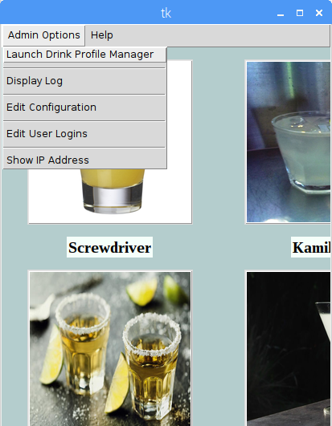

1. Admin Options Menu Bar

For the “Drink Profile Manager” option, the user is given the ability to change system information while inside the GUI. The goal of this option was to provide CRUD capabilities. CRUD is a software engineering abbreviation for “Create, Read, Update, and Delete”, and it describes the basic operations that should be offered for any application that deals with persistent storage. The following figure shows an image of this principle.

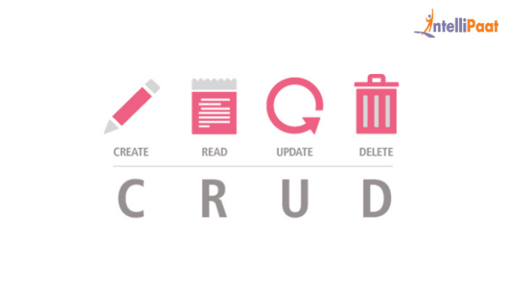

1. CRUD Principle

The DrinkProfile class is the class that is used internally for creating, reading, updating, and deleting drink profiles from the local file system. On startup of the application, DrinkProfile objects are created, so that they can store drink information, like the drink Id, drink name, picture location, and drink price. The information that is stored in these DrinkProfile objects are then extracted and displayed inside the GUI. In addition, each DrinkProfile object has methods that allow for creating new drink profiles that will get stored the local file system, deleting drink profiles, and editing drink profiles. This class is where the CRUD methods are implemented. Because CRUD methods must be available to the user of an application, these methods are only called within certain windows of the application.

The DrinkProfileManager class is a class made for editing drink profiles within the GUI. This class provides an interface in a top-level window that the user can interact with and access the CRUD capabilities. It will take DrinkProfile objects and display their information. This is not limited to active drinks, so inactive drink profiles will be loaded as well. This gives the user total control over current and past drink profiles. The user will be given the option to add a new drink, delete the current selected drink, or edit the current selected drink. This is shown in the next figure.

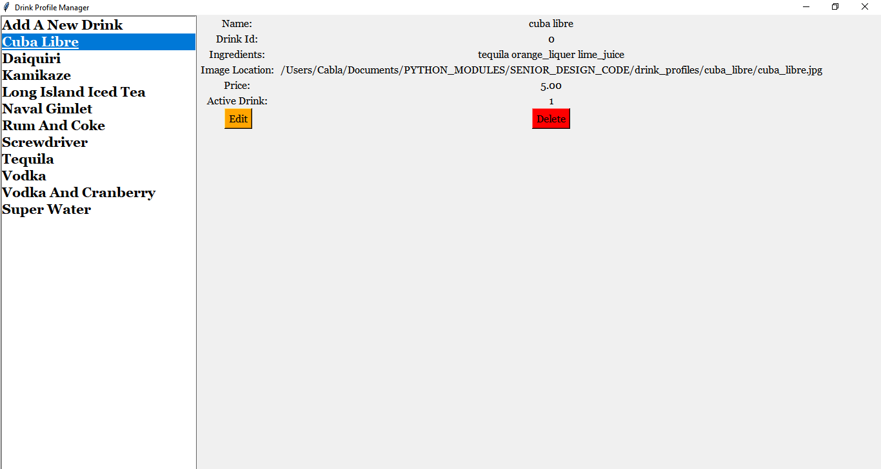

1. DrinkProfileManager Window

Depending on the option selected, the user will be taken to the drink editor window, which will allow the user to input their desired changes. The drink editor window makes use of the EmbeddedKeyboard class and entry fields as well. The entry fields are populated with the current drink profile information, and the drink profile information is only updated if the content in the entry field changes. The name, Id, ingredients, ounces, picture path, price, and active status are the parameters that can be changed. The ingredients must be selected from a list of registered ingredients, so that ingredients that are not available are not used in the recipe for a drink menu option. In addition, the number of ounces for each ingredient must be specified. For the current system, there is a limit of four ingredients for each recipe. A save button widget was added as well.

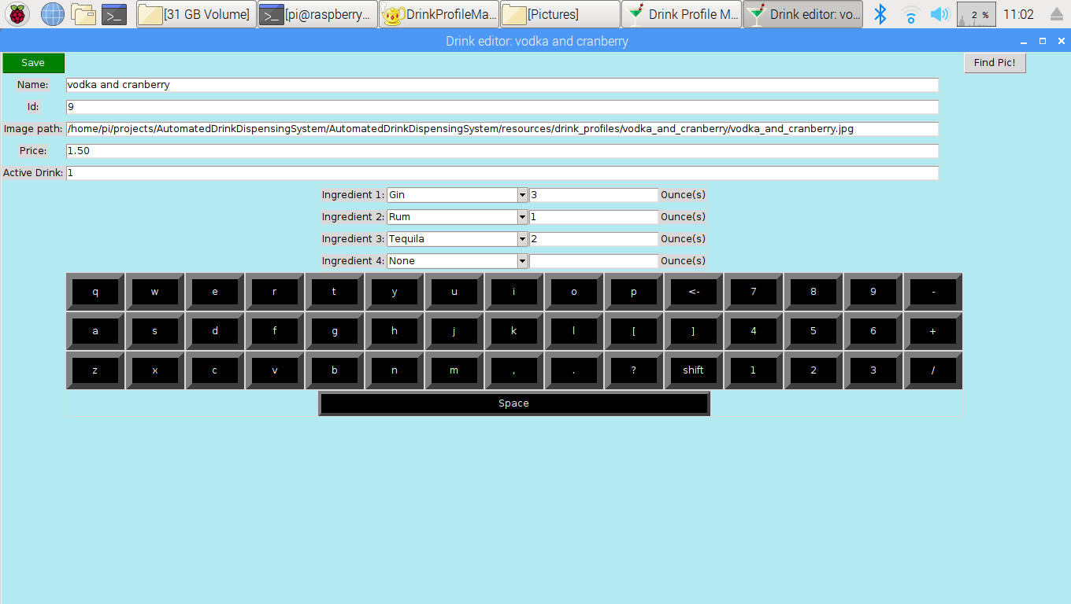

1. Drink Editor Window

The “Add A New Drink Option” option in the Drink Profile Manager window brings up the same drink editor, but the entry fields are not populated and the save button is replaced by a create button (each button calls different methods from the DrinkProfile class). The delete button widget in the Drink Profile Manager window allows the user to permanently delete a drink profile from the local file system, and it displays a confirmation box before completing the request.

In order to keep track of inventory items, an inventory manager was created. The InventoryManager handles basic operations and displaying of registered inventory items. The following features are available within the manager: adding new inventory items, switching the valves of registered inventory items, editing current quantity, and editing original quantity. The InventoryManager window also creates a graphic showing the proportion of current inventory to current inventory. These features will allow a user to have full control of each inventory item. Also, an embedded keyboard is used within the InventoryManager window. Whenever there is a change in the inventory item name or valve number, the new information is written to a file in the local file system and the drink recipes must be updated. If a recently provided inventory item is gone, then that will affect drink recipes, so there is a function to detect when those issues come about, so that action can be taken to resolve it. The inventory manager window can be seen in the next figure.

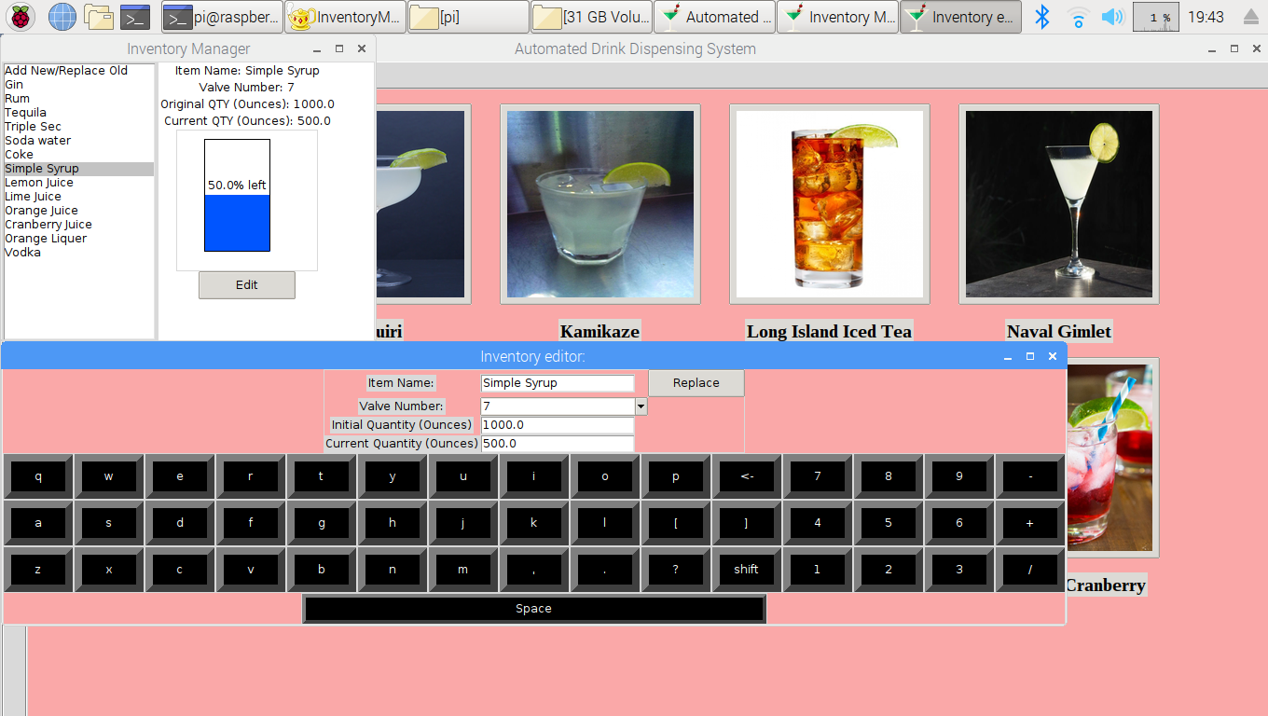

1. Inventory Manager

Another option for helping the user is a Log Manager. The log manager reads and displays log files that were created by the desktop application. There are three types of log files: shared data files, sales data files, and system log files. The shared data files are used to provide a system summary to devices that are using the phone application. The sales data files are for displaying daily sales within the desktop application. The system log files show what operations have been applied to the desktop application, which is good for tracking its daily use.

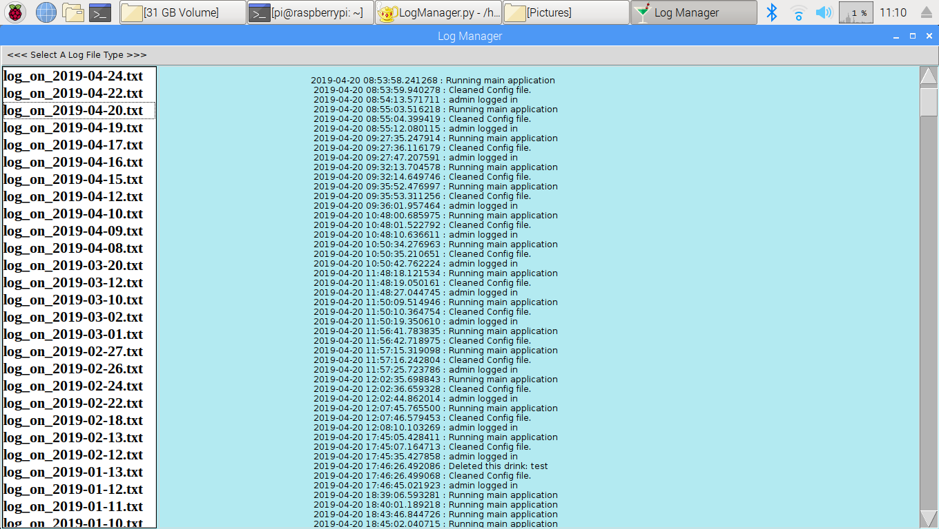

1. Log Manager

The next menu option for the admin user is the “Edit User Logins” option. When clicked, a top-level window will be instantiated that will show the current registered users for the application. This window is defined in the ApplicationUserEditor class. It simply decrypts the file that contains the user login credentials and displays them. Two button widgets are also placed inside the window. The ApplicationUserEditor window is displayed in the next figure.

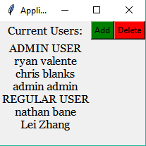

1. ApplicationUserEditor Window

The button widgets inside the ApplicationUserEditor window are for creating a new user login and for deleting an existing user login. These two buttons open the user editor top-level window. The “Delete a User” window has the following widgets: username label, username entry field, password label, password entry field, a done button, and a canvas that holds the embedded keyboard. The “Add a User” editor is slightly different because the user can click a checkbox for making the new user an Admin user. Both buttons will cause changes to the file that holds this information. This is shown in the next two figures.

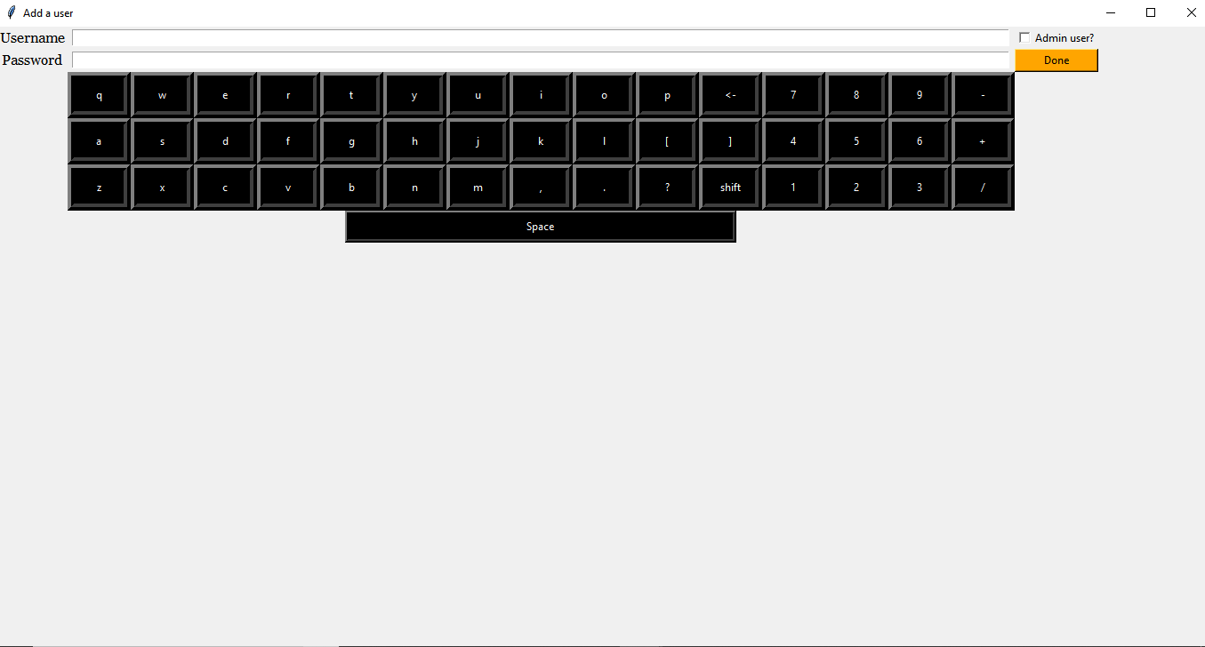

1. “Add a User” Window

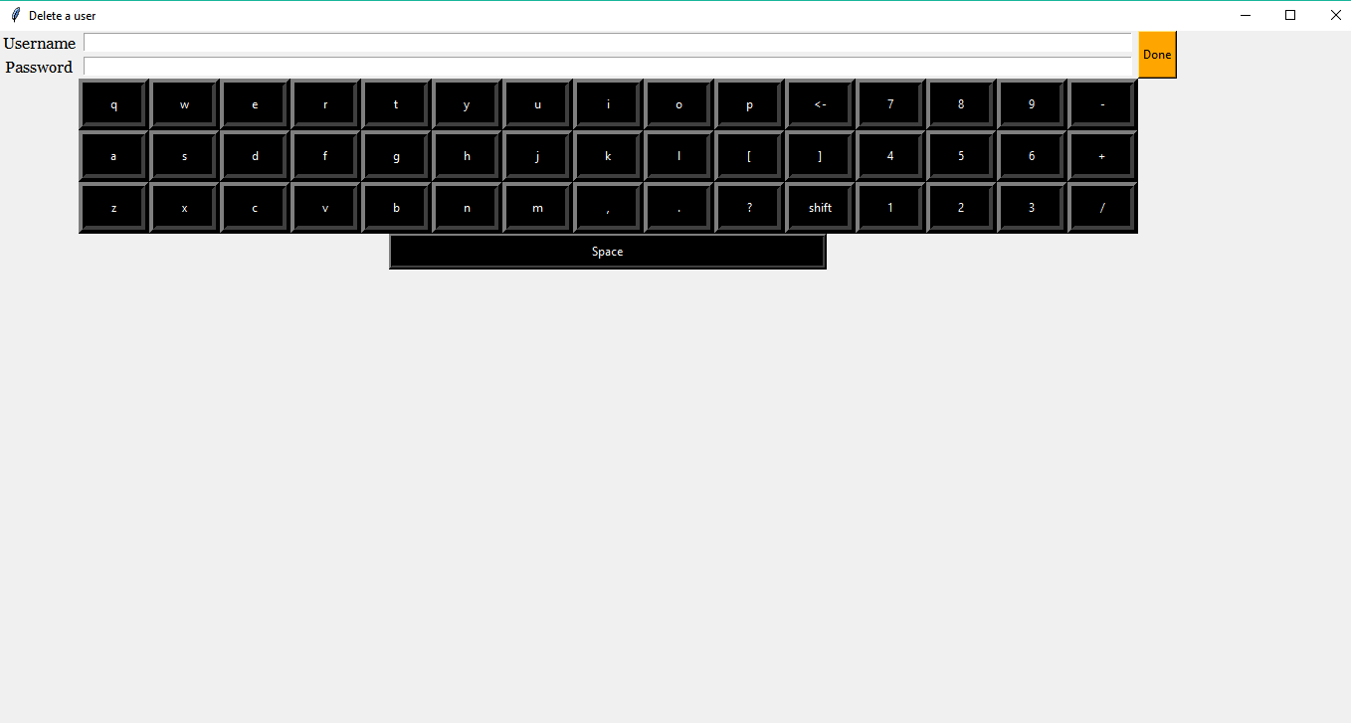

1. “Delete a User” Window

The next option in the admin list is the “Change Background Color” option. When a user clicks this option, a popup window is displayed that allows the user to change the background color of the application to whatever color in either the RGB or HSV representations (also a HTML color code option). This allows the manager of the system to be able to customize the color of the application to whatever they see fit. The current background color is then stored in the local file system, so that it will be retained between sessions of the desktop application software. The background color picker can be seen in the following figure.

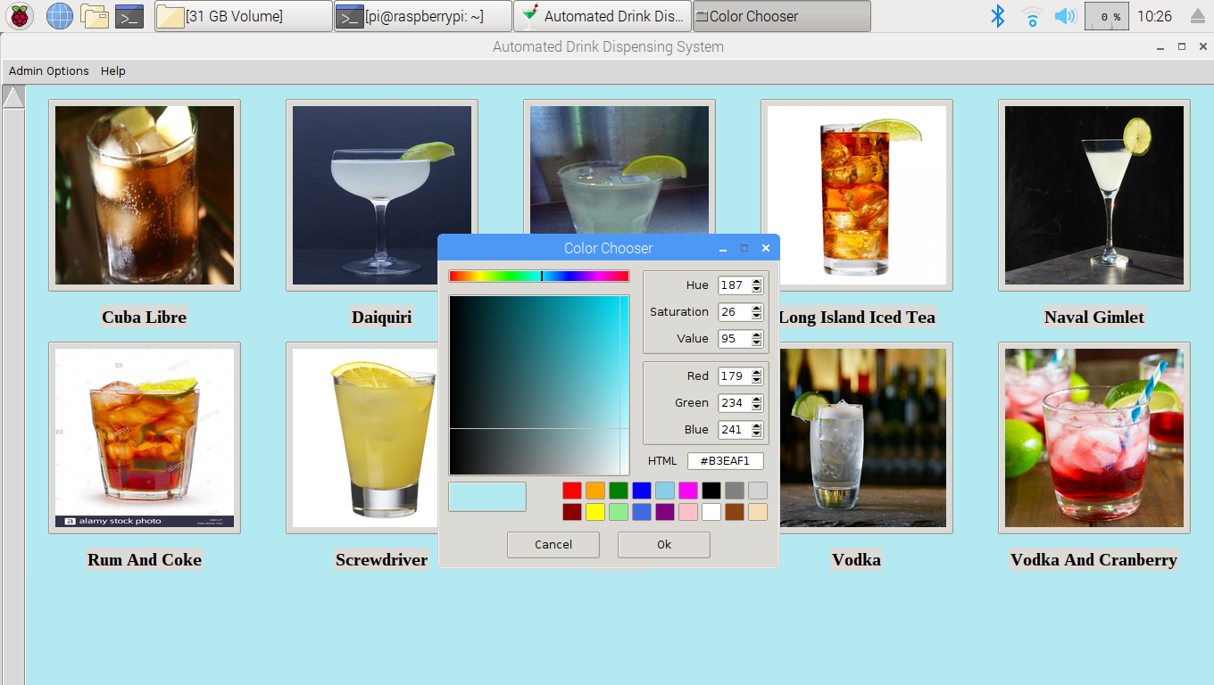

1. Background Color Picker

The next offered option for the admin user is the “Show IP Address” option. In order to make a desktop application that can share data with remote devices, a method must be used that can broadcast information over a network. The Hypertext Transfer Protocol (HTTP) was used because it is a common, well supported method for serving or grabbing information from other computers on different networks. On startup, the desktop application will initialize a public HTTP server on port 80 of the Raspberry Pi. This server will broadcast files from a certain directory on the Raspberry Pi, so that other computers can retrieve the data from the files. For other computers to see the files, the IP address and port number of the host computer must be known. The user of the application will be able to see the IP address with this option and enter this information into the phone app, so that it can get the necessary files. This way of sharing shared data only works if the main computer and the phone device are on the same network. This problem is addressed by also generating a URL through a HTTP tunneling software tool called NGROK. NGROK will forward the http server hosted on the raspberry to a cloud service, so that devices not on the same network can still access the shared data.

When the button for this option is clicked, a top-level window is displayed that contains a label widget. The label widget shows a string that is the wlan0 IP address number. This is an important option because the wlan0 IP address number can constantly change on public networks, so the user of the application must be able to view this information in order to properly share data between the main computer and the phone application. This top-level window is shown in the following figure.

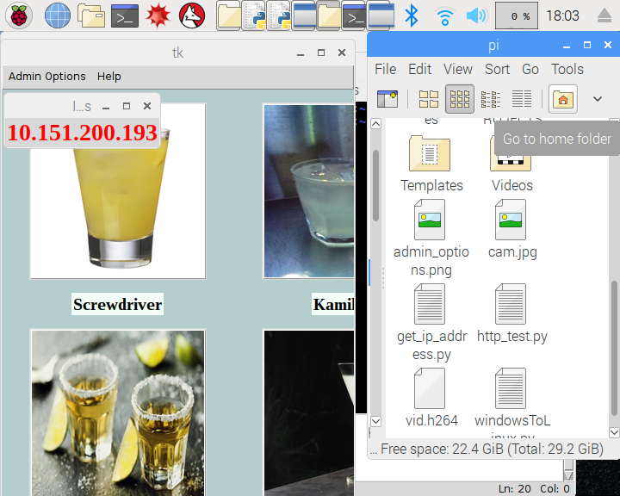

1. IP Address Window

The last option in the admin options menu is the “Show URL” option. This option is identical to the “Show IP Address” option, but instead shows the randomly generated URL created by the NGROK tool. The generated URL is for use within the phone application. When the phone application connects to the URL, it will request the shared data information from the server being hosted on the main computer. This URL is only temporary, and it will last for about 8 hours. A permanent URL can be rented from the NGROK tool’s company. Another limitation of the NGROK tool is that only a set number of devices can connect and request data from the hosted website within a certain time frame, but this problem will go away with buying services from NGROK’s company.

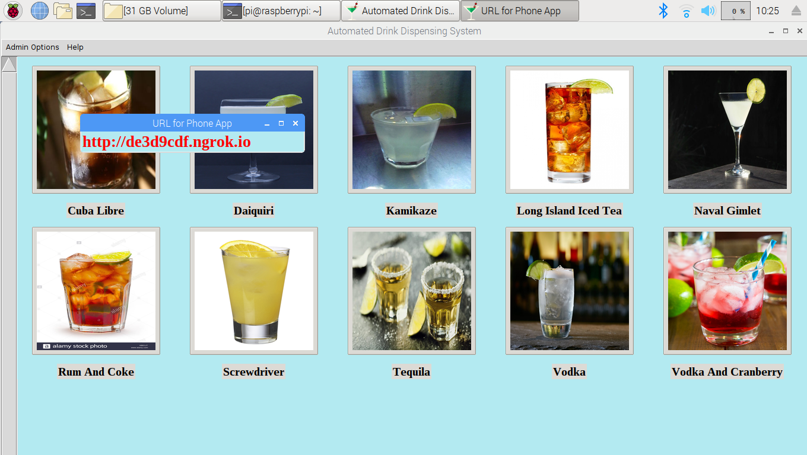

1. URL Window

For both the employee and customer windows, the “Help” menu bar is offered. This menu bar displays just two options,” How to Operate” and “Info About Contributors”. For a user to properly use the GUI, there has to be information inside the GUI about how to use the features. Providing this operation information inside a menu bar is standard practice for desktop applications. The “Info About Contributors” option is important because some users may want to contact the creators of the application to give feedback. The “Help” menu bar options can be seen in the following figure.

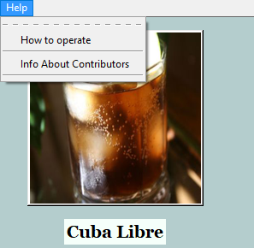

1. “Help” Menu Bar Options

The “How to Operate” option loads operation instructions from a text file into a top-level window. A different instruction file is used for both the employee and customer mode because they require different details about the operation. The employee mode’s instructions would be more about how to use all the features inside the employee window. The customer mode’s instructions would be about how to use the features inside the GUI to order a drink. This window can be seen in the next figure.

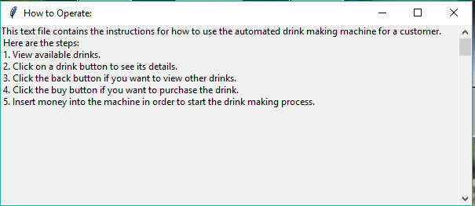

1. How to Operate Instructions Window for Customer

The “Contributors” option opens a top-level window that shows the names and roles of each person who contributed to the Automated Drink Dispensing Project. The name of our university is also displayed inside the window. Also contact information is provided inside this window. All this text exists within a single label widget. This window can be seen in the following figure.

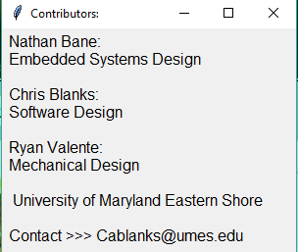

1. Contributors Window

These are the main features that are packed into the desktop application. With the features that have been mentioned, the user of the desktop application should be able to control the Automated Drink Dispensing System and make updates within the GUI.

#### Subtask 2. Develop an efficient way to organize system & drink information

This subtask dealt with developing an efficient way to organize system and drink information that would be used by the main application, phone application, and peripheral devices. The need for an organized collection of data is crucial because mismanaged information can ruin the performance of the complete system and lower user satisfaction regarding the full product. All the system and drink information are stored in the local file system of the main computer. For easy access, this information is stored in child directories to the “SENIOR_DESIGN_CODE” parent directory. The system information is stored in its own directory, “system_info”, and the drink information is stored in the “drink_profiles” directory.

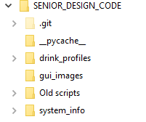

1. Parent and Child Directories

Within the drink profile directory, each drink that is offered on our current menu has its own child directory. Each of these children directories have their own image and text file. The images are all the JPEG format because that is the easiest format to work with when using Python’s native libraries for performing functions on images. The text file contains the information needed to build a drink profile inside the main application. On each line of the text file, there are space delimited values that become attributes for Drink objects. There are lines for the id number of the drink, the name, the ingredients, the location of the picture, and the price. The remaining lines are for internal use within the main application. By standardizing this format for the drink profiles, it allows the main application to load an arbitrary amount of drink profiles and contain all the relevant information in Drink objects that are used all over the code.

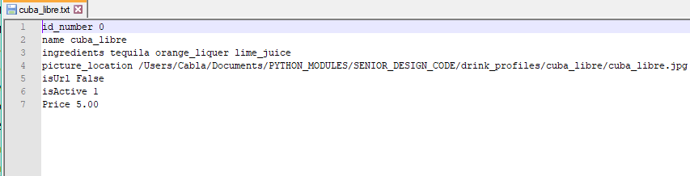

1. Example of the Text File Format of Each Drink Profile

Within the system_info directory, there are a few files that are for internal use in the desktop application. These files are the config.txt, instructions_4_customer.txt, instructions_4_employee.txt, inventory_info.txt, user_login.txt, and key.txt. The config.txt is for keeping a persistent record of system information that can be referenced by the desktop application and phone application. The instructions text files were created for providing instructions about how to use the GUI for employee users and customer users. Each type of user will need different instructions because there are different privileges and features for each one. The inventory_info.txt will be used for keeping track of the quantity of inventory items, which is very important. The user_login.txt file is a very important file because it stores all the user login credentials. The desktop application will read from this file whenever an employee tries to log into the system. The contents of this file are encrypted using symmetric key encryption, so it looks just like a bunch of random characters put together if the user were to open the file normally. The key.txt file stores the symmetric key that is needed for decrypting the user_login.txt file. The desktop application will attempt to retrieve the key from this file first before trying to read from the user_login.txt file. If a key does not exist, then the desktop application will make a new one. This also means that the current user_login.txt file cannot be decrypted if a backup key is not stored somewhere else.

There are three children directories located in the system_info directory, and they are the “drink_sales”, “log_files”, and “shared_data” directories. The drink_sales directory holds the daily drink sales files that hold information about what drinks were sold throughout the day and the price of the bought drinks. Eventually, these files will be viewable in the log window option within the employee window. New sales are simply appended to the end of the current sales file. The log_files directory contains the log files that describe actions that were executed throughout the day. These are already displayed inside the GUI, and when the user of the GUI chooses to clear a log file, the application deletes the current log file and makes a new one for the day. New actions are simply appended to the end of the current log file. The shared_data directory contains shared data files for each day. The format of the shared data files is the same for all the files, and they are simply overwritten whenever changes are made to the data that is being shared. There are three sections for the data inside the files. The “STATUS” section contains three lines about the current system state, current mode for the application, and current logged in registered user. The “INVENTORY” section contains information about the current quantity and original quantity of the inventory of the machine. The “SALES” section contains information about the daily sales for each drink that was bought. For the current main application, the shared data is updated every single minute. Using a HTTP server, this directory is shared to remote devices that are aware of the main computer’s current IP address. Only this directory is broadcasted, so the other system information cannot be obtained. The phone application will be directed to the main computer’s IP address and use html parsing in order to find relevant shared data files. The format of the shared data files can be seen in the following figure.

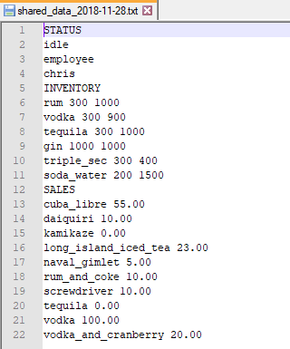

1. Shared Data File Format

#### Subtask 3. Add in capabilities for communication between main computer & peripheral devices

This subtask dealt with creating an interface between the main application and other peripheral devices. For this system work, there must be a standard interface for commands and data to be sent through. The main application will be sending out commands to peripheral devices and receiving data that will determine the next state of the whole system. The peripheral devices of the main computer are the employee mode switch, camera, the bill acceptor collector, the fluid microcontroller board, and any other addition that will add useful capabilities to the full system. By defining a standard interface, adding even more peripheral devices will not take as much time as writing an individual interface for each new device.

This interface is in the form of the PeripheralDevice class. The PeripheralDevice class setups up basic attributes that the main application will use to command and interact with a peripheral device. Some of the attributes are the name of the device, state of the device, the data buffer, the communication method, and the GPIO pin numbers on the Raspberry Pi that the device occupies. With this information, the main application will have complete information about the device and will be able to effectively use that device. Some methods that the main application will call deal with reporting the state to the main app, sending data to the main app, starting communication with the device and the main computer, and terminating communication. With the use of inheritance, the Peripheral Device class will act as the base class for each individual device class. While each individual device class will have its own methods, the main application will only have to use the methods in the base class. This allows for easy extendibility and prevents unacceptable amounts of coupling between the devices and the main application. A diagram is shown in the following figure that displays this relationship.

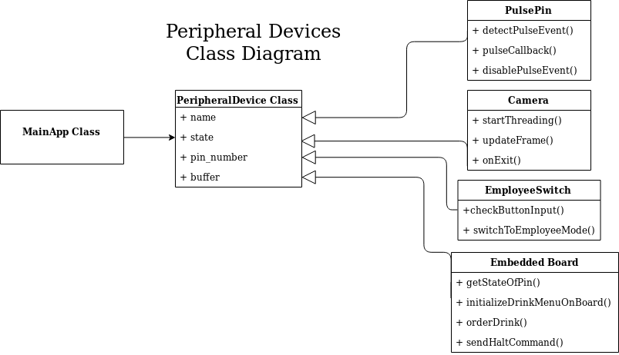

1. PeripheralDevice Inheritance Diagram

The first peripheral device that integrated into the system was the employee switch. The employee switch is a simple push button that is connected between a GPIO pin of the Master Computer and the Master Computer’s GND pin. The GPIO pin has an internal pull-up resistor connected to it, so that the pin remains at a logical high. When the push button is pressed, the GPIO pin is pulled to the GND voltage, which allows a user of the system to get to the login screen of the desktop application. Without being able to press the employee switch, the desktop application software will remain in customer mode. This GPIO pin is being polled every 2 seconds, so that it won’t disrupt the desktop application software.

The next peripheral device that was integrated into the system was a MEI bill acceptor. The bill acceptor can be configured to accept US bills (e.g. $1, $5, $10). The bill acceptor needs an input voltage of 115 VAC in order to turn on. When a bill is inserted into the bill acceptor, an input line sends a pulse for every dollar.

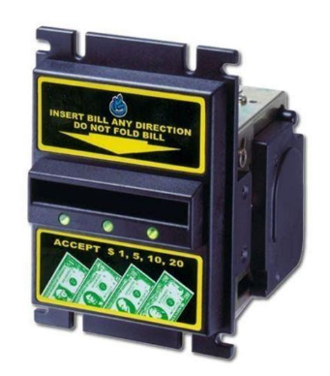

1. MEI Bill Acceptor

The bill acceptor input line was attached directly a GPIO pin on the Master Computer. The pin was waiting for the negative edge of a pulse in order to count the pulses that the bill acceptor emitted. The input line was connected to the collector of a NPN bipolar junction transistor (BJT). The emitter of the BJT was connected to the Master Computer’s GND pin. The gate of the BJT was assumed to be receiving pulses from some internal circuitry of the bill acceptor that counted the inserted money. For easier testing of the system, every drink option in the machine costs a dollar. There is no way to give change back to the user of the system, so either a change device will have to be integrated as well, every drink will have to be a certain dollar amount, or a new system for payment will have to be realized in order to make a full product.

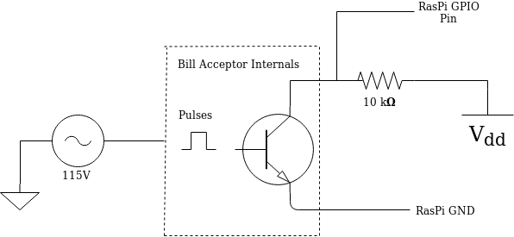

1. MEI Bill Acceptor Interface Schematic

The next peripheral device to be integrated into the system was the Picamera. The Picamera can connect with a slot on the Master Computer’s PCB. The Picamera must be enabled through the “raspi-config” utility in the Raspbian OS. The Picamera can take pictures and videos. The role of the Picamera in the full system was for entertainment purposes. The Picamera would be used to collect live videos and draw animations on frames depicting users on the machine. The desktop software collected each edited frame from the Picamera and displayed it within the GUI. The Due to not having a full system setup with a mount for the Picamera, a 3D structure was printed that would hold up the Picamera for testing purposes.

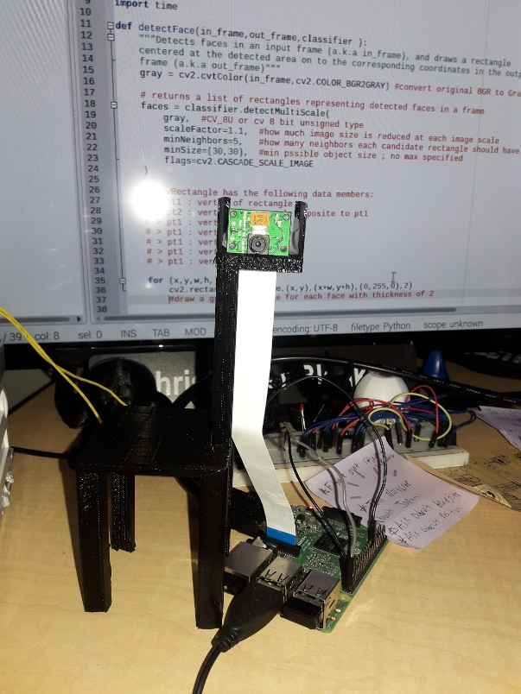

1. 3D Printed Picamera holder

The last peripheral device that had to be interfaced with was the fluid microcontroller board that was developed in task 2. The fluid microcontroller board was connected to the main computer through four GPIO pins. The serial data line (SDA) and serial clock line (SCL) were used on the main computer to connect to the fluid microcontroller’s SDA and SCL. This connection allowed for drink recipe data to be sent on startup of the GUI. In addition, ordering information was also able to be sent once a drink was selected by a user of the application. The ground lines of each board must be connected between the main computer and fluid microcontroller, so that communication can happen. The final pin for the main computer was a GPIO input pin that would poll the status of a GPIO output pin on the fluid microcontroller board. The output pin signaled when the fluid microcontroller was able to receive data. When the output pin is brought low, the fluid microcontroller board can receive data. If the output pin is high, then that signals that the fluid microcontroller board is busy with completing a task. The main computer will keep polling that pin until it goes low. In the case of the drink ordering process, the main computer will poll the GPIO pin of the fluid microcontroller before sending the drink order with I2C over the SDA and SCL lines. The fluid microcontroller’s GPIO pin will go to a high state after successfully receiving the order, and it will keep the pin high until the drink is successfully made. The desktop application will transfer to the wait screen when waiting for the drink to be finished, and it will finally go to the delivery screen once the GPIO pin of the fluid microcontroller goes low when the drink is finished. This process can be seen in the flowchart shown in the following figure.

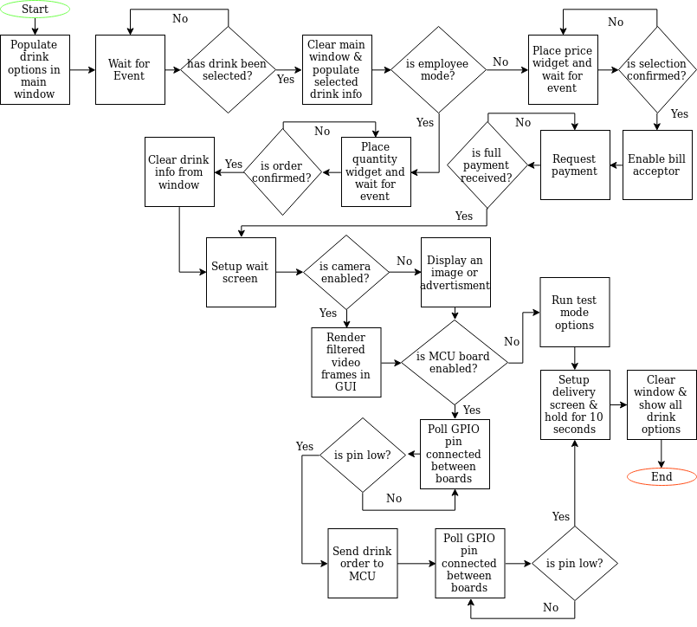

1. Flowchart for the Drink Ordering Process
   1. Implementation of Task 5.

#### Subtask 1. Design the user interface of the phone app with Android Studio’s SDK

The phone application for this project was built using Android Studio’s software development kit (SDK). Android Studio is a common tool used for making applications for phones running a version of the Android operating system. It allows you to build applications for many phones and different versions of the OS. For this project, the phone application can run on phones that have Ice Cream Sandwich (SDK version 15) up to Pie (SDK version 28), and it is compiled using SDK version 28. By building the application for these targets, there is at least 99.8% coverage of the android OS distribution of running devices (Android Developers, 2018). Android phone applications are usually written in the Java programming language and the Extensible Markup Language (XML). The Java portion will typically define the app behavior, and the XML portion will define the view/layout of the application. For testing the phone app, a J7 phone that is running Oreo (SDK version 26) was used.

For this project’s phone application, the application had to provide monitoring features for an owner/manager of the Automated Drink Dispensing System (ADDS). The phone app’s icon was made to be a picture of a drink because that reflected the function of the ADDS. The application was named “ADDS Phone App”. The icon and name of the application can be seen in the following figure.

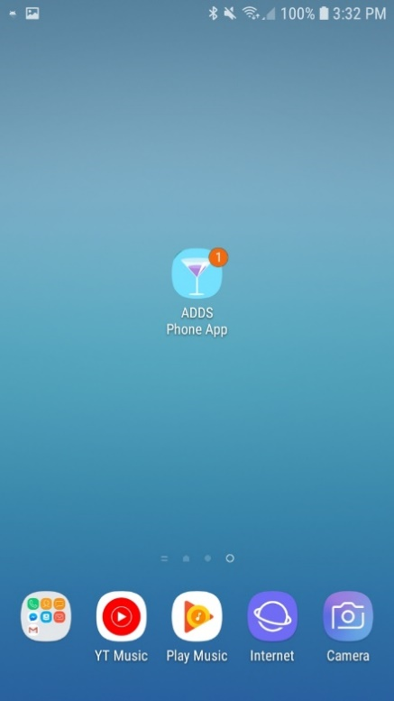

1. Phone app Icon with Notification Bubble

Because this phone app is supposed to be used by an employee of the establishment that purchases an ADDS, there is a login screen that is supposed to compare phone app user login credentials to the desktop application’s login credentials. This would require the phone app to acquire the user_login.txt and key.txt file from the Raspberry Pi and find a Java library that can make a cipher for decrypting the user login information. For the current phone app, there is only one registered user, and the registered user is the “admin” user.

In order to make the user of the phone app login to the app, a login page had to be made. Using XML and Android Studio’s layout constraint specifications, a simple login page was made. The login page can be seen in the following figure.

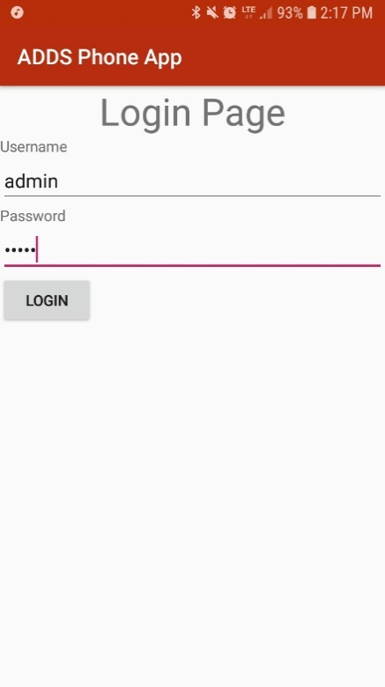

1. Login Page of Phone App

The login page uses TextView, EditText, and Button widgets. The TextView widgets (Username and Password) display the text “Username” and “Password”, which gives the user a hint about what the following EditText fields are used for. The EditText fields are basically entry fields. The password EditText will hide the password from being shown. Once the user is done with entering their login credentials and presses the “LOGIN” button, the phone app will check to see if it matches the stored username and password sets. If the user fails to enter correct login credentials, then a Toast (a temporary On-screen message) will be displayed that says, “Failed login. Try again.”. When the user fails three times, the login button will be locked. The user will be forced to close the application and try again. If the user is successful, then a Toast will be displayed that says, “Successful login”. The phone application will then proceed to the next screen/activity.

The next activity allows the user to interact with the monitoring features of the phone app. There were three main features that the phone app had to at least have for the user, and they were a sales feature, inventory feature, and a system status feature. The sales feature had to at least show the total sales for the current day. The inventory feature had to at least show the amount of inventory left in the machine. The system status feature had to at least show basic system information. Because there were three features that had to be displayed and each had equal importance, a tabbed view was selected for the main menu of the phone app. A tabbed view allows the designer of an app to split features between multiple tabs, and each tab can be accessed by either swiping the screen or clicking on the tab head. The tabbed view can be seen in the next figure.

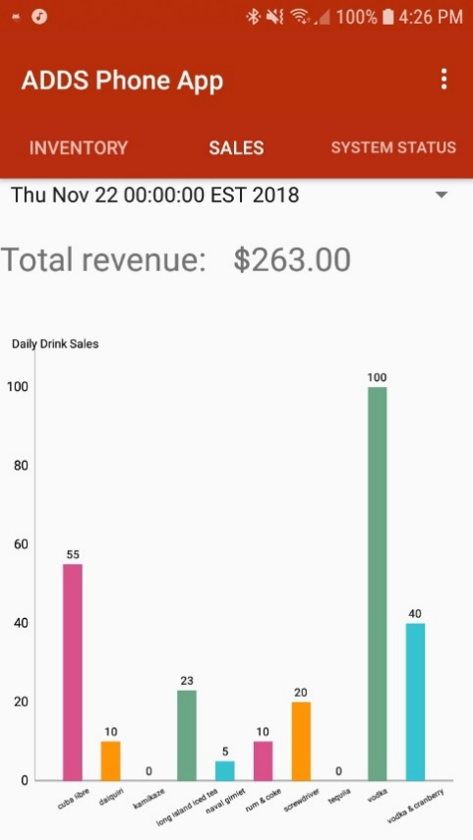

1. Tabbed View of Main Menu

A tabbed view allows each feature to take up the full screen. For Android Studio, tabbed views require a container and fragments. The container stores fragments and keeps track of the current fragment that is being displayed. Fragments are the different views that can be accessed by swiping or tapping. The container requires its own layout defined in XML, and each fragment requires its own layout described in XML. This allows for customization of each fragment, which is great if the designer wants to make each fragment handle different behavior and show different widgets. Because three different features were offered, three fragments were made. The fragments were named “Inventory”, “Sales”, and “System Status”, which can be seen in the previous figure. The data for each fragment is retrieved from the HTTP server that is being hosted by the Raspberry Pi. The user interface for each fragment is described in more detail in the following subtasks.

The user interface of the phone application was completed when all the main features were implemented and refined. There are still some features that can be added to the phone application in order to make it easier to use and more automated. That will be done in future work.

#### Subtask 2. Setup the HTTP client on the phone app & access the system information stored on the Raspberry Pi

For this subtask, the phone app needed to acquire the capability of accessing the files being broadcasted on the Raspberry Pi’s HTTP server. Naturally, this meant setting up a HTTP client on the phone application and guiding the client to the right Uniform Resource Locator (URL) and port number on the Raspberry Pi. The user can see the options for dealing with the HTTP server by clicking the settings icon in the bottom right corner of the action bar of the phone app. By clicking the “Update Data” option, the HTTP client will attempt to connect to the HTTP server and retrieve the specified data. A toast will be displayed with a message that is dependent on whether the HTTP client succeeds. These options are shown in the following figure.

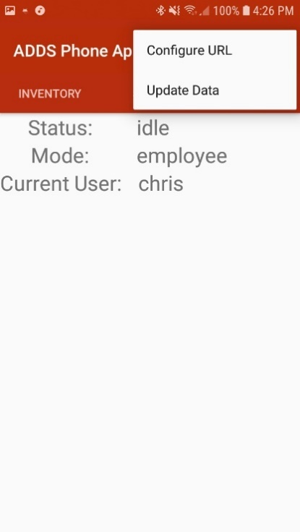

1. URL Settings Options

When the “Configure URL” button is clicked, the phone app switches to a new activity, which is used for editing the URL link that the phone app’s client is being directed towards. The current URL will be displayed in a TextEdit widget. A TextView is located above the Text Edit, so that it shows the user the TextEdit’s purpose. A save button widget is directly below the TextEdit widget, so that the user can save the new URL for future use. Whenever the URL is changed, the Android Preference value is changed. The new URL will show up every time the phone app is used until it is changed by the user again. The back button simply returns to the previous activity. These features are shown in the following figure.

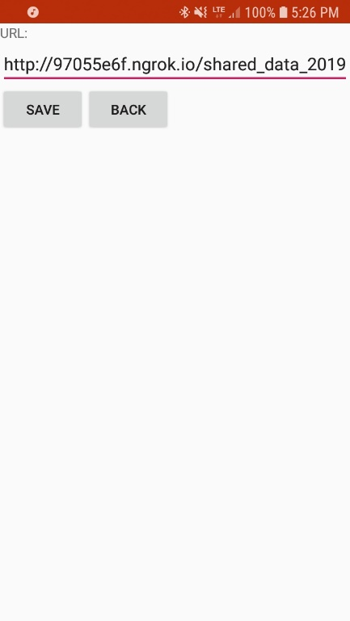

1. URL Editor Layout

#### Subtask 3. Provide monitoring features within the phone app

The inventory fragment uses a TableLayout widget for displaying inventory information. The TableLayout widget splits the screen into a grid with columns and rows. A TableLayout widget can take TableRow widgets that help with making an organized layout. Within each cell in the grid, a single widget can be placed inside. For this fragment, TextViews were placed inside each cell of each row. Because the number of inventory items can be changed depending on the owner’s choice of drinks, the TableLayout is made dynamically. Usually, layouts are defined statically with XML, but that method is not very adaptable. Depending on the number of inventory items, TableRow widgets will be created and packed into the parent TableLayout widget. The only statically defined TableRows in the TableLayout widget are column titles, which are “Items”, “QTY Left”, and “Original QTY”. The “Items” column will hold the inventory item name. The “QTY Left” column will show the amount of fluid left in the inventory item’s container. The “Original QTY” column will show the original amount of fluid in the inventory item’s container. These details can be seen in the next figure.

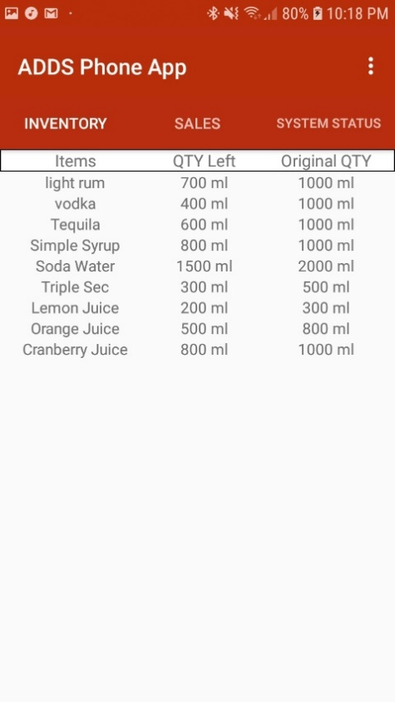

1. Inventory Fragment View

By finding the ratio of quantity left by original quantity, a notification can be sent to the user of the Phone App that will indicate when the ratio is ½ or below. This notification currently manifests as a bubble on the app icon and as a banner in the notification center. The notification can be given a title and a message. The current title is “High Priority”. The current message is “Running low on inventory”. This notification can be seen in the following figure.

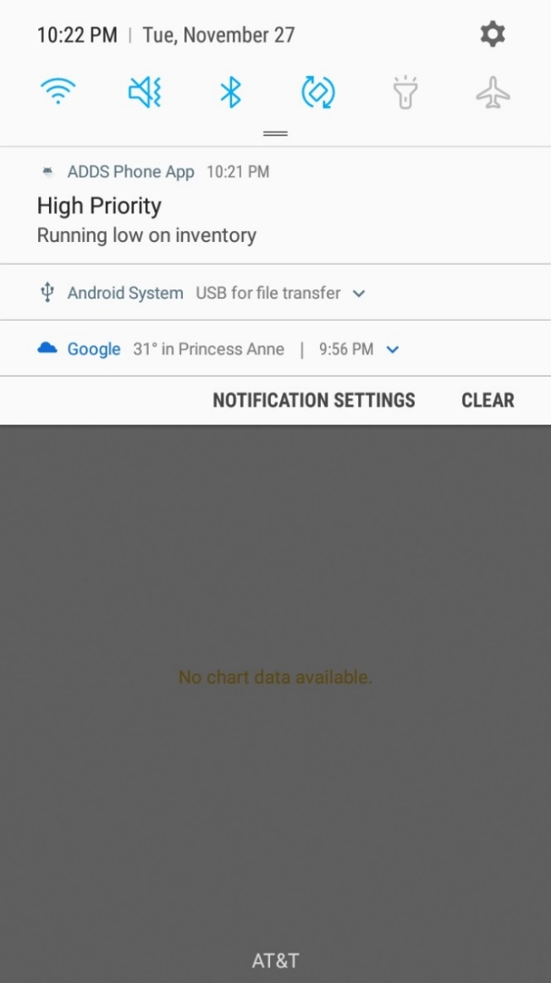

1. ADDS Phone App Notification

The sales fragment is meant to show the individual and total sales for a certain day. Each day of sales is displayed in the Spinner widget, which is essentially a dropdown menu with multiple items. The items are dynamically stored in the spinner because there is not a limit on how many shared data files the client will retrieve. For each shared data file, a item will be appended to the Spinner widget. The actual sales data will be plotted using a 3rd party Java library called “MPAndroidChart”. A bar graph was chosen as the graphical representation of the sales data because it was easy to implement and adapt for when a variable number of drinks are in the shared data file. The individual sales value is displayed at the top of each bar in the graph. The name of each drink is directly below their respective bars and the X-Axis. The bar graph is also capable of being zoomed in or out in the vertical direction, but not for the horizontal direction because it causes errors. The total sales are calculated by adding up the individual sales, and it is displayed with a TextView widget directly above the bar graph. This can be viewed in the following figure.

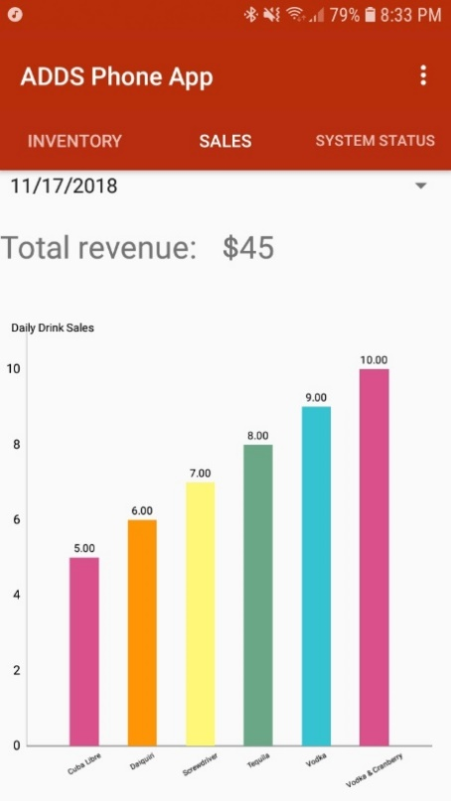

1. Sales Fragement View

The system status fragment uses just three TextView widgets to display the information gathered from the shared data file. The system status, system mode, and current user will be displayed next TextView labels. This information is important because it allows the employee to know how the machine is currently operating. This can be seen in the following figure.

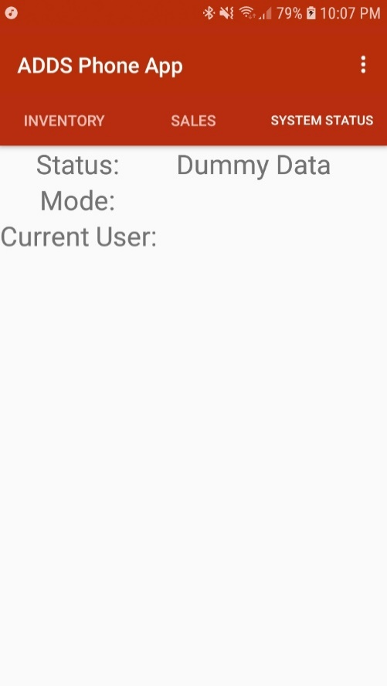

1. System Status Fragment View
   1. Implementation of Task 6

#### Subtask 1. Incorporate facial recognition into the desktop application

With the use of the Picamera peripheral device and the OpenCV (Open Computer Vision) library, facial recognition code was written to provide entertainment to users of the system. The Picamera acquired frames of images, and algorithms incorporating OpenCV facilities were used to edit the frames. The algorithms were based on first detecting a face within a frame and then drawing 2D animations onto the detected face. One animation even relied on detecting eyes within the subsection of the detected face.

The first 2D animation to be developed for the system was the bunny ears feature. The first step in this process was using a function in the OpenCV library that used Haar Cascade filters to detect faces within an image. The function returns likely candidates for a detected face within an image, which can be used to locate the center of a face and draw shapes onto it. The common drawing tools from OpenCV are circles, ellipses, lines, squares, and points. For the bunny ears, the center of the face was used to draw two concentric ellipses at the top of a user’s head.

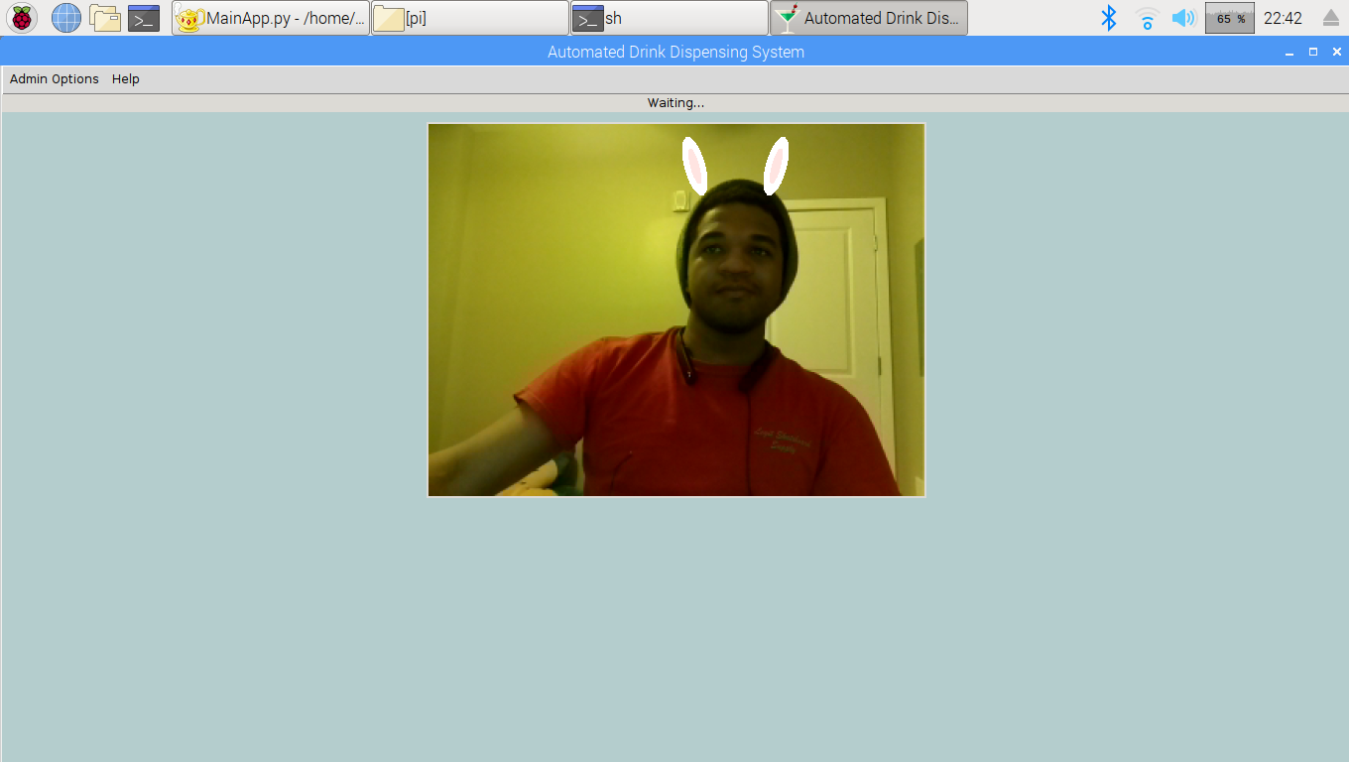

1. Bunny Ears Filter

The math for the bunny ears required doing planar math to calculate the correct position to place the ears at the head of the user. The plane of an image within the OpenCV library starts in the upper left corner of an image. The positive direction of the X and Y coordinates are in the south east direction. The math had to be done with respect to the unusual coordinate system. This is further explained and depicted in the following figure.

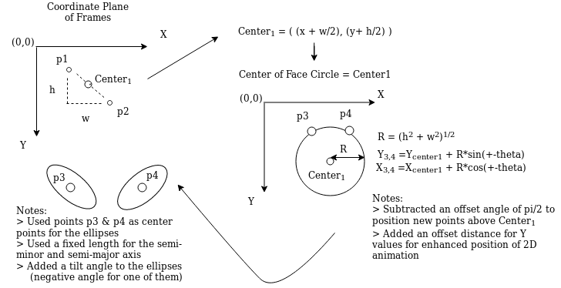

1. Bunny Ears Math

The next 2D animation was the rainbow mask. The rainbow mask required face detection within video frames as well. The filled circle function of the OpenCV library was used in order to shade the face of the user of the system. The color of the rainbow mask was randomized for every frame, so the mask can be any RGB color. For better animation effects, the rainbow mask was made to be transparent, so that the user can still see their face in the picture. One way to make a transparent mask was to perform a cross-dissolve operation on the original frame and the edited frame with the filled circle. The cross-dissolve operation was applied on every pixel in the image. The formula for the cross-dissolve is as follows: Pnew [i, j]= β*P1[i, j] + ɑ*P2[i, j]+ ɣ. The Pnew output value is the sum of scaled pixels from each frame plus an offset. To get the cross-dissolve effect with this formula, the gamma value should be 0 and the frame that contains the filled circle should have a scaled value that is one minus the other scaled value (i.e. β =1- ɑ ). This will weaken the influence of the filled circle image on the output pixel’s value, which makes it transparent like.

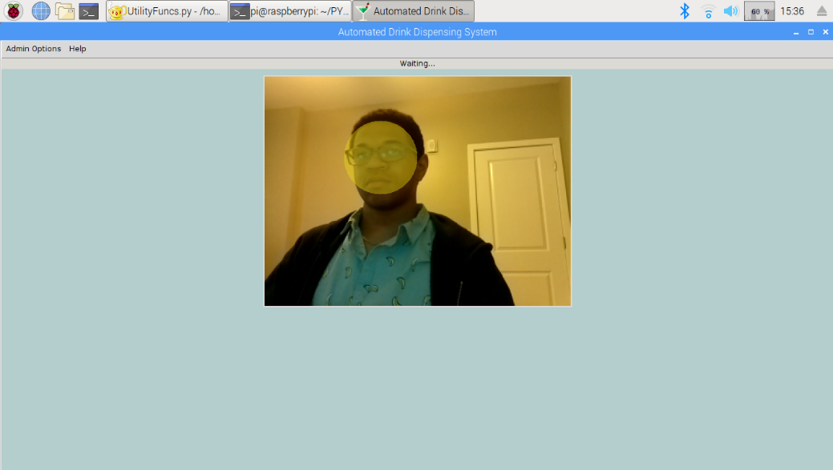

1. Rainbow Mask Filter

The final animation was the rainbow glasses. Like the rainbow mask, it relied on the face detection function of the OpenCV library. After faces were detected, the subregion of the face in the image frame was isolated used to detect eyes. This required a different Haar Cascade filter to recognize eyes. Once the eyes were recognized, circles were drawn to be concentric with the detected eyes. An algorithm was developed to figure out where to draw each piece of the frames of the drawn glasses. By using the distances between points at the circumference of each detected eye circle, the shortest distance between the right side of one circle and the left side of another circle would be denoted with a horizontal line, which would represent the bridge of the frame. The other points selected from the circle would help form the temples of the glasses (i.e. piece of a glasses frame that wraps around the ears). The temples were also lines, but they were drawn at an angle to represent hanging on the ears of the user.

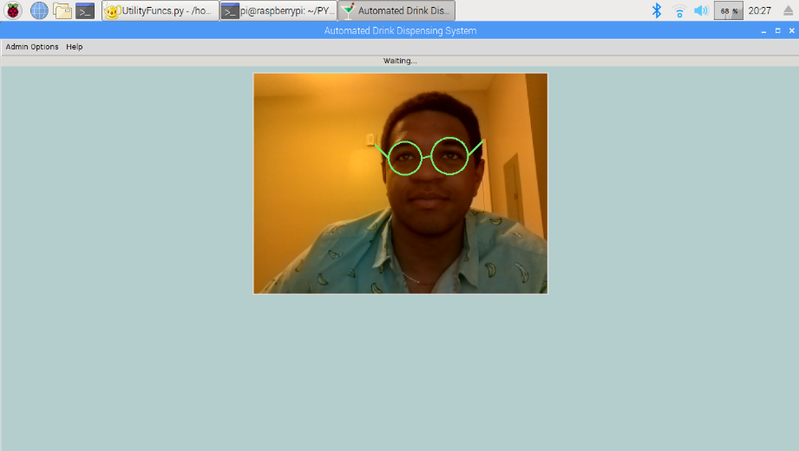

1. Rainbow Glasses Filter

The algorithm for implementing the rainbow glasses filter was called for every frame captured by the camera. The frame would be converted to grayscale, so that a Haar cascade filter could be used to detect faces. A set of potentially detected faces would be given as output from the face classifier. These face candidates would all be extracted from the frame, so that eyes could then be detected within the extracted regions. The next step in the process is seeing if the faces have been processed yet. If the faces have already been processed, then the filtered frame would be sent back to the GUI to be shown. If the faces have not been processed, then the algorithm will continue with the filter process. After checking to see if faces have been processed or not, a randomized color within the RGB spectrums would then be selected for drawing the glasses for a specific face candidate. A Haar cascade filter for detecting eyes within detected faces was applied on the extracted sections next, and a list of potential eyes was created. Like the check for processed face candidates, the eye candidates would be checked to see if they have been processed yet. If the candidate eyes have not all been processed, then the algorithm will enter a subloop. Within the subloop, a detected eye will get a circle drawn around it by using the center point of the detected eye in order to represent the “rims” of the 2D glasses. The next step in the subloop is to perform distance calculations between points on the drawn circle, so that the orientation of the detected eyes can be ascertained. When there are no more eyes to be processed, there is a check to see if there are at least two eye candidates that were detected within the face subsection of the frame. If there are not at least two eye candidates, then the filtered frame is simply stored before processing the next detected face. When there are two or more eye candidates, the two biggest eye candidates are selected from the set. The orientation of the selected eye candidates is used to determine where to draw the “bridge” of the 2D glasses. The “temples” of the 2D glasses are drawn on the frame subsection next. After storing the filtered frame, the next face candidate can then be processed until there are no more left. This algorithm can be seen in the following figure.

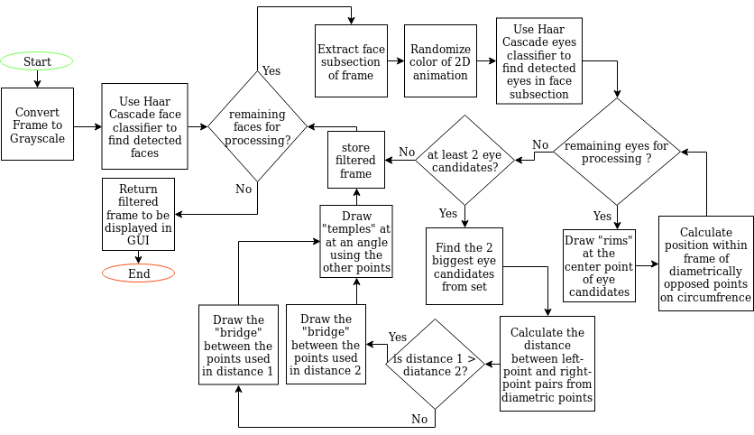

1. Rainbow Glasses Algorithm

#### Subtask 2. Adapt the desktop application for compliance with Python Package Index

In order to make easy upgrades of the desktop software, the software was restructured to meet the requirements of the **P**ython **P**ackage **I**ndex (PYPI) software repository. By storing current versions of the desktop application software in the Python Package Index, the desktop software can be downloaded by any computer in the world that has the PIP installer that comes with downloading the Python interpreter. The package is meant only for Python 3.5 and newer interpreters. The package is fully compatible with the Raspbian operating system, and it should be able to at least run on the Ubuntu operating system and its variants. In addition, when the package is downloaded with the PIP installer, all the 3rd Party library dependencies will be installed too.

The process for making the desktop application PYPI compliant required a series of steps. The first step to restructuring the source code of this project was to add create documentation strings for every function/method used within all source code files. The second step was to place the source code into a parent directory that has the name of the desired package name. The third step was to create a “setup.py” file that was used to define certain information for the project (e.g. name, version number, platform operating system, author, etc.). The fourth step was to create a “README.txt” file that would be used for informing other people the details of the project and any software dependencies needed. The fifth step was to create a “MANIFEST.in” file that would define which files within the parent and all children directories needed to be included within the package, so that downloaders will get all the necessary source code, test code, and resources. The sixth step was to choose a license for the package, and I chose the MIT license due to its liberal usage rules. The seventh step was to create a “CHANGES.txt” file that would be used by PYPI for tracking differences in the package versions. The 8th step was to create a wheel archive (a distribution format containing files and metadata) that will be hosted in PYPI and downloaded by others. The final step was to upload the wheel to PYPI. The following figure shows the results of following these steps.

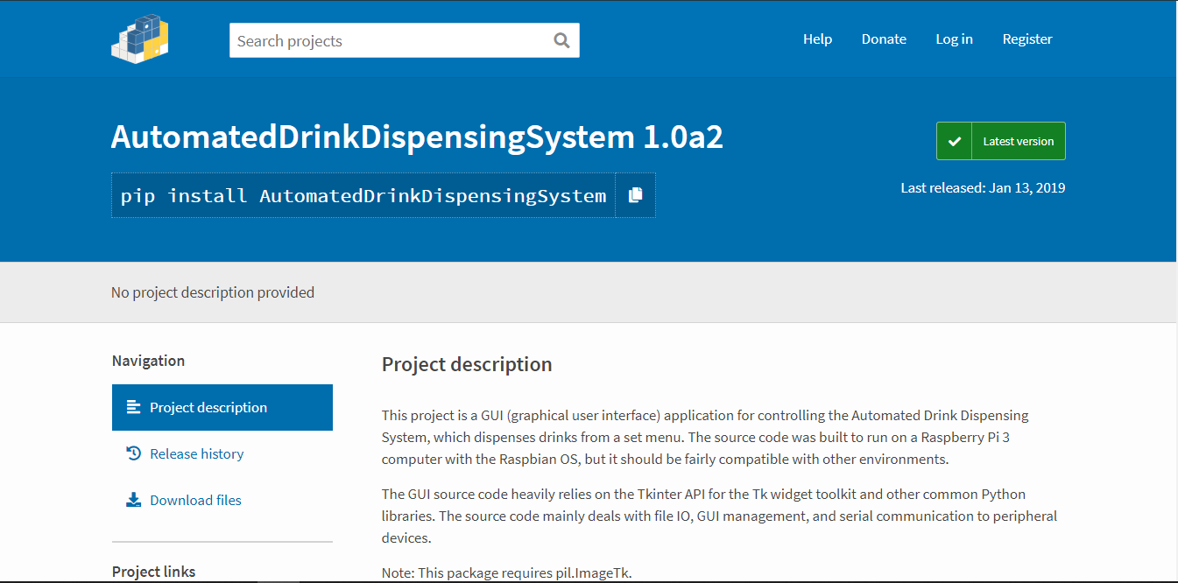

1. Desktop Application Package on PYPI
2. Conclusion

Throughout both semesters of our senior design project, our team has refined our initial ideas into a well-defined project that aims to solve a real-world problem. The problem that we identified was long wait times for alcoholic drinks within bar settings and inconsistent drinks. The solution for this problem had to be able to reduce the wait time considerably, so that customers waiting for a drink would no longer be left waiting and frustrated. Also, the mixed drinks would ideally be made exactly to the recipe defined by the alcohol-serving establishment. The solution that our team was aiming for was an interactive system that could take a drink order made on an ordering interface and produce a decent mixed drink that a user could consume. In addition, our solution had to be flexible enough to be effective in multiple settings (e.g. bars, clubs, restaurants) and to serve any kind of drink that an establishment would want to offer to their customers. In addition, our solution must conform to established industry standards and attempt to meet safety requirements.

In the first semester of senior design, our team conceived the idea for an automated drink dispensing system. With the aid of our senior design professor, our team was able to narrow down a set of requirements for the automated drink dispensing system. There were some hard constraints that we had to keep in mind as well. With the requirements and constraints, our team was able to start designing a solution. We planned out the high-level design of this kind of system and split up the work between us in order to reach each of our milestones within an acceptable timeframe. The bulk of our design work during this semester was split into two main sections: the hardware design of the electronics needed to implement the drink making process and the software design needed to create a drink ordering interface for the end-user. The hardware design consisted of integrating commercial-off-the-shelf devices onto printed circuit boards with supporting circuitry. These PCBs were meant to be capable of controlling the valves and pumps that were used for controlling the flow of liquids/inventory in order to make a drink. The software design consisted of writing a graphical user interface software application to create an ordering interface for multiple users: employees, managers, and customers. This application provided options for updating recipes, inventory, and users. This application software on the main computer was supplemented by a phone application that could provide remote monitoring of the system. Our team was able to complete the design of these two sections with no problem.

In the second semester of senior design, our team followed up on the progress made during the first semester. Although the remaining design work dealt with more hardware and software design, our focus was on writing embedded systems algorithms for controlling all peripheral devices. For example, the main computer needed to connect to multiple devices, and it had to either read or write data from each device. Code had to be written in order to get this interconnectivity. The next step in the design process was creating a test setup that would house the main components of the system and their peripherals. Our team created a wooden test setup that mounted most of the electronics to the inside of the housing. The bill acceptor and the touchscreen interface were exposed to the outside to varying degrees because the end-user of the automated drink dispensing system had to interact within those devices.

The outcomes of our senior design project were mostly good. At the component level of our system design, we were able to achieve full function. The designed hardware and software worked as we had anticipated. When it came to assembling all of the components together for a full system, we ran into a few issues. The biggest issue was processing of drink order data after being transferred from the master computer to the embedded microcontroller. Because the data could not be processed correctly, the system could not move past that step in the drink ordering process. Of course, that meant that our machine could not reach the goal of going from ordering at the touchscreen interface to getting a mixed drink. The next problem was that there was some physical damage on the electronics for the touchscreen, so it stopped working while we were doing testing. This could be an easy fix by just ordering another touchscreen display to replace the damaged one. If those two issues were resolved, then the system would be functioning as per the requirements that were defined earlier in the paper.

In conclusion, our senior design project was a good attempt at solving a real-world problem within the time limit of two semesters and considering the few setbacks that we had.

Acknowledgement

Our team would like to acknowledge the following people and entities that supported our work. The Department of Engineering within the School of Business and Technology at University of Maryland Eastern Shore supported our work throughout the span of time that our team developed our ideas and proposed system. Our mentor for the project, Dr. Lei Zhang, guided our ideas, so that our team could make a well-thought out design and system. In addition, our team would like to acknowledge the help of Justin Derickson who helped with brainstorming the scope of the proposed system. Finally, we would like to acknowledge the help and mechanical system tips from Ryan Valente.

Appendix

1. Component Specs
2. Specs of the Raspberry Pi 3 Model B

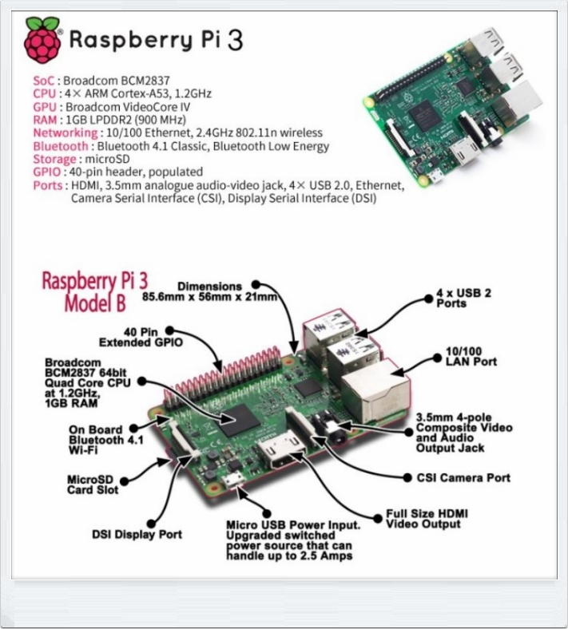

1. Raspberry Pi 3 Model B Specifications

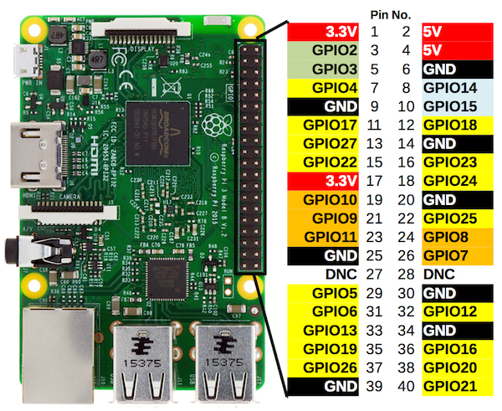

1. Raspberry Pi 3 Model B General Purpose Input & Output Pins
2. Specs of the Embedded Board

* Voltage: 12 – 24V
* Current: 15 A
* Dimensions: 2” x 6.5” (l * w)

1. Industry Standards

For this project, there were a few industry standards that were followed for the embedded system design and software design. The focus of the software design was on creating desktop applications and phone applications. Regarding the desktop application that was created, the Python language’s Python Enhancement Proposal (PEP) #8 was followed. PEP 8 specifies a style for writing Python scripts that encourages writing clean, maintainable code. This is very important for anybody who is making a large Python project because more readability and maintainability allows for easier testing, debugging, and adapting of a code base. Regarding the Android phone application, the best practices guide and quality guidelines on the Android Developer website were referenced, and it is maintained by the people who created the Android platform. The best practices guide gives tips about how to create Android phone applications that will be stable on multiple platforms with different hardware specifications. The quality guidelines specify how to handle features that deal with functionality, visual design, user interaction, compatibility, performance, security, and interacting with the google play store.

The embedded design followed several basic industry standards such as separating power and ground traces from the signal planes. The purpose of this is to reduce the electromagnetic interference that can occur as a result of the mixed power and ground rails among signal traces.

As far as food equipment safety rules, the NSF International organization has a set of standards for acquiring an internationally recognized certification for this project. The NSF/ANSI Standard 169 would most likely be the standard most likely applied to our system, which is meant for special food equipment machines that perform complex/combined functions that the other standards do not cover. Due to our proposed system’s many features, Standard 169 would have to be used. Unfortunately, you must purchase the document to view the exact details for conformity, so our team was not able to view it. Our team did our best to select materials that would best meet sanitation needs for the system despite that issue.

1. Source Code.
2. Source Code of the Desktop Application

#### MainApp.py

#!/usr/bin/env python3

"""

Programmer: Chris Blanks

Last Edited: May 2019

Project: Automated Self-Serving System

Purpose: This script defines the MainApp class that runs the desktop application.

Note:

>This script takes command line arguments now

>two arguments must be sent

> when "enable" is sent as 1st arg, all peripheral devices are enabled

> when "testing" is sent as the 2nd arg, the camera is not used

"""

**import** os

**import** sys

**import** json

#allows all scripts to be disocoverable on system path

#Note: can use os.sep to create dynamic paths

main_path **=** **(**os**.**path**.**abspath**(**__file__**)).**replace**(**"/MainApp.py"**,**""**)**

sys**.**path**.**append**(**os**.**path**.**dirname**(**os**.**path**.**abspath**(**__file__**)))**

icon_path **=** "{}/resources/gui_images/martini.png"**.**format**(**main_path**)**

#Standard library imports

**import** tkinter **as** tk

**from** tkinter **import** ttk

**from** tkinter **import** font **as** tkFont

**import** time

**import** datetime

**from** subprocess **import** check_output

**import** subprocess

**from** threading **import** Timer

**import** _thread **as** thread

**from** cryptography**.**fernet **import** Fernet

**import** http**.**server **as** hs

**import** socketserver **as** ss

#My Modules

**from** CustomerWindow **import** CustomerWindow

**from** EmployeeWindow **import** EmployeeWindow

**import** DrinkProfile **as** dp_class

**from** Inventory **import** InventoryItem

**from** LoginWindow **import** LoginWindow

**from** KeyboardWindow **import** KeyboardWindow

#Periphal Device classes

**from** EmployeeSwitch **import** EmployeeSwitch

**from** PulsePin **import** PulsePin

**from** Camera **import** Camera

**from** EmbeddedBoard **import** EmbeddedBoard

**def** runMainApplication**():**

"""Initializes the application and all of its features."""

root **=** tk**.**Tk**()** #initiliazes the tk interpreter

root**.**title**(**"Automated Drink Dispensing System"**)**

combobox_font **=** tkFont**.**Font**(**family**=**"Helvetica"**,**size**=**20**)**

root**.**option_add**(**"*TCombobox*Listbox*Font"**,**combobox_font**)**

icon_img **=** tk**.**Image**(**"photo"**,**file**=** icon_path**)** # found image online; created by RoundIcons

root**.**tk**.**call**(**"wm"**,**"iconphoto"**,**root**.**_w**,**icon_img**)** #sets the application icon

enableDevices **=** **False**

enableEmbedBoard **=** **False**

#checks command line arguments

**if** len**(**sys**.**argv**)** **>** 1**:**

**print(**"CLI args:"**,**sys**.**argv**)**

**for** arg **in** sys**.**argv**:**

**if** arg **==** "enable"**:**

enableDevices **=** **True** #if true is sent as a command line arg then enable devices

**if** arg **==** "embed_en"**:**

enableEmbedBoard **=** **True**

style **=** ttk**.**Style**()**

current_theme **=** style**.**theme_use**(**'clam'**)** #sets up the clam style for all ttk widgets

main_app **=** MainApp**(**root**,**icon_img**,**enableDevices**,**enableEmbedBoard**,**style**)**

root**.**mainloop**()** #starts loop for displaying content

**class** **MainApp:**

#class member variables

MAIN_DIRECTORY_PATH **=** main_path

RESOURCES_PATH **=** "{}/resources"**.**format**(**MAIN_DIRECTORY_PATH**)**

DRINK_PROFILE_DIRECTORY_PATH **=** "{}/drink_profiles"**.**format**(**RESOURCES_PATH**)**

SYSTEM_INFO_PATH **=** "{}/system_info"**.**format**(**RESOURCES_PATH**)**

GUI_IMAGES_PATH **=** "{}/gui_images"**.**format**(**RESOURCES_PATH**)**

OTHER_PATH **=** "{}/other"**.**format**(**RESOURCES_PATH**)**

SHARED_DATA_PATH **=** "{}/shared_data"**.**format**(**SYSTEM_INFO_PATH**)**

WAIT_SCREEN_IMG_PATH **=** "{}/drink_pour.jpg"**.**format**(**GUI_IMAGES_PATH**)**

DELIVERY_SCREEN_IMG_PATH **=** "{}/pick_up_drink.jpg"**.**format**(**GUI_IMAGES_PATH**)**

CONFIG_FILE_PATH **=** "{}/config.txt"**.**format**(**SYSTEM_INFO_PATH**)**

USER_LOGIN_FILE_PATH**=** "{}/user_login.txt"**.**format**(**SYSTEM_INFO_PATH**)**

ENCRYPTION_KEY_FILE_PATH **=** "{}/key.txt"**.**format**(**SYSTEM_INFO_PATH**)**

INVENTORY_FILE_PATH **=** "{}/inventory_info.csv"**.**format**(**SYSTEM_INFO_PATH**)**

DRINK_MENU_FILE_PATH **=** "{}/drink_menu.txt"**.**format**(**SYSTEM_INFO_PATH**)**

CASCADES_PATH **=** "{}/haar_cascade_files"**.**format**(**OTHER_PATH**)**

MASTER_BACKGROUND_COLOR **=** "LightCyan3"

#DEVICE CONFIGURATION

BUTTON_ENABLE **=** **True**

DELAY **=** 2000 # button input will be polled every 2 seconds

AMOUNT_PAID **=** 0 # keeps track of how much a customer has paid; $0

drink_names **=** **[]** #keeps a record of drink names

isEmployeeMode**=** **False** #controls what is displayed in employee mode

isValidLogin **=** **False** #controls whethere a user is given access to employee mode

isWithoutLogin **=** **False** #controls whether a new user login file is created

data_demo_key **=** **True** #toggles between pre-made shared data messages

**def** __init__**(**self**,**master**,**icon_img**,**peri_dev_enable**=False,**em_bd_enable**=False,**style**=None):**

self**.**master **=** master

self**.**style**=** style # style used for ttk widgets

stored_color **=** self**.**retrieveBackgroundColor**()**

**if** stored_color **!=** self**.**MASTER_BACKGROUND_COLOR**:**

**print(**"Change in background color"**)**

self**.**MASTER_BACKGROUND_COLOR **=** stored_color

self**.**master**.**configure**(**background**=**self**.**MASTER_BACKGROUND_COLOR**)**

self**.**screen_width **=** self**.**master**.**winfo_screenwidth**()**

self**.**screen_height **=** self**.**master**.**winfo_screenheight**()**

self**.**geometry_string **=** str**(**self**.**screen_width**)+**"x"**+** str**(**self**.**screen_height**)**

self**.**icon_img **=** icon_img #included for use in children windows

self**.**ip_address **=** self**.**getIPAddress**()** #retrieves current wlan0 IP address

self**.**url **=** **None**

self**.**writeToLog**(**"Running main application"**)**

self**.**writeToSharedData**()**

self**.**startHTTPThread**()**

self**.**cipher_suite **=** self**.**setupUserEncryption**()** #A cipher suite object is returned for decryption

**if** self**.**isWithoutLogin **==** **True:**

self**.**createDefaultUserLoginFile**()** #creates a new user login file

self**.**active_drink_objects **=** self**.**getDrinks**()** #returns a list of drink_objects for later use

self**.**inventory_items **=** self**.**collectInventoryInfo**()**

self**.**device_enable **=** peri_dev_enable

self**.**embedded_board_enable **=** em_bd_enable

#check args

**if** self**.**device_enable**:**

self**.**createDevices**()** #creates device instances for later use

self**.**initializeDrinkMenuOnEmbeddedBoard**(**self**)**

**elif** self**.**embedded_board_enable**:**

#if other devices off & want to still test embedded board

self**.**embedded_board **=** EmbeddedBoard**(**self**)**

self**.**embedded_board**.**initializeDrinkMenuOnBoard**()**

self**.**updateDrinkMenu**()**

self**.**createMainWindow**()**

self**.**retrieveHttpURL**()**

self**.**retrieveConfigurationInformation**()**

self**.**cleanOldDrinksFromConfig**()**

**def** retrieveBackgroundColor**(**self**):**

"""Reads background color file for last saved background value."""

path**=** "{}/background_color.txt"**.**format**(**self**.**SYSTEM_INFO_PATH**)**

**with** open**(**path **,**"r"**)** **as** file**:**

color **=** file**.**read**()**

**return** color

**def** selectWindow**(**self**,**selection**):**

"""Determines what window is open."""

**if** hasattr**(**self**,** 'employee_top_lvl'**):**

self**.**employee_top_lvl**.**destroy**()** #destroys old windows

**if** hasattr**(**self**,** 'customer_top_lvl'**):**

self**.**customer_top_lvl**.**destroy**()** #destroys old windows

**if** selection **==** 1**:**

self**.**isEmployeeMode **=** **True**

self**.**launchLoginWindow**()**

**else:**

self**.**isEmployeeMode **=** **False**

self**.**master**.**withdraw**()**

self**.**createCustomerWindow**()**

**def** createMainWindow**(**self**):**

"""Displays main window elements. """

self**.**master**.**geometry**(**self**.**geometry_string**)**

**print(**"\nWindow Size(Width): {}"**.**format**(** self**.**master**.**winfo_screenwidth**()** **)** **)**

**print(**"Window Size(Width): {}"**.**format**(** self**.**master**.**winfo_screenheight**()** **)** **)**

self**.**main_title **=** ttk**.**Label**(**self**.**master**,**text**=**"Selection Window"**)**

self**.**main_title**.**pack**()**

self**.**style**.**configure**(**"artsy_text.TButton"**,**font**=(**'Helvetica'**,**20**))**

self**.**customer_window_btn **=** ttk**.**Button**(**self**.**master**,**text**=**"customer window"**,**

command**=** **lambda** window**=**"customer"**:** self**.**relaunchWindow**(**window**),**

style**=**"artsy_text.TButton"**)**

self**.**customer_window_btn**.**pack**(**fill**=**tk**.**BOTH**)**

self**.**employee_window_btn **=** ttk**.**Button**(**self**.**master**,**text**=**"employee window"**,**

command**=** **lambda** window**=**"employee"**:** self**.**relaunchWindow**(**window**),**

style**=**"artsy_text.TButton"**)**

self**.**employee_window_btn**.**pack**(**fill**=**tk**.**BOTH**)**

**def** relaunchWindow**(**self**,**window**):**

""" Relaunches the selected window."""

**if** hasattr**(**self**,** 'switch'**):**

self**.**BUTTON_ENABLE **=** **True** #enable button before entering a mode

self**.**switch**.**state **=** "enabled"

**if** window **==** "customer"**:**

self**.**isEmployeeMode **=** **False**

self**.**master**.**withdraw**()**

self**.**createCustomerWindow**()**

**elif** window **==** "employee"**:**

self**.**isEmployeeMode **=** **True**

self**.**master**.**withdraw**()**

self**.**launchLoginWindow**()**

**else:**

**print(**"What the heck?"**)**

**def** createCustomerWindow**(**self**):**

"""Creates separate customer window."""

self**.**customer_top_lvl **=** tk**.**Toplevel**(**self**.**master**,**background**=**self**.**MASTER_BACKGROUND_COLOR**)**

self**.**customer_top_lvl**.**tk**.**call**(**"wm"**,**"iconphoto"**,**self**.**customer_top_lvl**.**_w**,**self**.**icon_img**)**

self**.**customer_window **=** CustomerWindow**(**self**)**

**def** createEmployeeWindow**(**self**,**isAdminMode**):**

"""Creates separate employee window """

self**.**employee_top_lvl **=** tk**.**Toplevel**(**self**.**master**,**background**=**self**.**MASTER_BACKGROUND_COLOR**)**

self**.**employee_top_lvl**.**tk**.**call**(**"wm"**,**"iconphoto"**,**self**.**employee_top_lvl**.**_w**,**self**.**icon_img**)**

self**.**employee_window **=** EmployeeWindow**(**self**,**isAdminMode**)**

**def** launchLoginWindow**(**self**):**

"""Launches login window when employee mode is selected."""

self**.**login_top_lvl **=** tk**.**Toplevel**(**self**.**master**,**background**=**self**.**MASTER_BACKGROUND_COLOR**)**

self**.**login_top_lvl**.**tk**.**call**(**"wm"**,**"iconphoto"**,**self**.**login_top_lvl**.**_w**,**self**.**icon_img**)**

self**.**login_window **=** LoginWindow**(**self**)**

**def** launchKeyboardWindow**(**self**):**

"""Launches a top level window that contains a keyboard that can deliver

input to processes that need it."""

self**.**keyboard_top_lvl **=** tk**.**Toplevel**(**self**.**master**,**background**=**self**.**MASTER_BACKGROUND_COLOR**)**

self**.**keyboard_window **=** KeyboardWindow**(**self**)**

**def** getDrinks**(**self**):**

"""Retrieves a list of active Drink objects."""

active_drinks **=** **[]**

self**.**all_drinks **=** **[]**

os**.**chdir**(**self**.**DRINK_PROFILE_DIRECTORY_PATH**)**

drink_profile_names **=** os**.**listdir**(**self**.**DRINK_PROFILE_DIRECTORY_PATH**)**

#removes the __pycache__ directory and __init__.py file that gets initiated in this directory

**if** "__pycache__" **in** drink_profile_names**:**

drink_profile_names**.**remove**(**"__pycache__"**)**

**if** "/__pycache__" **in** drink_profile_names**:**

drink_profile_names**.**remove**(**"/__pycache__"**)**

**if** "__init__.py" **in** drink_profile_names**:**

drink_profile_names**.**remove**(**"__init__.py"**)**

**if** "__init_.py" **in** drink_profile_names**:**

drink_profile_names**.**remove**(**"__init_.py"**)**

**for** name **in** drink_profile_names**:**

path_builder **=** self**.**DRINK_PROFILE_DIRECTORY_PATH **+**"/"**+** name

os**.**chdir**(**path_builder**)**

#finds index of text file in individual drink directory listings

text_file_index **=** 0

**if** ".txt" **in** os**.**listdir**(**path_builder**)[**0**]:**

**pass**

**else:**

text_file_index**=** 1

drink **=** dp_class**.**DrinkProfile**(**"{}/{}"**.**format**(**path_builder**,** os**.**listdir**(**path_builder**)[**text_file_index**]),**self**.**MAIN_DIRECTORY_PATH**)**

**if** drink**.**isActive **==** "1"**:**

drink**.**name **=** **(**drink**.**name**).**replace**(**" "**,**"_"**)**

drink**.**addDrinkToConfig**()** #config file keeps record of active drinks

active_drinks**.**append**(**drink**)** #creates a separate list for active drinks (drinks to be displayed)

self**.**all_drinks**.**append**(**drink**)** #creates a list of active and inactive drinks

os**.**chdir**(**self**.**MAIN_DIRECTORY_PATH**)**

**return** active_drinks

**def** collectInventoryInfo**(**self**):**

list_of_items **=** **[]**

**with** open**(**self**.**INVENTORY_FILE_PATH**,**"r+"**)** **as** inventory_file**:**

content **=** inventory_file**.**readlines**()**

count **=** 0

**print(**"Inventory:"**)**

**for** line **in** content**:**

**if** "Inventory" **in** line**:**

count **+=** 1

**continue** #skip first line

line_vals **=** line**.**replace**(**"\n"**,**""**).**split**(**","**)**

name **=** line_vals**[**0**]**

current_quant**=** float**(**line_vals**[**1**])**

original_quant **=** float**(**line_vals**[**2**])**

ratio **=** float**(**current_quant**)/**float**(**original_quant**)**

#valve number corresponds with line count

#(e.g. line 2 is valve 1 or second index of content)

inventory_item **=** InventoryItem**(**self**.**INVENTORY_FILE_PATH**,**

name**,**original_quant**,**current_quant**,**count**)**

**print(**inventory_item**.**name**)**

list_of_items**.**append**(**inventory_item**)**

count **+=** 1

**return** list_of_items

**def** getInventoryItemNames**(**self**):**

"""Get inventory item names."""

names **=** **[]**

**for** item **in** self**.**inventory_items**:**

names**.**append**(**item**.**name**)**

**return** names

**def** retrieveConfigurationInformation**(**self**):**

"""Retrieves configuration info (e.g. drink names) from config file """

**with** open**(**self**.**CONFIG_FILE_PATH**,**'r+'**)** **as** f**:**

lines **=** f**.**read**().**splitlines**()**

line_number **=** 1

**for** line **in** lines**:**

**if** line_number **==** 1**:**

**if** line**.**split**()[**1**]** **==** '0'**:**

**print(**"Config file is not locked.\n\n"**)**

**else:**

self**.**isLocked **=** **True**

**print(**"Config file is locked.\n\n"**)**

**if** line_number **==** 2**:**

drinks **=** line**.**split**(**" "**)**

**for** i **in** range**(**len**(**drinks**)-**1**):**

self**.**drink_names**.**append**(**drinks**[**i**+**1**])**

line_number**+=**1

**def** updateConfigurationFile**(**self**,**item_to_update**,**updated_value**=** **None):**

""" """

**with** open**(**self**.**CONFIG_FILE_PATH**,**"r+"**)** **as** f**:**

lines **=** f**.**read**().**splitlines**()**

f**.**seek**(**0**)**

line_headers **=** **[**"locked "**,**"active_drink_list "**,**"system_status "**]**

line_to_edit **=** 0

**if** item_to_update **==** "data_lock"**:**

line_to_edit **=** 1

**if** item_to_update **==** "drink_list"**:**

line_to_edit **=** 2

**if** item_to_update **==** "system_status"**:**

line_to_edit **=** 3

line_number **=** 1

**for** line **in** lines**:**

**if** line_number **==** line_to_edit **and** updated_value **!=** **None:**

line **=** line_headers**[**line_to_edit **-** 1**]** **+** updated_value

f**.**write**(**line**+**"\n"**)**

**else:**

f**.**write**(**line**+**"\n"**)**

**if** line_number **==** 3**:**

**break**

line_number**+=**1

**def** cleanOldDrinksFromConfig**(**self**):**

"""Updates the active drinks in the config file."""

cleaned_list_of_names **=** ""

loaded_drink_object_names **=** **[]**

**for** drink **in** self**.**active_drink_objects**:**

loaded_drink_object_names**.**append**((**drink**.**name**).**replace**(**"_"**,**" "**))**

**for** config_name **in** self**.**drink_names**:**

**if** config_name**.**replace**(**"_"**,**" "**)** **in** loaded_drink_object_names**:**

cleaned_list_of_names **=** cleaned_list_of_names **+** config_name **+** " "

self**.**updateConfigurationFile**(**"drink_list"**,**cleaned_list_of_names**)**

self**.**writeToLog**(**"Cleaned Config file."**)**

**def** writeToLog**(**self**,** message**):**

"""Writes messages into the log.txt file."""

self**.**todays_log **=** "{}/log_files/log_on_{}.txt"**.**format**(**self**.**SYSTEM_INFO_PATH**,** str**(** datetime**.**date**.**today**()** **)** **)**

**with** open**(**self**.**todays_log**,**"a+"**)** **as** log**:**

log**.**write**(**"{} : {}\n"**.**format**(** str**(** datetime**.**datetime**.**now**()** **)** **,** message**))**

**def** writeToDrinkSalesLog**(**self**,** message**):**

"""Writes time-stamped sales info into a log for each day."""

self**.**todays_drink_sales **=** "{}/drink_sales/drink_sales_{}.txt"**.**format**(**self**.**SYSTEM_INFO_PATH **,** str**(** datetime**.**date**.**today**()** **)** **)**

**with** open**(**self**.**todays_drink_sales**,**"a+"**)** **as** log**:**

log**.**write**(**"{} : {}\n"**.**format**(** str**(** datetime**.**datetime**.**now**()** **)** **,** message**))**

**def** addUserToLogin**(**self**,**user_type**,**username**,**password**):**

"""Creates a new user in the user_login file. Ex: self.addUserToLogin("R","Lei","Zhang")"""

**with** open**(**self**.**USER_LOGIN_FILE_PATH**,**"rb+"**)** **as** file**:**

lines **=** file**.**read**().**splitlines**()**

file**.**seek**(**0**)**

line_num **=** 1

next_line **=** **False**

#if admin user, then add to admin section of user login file

**if** user_type **==** "A"**:**

**for** line **in** lines**:**

line **=** str**((**self**.**cipher_suite**.**decrypt**(**line**)).**decode**(**'ASCII'**))**

**if** next_line **==** **True:**

file**.**write**(**temp**+**b"\n"**)**

next_line **=** **False**

**if** "ADMIN USER" **in** line**:**

temp **=** "{} {}"**.**format**(**username**,**password**)**

temp **=** self**.**cipher_suite**.**encrypt**(**temp**.**encode**(**encoding**=**'UTF-8'**))**

next_line **=** **True**

**if** "END" **in** line**:**

line **=** self**.**cipher_suite**.**encrypt**(**line**.**encode**(**encoding**=**'UTF-8'**))**

file**.**write**(**line**+**b"\n"**)**

**break**

line **=** self**.**cipher_suite**.**encrypt**(**line**.**encode**(**encoding**=**'UTF-8'**))**

file**.**write**(**line**+**b"\n"**)**

#if regular user ("R"), then add to regular section of user login file

**else:**

**for** line **in** lines**:**

line **=** str**((**self**.**cipher_suite**.**decrypt**(**line**)).**decode**(**'ASCII'**))**

**if** "REGULAR USER" **in** line**:**

line **=** self**.**cipher_suite**.**encrypt**(**line**.**encode**(**encoding**=**'UTF-8'**))**

file**.**write**(**line**+**b"\n"**)** #write REGULAR USER and add a new line

new_login **=** "{} {}"**.**format**(**username**,**password**)**

new_encrypt **=** self**.**cipher_suite**.**encrypt**(**new_login**.**encode**(**encoding**=**'UTF-8'**))**

file**.**write**(**new_encrypt**+**b"\n"**)** #write new login and a new line before next line

**continue**

**if** "END" **in** line**:**

line **=** self**.**cipher_suite**.**encrypt**(**line**.**encode**(**encoding**=**'UTF-8'**))**

file**.**write**(**line**+**b"\n"**)**

**break**

line **=** self**.**cipher_suite**.**encrypt**(**line**.**encode**(**encoding**=**'UTF-8'**))**

file**.**write**(**line**+**b"\n"**)**

self**.**writeToLog**(**"Added {} account to login."**.**format**(**username**)** **)**

**def** deleteUserFromLogin**(**self**,** username**,** password**):**

"""Deletes a user in the user_login file (besides the original admin account)."""

login_combo **=** username **+**" " **+** password

**with** open**(**self**.**USER_LOGIN_FILE_PATH**,**"rb+"**)** **as** file**:**

lines **=** file**.**read**().**splitlines**()**

file**.**seek**(**0**)**

**print(**"Looking for: " **+** login_combo**)**

**for** line **in** lines**:**

line **=** str**((**self**.**cipher_suite**.**decrypt**(**line**)).**decode**(**'ASCII'**))**

**print(**"line content: "**+** line**)**

**if** "END" **in** line**:**

line **=** self**.**cipher_suite**.**encrypt**(**line**.**encode**(**encoding**=**'UTF-8'**))**

file**.**write**(**line**+**b"\n"**)**

**break** #last line, so break out of loop

**elif** login_combo **not** **in** line**:**

**print(**"not desired login: "**+**str**(**line**)** **)**

line **=** self**.**cipher_suite**.**encrypt**(**line**.**encode**(**encoding**=**'UTF-8'**))**

file**.**write**(**line**+**b"\n"**)**

**else:**

**print(**"Found {} in this line: {}"**.**format**(**login_combo**,** line**))** #skips over line if login_combo is in it

self**.**writeToLog**(**"Removed {} account from login."**.**format**(**username**)** **)**

**def** setupUserEncryption**(**self**):**

"""Creates an encryption key if one is not already made """

#if there's a key file, then acquire key from encryption

**if** os**.**path**.**exists**(**self**.**ENCRYPTION_KEY_FILE_PATH**):**

**with** open**(**self**.**ENCRYPTION_KEY_FILE_PATH**,**"rb"**)** **as** file**:**

key **=** file**.**readline**()** #one line file

# if no user login file, then it will be created

**if** os**.**path**.**exists**(**self**.**USER_LOGIN_FILE_PATH**):**

**pass**

**else:**

self**.**isWithoutLogin **=** **True**

**else:**

key **=** Fernet**.**generate_key**()**

**with** open**(**self**.**ENCRYPTION_KEY_FILE_PATH**,**"wb"**)** **as** file**:**

file**.**write**(**key**)** #store key in file system

self**.**isWithoutLogin **=** **True**

cipher_suite **=** Fernet**(**key**)**

**return** cipher_suite

**def** createDefaultUserLoginFile**(**self**):**

"""Creates a default user_login.txt file that has the

default login credentials in an encrypted form. """

admin_str **=** "ADMIN USER"

default_usr_str**=**"admin admin"

reg_usr_str **=** "REGULAR USER"

end_str **=** "END"

**with** open**(**self**.**USER_LOGIN_FILE_PATH**,**'wb'**)** **as** new_user_login**:**

admin_str **=** self**.**cipher_suite**.**encrypt**(**admin_str**.**encode**(**encoding**=**'UTF-8'**))**

default_usr_str **=** self**.**cipher_suite**.**encrypt**(**default_usr_str**.**encode**(**encoding**=**'UTF-8'**))**

reg_usr_str **=** self**.**cipher_suite**.**encrypt**(**reg_usr_str**.**encode**(**encoding**=**'UTF-8'**))**

end_str **=** self**.**cipher_suite**.**encrypt**(**end_str**.**encode**(**encoding**=**'UTF-8'**))**

new_user_login**.**write**(**admin_str**+**b"\n"**)**

new_user_login**.**write**(**default_usr_str**+**b"\n"**)**

new_user_login**.**write**(**reg_usr_str**+**b"\n"**)**

new_user_login**.**write**(**end_str**+**b"\n"**)**

self**.**isWithoutLogin **=** **False**

self**.**writeToLog**(**"Made new login file"**)**

**def** getIPAddress**(**self**):**

host_info**=None**

ip_address**=None**

**try:**

host_info **=** check_output**([**'hostname'**,**'-I'**])**

ip_address **=** host_info**.**split**()[**0**].**decode**(**'ascii'**)**

**except:**

**print(**"Couldn't get ip address"**)**

ip_address**=**"localhost"

**print(** "IP: {}\n"**.**format**(**ip_address**)** **)**

**return** ip_address

**def** writeToSharedData**(**self**):**

"""Updates the write to shared data every 5 minutes."""

MILLI **=** 1000

MIN_IN_SEC **=** 60

now **=** time**.**strftime**(**"%H:%M:%S"**)**

**print(**now**)** #keeps track of write time

self**.**todays_shared_data**=** "{}/shared_data/shared_data_{}.txt"**.**format**(**self**.**SYSTEM_INFO_PATH**,** str**(** datetime**.**date**.**today**()** **)** **)**

**with** open**(**self**.**todays_shared_data**,**"w"**)** **as** shared_log**:**

msg **=** """STATUS

idle

employee

chris

INVENTORY

rum 300 1000

vodka 300 900

tequila 300 1000

gin 1000 1000

triple_sec 300 400

soda_water 200 1500

SALES

cuba_libre 55.00

daiquiri 10.00

kamikaze 0.00

long_island_iced_tea 23.00

naval_gimlet 5.00

rum_and_coke 10.00

screwdriver 10.00

tequila 0.00

vodka 100.00

vodka_and_cranberry 20.00"""

msg2 **=** """STATUS

mixing

employee

admin

INVENTORY

rum 300 1000

vodka 500 900

tequila 300 1000

gin 1000 1000

triple_sec 300 400

soda_water 200 1500

SALES

cuba_libre 25.00

daiquiri 10.00

kamikaze 10.00

long_island_iced_tea 23.00

naval_gimlet 5.00

rum_and_coke 10.00

screwdriver 10.00

tequila 0.00

vodka 19.00

vodka_and_cranberry 20.00"""

**if** self**.**data_demo_key **==** **True:**

shared_log**.**write**(**msg**)**

**else:**

shared_log**.**write**(**msg2**)**

self**.**data_demo_key **=** **not** self**.**data_demo_key #toggles between the two shared data sets

self**.**master**.**after**(**MIN_IN_SEC**\***MILLI**,**self**.**writeToSharedData**)** #recursively writes to shared data every 5 minutes

**def** startHTTPThread**(**self**):**

"""Creates a http server in a separate thread from the GUI in order to prevent delays in the GUI."""

thread**.**start_new_thread**(**self**.**startHTTPServer**,**tuple**())**

thread**.**start_new_thread**(**self**.**startNgrok**,**tuple**())**

**def** startNgrok**(**self**):**

"""Starts http tunneling software in a thread."""

**try:**

os**.**chdir**(**self**.**SHARED_DATA_PATH**)**

cmd **=** "sh run_ngrok.sh &" #the '&' allows ngrok to run in the background

# which means it doesn't get terminated until the 8 hour timeout

p **=** subprocess**.**Popen**(**cmd**,**shell**=True,**stdout**=**subprocess**.**PIPE**,**stderr**=**subprocess**.**STDOUT**)**

out**=** p**.**communicate**()[**0**]**

**print(**out**)**

#subprocess.call(["sh","run_ngrok.sh"])

**except:**

**print(**"Could not open ngrok.."**)** #printed in the abyss

e **=** sys**.**exc_info**()[**0**]**

**print(**e**)**

os**.**chdir**(**self**.**MAIN_DIRECTORY_PATH**)**

**return**

**def** retrieveHttpURL**(**self**):**

"""Acquires http url generated by ngrok."""

**try:**

subprocess**.**call**([**"curl"**,**"http://localhost:4040/api/tunnels"**,**"-o"**,**"tunnels.json"**])**

**with** open**(**"tunnels.json"**)** **as** data_file**:**

datajson**=**json**.**load**(**data_file**)**

**for** i **in** datajson**[**'tunnels'**]:**

**print(**i**[**'public_url'**])**

**if** "http:" **in** i**[**'public_url'**]:**

self**.**url **=** i**[**'public_url'**]**

#other url should just be a https version

**print(**"current url: {}"**.**format**(**self**.**url**))**

**except:**

**print(**"Could not receive http url"**)**

**def** startHTTPServer**(**self**):**

"""Opens a http server in the shared data directory."""

**try:**

os**.**chdir**(**self**.**SHARED_DATA_PATH**)**

subprocess**.**call**([**"sudo"**,** "python"**,** "-m"**,** "SimpleHTTPServer"**,**"80"**])**

**except:**

**print(**"Port is already open."**)** #printed in the abyss

e **=** sys**.**exc_info**()[**0**]**

**print(**e**)**

os**.**chdir**(**self**.**MAIN_DIRECTORY_PATH**)**

**def** createDevices**(**self**):**

"""Instantiates all devices."""

self**.**switch **=** EmployeeSwitch**(**self**)** #pass main app instance

**print(**"\n{} : {}"**.**format**(**self**.**switch**.**name**,**self**.**switch**.**state**))**

self**.**checkButtonState**()**

self**.**pulse_pin **=** PulsePin**(**self**)**

**print(**"\n{} : {}"**.**format**(**self**.**pulse_pin**.**name**,**self**.**pulse_pin**.**state**))**

self**.**camera **=** Camera**(**self**)**

**print(**"\n{} : {}"**.**format**(**self**.**camera**.**name**,**self**.**camera**.**state**)** **)**

self**.**embedded_board **=** EmbeddedBoard**(**self**)**

**print(**"\n{} : {}"**.**format**(**self**.**embedded_board**.**name**,**self**.**embedded_board**.**state**)** **)**

**print(**"\n"**)**

**def** checkButtonState**(**self**):**

"""Recursively calls itself to check button state."""

self**.**switch**.**checkButtonInput**()** #check pin input

self**.**master**.**after**(**self**.**DELAY**,**self**.**checkButtonState**)**

**def** initializeDrinkMenuOnEmbeddedBoard**(**self**):**

"""Acquire drink information for file and send to EmbeddedBoard device

for future use."""

**print(**"Starting initialization of drink menu"**)**

self**.**embedded_board**.**initializeDrinkMenuOnBoard**()**

**def** updateDrinkMenu**(**self**):**

"""Drink Menu file is updated when drink profile of a drink is changed

Notes:

Need to generate a string of pump times that corresponds to valves on

boards, so ingredients must be associated with valve numbers

Need to convert ounces of ingredients to a pump time and then

make a comma delimited string that will be represent pump times

for each valve.

Need to make unused valves get a value of 0.

conversion between ounces to millimeters:

1 fluid Oz = 29.5753 milliliters

Time resolution: 30/256 = 0.117 sec = 0.117 sec

Calculation:

time_res = 30/256 #30 seconds divided by 256 (A byte max value)

milli_req = OZ_num * 29.5735

pump_time = int(milli_req / time_res)

amount_of_fluid = pump_time * (500 / 60) #500 ml per sec pump speed

"""

#Constants

OZ_TO_ML_CONV **=** 29.5753 # 1 fluid Oz = 29.

MAX_TIME **=** 30 #pump will run for a max of 30 seconds

BIT_RES **=** 256

PUMP_SPEED_ML_PER_SEC **=** int**(**500**/**60**)** #rating of pump

#other pump speed may be: PUMP_SPEED_ML_PER_SEC = int(1000/60)

#sort by id_number of drinks

self**.**active_drink_objects**.**sort**(**key**=lambda** x**:** x**.**id_number**)**

recipe_menu**=[]**

inventory_names_list **=** self**.**getInventoryItemNames**()**

**print(**inventory_names_list**)**

oz**=** 0

**for** recipe **in** self**.**active_drink_objects**:**

recipe_packet**=[]**

b1_r1**=[**0**,**0**,**0**,**0**,**0**,**0**,**0**,**0**]** #board 1, register 1

b1_r2**=[**0**,**0**,**0**,**0**,**0**,**0**,**0**,**0**]**

b2_r1**=[**0**,**0**,**0**,**0**,**0**,**0**,**0**,**0**]**

b2_r2**=[**0**,**0**,**0**,**0**,**0**,**0**,**0**,**0**]**

count **=** 0 #index for ounces values for each ingredient

**for** ingredient **in** recipe**.**ingredients**:**

inventory_id **=** inventory_names_list**.**index**(**ingredient**.**replace**(**"_"**,**" "**).**title**())+**1

**print(**"Ingredient {} in {} has id {}."**.**format**(**ingredient**,**recipe**.**name**,**inventory_id**))**

#inventory ids start at 1

**if** inventory_id **<=**8**:**

**print(**'ounces: {}'**.**format**(**recipe**.**ounces**[**count**]))**

oz **=** float**(**recipe**.**ounces**[**count**])**

pump_time **=** int**(**oz**\***OZ_TO_ML_CONV **/** **(**PUMP_SPEED_ML_PER_SEC **\***MAX_TIME**/**BIT_RES**)** **)**

**print(**"Pump time is {} /255"**.**format**(**pump_time**))**

b1_r1**[**inventory_id**-**1**]** **=** pump_time

**elif** inventory_id **<=**16**:**

inventory_id **=** inventory_id**-**8

**print(**'ounces: {}'**.**format**(**recipe**.**ounces**[**count**]))**

oz **=** float**(**recipe**.**ounces**[**count**])**

pump_time **=** int**(**oz**\***OZ_TO_ML_CONV **/** **(**PUMP_SPEED_ML_PER_SEC **\***MAX_TIME**/**BIT_RES**)** **)**

**print(**"Pump time is {} /255"**.**format**(**pump_time**))**

b1_r2**[**inventory_id**-**1**]** **=** pump_time

**elif** inventory_id **<=**24**:**

inventory_id **=** inventory_id**-**16

oz **=** float**(**recipe**.**ounces**[**count**])**

pump_time **=** int**(**oz**\***OZ_TO_ML_CONV **/** **(**PUMP_SPEED_ML_PER_SEC **\***MAX_TIME**/**BIT_RES**)** **)**

b2_r1**[**inventory_id**-**1**]** **=** pump_time

**elif** inventory_id **<=**32**:**

inventory_id **=** inventory_id**-**16

oz **=**float**(**recipe**.**ounces**[**count**])**

pump_time **=** int**(**oz**\***OZ_TO_ML_CONV **/** **(**PUMP_SPEED_ML_PER_SEC **\***MAX_TIME**/**BIT_RES**)** **)**

b2_r2**[**inventory_id**-**1**]** **=** pump_time

count **+=**1

recipe_packet**.**extend**([**b1_r1**,**b1_r2**,**b2_r1**,**b2_r2**])**

recipe_menu**.**append**(**recipe_packet**)**

#populate the rest of the recipe menu

empty_reg**=[**0**,**0**,**0**,**0**,**0**,**0**,**0**,**0**]** #board 1, register 1

**for** i **in** range**(**24**-**len**(**self**.**active_drink_objects**)):**

empty_recipe**=[]**

**for** i **in** range**(**4**):**

empty_recipe**.**append**(**empty_reg**)**

recipe_menu**.**append**(**empty_recipe**)**

data **=** **[]**

time1 **=** 0

time2 **=** 0

time3 **=** 0

time4 **=** 0

time5 **=** 0

time6 **=** 0

time7 **=** 0

time8 **=** 0

**with** open**(**self**.**DRINK_MENU_FILE_PATH**,**"w+"**)** **as** drink_menu**:**

**for** recipe_num **in** range**(**24**):**

**for** reg_num **in** range**(**4**):**

**if** recipe_num **>=** len**(**recipe_menu**):**

time1 **=** 0

time2 **=** 0

time3 **=** 0

time4 **=** 0

time5 **=** 0

time6 **=** 0

time7 **=** 0

time8 **=** 0

**else:**

time1 **=** recipe_menu**[**recipe_num**][**reg_num**][**0**]**

time2 **=** recipe_menu**[**recipe_num**][**reg_num**][**1**]**

time3 **=** recipe_menu**[**recipe_num**][**reg_num**][**2**]**

time4 **=** recipe_menu**[**recipe_num**][**reg_num**][**3**]**

time5 **=** recipe_menu**[**recipe_num**][**reg_num**][**4**]**

time6 **=** recipe_menu**[**recipe_num**][**reg_num**][**5**]**

time7 **=** recipe_menu**[**recipe_num**][**reg_num**][**6**]**

time8 **=** recipe_menu**[**recipe_num**][**reg_num**][**7**]**

data_out **=** **[**recipe_num**,**time1**,**time2**,**time3**,**time4**,**time5**,**time6**,**time7**,**time8**,**reg_num**]**

data_out_s **=** **[**str**(**x**)** **for** x **in** data_out**]**

data**.**append**(**","**.**join**(**data_out_s**)+**"\n"**)**

**print(**data**)**

drink_menu**.**writelines**(**data**)**

**if** __name__ **==** "__main__"**:**

runMainApplication**()**

#### ApplicationUserEditor.py

#!/usr/bin/env python3

"""

Programmer: Chris Blanks

Last Edited: May 2019

Project: Automated Self-Serving System

Purpose: This script defines the ApplicationUserEditor class that creates an

editor window for the GUI and can edit user login information.

"""

**from** tkinter **import** messagebox

**import** tkinter **as** tk

**from** EmbeddedKeyboard **import** EmbeddedKeyboard

**class** **ApplicationUserEditor:**

**def** __init__**(**self**,**master**,**main_app**,**size**):**

self**.**master **=** master

self**.**main_app **=** main_app

self**.**background_color **=** self**.**main_app**.**MASTER_BACKGROUND_COLOR

self**.**width **=** size**[**0**]**

self**.**height **=** size**[**1**]**

self**.**font **=** **(**"Georgia"**,**12**,**""**)**

self**.**users **=** self**.**getUsers**()**

self**.**configureWindow**()**

**def** configureWindow**(**self**):**

self**.**master**.**configure**(**width**=**self**.**width**,**height**=**self**.**height**)**

self**.**master**.**protocol**(**"WM_DELETE_WINDOW"**,**self**.**deployExitMessageBox**)**

self**.**addWindowElements**()**

**def** getUsers**(**self**):**

"""Gets a list of users."""

**with** open**(**self**.**main_app**.**USER_LOGIN_FILE_PATH**,**"rb+"**)** **as** file**:**

lines **=** file**.**read**().**splitlines**()**

user_list **=** ""

**for** line **in** lines**:**

line **=** **(**self**.**main_app**.**cipher_suite**.**decrypt**(**line**)).**decode**(**'ASCII'**)**

**if** "END" **not** **in** line**:**

user_list **=** user_list **+** line**+** "\n"

**return** user_list

**def** addWindowElements**(**self**):**

self**.**user_list_label **=** tk**.**Label**(**self**.**master**,**text**=**"Current Users:"**,**

font**=**self**.**font**,**bg**=**self**.**background_color**)**

self**.**user_list_label**.**grid**(**row**=**0**,**column**=**0**)**

self**.**users_in_gui **=** tk**.**Label**(**self**.**master**,**text**=**self**.**users**,**font**=**self**.**font**,**

bg**=**self**.**background_color**)**

self**.**users_in_gui**.**grid**(**row**=**1**,**column**=**0**)**

self**.**add_button **=** tk**.**Button**(**self**.**master**,**text**=**"Add"**,**bg**=**"green"**,**

command**=lambda** x**=**"Add"**:** self**.**launchEditorWindow**(**x**,**"Add a user"**))**

self**.**add_button**.**grid**(**row**=**0**,**column**=**1**)**

self**.**delete_button **=** tk**.**Button**(**self**.**master**,**text**=**"Delete"**,**bg**=**"red"**,**

command**=lambda** x**=**"Delete"**:** self**.**launchEditorWindow**(**x**,**"Delete a user"**))**

self**.**delete_button**.**grid**(**row**=**0**,**column**=**2**)**

**def** launchEditorWindow**(**self**,**button_type**,**title**):**

self**.**top **=** tk**.**Toplevel**(**self**.**master**,**bg**=**self**.**background_color**)**

self**.**top**.**tk**.**call**(**"wm"**,**"iconphoto"**,**self**.**top**.**_w**,**self**.**main_app**.**icon_img**)**

self**.**top**.**title**(**title**)**

self**.**top**.**geometry**(**"{0}x{1}+0+0"**.**format**(**self**.**width**,**self**.**height**))**

self**.**frame **=** tk**.**Frame**(**self**.**top**,**bg**=**self**.**background_color**)**

username_label **=** tk**.**Label**(**self**.**frame**,**text**=**"Username"**,**font**=**self**.**font**,**

bg**=**self**.**background_color**)**

username_label**.**grid**(**row**=**0**,**column **=** 0**)**

self**.**user_name_entry **=** tk**.**Entry**(**self**.**frame**,**width**=**128**)**

self**.**user_name_entry**.**grid**(**row**=**0**,**column**=**1**)**

pass_label **=** tk**.**Label**(**self**.**frame**,**text**=**"Password"**,**font**=**self**.**font**,**

bg**=**self**.**background_color**)**

pass_label**.**grid**(**row**=**1**,**column **=** 0**)**

self**.**pass_entry **=** tk**.**Entry**(**self**.**frame**,**width**=**128**)**

self**.**pass_entry**.**grid**(**row**=**1**,**column**=**1**)**

**if** button_type **==** "Delete"**:**

self**.**setupDeleteItems**()**

**elif** button_type **==** "Add"**:**

self**.**setupAddItems**()**

**else:**

**print(**"How?"**)**

entries **=** **[**self**.**user_name_entry**,**self**.**pass_entry**]**

keyboard_canvas **=** tk**.**Canvas**(**self**.**frame**,**width**=**100**,**height**=**350**,**bg**=**self**.**background_color**)**

embed_keyboard **=** EmbeddedKeyboard**(**keyboard_canvas**,**entries**)**

keyboard_canvas**.**grid**(**column**=**1**,**sticky**=**"s"**)**

self**.**frame**.**grid**()**

self**.**done **=** tk**.**Button**(**self**.**frame**,**text**=**"Done"**,**bg**=**"orange"**,**

command**=lambda** x**=**"add"**:** self**.**deployDoneMessageBox**(**x**))**

self**.**done**.**grid**(**column**=**0**)**

**def** setupDeleteItems**(**self**):**

self**.**done **=** tk**.**Button**(**self**.**frame**,**text**=**"Done"**,**bg**=**"orange"**,**

command**=lambda** x**=**"delete"**:** self**.**deployDoneMessageBox**(**x**))**

self**.**done**.**grid**(**row**=**0**,**column**=**2**,**sticky**=**"nsew"**,**rowspan**=**2**)**

**def** setupAddItems**(**self**):**

#self.done = tk.Button(self.frame,text="Done",bg="orange",

# command=lambda x="add": self.deployDoneMessageBox(x))

self**.**checkbut_state **=** tk**.**IntVar**()**

self**.**admin_check **=** tk**.**Checkbutton**(**self**.**frame**,**text**=**"Admin user?"**,**

variable**=**self**.**checkbut_state**,**bg**=**self**.**background_color**)**

self**.**admin_check**.**grid**(**column**=**0**)**

#self.done.grid(column=0)

#self.admin_check.grid(row=0,column=2)

#self.done.grid(row=1,column=2,sticky="nsew",rowspan=2)

**def** deployDoneMessageBox**(**self**,**button_type**):**

"""Destroys window and brings back previous window."""

username **=** self**.**user_name_entry**.**get**()**

password **=** self**.**pass_entry**.**get**()**

**if** username **==** "" **or** password **==** ""**:**

self**.**deployIncompleteMessageBox**()** #if either empty, show warning

**return**

**if** messagebox**.**askokcancel**(**"Done"**,**"Are you sure?"**,**parent**=**self**.**master**):**

**if** button_type **==** "add"**:**

user_type **=** "" # when empty, user is regular user

**if** self**.**checkbut_state**.**get**()** **==** 1**:**

user_type **=** "A" # A = admin user

self**.**main_app**.**addUserToLogin**(**user_type**,**username**,**password**)**

**elif** button_type **==**"delete"**:**

self**.**main_app**.**deleteUserFromLogin**(**username**,**password**)**

self**.**top**.**destroy**()**

self**.**master**.**destroy**()**

**def** deployIncompleteMessageBox**(**self**):**

"""Warns user about incomplete user login."""

messagebox**.**showwarning**(**"Incomplete"**,**"Please fill all fields."**,**parent**=**self**.**top**)**

**def** deployExitMessageBox**(**self**):**

"""Destroys window and brings back previous window."""

**if** messagebox**.**askokcancel**(**"Quit"**,**"Are you sure?"**,**parent**=**self**.**master**):**

self**.**master**.**destroy**()**

#### AppWindow.py

#!/usr/bin/env python3

"""

Programmer: Chris Blanks

Last Edited: 11/3/2018

Project: Automated Self-Serving System

Purpose: This script defines the AppWindow Class, which

the Employee and Customer windows inherit from.

Note:

-The spacing of the buttons is inconsistent when the drink profile is up for either

employee or customer mode. (seems to be dependent on columnspan of ingredient label)

"""

**from** tkinter **import** messagebox

**import** tkinter **as** tk

**from** PIL **import** Image

**from** PIL **import** ImageTk

**class** **AppWindow():**

background_color **=** "LightCyan3"

bg_color_other **=** "mint cream"

var **=** 10

**def** __init__**(**self**,**main_app**):**

"""Provides basic functionality to each window of the main application."""

self**.**main_app_instance **=** main_app

**pass**

**def** displayDrinkOptionsInGUI**(**self**):**

"""Displays each drink button/image/label in the GUI."""

drink_num **=** 0

column_position **=** 0

row_position **=** 0

self**.**drink_option_references **=** **[]**

**for** drink **in** self**.**main_app**.**drink_objects**:**

**if** column_position **>** 4**:**

row_position **=** 2

column_position **=** 0 #resets column position to fit all buttons

drink_img **=** Image**.**open**(**drink**.**pic_location**)**

drink_img **=** drink_img**.**resize**((**200**,**200**),**Image**.**ANTIALIAS**)**

drink_photo **=** ImageTk**.**PhotoImage**(**drink_img**)**

self**.**drink_button **=** tk**.**Button**(**self**.**frame**,**image**=**drink_photo**,**bg**=**"white"

**,**command**=lambda** drink_op**=** self**.**main_app**.**drink_objects**[**drink_num**]:** self**.**setupDrinkEvent**(**drink_op**))**

self**.**drink_button**.**img_ref **=** drink_photo

self**.**drink_button**.**grid**(**row **=**row_position**,**column**=**column_position**,** padx **=** 32

**,**pady **=** 15**)**

drink**.**name **=(**drink**.**name**).**replace**(**"_"**,**" "**)**

self**.**drink_label **=** tk**.**Label**(**self**.**frame**,**text**=(**drink**.**name**).**title**(),**

font**=(**"Georgia"**,**"15"**,**"bold"**),**bg**=**self**.**bg_color_other**)**

self**.**drink_label**.**grid**(**row**=**row_position**+**1**,**column**=**column_position**)**

self**.**drink_option_references**.**append**(** **(**self**.**drink_button**,**self**.**drink_label**)** **)**

column_position **=** column_position **+** 1

drink_num **=** drink_num **+** 1

**def** setupDrinkEvent**(**self**,**drink_option**):**

"""Changes current drink before initiating drink event."""

self**.**current_drink **=** drink_option

self**.**initiateDrinkEvent**()**

**def** initiateDrinkEvent**(**self**):**

"""Initiates drink event """

**print(**"Drink #"**,**int**(**self**.**current_drink**.**id_number**)+**1**,**": "**,(**self**.**current_drink**.**name**).**replace**(**"_"**,**" "**))**

self**.**clearDrinkOptionsFromGUI**()**

self**.**setupDrinkProfileInGUI**()**

**def** clearDrinkOptionsFromGUI**(**self**):**

"""Clears drink option items in GUI in order to make room for the next window."""

**for** item **in** self**.**drink_option_references**:**

item**[**0**].**grid_forget**()**

item**[**1**].**grid_forget**()**

**def** setupDrinkProfileInGUI**(**self**):**

"""Creates a drink profile for the current drink."""

self**.**drink_profile_elements **=** **[]**

img **=** Image**.**open**(**self**.**current_drink**.**pic_location**)**

img **=** img**.**resize**((**500**,**400**),**Image**.**ANTIALIAS**)**

tk_photo **=** ImageTk**.**PhotoImage**(**img**)**

self**.**img_item_reference **=** tk_photo #keeping a reference allows photo to display

img_item **=** tk**.**Label**(**self**.**frame**,**image**=**tk_photo**)**

img_item**.**grid**(**row**=**0**,**column**=**0**)**

name_of_drink **=** tk**.**Label**(**self**.**frame**,**text**=(**self**.**current_drink**.**name**).**title**(),**font**=(**"Georgia"**,**30**,**"bold"**))**

name_of_drink**.**grid**(**row**=**1**,**column**=**0**)**

text_builder **=**" "**.**join**(**self**.**current_drink**.**ingredients**).**replace**(**' '**,**', '**).**replace**(**'_'**,**' '**)**

ingredient_text **=** tk**.**Label**(**self**.**frame**,**text**=**"Ingredients: " **+** text_builder**,**font**=(**"Georgia"**,**14**,**"bold"**))**

ingredient_text**.**grid**(**row**=**0**,**column **=** 1**,**columnspan**=**10**,**sticky**=**"n"**)**

**if** self**.**main_app**.**isEmployeeMode **==** **False:**

drink_price_str **=** "Price: $"**+**str**(**self**.**current_drink**.**price**)**

drink_price **=** tk**.**Label**(**self**.**frame**,**text**=** drink_price_str**,**font**=(**"Georgia"**,**16**,**"bold"**),**fg**=**"green"**)**

drink_price**.**grid**(**row**=**1**,**column**=**2**)**

buy_button **=** tk**.**Button**(**self**.**frame**,**text**=**"Buy?"**,**bg**=**"Green"**,**fg**=**"white"**,**command**=**self**.**startBuyEvent**)**

buy_button**.**grid**(**row**=**2**,**column**=**2**,**sticky**=**"nsew"**)**

self**.**drink_profile_elements**.**extend**((**buy_button**,**drink_price**))**

**else:**

quantity_label **=** tk**.**Label**(**self**.**frame**,**text**=**"Order Quantity:"**,**font**=(**"Georgia"**,**16**,**"bold"**))**

quantity_label**.**grid**(**row**=**2**,**column**=**1**,**sticky**=**"n"**)**

self**.**drink_profile_elements**.**append**(**quantity_label**)**

**for** i **in** range**(**5**):**

quantity_btn **=** tk**.**Button**(**self**.**frame**,**text**=**str**(**i**+**1**),**bg**=**"white"**,**fg**=**"green"**,**font**=(**"Arial"**,**12**,**"bold"**),**

command**=** **lambda** x **=** i**+**1**:** self**.**startEmployeeOrderEvent**(**x**)** **)**

quantity_btn**.**configure**(**height**=**2**,**width**=**2**)**

quantity_btn**.**grid**(**row**=** 2**,**column**=**i**+**2**,**padx**=**6**,**sticky**=**"w"**)**

self**.**drink_profile_elements**.**append**(**quantity_btn**)**

back_button **=** tk**.**Button**(**self**.**frame**,** text**=**"Back"**,**bg**=**"white"**,**fg**=**"red"**,**command**=**self**.**resetDrinkOptions**)**

back_button**.**grid**(**row**=**3**,**column**=**0**)**

self**.**drink_profile_elements**.**extend**((**img_item**,**name_of_drink**,**ingredient_text**,**back_button**))**

**def** startBuyEvent**(**self**):**

"""Starts the buying process for the customer mode."""

self**.**isOrdered **=** self**.**displayConfirmationMessageBox**()**

**if** self**.**isOrdered**:**

**pass**

**def** startEmployeeOrderEvent**(**self**,**num_of_drinks**):**

"""Starts the ordering process for the employee mode."""

self**.**isOrdered **=** self**.**displayConfirmationMessageBox**(**"Employee"**,**num_of_drinks**)**

**if** self**.**isOrdered**:**

**pass**

**def** displayConfirmationMessageBox**(**self**,**mode**=**"Customer"**,**num_of_drinks**=**1**):**

"""Asks the user if they are sure about their drink selection """

**if** mode **==** "Customer"**:**

**if** messagebox**.**askokcancel**(**"Confirmation"**,**"Are you sure that you want a "**+**self**.**current_drink**.**name**+**"?"**):**

**print(**"Order is confirmed."**)**

**print(**"One order of "**+**self**.**current_drink**.**name **+**" on the way."**)**

msg **=** "1 "**+** self**.**current_drink**.**name **+** " was ordered."

self**.**main_app_instance**.**writeToDrinkSalesLog**(**msg**)**

**return** **True**

**else:**

**return** **False**

**else:**

**if** messagebox**.**askokcancel**(**"Confirmation"**,**

"Are you sure that you want "**+**str**(**num_of_drinks**)+**" "**+**self**.**current_drink**.**name**.**title**().**replace**(**"_"**,**" "**)+**"(s) ?"**):**

**print(**"Order is confirmed."**)**

**print(** str**(**num_of_drinks**)+**" order(s) of "**+**self**.**current_drink**.**name **+**" on the way."**)**

**if** num_of_drinks **==** 1**:**

msg **=** str**(**num_of_drinks**)+**" "**+** self**.**current_drink**.**name **+** " was ordered."

**elif** num_of_drinks **>** 1**:**

msg **=** str**(**num_of_drinks**)+**" "**+** self**.**current_drink**.**name **+** "s were ordered."

self**.**main_app_instance**.**writeToDrinkSalesLog**(**msg**)**

**return** **True**

**else:**

**return** **False**

**def** resetDrinkOptions**(**self**):**

**for** element **in** self**.**drink_profile_elements**:**

element**.**grid_forget**()**

self**.**displayDrinkOptionsInGUI**()**

**def** createHelpMenu**(**self**):**

"""Defines a menu that offers information about the machine."""

info_menu **=** tk**.**Menu**(**self**.**parent_menu**)**

self**.**parent_menu**.**add_cascade**(**label**=**"Help"**,**menu**=** info_menu**)**

#Will call the method defined in the child class

info_menu**.**add_separator**()**

info_menu**.**add_command**(**label**=**""**,** command**=** self**.**secret**)**

info_menu**.**add_separator**()**

info_menu**.**add_separator**()**

info_menu**.**add_command**(**label**=**"How to operate"**,** command**=** self**.**showOperationInstructions**)**

info_menu**.**add_separator**()**

info_menu**.**add_command**(**label**=**"Info About Contributors"**,**command**=**self**.**showContributors**)**

info_menu**.**add_separator**()**

**def** secret**(**self**):**

"""Does a secret action."""

self**.**var **=** self**.**var **-** 1

**if** self**.**var **==** 0**:**

self**.**master**.**destroy**()**

self**.**main_app**.**master**.**deiconify**()**

**def** showContributors**(**self**):**

"""Lists contributors of the project in a top level window's message box."""

top **=** tk**.**Toplevel**()**

top**.**attributes**(**'-topmost'**,**'true'**)**

top**.**title**(**"Contributors:"**)**

top**.**geometry**(**"300x230"**)**

self**.**contributors_msg **=** tk**.**Message**(**top**)**

msg**=** """Nathan Bane:\nEmbedded Systems Design\n\nChris Blanks:\nSoftware Design

\nRyan Valente:\nMechanical Design\n\n University of Maryland Eastern Shore\n\nContact >>> Cablanks@umes.edu"""

self**.**contributors_msg**.**config**(**text**=**msg**,**font**=** **(**"Arial"**,**12**,**""**))**

self**.**contributors_msg**.**grid**()**

**def** showOperationInstructions**(**self**):**

"""Instructs the user on how to order from the GUI."""

file **=** open**(**self**.**operation_instructions_file_path**,**'r'**)**

lines **=** file**.**readlines**()**

file**.**close**()**

msg **=** " "**.**join**(**lines**)**

top **=** tk**.**Toplevel**()**

top**.**attributes**(**'-topmost'**,**'true'**)**

top**.**title**(**"How to Operate:"**)**

top**.**geometry**(**"600x230"**)**

scroll **=** tk**.**Scrollbar**(**top**,**orient**=** tk**.**VERTICAL**)**

scroll**.**grid**(**row**=**0**,**column**=**1**,**sticky**=**"ns"**)**

canvas **=** tk**.**Canvas**(**top**,**width**=**350**,**

height**=**230**,**

scrollregion**=(**0**,**0**,**2000**,**2000**))**

canvas**.**grid**(**row**=**0**,**column**=**0**,**sticky**=**"nsew"**)**

scroll**.**config**(**command**=**canvas**.**yview**)**

canvas**.**config**(**yscrollcommand **=** scroll**.**set**)**

canvas**.**create_text**((**0**,**0**),**text**=**msg**,**anchor**=**"nw"**)** #top left and anchored to the right

top**.**rowconfigure**(**0**,**weight**=**1**)**

top**.**columnconfigure**(**0**,**weight**=**1**)**

#### Camera.py

#!/usr/bin/env python3

"""

Programmer: Chris Blanks

Last Edited: March 2019

Project: Automated Self-Serving System

Purpose: This script defines the Camera class. It inherits the basic attributes

of the peripheral device class, so that it can have a standard interface that

a MainApp instance can use. Also it uses UtilityFuncs functions in order

to apply filters to frames captured by a PiCamera.

"""

#Built-Ins

**import** os

**import** time

**import** threading

**import** datetime

**import** random

**import** tkinter **as** tk

#3rd Party

**import** imutils

**import** cv2

**from** PIL **import** Image**,** ImageTk

**from** imutils**.**video **import** VideoStream

#My Modules

**import** UtilityFuncs **as** UF

**from** PeripheralDevice **import** PeripheralDevice

**class** **Camera(**PeripheralDevice**):**

ALIAS_NAME **=** "UF" #concatenated with strings of functions

**def** __init__**(**self**,**main_app_instance**):**

super**().**__init__**(**main_app_instance**)**

#PeripheralDevice info

self**.**name **=** "camera"

self**.**state **=** "off" #not on until threading starts

self**.**pin_number **=** **None**

self**.**buffer **=** **None** #will pass images through this variable

self**.**buffer_data_type **=** "ImageTk's PhotoImages"

self**.**face_xml_path **=** "{}/haarcascade_frontalface_default.xml"**.**format**(**self**.**main_app**.**CASCADES_PATH**)**

self**.**eyes_xml_path **=** "{}/haarcascade_eye.xml"**.**format**(**self**.**main_app**.**CASCADES_PATH**)**

self**.**face_cascade **=** cv2**.**CascadeClassifier**(**self**.**face_xml_path**)** #takes about 0.2 seconds to complete

self**.**eyes_cascade **=** cv2**.**CascadeClassifier**(**self**.**eyes_xml_path**)** #another performance hit.. oh no!

**def** startThreading**(**self**,**video_tk_label**):**

"""Starts thread for reading camera input. Takes video_tk_label arg

for continuously updating a Tk label's image parameter in order to show

the Picamera's video output."""

self**.**vs **=** VideoStream**(**usePiCamera**=**1**).**start**()** #video stream object

self**.**state **=** "enabled"

self**.**MAX_WIDTH **=** 500 #sets max width of frames

self**.**frame **=** **None**

self**.**panel **=** **None**

self**.**thread **=** **None** #video will have to run a separate thread

draw_funcs **=** **[]** #will store name of functions as strings

format_str **=** "{}.{}(self.frame,self.buffer,self.face_cascade)"

format_str2 **=** "{}.{}(self.frame,self.buffer,self.face_cascade,self.eyes_cascade)"

**[**draw_funcs**.**append**(** dir**(**UF**)[**j**]** **)** **for** j **in** range**(**0**,** len**(**dir**(**UF**))-**1**)** **if** "draw" **in** dir**(**UF**)[**j**]** **]**

#searches for any items in UtilityFuncs that has "draw" in its name

face_funcs **=** **[**format_str**.**format**(**self**.**ALIAS_NAME**,**item**)** **for** item **in** draw_funcs **if** "Eyes" **not** **in** item**]**

eye_funcs **=** **[**format_str2**.**format**(**self**.**ALIAS_NAME**,**item**)** **for** item **in** draw_funcs **if** "Eyes" **in** item**]**

all_funcs **=** face_funcs **+** eye_funcs

#after doing separate formatting, select one for the current filter

selection **=** random**.**randint**(**0**,**len**(**all_funcs**)-**1**)**

self**.**current_filter **=** all_funcs**[**selection**]**

**print(**"\nFilter function to execute is: {}\n"**.**format**(**self**.**current_filter**))**

self**.**stopEvent **=** threading**.**Event**()** #controls exit behavior of GUI

self**.**thread **=** threading**.**Thread**(**target**=**self**.**updateFrame**,**kwargs**={**'tk_label'**:** video_tk_label**})**

self**.**thread**.**start**()** #starts a separate thread to avoid conflicts w/ GUI

**def** updateFrame**(**self**,**tk_label**):**

"""Starts an infinite loop in the thread that will read each frame

from the Picamera and display it in the GUI application."""

self**.**panel **=** tk_label

time**.**sleep**(**2.0**)** #allow the camera to warm up

**try:**

initialFrame **=** **True**

**while** **not** self**.**stopEvent**.**is_set**()** **:**

self**.**frame **=** self**.**vs**.**read**()**

self**.**frame **=** imutils**.**resize**(**self**.**frame**,**width**=**self**.**MAX_WIDTH**)**

#cv2 makes images use BGR color space by default, but

#need RGB for Image objects

self**.**buffer **=** cv2**.**cvtColor**(**self**.**frame**,**cv2**.**COLOR_BGR2RGB**)**

**exec(**self**.**current_filter**)** #executes the function in the string

self**.**buffer **=** Image**.**fromarray**(**self**.**buffer**)** #convets Mat object to Image

self**.**buffer **=** ImageTk**.**PhotoImage**(**self**.**buffer**)** #image is now TK compatible

**if** initialFrame**:**

self**.**panel**.**configure**(**image**=**self**.**buffer**)**

self**.**panel**.**image **=** self**.**buffer

self**.**panel**.**pack**(**padx**=**10**,**pady**=**10**)**

initialFrame **=** **False**

**else:**

self**.**panel**.**configure**(**image**=**self**.**buffer**)**

self**.**panel**.**image **=** self**.**buffer #needed so image will be displayed

**except** RuntimeError**:**

**print(**"Runtime error!"**)**

**def** onExit**(**self**):**

"""Performs the exit behavior."""

**print(**"Exiting..."**)**

self**.**stopEvent**.**set**()** #when set, the continuous loop in callback stops

self**.**vs**.**stop**()** #stop video stream

self**.**state **=** "off"

#### CustomerWindow.py

"""

Programmer: Chris Blanks

Last Edited: May 2019

Project: Automated Self-Serving System

Purpose: This script defines the CustomerWindow Class, which defines the

views that a Customer user of the GUI will see.

"""

**import** tkinter **as** tk

**from** tkinter **import** messagebox

#my scripts

**from** AppWindow **import** AppWindow

**class** **CustomerWindow(**AppWindow**):**

**def** __init__**(**self**,**main_app_instance**):**

AppWindow**.**__init__**(**self**,**main_app_instance**)**

self**.**main_app **=** main_app_instance

self**.**operation_instructions_file_path **=** self**.**main_app**.**SYSTEM_INFO_PATH **+**"/instructions_4_customer.txt"

self**.**master **=** self**.**main_app**.**customer_top_lvl

self**.**master**.**configure**(**bg**=** self**.**main_app**.**MASTER_BACKGROUND_COLOR**)**

self**.**frame **=** tk**.**Frame**(**self**.**master**)**

self**.**frame**.**grid**()**

self**.**frame**.**configure**(**bg**=** self**.**main_app**.**MASTER_BACKGROUND_COLOR**)**

self**.**parent_menu **=** tk**.**Menu**(**self**.**frame**)**

self**.**master**.**config**(**menu**=** self**.**parent_menu**)**

self**.**configureWindow**()**

self**.**displayDrinkOptionsInGUI**()** #Method from AppWindow

self**.**createHelpMenu**()**

**def** configureWindow**(**self**):**

"""Sets window geometry and limits."""

self**.**master**.**geometry**(**"{0}x{1}+0+0"**.**format**(**self**.**master**.**winfo_screenwidth**()**

**,**self**.**master**.**winfo_screenheight**()))**

self**.**master**.**resizable**(**width**=False,** height**=False)**

self**.**master**.**attributes**(**'-fullscreen'**,True)**

#self.master.overrideredirect(True) #no window options (e.g. resizing)

self**.**master**.**protocol**(**"WM_DELETE_WINDOW"**,**self**.**deployExitMessageBox**)** #ALT + F4 will close the window in Windows

**def** deployExitMessageBox**(**self**):**

**pass**

#if messagebox.askokcancel("Quit","Are you sure?",parent=self.master)):

#

#self.master.destroy()

#self.main_app.master.deiconify()

#### DrinkProfile.py

#!/usr/bin/env python3

"""

Programmer: Chris Blanks

Last Edited: May 2019

Project: Automated Self-Serving System

Purpose: This script defines the Drink Class, which provides basic file IO

functions for managing drink profiles (a.k.a recipes).

Note:

- The current code can only handle JPGs, so have to make it capable of more

file types if the user will eventually be able to pull images from google images

- Possible additions:

*a pop up window that displays current drink profiles and related ingredients

*a method for retrieving images from url (or really from anywhere)

"""

**import** os

**import** pathlib

**import** shutil

**class** **DrinkProfile:**

**def** __init__**(**self**,**drink_txt_file_path **=** **None,**main_directory**=None):**

**if** main_directory **==** **None:**

self**.**MAIN_DIRECTORY_PATH **=** ""

**else:**

self**.**MAIN_DIRECTORY_PATH **=** main_directory

self**.**DRINK_PROFILE_DIRECTORY **=** self**.**MAIN_DIRECTORY_PATH **+**"/resources/drink_profiles"

self**.**CONFIG_FILE_PATH **=** self**.**MAIN_DIRECTORY_PATH **+** "/resources/system_info/config.txt"

self**.**drink_txt_file **=** drink_txt_file_path

self**.**pic_extension **=** **None**

self**.**isNewDrink **=** **False**

#drink attributes that can be set by GUI

self**.**id_number **=** **None**

self**.**name **=** **None**

self**.**ingredients **=** **None**

self**.**pic_location **=** **None**

self**.**isUrl **=** "False"

self**.**isActive **=** "1"

self**.**price **=** 0.0

self**.**ounces **=** ""

#comma delimited string that has an ordered 1-to-1 relationship with ingredients

"""

Note on self.edited_attributes:

Changes in the values of this attribute will mean that the new value

will replace the previous value in the text file for the drink profile.

Each index corresponds to the drink attributes declared above in descending

order, so index 0 is id_number and index 7 is price of the drinks

"""

self**.**edited_attributes **=** **[**0**,**0**,**0**,**0**,**0**,**0**,**0**,**0**]**

self**.**checkIfNew**()**

**def** checkIfNew**(**self**):**

"""Checks to see if the drink object is a new drink option. If new then the isNewDrink boolean will be True

until the instance's attributes are defined and the createDrinkProfile method is called on the instance.S"""

**if** self**.**drink_txt_file **==** **None:**

self**.**isNewDrink **=** **True**

**else:**

self**.**getDrinkProfile**()**

**def** getDrinkProfile**(**self**):**

"""Retrieves drink profile information from a subdirectory"""

isNewPath **=** **False**

lines **=** **[]**

**with** open**(**self**.**drink_txt_file**,**'r+'**,**encoding**=**"ISO-8859-1"**)** **as** file**:**

line_count **=** 1

**for** line **in** file**:**

line **=** line**.**encode**(**'utf8'**).**decode**(**'iso-8859-1'**)**

**if** line_count **==** 1**:**

self**.**id_number **=** line**.**split**()[**1**]**

**if** line_count **==** 2**:**

self**.**name **=** line**.**split**()[**1**].**replace**(**'_'**,**' '**)**

**if** line_count **==** 3**:**

ingredient_list **=** line**.**split**()**

self**.**ingredients **=** ingredient_list**[**1**:**len**(**ingredient_list**)]**

**if** line_count **==** 4**:**

pic_path **=** line**.**split**()[**1**]**

paths **=** pic_path**.**split**(**"/"**)**

cur_dir_paths **=** **(**self**.**MAIN_DIRECTORY_PATH**).**split**(**"/"**)**

path_check_indx **=** len**(**cur_dir_paths**)-**1 #resources directory should always be longer

**if** paths**[:**path_check_indx**]** **==** cur_dir_paths**[:**path_check_indx**]:**

self**.**pic_location **=** pic_path

**else:**

**print(**"Paths seem to be different."**)**

**if** ".jpg" **in** pic_path**:**

self**.**pic_location **=** **(**self**.**drink_txt_file**).**replace**(**".txt"**,**".jpg"**)**

isNewPath **=** **True**

**if** line_count **==** 5**:**

self**.**isUrl **=** line**.**split**()[**1**]**

**if** line_count **==** 6**:**

self**.**isActive **=** line**.**split**()[**1**]**

**if** line_count **==** 7**:**

self**.**price **=** line**.**split**()[**1**]**

**if** line_count **==** 8**:**

ounces_vals **=** line**.**split**()**

self**.**ounces **=** ounces_vals**[**1**:**len**(**ingredient_list**)]**

line_count **+=** 1

lines**.**append**(**line**)**

**if** self**.**isUrl **==** "False"**:**

self**.**pic_extension **=** os**.**path**.**splitext**(**self**.**pic_location**)[**1**]**

#if paths don't match up, rewrite old one

**if** isNewPath **==** **True:**

lines**[**3**]** **=** "picture_location " **+** self**.**pic_location **+** "\n"

**with** open**(**self**.**drink_txt_file**,**'w'**,**encoding**=**"ISO-8859-1"**)** **as** file**:**

file**.**writelines**(**lines**)**

**def** createDrinkProfile**(**self**,**desired_pic_path**=None):**

"""Creates a new drink profile in the designated directory.

*Functions as a callback for a GUI element after the instance's attributes are populated.

*Drinks are by default active until changed to inactive in GUI."""

self**.**drink_profile_path **=** self**.**DRINK_PROFILE_DIRECTORY **+** "/" **+** self**.**name

self**.**pic_location **=** self**.**drink_profile_path **+** "/" **+** self**.**name **+** self**.**pic_extension

pathlib**.**Path**(**self**.**drink_profile_path**).**mkdir**(**exist_ok **=** **True)**

os**.**chdir**(**self**.**drink_profile_path**)**

new_name **=** self**.**name **+**".txt"

**with** open**(**new_name**,**"w"**,**encoding**=**"ISO-8859-1"**)** **as** new_text_file **:**

new_text_file**.**write**(**"id_number " **+** self**.**id_number**+**"\n"**)**

new_text_file**.**write**(**"name " **+** self**.**name**+**"\n"**)**

new_text_file**.**write**(**"ingredients " **+** self**.**ingredients**+**"\n"**)**

new_text_file**.**write**(**"picture_location " **+** self**.**pic_location**+**"\n"**)**

new_text_file**.**write**(**"isUrl " **+** str**(**self**.**isUrl**)+**"\n"**)**

new_text_file**.**write**(**"isActive " **+** self**.**isActive**+**"\n"**)**

new_text_file**.**write**(**"Price "**+**str**(**self**.**price**)+** "\n"**)**

new_text_file**.**write**(**"ounces "**+**str**(**self**.**ounces**)+** "\n"**)**

**if** self**.**isUrl **!=** "False"**:**

**print(**"Somehow the impossible happened?"**)**

**print(**self**.**isURL**)**

**pass** #grab pic from url

**else:**

**if** desired_pic_path **==** **None:**

**pass**

**elif** os**.**path**.**exists**(**desired_pic_path**):**

**try:**

shutil**.**copyfile**(**desired_pic_path**,**self**.**pic_location**)**

**except** IOError **as** e**:**

**print(**"Unable to copy file. %s" **%**e**)**

**else:**

**print(**"Desired path does not exist."**)**

self**.**isNewDrink **=** **False**

os**.**chdir**(**self**.**MAIN_DIRECTORY_PATH**)**

**def** editDrinkProfile**(**self**):**

"""Edits an existing drink profile with the value change that was packed into the instance's

edited_attributes attribute."""

attrib_indx **=** 0

changes **=** **[]**

**for** attrib_change **in** self**.**edited_attributes**:**

**print(**attrib_change**)**

**if** attrib_change **==** 0**:**

**pass**

**else:**

changes**.**append**((**attrib_indx **+** 1**,**attrib_change**))** #attrib_indx must match line number

attrib_indx **+=**1

self**.**changeValuesInTextFile**(**changes**)**

#reset edited_attributes

**for** i **in** range**(**len**(**self**.**edited_attributes**)):**

self**.**edited_attributes**[**i**]** **=** 0

**def** changeValuesInTextFile**(**self**,**changes**):**

"""Takes a tuple as input. The first parameter is the row number, and the second parameter

is the new value."""

**with** open**(**self**.**drink_txt_file**,**'r+'**,**encoding**=**"ISO-8859-1"**)** **as** file**:**

lines **=** file**.**read**().**splitlines**()**

file**.**seek**(**0**)**

line_headers **=** **[**"id_number "**,**"name "**,**"ingredients "**,**"picture_location "**,**

"isUrl "**,**"isActive "**,**"Price "**,**"ounces "**]**

line_count **=** 1

**for** line **in** lines**:**

**for** i **in** range**(**len**(**changes**)):**

**if** line_count **==** changes**[**i**][**0**]:**

line **=** line_headers**[**line_count **-** 1**]+**str**(**changes**[**i**][**1**])**

**print(**line**)**

**if** changes**[**i**][**0**]** **==** 4**:**

self**.**acquireDesiredPic**(**changes**[**i**][**1**])** #change picture

file**.**write**(**line**+**"\n"**)**

line_count **+=**1

**def** deleteDrinkProfile**(**self**):**

"""Deletes an existing drink profile """

self**.**name **=** **(**self**.**name**).**replace**(**' '**,**'_'**)**

drink_profile_path **=** self**.**DRINK_PROFILE_DIRECTORY **+** "/" **+** self**.**name

pic_location **=** drink_profile_path **+** "/" **+** self**.**name **+** self**.**pic_extension

txt_file **=** drink_profile_path **+** "/" **+** self**.**name **+** ".txt"

os**.**remove**(**txt_file**)**

os**.**remove**(**pic_location**)**

os**.**rmdir**(**drink_profile_path**)**

**def** addDrinkToConfig**(**self**,** path**=** **None):**

"""Adds a drink to the configuration file for the main application if it is new."""

**if** path **==** **None:**

path **=** self**.**CONFIG_FILE_PATH

**with** open**(**path**,**"r+"**,**encoding**=**"ISO-8859-1"**)** **as** f**:**

lines **=** f**.**read**().**splitlines**()**

f**.**seek**(**0**)**

line_number **=** 1

**for** line **in** lines**:**

**if** line_number **==** 2**:**

occurences_indx **=** **[]**

start **=** 0

**while** **True:**

index_new **=** line**.**find**(**self**.**name**,**start**)**

**if** index_new **==** **-**1**:**

**break**

start **=** index_new **+** len**(**self**.**name**)**

occurences_indx**.**append**(**index_new**)**

**if** **not** occurences_indx**:**

line **=** line **+**" "**+** self**.**name

**else:**

isNotARepeat **=** **True**

**for** sub_indx **in** occurences_indx**:**

**if** line**.**endswith**(**self**.**name**)** **or** line**[** sub_indx **+** len**(**self**.**name**)]** **==** " "**:**

isNotARepeat **=** **False**

**if** isNotARepeat**:**

line **=** line **+**" "**+** self**.**name **+** " "

f**.**write**(**line**+**"\n"**)** #overwrites existing content

line_number **+=** 1

**def** acquireDesiredPic**(**self**,**desired_pic_path**):**

"""Acquires the desired pic and sets the pic_location attribute of the drink object."""

**if** ".jpg" **in** desired_pic_path**:**

self**.**pic_extension **=** ".jpg" #setup extension

**elif** "png" **in** desired_pic_path **:**

self**.**pic_extension **=** ".png" #setup extension

**if** " " **in** self**.**name**:**

self**.**name **=** **(**self**.**name**).**replace**(**" "**,**"_"**)**

self**.**drink_profile_path **=** self**.**DRINK_PROFILE_DIRECTORY **+** "/" **+** self**.**name

self**.**pic_location **=** self**.**drink_profile_path **+** "/" **+** self**.**name **+** self**.**pic_extension

**if** desired_pic_path **==** self**.**pic_location**:**

**pass** #nothing to change

**else:**

shutil**.**copyfile**(**desired_pic_path**,**self**.**pic_location**)**

### Functions for testing DrinkProfile class' robustness

**def** testExistingDrink**():**

"""Tests viewing the attributes of an existing drink profile."""

test_drink **=** DrinkProfile**(**self**.**DRINK_PROFILE_DIRECTORY**+**"/cuba_libre/cuba_libre.txt"**)**

**print(**test_drink**.**name**,**"\nId:"**,**test_drink**.**id_number**,**"\n"**,**test_drink**.**ingredients**)**

**print(**test_drink**.**pic_location**,**"\n"**,**test_drink**.**isUrl**,**"\n"**,**test_drink**.**pic_extension**)**

**print(**test_drink**.**price**)**

**def** testNewDrink**():**

"""Tests creating a drink profile."""

test_drink2 **=** DrinkProfile**()**

test_drink2**.**name **=** "test_drink_2"

test_drink2**.**id_number **=** "24"

test_drink2**.**ingredients **=** "stuff ingredients nothing really"

test_drink2**.**isUrl **=** "False"

test_drink2**.**pic_extension **=** ".jpg"

test_drink2**.**price **=** 5.99

test_drink2**.**createDrinkProfile**(**"/home/pi/Pictures/drink.jpg"**)**

**def** testAddingDrinkToConfig**():**

"""Tests adding a drink name to the config file for the system."""

test_drink3 **=** DrinkProfile**()**

test_drink3**.**name **=** "vodka"

test_drink3**.**id_number **=** "25"

test_drink3**.**ingredients **=** "stuff ingredients nothing really"

test_drink3**.**isUrl **=** "False"

test_drink3**.**pic_extension **=** ".jpg"

test_drink3**.**addDrinkToConfig**(**"config_copy.txt"**)**

**def** testDeletingADrinkProfile**():**

"""Tests deleting a drink profile."""

test_drink4 **=** DrinkProfile**(**self**.**DRINK_PROFILE_DIRECTORY**+**"/Test_drink_2/test_drink_2.txt"**)**

test_drink4**.**deleteDrinkProfile**()**

**def** testEditDrinkProfile**():**

"""Tests editing a drink profile."""

test_drink5 **=** DrinkProfile**(**self**.**DRINK_PROFILE_DIRECTORY**+**"/Test_drink_2/test_drink_2.txt"**)**

test_drink5**.**id_number **=** "100"

test_drink5**.**isActive **=** "0"

test_drink5**.**price **=** 4.05

test_drink5**.**edited_attributes**[**0**]** **=** test_drink5**.**id_number

test_drink5**.**edited_attributes**[**6**]** **=** test_drink5**.**isActive

test_drink5**.**edited_attributes**[**7**]** **=** test_drink5**.**price

test_drink5**.**editDrinkProfile**()**

**print(**test_drink5**.**edited_attributes**)**

**if** __name__ **==** "__main__"**:**

#testExistingDrink()

#testNewDrink()

#testAddingDrinkToConfig()

#testDeletingADrinkProfile()

#testEditDrinkProfile()

**pass**

#### DrinkProfileManager.py

#!/usr/bin/env python3

"""

Programmer: Chris Blanks

Last Edited: May 2019

Project: Automated Self-Serving System

Purpose: This script defines the DrinkProfileManager class

that offers editing features to the regular employee and manager.

Note:

- The amount of file IO can be reduced greatly

"""

**from** tkinter **import** messagebox

**from** tkinter **import** filedialog

**import** tkinter **as** tk

**from** tkinter **import** ttk

**import** os

#my classes

**from** DrinkProfile **import** DrinkProfile

**from** EmbeddedKeyboard **import** EmbeddedKeyboard

**from** AppWindow **import** AppWindow

**class** **DrinkProfileManager:**

**def** __init__**(**self**,**master**,**main_app**,**admin_mode**):**

self**.**master **=** master

self**.**main_app **=** main_app

self**.**admin_mode **=** admin_mode

self**.**font1 **=** **(**"Georgia"**,**12**,**""**)**

self**.**current_inventory **=** self**.**main_app**.**inventory_items

self**.**inventory_names **=** self**.**getInventoryNames**()**

self**.**delete_button **=** **None**

self**.**edit_button **=** **None**

self**.**configureWindow**()**

**def** configureWindow**(**self**):**

"""Sets window geometry and exit before launching profile manager."""

self**.**master**.**configure**(**width**=**self**.**main_app**.**screen_width**,**

height**=**self**.**main_app**.**screen_height**,**background**=**self**.**main_app**.**MASTER_BACKGROUND_COLOR**)**

self**.**main_app**.**employee_window**.**top**.**protocol**(**"WM_DELETE_WINDOW"**,**self**.**deployExitMessageBox**)**

self**.**createProfileManagerMainWindow**()**

**def** getInventoryNames**(**self**):**

"""Gets all inventory names and returns as a list."""

names **=** **[**"None"**]**

**for** item **in** self**.**current_inventory**:**

names**.**append**(**item**.**name**)**

**return** names

**def** createProfileManagerMainWindow**(**self**):**

"""Creates the main window of the profile manager."""

self**.**drinks **=** tk**.**Listbox**(**self**.**master**,**font**=(**"Georgia"**,**16**,**"bold"**))**

self**.**drinks**.**bind**(**'<<ListboxSelect>>'**,**self**.**listboxCallback**)**

self**.**names **=** **[]**

self**.**drinks**.**insert**(**1**,**"Add A New Drink"**)**

count **=** 2

**for** drink **in** self**.**main_app**.**all_drinks**:**

self**.**drinks**.**insert**(**count**,**drink**.**name**.**title**())**

self**.**names**.**append**(**drink**.**name**.**replace**(**"_"**,**" "**).**title**())**

count **+=**1

self**.**master**.**add**(**self**.**drinks**)**

self**.**drink_selected **=** **None**

self**.**canvas **=** tk**.**Canvas**(**self**.**master**,**background**=**self**.**main_app**.**MASTER_BACKGROUND_COLOR**)**

drink_name **=** tk**.**Label**(**self**.**canvas**,**text**=**"Name: "**,**font**=**self**.**font1**)**

drink_name**.**grid**(**row**=**0**,**column**=**0**)**

self**.**name_var **=** tk**.**StringVar**()**

cur_drink_name **=** tk**.**Label**(**self**.**canvas**,**textvariable**=**self**.**name_var**,**font**=**self**.**font1**)**

cur_drink_name**.**grid**(**row**=**0**,**column**=**1**)**

drink_id **=** tk**.**Label**(**self**.**canvas**,**text**=**"Drink Id: "**,**font**=**self**.**font1**)**

drink_id**.**grid**(**row**=**1**,**column**=**0**)**

self**.**id_var **=** tk**.**StringVar**()**

cur_id **=** tk**.**Label**(**self**.**canvas**,**textvariable**=**self**.**id_var**,**font**=**self**.**font1**)**

cur_id**.**grid**(**row**=**1**,**column**=**1**)**

drink_ingredients**=** tk**.**Label**(**self**.**canvas**,**text**=**"Ingredients: "**,**font**=**self**.**font1**)**

drink_ingredients**.**grid**(**row**=**2**,**column**=**0**)**

self**.**ingredients_var **=** tk**.**StringVar**()**

cur_ingredients **=** tk**.**Label**(**self**.**canvas**,**textvariable**=**self**.**ingredients_var**,**font**=**self**.**font1**)**

cur_ingredients**.**grid**(**row**=**2**,**column**=**1**)**

pic_loc **=** tk**.**Label**(**self**.**canvas**,**text**=**"Image Location: "**,**font**=**self**.**font1**)**

pic_loc**.**grid**(**row**=**3**,**column**=**0**)**

self**.**pic_loc_var **=** tk**.**StringVar**()**

cur_loc **=** tk**.**Label**(**self**.**canvas**,**textvariable**=**self**.**pic_loc_var**,**font**=**self**.**font1**)**

cur_loc**.**grid**(**row**=**3**,**column**=**1**)**

price **=** tk**.**Label**(**self**.**canvas**,**text**=**"Price: "**,**font**=**self**.**font1**)**

price**.**grid**(**row**=**4**,**column**=**0**)**

self**.**price_var **=** tk**.**StringVar**()**

cur_price **=** tk**.**Label**(**self**.**canvas**,**textvariable**=**self**.**price_var**,**font**=**self**.**font1**)**

cur_price**.**grid**(**row**=**4**,**column**=**1**)**

active **=** tk**.**Label**(**self**.**canvas**,**text**=**"Active Drink: "**,**font**=**self**.**font1**)**

active**.**grid**(**row**=**5**,**column**=**0**)**

self**.**active_var **=** tk**.**StringVar**()**

cur_active **=** tk**.**Label**(**self**.**canvas**,**textvariable**=**self**.**active_var**,**font**=**self**.**font1**)**

cur_active**.**grid**(**row**=**5**,**column**=**1**)**

self**.**master**.**add**(**self**.**canvas**)**

self**.**master**.**grid**()**

**def** listboxCallback**(**self**,**event**):**

"""What's selected in the listbox is displayed in main window"""

**if** self**.**edit_button **!=** **None:**

self**.**edit_button**.**grid_forget**()**

**if** self**.**delete_button **!=** **None:**

self**.**delete_button**.**grid_forget**()**

**try:**

self**.**drink_selected **=** self**.**drinks**.**get**(**self**.**drinks**.**curselection**())**

index **=** self**.**drinks**.**index**(**self**.**drinks**.**curselection**())**

**except** tk**.**_tkinter**.**TclError**:**

**return** #suppresses empty listbox error

**if** self**.**drink_selected **==** "Add A New Drink"**:**

self**.**createNewDrink**()**

**elif** self**.**drink_selected **in** self**.**names**:**

drink_to_display **=** **None**

**for** drink **in** self**.**main_app**.**all_drinks**:**

**if** self**.**drink_selected **==** drink**.**name**.**title**():**

drink_to_display **=** drink

self**.**name_var**.**set**(**drink_to_display**.**name**.**replace**(**"_"**,**" "**))**

self**.**id_var**.**set**(**str**(**drink_to_display**.**id_number**))**

self**.**ingredients_var**.**set**(**drink_to_display**.**ingredients**)**

self**.**pic_loc_var**.**set**(**drink_to_display**.**pic_location**)**

self**.**active_var**.**set**(**str**(**drink_to_display**.**isActive**))**

self**.**price_var**.**set**(**str**(**drink_to_display**.**price**))**

self**.**edit_button **=** tk**.**Button**(**self**.**canvas**,**text**=**"Edit"**,**font**=**self**.**font1**,**bg**=**"Orange"**,**

command**=lambda** x**=**drink_to_display**:** self**.**launchEditor**(**x**))**

self**.**edit_button**.**grid**(**row**=**6**,**column**=**0**)**

**if** self**.**admin_mode**:**

self**.**delete_button **=** tk**.**Button**(**self**.**canvas**,**text**=**"Delete"**,**font**=**self**.**font1**,**bg**=**"red"**,**

command**=lambda** x**=**drink_to_display**:** self**.**deployDeleteMessageBox**(**x**,**index**))**

self**.**delete_button**.**grid**(**row**=**6**,**column**=**1**)**

**else:**

**pass**

**def** createNewDrink**(**self**):**

"""A variation on the launchEditor() that creates a new drink."""

self**.**new_drink **=** DrinkProfile**(**main_directory**=**self**.**main_app**.**MAIN_DIRECTORY_PATH**)**

self**.**launchEditor**(None,**"Make A New Drink"**)**

self**.**main_app**.**employee_window**.**top**.**withdraw**()**

**def** launchEditor**(**self**,**drink**=None,**title**=None):**

"""Launches an editor with an embedded keyboard"""

**if** drink **==** **None:**

title **=** "Make A New Drink"

**else:**

title **=** drink**.**name

self**.**top **=** tk**.**Toplevel**(**background**=**self**.**main_app**.**MASTER_BACKGROUND_COLOR**)**

self**.**top**.**tk**.**call**(**"wm"**,**"iconphoto"**,**self**.**top**.**_w**,**self**.**main_app**.**icon_img**)**

self**.**top**.**title**(**"Drink editor: " **+** title**)**

self**.**top**.**geometry**(**"{0}x{1}+0+0"**.**format**(**self**.**master**.**winfo_screenwidth**()**

**,**self**.**master**.**winfo_screenheight**()))**

self**.**top**.**protocol**(**"WM_DELETE_WINDOW"**,**self**.**deployCancelMessageBox**)**

self**.**drinkToEdit **=** drink

self**.**configureEditor**(**title**)**

**def** configureEditor**(**self**,**title**):**

"""Sets up the window for editing drink profiles."""

name_label **=** tk**.**Label**(**self**.**top**,**text**=**"Name:"**)**

name_label**.**grid**(**row**=**1**,**column**=**0**)**

self**.**name_entry **=** tk**.**Entry**(**self**.**top**,**width**=**138**)**

self**.**name_entry**.**grid**(**row**=**1**,**column**=**1**,**sticky**=**"w"**,**pady**=**4**)**

**if** title **!=** "Make A New Drink"**:**

self**.**name_entry**.**insert**(**0**,**self**.**drinkToEdit**.**name**)**

id_label **=** tk**.**Label**(**self**.**top**,**text**=**"Id:"**)**

id_label**.**grid**(**row**=**2**,**column**=**0**)**

self**.**id_entry **=** tk**.**Entry**(**self**.**top**,**width**=**138**)**

self**.**id_entry**.**grid**(**row**=**2**,**column**=**1**,**sticky**=**"w"**,**pady**=**4**)**

**if** title **!=** "Make A New Drink"**:**

self**.**id_entry**.**insert**(**0**,**self**.**drinkToEdit**.**id_number**)**

pic_loc_label **=** tk**.**Label**(**self**.**top**,**text**=**"Image path:"**)**

pic_loc_label**.**grid**(**row**=**5**,**column**=**0**)**

self**.**pic_loc_entry **=** tk**.**Entry**(**self**.**top**,**width**=**138**)**

self**.**pic_loc_entry**.**grid**(**row**=**5**,**column**=**1**,**sticky**=**"w"**,**pady**=**4**)**

**if** title **!=** "Make A New Drink"**:**

self**.**pic_loc_entry**.**insert**(**0**,**self**.**drinkToEdit**.**pic_location**)**

price_label **=** tk**.**Label**(**self**.**top**,**text**=**"Price:"**)**

price_label**.**grid**(**row**=**6**,**column**=**0**)**

self**.**price_entry **=** tk**.**Entry**(**self**.**top**,**width**=**138**)**

self**.**price_entry**.**grid**(**row**=**6**,**column**=**1**,**sticky**=**"w"**,**pady**=**4**)**

**if** title **!=** "Make A New Drink"**:**

self**.**price_entry**.**insert**(**0**,**self**.**drinkToEdit**.**price**)**

active_label **=** tk**.**Label**(**self**.**top**,**text**=**"Active Drink:"**)**

active_label**.**grid**(**row**=**7**,**column**=**0**)**

self**.**active_entry **=** tk**.**Entry**(**self**.**top**,**width**=**138**)**

self**.**active_entry**.**grid**(**row**=**7**,**column**=**1**,**sticky**=**"w"**,**pady**=**4**)**

**if** title **!=** "Make A New Drink"**:**

ingredient_buffer **=** **[]**

drink_edit_names**=** " "**.**join**(**self**.**drinkToEdit**.**ingredients**)**

**for** name **in** self**.**inventory_names**:**

**if** name **in** drink_edit_names**.**replace**(**"_"**,**" "**).**title**():**

ingredient_buffer**.**append**(**name**)**

**if** len**(**ingredient_buffer**)** **<** 4**:**

**for** i **in** range**(**4**-**len**(**ingredient_buffer**)):**

ingredient_buffer**.**append**(**"None"**)**

ordered_ounces **=** **[]**

list_of_OZ**=** self**.**drinkToEdit**.**ounces

**for** oz **in** list_of_OZ**:**

ordered_ounces**.**append**(**oz**)**

**print(**ordered_ounces**)**

**if** len**(**ordered_ounces**)** **<** 4**:**

**for** i **in** range**(**4**-**len**(**ordered_ounces**)):**

ordered_ounces**.**append**(**" "**)**

#ingredients setions

ingredient_canvas **=** tk**.**Canvas**(**self**.**top**,**background**=**self**.**main_app**.**MASTER_BACKGROUND_COLOR**)**

ingredients_section1 **=** tk**.**Label**(**ingredient_canvas**,**text**=**"Ingredient 1:"**)**

ingredients_section1**.**grid**(**row**=**0**,**column**=**0**)**

self**.**ingredient_options1 **=** ttk**.**Combobox**(**ingredient_canvas**,**values**=**self**.**inventory_names**)**

self**.**ingredient_options1**.**grid**(**row**=**0**,**column**=**1**)**

self**.**ingredient_options1**.**set**(**ingredient_buffer**[**0**])**

self**.**Ounce_entry1 **=** tk**.**Entry**(**ingredient_canvas**,**width**=**20**)**

self**.**Ounce_entry1**.**insert**(**0**,**ordered_ounces**[**0**])**

self**.**Ounce_entry1**.**grid**(**row**=**0**,**column**=**2**,**sticky**=**"w"**,**pady**=**4**)**

ounce_label1 **=** tk**.**Label**(**ingredient_canvas**,**text**=**"Ounce(s)"**)**

ounce_label1**.**grid**(**row**=**0**,**column**=**3**)**

ingredients_section2 **=** tk**.**Label**(**ingredient_canvas**,**text**=**"Ingredient 2:"**)**

ingredients_section2**.**grid**(**row**=**1**,**column**=**0**)**

self**.**ingredient_options2 **=** ttk**.**Combobox**(**ingredient_canvas**,**values**=**self**.**inventory_names**)**

self**.**ingredient_options2**.**grid**(**row**=**1**,**column**=**1**)**

self**.**ingredient_options2**.**set**(**ingredient_buffer**[**1**])**

self**.**Ounce_entry2 **=** tk**.**Entry**(**ingredient_canvas**,**width**=**20**)**

self**.**Ounce_entry2**.**insert**(**0**,**ordered_ounces**[**1**])**

self**.**Ounce_entry2**.**grid**(**row**=**1**,**column**=**2**,**sticky**=**"w"**,**pady**=**4**)**

ounce_label2 **=** tk**.**Label**(**ingredient_canvas**,**text**=**"Ounce(s)"**)**

ounce_label2**.**grid**(**row**=**1**,**column**=**3**)**

ingredients_section3 **=** tk**.**Label**(**ingredient_canvas**,**text**=**"Ingredient 3:"**)**

ingredients_section3**.**grid**(**row**=**2**,**column**=**0**)**

self**.**ingredient_options3 **=** ttk**.**Combobox**(**ingredient_canvas**,**values**=**self**.**inventory_names**)**

self**.**ingredient_options3**.**grid**(**row**=**2**,**column**=**1**)**

self**.**ingredient_options3**.**set**(**ingredient_buffer**[**2**])**

self**.**Ounce_entry3 **=** tk**.**Entry**(**ingredient_canvas**,**width**=**20**)**

self**.**Ounce_entry3**.**insert**(**0**,**ordered_ounces**[**2**])**

self**.**Ounce_entry3**.**grid**(**row**=**2**,**column**=**2**,**sticky**=**"w"**,**pady**=**4**)**

ounce_label3 **=** tk**.**Label**(**ingredient_canvas**,**text**=**"Ounce(s)"**)**

ounce_label3**.**grid**(**row**=**2**,**column**=**3**)**

ingredients_section4 **=** tk**.**Label**(**ingredient_canvas**,**text**=**"Ingredient 4:"**)**

ingredients_section4**.**grid**(**row**=**3**,**column**=**0**)**

self**.**ingredient_options4 **=** ttk**.**Combobox**(**ingredient_canvas**,**values**=**self**.**inventory_names**)**

self**.**ingredient_options4**.**grid**(**row**=**3**,**column**=**1**)**

self**.**ingredient_options4**.**set**(**ingredient_buffer**[**3**])**

self**.**Ounce_entry4 **=** tk**.**Entry**(**ingredient_canvas**,**width**=**20**)**

self**.**Ounce_entry4**.**grid**(**row**=**3**,**column**=**2**,**sticky**=**"w"**,**pady**=**4**)**

self**.**Ounce_entry4**.**insert**(**0**,**ordered_ounces**[**3**])**

ounce_label4 **=** tk**.**Label**(**ingredient_canvas**,**text**=**"Ounce(s)"**)**

ounce_label4**.**grid**(**row**=**3**,**column**=**3**)**

ingredient_canvas**.**grid**(**column**=**1**,**sticky**=**"s"**)**

**else:**

ingredient_canvas **=** tk**.**Canvas**(**self**.**top**,**background**=**self**.**main_app**.**MASTER_BACKGROUND_COLOR**)**

ingredients_section1 **=** tk**.**Label**(**ingredient_canvas**,**text**=**"Ingredient 1:"**)**

ingredients_section1**.**grid**(**row**=**0**,**column**=**0**)**

self**.**ingredient_options1 **=** ttk**.**Combobox**(**ingredient_canvas**,**values**=**self**.**inventory_names**)**

self**.**ingredient_options1**.**grid**(**row**=**0**,**column**=**1**)**

self**.**Ounce_entry1 **=** tk**.**Entry**(**ingredient_canvas**,**width**=**20**)**

self**.**Ounce_entry1**.**grid**(**row**=**0**,**column**=**2**,**sticky**=**"w"**,**pady**=**4**)**

ounce_label1 **=** tk**.**Label**(**ingredient_canvas**,**text**=**"Ounce(s)"**)**

ounce_label1**.**grid**(**row**=**0**,**column**=**3**)**

ingredients_section2 **=** tk**.**Label**(**ingredient_canvas**,**text**=**"Ingredient 2:"**)**

ingredients_section2**.**grid**(**row**=**1**,**column**=**0**)**

self**.**ingredient_options2 **=** ttk**.**Combobox**(**ingredient_canvas**,**values**=**self**.**inventory_names**)**

self**.**ingredient_options2**.**grid**(**row**=**1**,**column**=**1**)**

self**.**Ounce_entry2 **=** tk**.**Entry**(**ingredient_canvas**,**width**=**20**)**

self**.**Ounce_entry2**.**grid**(**row**=**1**,**column**=**2**,**sticky**=**"w"**,**pady**=**4**)**

ounce_label2 **=** tk**.**Label**(**ingredient_canvas**,**text**=**"Ounce(s)"**)**

ounce_label2**.**grid**(**row**=**1**,**column**=**3**)**

ingredients_section3 **=** tk**.**Label**(**ingredient_canvas**,**text**=**"Ingredient 3:"**)**

ingredients_section3**.**grid**(**row**=**2**,**column**=**0**)**

self**.**ingredient_options3 **=** ttk**.**Combobox**(**ingredient_canvas**,**values**=**self**.**inventory_names**)**

self**.**ingredient_options3**.**grid**(**row**=**2**,**column**=**1**)**

self**.**Ounce_entry3 **=** tk**.**Entry**(**ingredient_canvas**,**width**=**20**)**

self**.**Ounce_entry3**.**grid**(**row**=**2**,**column**=**2**,**sticky**=**"w"**,**pady**=**4**)**

ounce_label3 **=** tk**.**Label**(**ingredient_canvas**,**text**=**"Ounce(s)"**)**

ounce_label3**.**grid**(**row**=**2**,**column**=**3**)**

ingredients_section4 **=** tk**.**Label**(**ingredient_canvas**,**text**=**"Ingredient 4:"**)**

ingredients_section4**.**grid**(**row**=**3**,**column**=**0**)**

self**.**ingredient_options4 **=** ttk**.**Combobox**(**ingredient_canvas**,**values**=**self**.**inventory_names**)**

self**.**ingredient_options4**.**grid**(**row**=**3**,**column**=**1**)**

self**.**Ounce_entry4 **=** tk**.**Entry**(**ingredient_canvas**,**width**=**20**)**

self**.**Ounce_entry4**.**grid**(**row**=**3**,**column**=**2**,**sticky**=**"w"**,**pady**=**4**)**

ounce_label4 **=** tk**.**Label**(**ingredient_canvas**,**text**=**"Ounce(s)"**)**

ounce_label4**.**grid**(**row**=**3**,**column**=**3**)**

ingredient_canvas**.**grid**(**column**=**1**,**sticky**=**"s"**)**

**if** title **!=** "Make A New Drink"**:**

self**.**active_entry**.**insert**(**0**,**self**.**drinkToEdit**.**isActive**)**

pic_select_button **=** tk**.**Button**(**self**.**top**,**text**=**"Find Pic!"**,** command**=**self**.**selectAnImage**)**

pic_select_button**.**grid**(**row**=**4**,**column**=**0**)**

entries **=** **(**self**.**name_entry**,**self**.**id_entry**,**self**.**pic_loc_entry**,**

self**.**price_entry**,**self**.**active_entry**)**

keyboard_canvas **=** tk**.**Canvas**(**self**.**top**,**width**=**100**,**height**=**350**,**

background**=**self**.**main_app**.**MASTER_BACKGROUND_COLOR**)**

embed_keyboard **=** EmbeddedKeyboard**(**keyboard_canvas**,**entries**)**

keyboard_canvas**.**grid**(**column**=**1**,**sticky**=**"s"**)**

**if** title **==** "Make A New Drink"**:**

create_button **=** tk**.**Button**(**self**.**top**,**text**=**"Create"**,**bg**=**"green"**,**fg**=**"white"**,**

command**=**self**.**createNewProfile**)**

create_button**.**grid**(**column**=**0**,**sticky**=**"new"**,**rowspan**=**2**)**

#create_button.grid(row=0,column=0,sticky="new",rowspan=2)

**else:**

save_button **=** tk**.**Button**(**self**.**top**,**text**=**"Save"**,**bg**=**"green"**,**fg**=**"white"**,**

command**=**self**.**saveChanges**)**

save_button**.**grid**(**column**=**0**,**sticky**=**"new"**,**rowspan**=**2**)**

#save_button.grid(row=0,column=0,sticky="new",rowspan=2)

**def** selectAnImage**(**self**):**

"""Prompts the user to select an image for a drink &

inserts it into the entry box for image location. """

self**.**pic_path **=** filedialog**.**askopenfilename**(**initialdir**=**"/home"

**,**title**=**"Select Drink Image (jpeg or png)"

**,**filetypes**=((**"jpeg files"**,**"*.jpg"**),(**"png files"**,**"*.png"**))**

**,**parent**=**self**.**top**)**

**if** self**.**pic_path **==** ""**:**

**print(**"User canceled"**)**

**elif** ".jpg" **in** self**.**pic_path**:**

**print(**"Picture Path(new): "**+**self**.**pic_path**)**

self**.**pic_loc_entry**.**delete**(**0**,**tk**.**END**)**

self**.**pic_loc_entry**.**insert**(**0**,**self**.**pic_path**)**

**else:**

**print(**"No support for other image types (i.e. png)"**)**

**def** createNewProfile**(**self**):**

"""Creates a drink profile from the given parameters"""

self**.**new_drink**.**name **=** self**.**name_entry**.**get**()**

self**.**new_drink**.**id_number **=** self**.**id_entry**.**get**()**

pic_path **=** self**.**pic_loc_entry**.**get**()**

self**.**new_drink**.**price **=** self**.**price_entry**.**get**()**

self**.**new_drink**.**isActive **=** self**.**active_entry**.**get**()**

#get ingredients

ingredient1 **=** self**.**ingredient_options1**.**get**()**

ounce_1 **=** self**.**Ounce_entry1**.**get**()**

ingredient2 **=** self**.**ingredient_options2**.**get**()**

ounce_2 **=** self**.**Ounce_entry2**.**get**()**

ingredient3 **=** self**.**ingredient_options3**.**get**()**

ounce_3 **=** self**.**Ounce_entry3**.**get**()**

ingredient4 **=** self**.**ingredient_options4**.**get**()**

ounce_4 **=** self**.**Ounce_entry4**.**get**()**

ingre **=** "{} {} {} {}"**.**format**(**ingredient1**,**ingredient2**,**

ingredient3**,**ingredient4**)**

ingre**.**replace**(**"None"**,**""**).**lower**().**replace**(**" juice"**,**"_juice"**).**replace**(**" sec"**,**"_sec"**)**

ounces **=** "{} {} {} {}"**.**format**(**ounce_1**,**ounce_2**,**

ounce_3**,**ounce_4**)**

**print(**"Ingredients:"**,**ingre**)**

**print(**"Ounces:"**,**ounces**)**

self**.**new_drink**.**name **=** **(**self**.**new_drink**.**name**).**replace**(**" "**,**"_"**)** #prevents spaces in drink profile names

**if** self**.**new_drink**.**name **==** "" **or** self**.**new_drink**.**id_number **==** "" **or** self**.**new_drink**.**ingredients **==** "" **or** \

pic_path **==** "" **or** self**.**new_drink**.**price **==** "" **or** self**.**new_drink**.**isActive **==** ""**:**

self**.**deployIncompleteMessageBox**()** #if any empty, show warning#if any empty, show warning

**return**

# Processing of ingredients

#temp_edit = self.new_drink.ingredients.replace(","," ") #get rid of commas

#self.new_drink.ingredients = temp_edit

#must be a space delimited string when creating a new drink profile

self**.**new_drink**.**ingredients **=** ingre

self**.**new_drink**.**ounces **=** ounces

#limited for right now

**if** ".jpg" **in** pic_path**:**

self**.**new_drink**.**pic_extension **=** ".jpg"

**elif** ".png" **in** pic_path**:**

self**.**new_drink**.**pic_extension **=** ".png"

**else:**

#will give it a dummy pic

pic_path **=** "/home/pi/Pictures/drink.jpg"

self**.**new_drink**.**pic_extension **=** ".jpg"

self**.**new_drink**.**createDrinkProfile**(**pic_path**)**

self**.**new_drink**.**ingredients **=** ingre**.**split**()**

self**.**new_drink**.**ounces **=** ounces**.**split**()**

#split into a list by space delimiters for correct format in drink profile display

self**.**main_app**.**all_drinks**.**append**(**self**.**new_drink**)**

self**.**main_app**.**active_drink_objects**.**append**(**self**.**new_drink**)**

self**.**main_app**.**writeToLog**(**"Created new drink: "**+**self**.**new_drink**.**name**)**

self**.**deploySuccesfulMessageBox**()**

self**.**main_app**.**active_drink_objects **=** self**.**main_app**.**getDrinks**()**

self**.**main_app**.**updateDrinkMenu**()**

**def** deleteDrink**(**self**,**drink**,**index**):**

"""Deletes drink arg and cleans it from config file."""

drink**.**deleteDrinkProfile**()**

drinkTrash **=** drink

**for** el **in** self**.**main_app**.**active_drink_objects**:**

**if** el**.**name **==** drinkTrash**.**name**:**

self**.**main_app**.**active_drink_objects**.**remove**(**drink**)**

self**.**main_app**.**all_drinks**.**remove**(**drink**)**

**del** drink

self**.**drinks**.**delete**(**index**)**

self**.**main_app**.**cleanOldDrinksFromConfig**()**

dir**(**self**.**main_app**.**employee_window**)**

#issue: self.main_app.employee_window.resetDrinkOptions()

**def** saveChanges**(**self**):**

"""Checks for changed fields and puts into effect the changes."""

new_name **=** self**.**name_entry**.**get**()**

new_id **=** self**.**id_entry**.**get**()**

new_pic_loc **=** self**.**pic_loc_entry**.**get**()** #would have to parse and update extension here

new_price **=** self**.**price_entry**.**get**()**

new_active_condition **=** self**.**active_entry**.**get**()**

#get ingredients

ingredient1 **=** self**.**ingredient_options1**.**get**()**

ounce_1 **=** self**.**Ounce_entry1**.**get**()**

ingredient2 **=** self**.**ingredient_options2**.**get**()**

ounce_2 **=** self**.**Ounce_entry2**.**get**()**

ingredient3 **=** self**.**ingredient_options3**.**get**()**

ounce_3 **=** self**.**Ounce_entry3**.**get**()**

ingredient4 **=** self**.**ingredient_options4**.**get**()**

ounce_4 **=** self**.**Ounce_entry4**.**get**()**

ingre **=** "{} {} {} {}"**.**format**(**ingredient1**,**ingredient2**,**

ingredient3**,**ingredient4**)**

ingre **=** ingre**.**replace**(**"None"**,**

""**).**lower**().**replace**(**" juice"**,**"_juice"**).**replace**(**" sec"**,**"_sec"**)**

ounces **=** "{} {} {} {}"**.**format**(**ounce_1**,**ounce_2**,**

ounce_3**,**ounce_4**)**

**print(**"Ingredients:"**,**ingre**)**

**print(**"Ounces:"**,**ounces**)**

new_ingredients **=** ingre

**if** new_name **==** "" **or** new_id **==** "" **or** new_ingredients **==** "" **or** new_pic_loc **==** "" \

**or** new_price **==** "" **or** new_active_condition **==** ""**:**

self**.**deployIncompleteMessageBox**()**

**return**

**if** new_id **!=** "" **and** new_id **!=** self**.**drinkToEdit**.**id_number**:**

self**.**drinkToEdit**.**id_number **=** new_id

self**.**changeIdNum**()**

**if** new_name **!=** "" **and** new_name **!=** self**.**drinkToEdit**.**name**:**

self**.**drinkToEdit**.**name **=** new_name

self**.**changeName**()**

**if** new_ingredients **!=** "" **and** new_ingredients **!=** self**.**drinkToEdit**.**ingredients**:**

**print(**new_ingredients**)**

self**.**drinkToEdit**.**ingredients **=** new_ingredients

self**.**changeIngredients**()**

**if** ounces **!=** "" **and** ounces **!=** self**.**drinkToEdit**.**ounces**:**

self**.**drinkToEdit**.**ounces **=** ounces

self**.**changeOunces**()**

**if** new_pic_loc **!=** "" **and** new_pic_loc **!=** self**.**drinkToEdit**.**pic_location**:**

self**.**changeDrinkPicLocation**(**self**.**drinkToEdit**,**new_pic_loc**)**

**if** new_price **!=** "" **and** new_price **!=** self**.**drinkToEdit**.**price**:**

self**.**drinkToEdit**.**price **=** new_price

self**.**changePrice**()**

**if** new_active_condition **!=** self**.**drinkToEdit**.**isActive**:**

**if** str**(**new_active_condition**)** **==** "1"**:**

**print(**"active"**)**

self**.**makeActive**(**self**.**drinkToEdit**)**

**elif** str**(**new_active_condition**)** **==** "0"**:**

**print(**"not active"**)**

self**.**deactivateDrink**(**self**.**drinkToEdit**)**

**else:**

**print(**"Incorrect state for isActive"**)**

self**.**main_app**.**updateDrinkMenu**()**

self**.**main_app**.**writeToLog**(**"Edited this drink: "**+** self**.**drinkToEdit**.**name**)**

self**.**top**.**destroy**()**

**def** changeIdNum**(**self**):**

"""Changes drink id in its respective text file."""

self**.**drinkToEdit**.**edited_attributes**[**0**]** **=** self**.**drinkToEdit**.**id_number

self**.**drinkToEdit**.**editDrinkProfile**()**

**def** changeName**(**self**):**

"""Changes drink name in its respective text file."""

self**.**drinkToEdit**.**edited_attributes**[**1**]** **=** self**.**drinkToEdit**.**name

self**.**drinkToEdit**.**editDrinkProfile**()**

**def** changeIngredients**(**self**):**

"""Changes drink ingredients in its respective text file."""

self**.**drinkToEdit**.**edited_attributes**[**2**]** **=** self**.**drinkToEdit**.**ingredients

self**.**drinkToEdit**.**editDrinkProfile**()**

self**.**drinkToEdit**.**ingredients **=** self**.**drinkToEdit**.**ingredients**.**split**()**

**def** changeOunces**(**self**):**

"""Changes ounces value. """

self**.**drinkToEdit**.**edited_attributes**[**7**]** **=** self**.**drinkToEdit**.**ounces

self**.**drinkToEdit**.**editDrinkProfile**()**

self**.**drinkToEdit**.**ounces **=** self**.**drinkToEdit**.**ounces**.**split**()**

**def** changePrice**(**self**):**

"""Changes drink name in its respective text file."""

self**.**drinkToEdit**.**edited_attributes**[**6**]** **=** self**.**drinkToEdit**.**price

self**.**drinkToEdit**.**editDrinkProfile**()**

**def** makeActive**(**self**,**drink**):**

"""Makes inactive drinks active."""

drink**.**isActive **=** "1"

drink**.**edited_attributes**[**5**]** **=** drink**.**isActive

drink**.**editDrinkProfile**()**

**def** deactivateDrink**(**self**,**drink**):**

"""Makes active drinks inactive."""

drink**.**isActive **=** "0"

drink**.**edited_attributes**[**5**]** **=** drink**.**isActive

drink**.**editDrinkProfile**()**

**def** changeDrinkPicLocation**(**self**,**drink**,**new_pic_path**):**

"""Updates the drink path/location"""

**if** os**.**path**.**exists**(**new_pic_path**):**

drink**.**pic_location **=** new_pic_path

drink**.**edited_attributes**[**3**]** **=** drink**.**pic_location

drink**.**editDrinkProfile**()**

**else:**

**print(**"Path does not exist."**)**

**def** deploySuccesfulMessageBox**(**self**):**

"""Advises the user to finish making the new drink """

**if** messagebox**.**showinfo**(**"Successful!"**,**"Press Ok to continue..."**,**parent**=**self**.**top**):**

self**.**top**.**destroy**()**

self**.**main_app**.**employee_window**.**master**.**deiconify**()**

**def** deployDeleteMessageBox**(**self**,**drink**,**index**):**

"""Advises the user to finish making the new drink """

**if** messagebox**.**askokcancel**(**"Delete"**,**"Are you sure that you want to delete this drink?"**,**parent**=**self**.**master**):**

self**.**main_app**.**writeToLog**(**"Deleted this drink: "**+**drink**.**name**)**

self**.**deleteDrink**(**drink**,**index**)**

**def** deployIncompleteMessageBox**(**self**):**

"""Advises the user to finish making the new drink """

**if** messagebox**.**showwarning**(**"Incomplete"**,**"Please fill all fields."**,**parent**=**self**.**top**):**

**pass**

**def** deployCancelMessageBox**(**self**):**

"""Prompts user before closing editor."""

**if** messagebox**.**askokcancel**(**"Cancel"**,**"Are you sure? All progress will be lost."**,**parent**=**self**.**top**):**

self**.**top**.**destroy**()**

self**.**main_app**.**employee_window**.**top**.**deiconify**()**

**def** deployExitMessageBox**(**self**):**

"""Prompts user before closing window."""

**if** messagebox**.**askokcancel**(**"Quit"**,**"Are you sure?"**,**parent**=**self**.**master**):**

self**.**main_app**.**employee_window**.**master**.**deiconify**()**

self**.**main_app**.**employee_window**.**top**.**destroy**()**

#### EmbeddedBoard.py

#!/usr/bin/env python3

"""

Programmer: Chris Blanks

Last Edited: May 2019

Project: Automated Self-Serving System

Purpose: This script defines the EmbeddedBoard class, which inherits basic

attribute from the PeripheralDevice class. The methods of this class define

the interactions needed to send recipes and orders to the Fluid Microcontroller

PCB.

Notes:

> If the following error is received, the it is most likely due to a

mismatch in the number of bytes that are meant to be sent on the

master computer side and to be received on the embedded board side.

'OSError: [Errno 121] Remote I/O error'

"""

#standard library imports

**import** time

#3rd party module imports

**from** smbus2 **import** SMBusWrapper

**import** RPi**.**GPIO **as** GPIO

#my modules

**from** PeripheralDevice **import** PeripheralDevice

**class** **EmbeddedBoard(**PeripheralDevice**):**

#Class variables

HALT_ADDRESS **=** 16 # 16 = 0x10

#Have to send dummy data (1 byte)

I2C_SLAVE_ADDRESS **=** 51 # 51 = 0x33 is the address of the Embedded board

RECIPE_MAKER_ADDRESS **=** 55 # 55 = 0x37 is the address of a "register"

ORDER_DRINK_ADDRESS **=** 87 #

# 87 = 0x57 is the address to write to in order to transmit Drink ID & time to pump

TRANSMIT_DELAY **=** 0.1 #delay for for 100 milliseconds between data transmission

COMM_INPUT_PIN **=** 4 #GPIO pin used for communication protocol with embedded board

**def** __init__**(**self**,**main_app_instance**):**

"""Sets up an EmbeddedBoard device for communication with the

main computer."""

self**.**main_app **=** main_app_instance

"""

pins 2 & 3 are used for i2c

pin 4 is used as an input pin to determine whether the embedded

board is ready for communication.

"""

self**.**name **=** "Embedded Board"

self**.**state **=** "off"

self**.**pin_number **=** **[**'2'**,**'3'**,**'4'**]**

self**.**buffer **=** **None** # Any data that needs to be used in the main app

self**.**buffer_data_type **=** "Strings"

GPIO**.**setmode**(**GPIO**.**BCM**)**

GPIO**.**setup**(**self**.**COMM_INPUT_PIN**,**GPIO**.**IN**,**pull_up_down**=**GPIO**.**PUD_UP**)**

#setup pin 4 as input

#pull-up is setup on pin 4

**def** getStateOfPin**(**self**):**

**return** GPIO**.**input**(**self**.**COMM_INPUT_PIN**)**

**def** pollPinUntilLow**(**self**):**

"""Poll until pin 4 is low (signals that data transmission can start)"""

**print(**GPIO**.**input**(**self**.**COMM_INPUT_PIN**))**

**while** str**(**GPIO**.**input**(**self**.**COMM_INPUT_PIN**))** **==** "1"**:**

**print(**GPIO**.**input**(**self**.**COMM_INPUT_PIN**))**

**def** initializeDrinkMenuOnBoard**(**self**,** data_sequence**=None):**

"""This function writes a series of data (HEX form) to the embedded

boards via I2C. Note: Only can transmit 30 bytes of data.

Recipe Data Format: [id, time_val_0,time_val_1,time_val_2,time_val_3,time_val_4,time5,time6,time7,valve_num ]

Data length: 10 items/Bytes

"""

data_buffer **=** **None** #stores recipe data from drink menu file

**if** self**.**main_app **is** **not** **None:**

#If not testing, then grab data from drink menu file.

**with** open**(**self**.**main_app**.**DRINK_MENU_FILE_PATH**,**"r"**)** **as** drink_menu**:**

data_buffer **=** drink_menu**.**readlines**()**

buffer_count **=** 0

#write data for all 24 potential recipes

**for** i **in** range**(**24**):**

**print(**"Recipe #{}"**.**format**(**str**(**i**)))**

DRINK_ID **=** i

**with** SMBusWrapper**(**1**)** **as** bus**:**

**for** j **in** range**(**4**):**

valve_array_num **=** j #there are 4 valve arrays; 2 boards with 2 registers dedicated to valves

**print(**"Valve #{}"**.**format**(**str**(**j**)))**

**if** self**.**main_app **is** **None:**

DATA**=** **[**DRINK_ID**,** 51**+**i**,**52**+**i**,**53**+**i**,**54**+**i **,**55**+**i**,**56**+**i**,**57**+**i**,**58**+**i**,** valve_array_num**]**

#each element after DRINK_ID represents a pump time for each valve connected to the embedded board

**else:**

DATA **=** **(**data_buffer**[**buffer_count**]).**split**(**","**)**

DATA **=** **[**int**(**x**)** **for** x **in** DATA**]** #convert into a list of integers

buffer_count **+=**1

**pass**

#Writing the recipe

**try:**

bus**.**write_i2c_block_data**(**self**.**I2C_SLAVE_ADDRESS**,**self**.**RECIPE_MAKER_ADDRESS**+**j**,**DATA**)**

time**.**sleep**(**self**.**TRANSMIT_DELAY**)** #takes floats

**except** OSError**:**

**print(**"Error: Not able to write data at recipe stage."**)**

**def** orderDrink**(**self**,**data_sequence**=None):**

"""This function writes data to embedded board device, so that the drink

specified in the data_sequence variable is ordered

Order Data Format: [id, quantity_of_drinks,placeholder,placeholder,placeholder,placeholder,

placeholder,placeholder,placeholder,placeholder ]

Data length: 10 items/Bytes

*Placeholder values will not be used by embedded board..

"""

**if** data_sequence **is** **None:**

# Test data

DRINK_ID **=** 1

DATA **=[**DRINK_ID**,**2**,**0**,**0**,**0**,**0**,**0**,**0**,**0**,**0**]**

**else:**

DATA **=** data_sequence

**print(**"Sending drink data now."**)**

**with** SMBusWrapper**(**1**)** **as** bus**:**

# Ordering the drink(s)

bus**.**write_i2c_block_data**(**self**.**I2C_SLAVE_ADDRESS**,**self**.**ORDER_DRINK_ADDRESS**,**DATA**)**

time**.**sleep**(**self**.**TRANSMIT_DELAY**)** #takes floats

**def** sendHaltCommand**(**self**):**

"""Commands the embedded board to stop making a drink."""

**with** SMBusWrapper**(**1**)** **as** bus**:**

# Ordering the drink(s)

bus**.**write_byte_data**(**self**.**I2C_SLAVE_ADDRESS**,**self**.**HALT_ADDRESS**,**0**)**

time**.**sleep**(**self**.**TRANSMIT_DELAY**)** #takes floats

**if** __name__ **==** "__main__"**:**

MainApp **=** **None**

embedded_dev **=** EmbeddedBoard**(**MainApp**)**

embedded_dev**.**orderDrink**()**

#### EmbeddedKeyboard.py

#!/usr/bin/env python3

"""

Programmer: Chris Blanks

Last Edited: 11/9/2018

Project: Automated Self-Serving System

Purpose: This script defines the EmbeddedKeyboard class. This

class creates a keyboard that takes a variable amount of entry fields

and can iterate through them with the "Next Field button"

"""

**import** tkinter **as** tk

**class** **EmbeddedKeyboard:**

buttons **=** **[**

'q'**,**'w'**,**'e'**,**'r'**,**'t'**,**'y'**,**'u'**,**'i'**,**'o'**,**'p'**,**'<-'**,**'7'**,**'8'**,**'9'**,**'-'**,**

'a'**,**'s'**,**'d'**,**'f'**,**'g'**,**'h'**,**'j'**,**'k'**,**'l'**,**'['**,**']'**,**'4'**,**'5'**,**'6'**,**'+'**,**

'z'**,**'x'**,**'c'**,**'v'**,**'b'**,**'n'**,**'m'**,**','**,**'.'**,**'?'**,**'shift'**,**'1'**,**'2'**,**'3'**,**'/'**,**' Space '**]**

upper **=** **[**

'Q'**,**'W'**,**'E'**,**'R'**,**'T'**,**'Y'**,**'U'**,**'I'**,**'O'**,**'P'**,**'<-'**,**'7'**,**'8'**,**'9'**,**'-'**,**

'A'**,**'S'**,**'D'**,**'F'**,**'G'**,**'H'**,**'J'**,**'K'**,**'L'**,**'['**,**']'**,**'4'**,**'5'**,**'6'**,**'+'**,**

'Z'**,**'X'**,**'C'**,**'V'**,**'B'**,**'N'**,**'M'**,**','**,**'.'**,**'?'**,**'shift'**,**'1'**,**'2'**,**'3'**,**'/'**,**' Space '**]**

**def** __init__**(**self**,**master**,**target_entry_fields**,**background**=None):**

self**.**master **=** master

self**.**background_arg **=** background

self**.**entries **=** **[]**

self**.**entries**.**extend**(**target_entry_fields**)**

self**.**num_of_entries **=** len**(**self**.**entries**)**

self**.**current_entry **=** 0 #starts at first given entry field

self**.**setBindings**()**

self**.**setBackgroundColorOfKeys**()**

self**.**current_case **=** "lower"

self**.**initializeKeyboard**()**

**def** setBackgroundColorOfKeys**(**self**):**

"""Sets background color of keys in keyboard."""

**if** self**.**background_arg **!=** **None:**

self**.**bg **=** self**.**background_arg

**else:**

self**.**bg **=** "#000000"

**def** setBindings**(**self**):**

"""Sets the bindings for the entry fields. Six entries max."""

entry_id **=** 0

**for** entry **in** self**.**entries**:**

**if** entry_id **==** 0**:**

entry**.**bind**(**"<Button-1>"**,lambda** x**=**''**:** self**.**select**(**'Next Field'**,**0**))**

**if** entry_id **==** 1**:**

entry**.**bind**(**"<Button-1>"**,lambda** x**=**''**:** self**.**select**(**'Next Field'**,**1**))**

**if** entry_id **==** 2**:**

entry**.**bind**(**"<Button-1>"**,lambda** x**=**''**:** self**.**select**(**'Next Field'**,**2**))**

**if** entry_id **==** 3**:**

entry**.**bind**(**"<Button-1>"**,lambda** x**=**''**:** self**.**select**(**'Next Field'**,**3**))**

**if** entry_id **==** 4**:**

entry**.**bind**(**"<Button-1>"**,lambda** x**=**''**:** self**.**select**(**'Next Field'**,**4**))**

**if** entry_id **==** 5**:**

entry**.**bind**(**"<Button-1>"**,lambda** x**=**''**:** self**.**select**(**'Next Field'**,**5**))**

**if** entry_id **==** 6**:**

entry**.**bind**(**"<Button-1>"**,lambda** x**=**''**:** self**.**select**(**'Next Field'**,**6**))**

entry_id**+=**1

**def** initializeKeyboard**(**self**):**

"""Creates the keyboard window."""

varRow **=** 1

varColumn **=** 0

self**.**button_ref **=** **[]**

**for** button **in** self**.**buttons**:**

command **=** **lambda** x**=**button**:** self**.**select**(**x**)**

**if** button **!=** " Space "**:**

self**.**but **=** tk**.**Button**(**self**.**master**,** text**=** button**,** width **=** 5**,** bg**=**self**.**bg**,**fg**=**"#ffffff"**,**

activebackground**=**"#ffffff"**,**activeforeground**=**"#000000"**,** relief**=**"raised"**,**

padx**=** 8**,** pady**=**8**,** bd**=**8**,**command**=**command**)**

self**.**but**.**grid**(**row**=**varRow**,**column**=**varColumn**)**

self**.**button_ref**.**append**(**self**.**but**)**

**else:**

self**.**but **=** tk**.**Button**(**self**.**master**,** text**=** button**,** width **=** 60**,** bg**=** self**.**bg**,**fg**=**"#ffffff"**,**

activebackground**=**"#ffffff"**,**activeforeground**=**"#000000"**,** relief**=**"raised"**,**

padx**=** 4**,** pady**=**4**,** bd**=**4**,**command**=**command**)**

self**.**but**.**grid**(**row**=**6**,**columnspan**=** 16**)**

self**.**button_ref**.**append**(**self**.**but**)**

varColumn **+=** 1

**if** varColumn **>** 14 **and** varRow **==** 1**:**

varColumn **=** 0

varRow **+=** 1

**if** varColumn **>** 14 **and** varRow **==** 2**:**

varColumn **=** 0

varRow **+=** 1

**def** setupUpper**(**self**):**

"""Sets up an uppercase keyboard."""

varRow **=** 1

varColumn **=** 0

self**.**upper_but_ref **=** **[]**

**for** upper **in** self**.**upper**:**

command **=** **lambda** x**=**upper**:** self**.**select**(**x**)**

**if** upper **!=** " Space "**:**

self**.**but **=** tk**.**Button**(**self**.**master**,** text**=** upper**,** width **=** 5**,** bg**=**self**.**bg**,**fg**=**"#ffffff"**,**

activebackground**=**"#ffffff"**,**activeforeground**=**"#000000"**,** relief**=**"raised"**,**

padx**=** 8**,** pady**=**8**,** bd**=**8**,**command**=**command**)**

self**.**but**.**grid**(**row**=**varRow**,**column**=**varColumn**)**

self**.**upper_but_ref**.**append**(**self**.**but**)**

**else:**

self**.**but **=** tk**.**Button**(**self**.**master**,** text**=** upper**,** width **=** 60**,** bg**=** self**.**bg**,**fg**=**"#ffffff"**,**

activebackground**=**"#ffffff"**,**activeforeground**=**"#000000"**,** relief**=**"raised"**,**

padx**=** 4**,** pady**=**4**,** bd**=**4**,**command**=**command**)**

self**.**but**.**grid**(**row**=**6**,**columnspan**=** 16**)**

self**.**upper_but_ref**.**append**(**self**.**but**)**

varColumn **+=** 1

**if** varColumn **>** 14 **and** varRow **==** 1**:**

varColumn **=** 0

varRow **+=** 1

**if** varColumn **>** 14 **and** varRow **==** 2**:**

varColumn **=** 0

varRow **+=** 1

**def** shiftKeys**(**self**):**

"""Toggles between upper and lower case."""

**if** self**.**current_case **==** "lower"**:**

**for** but **in** self**.**button_ref**:**

but**.**grid_forget**()**

self**.**current_case **=** "upper"

self**.**setupUpper**()**

**else:**

**for** but **in** self**.**upper_but_ref**:**

but**.**grid_forget**()**

self**.**current_case **=** "lower"

self**.**initializeKeyboard**()**

**def** select**(**self**,**value**,**entry__id **=** 0**):**

"""Defines the action for each button in the keyboard."""

pos**=** self**.**entries**[**self**.**current_entry**].**index**(**tk**.**INSERT**)**

self**.**entries**[**self**.**current_entry**].**icursor**(**pos**)**

**if** value **==** "<-"**:**

**if** pos **!=** 0**:**

self**.**entries**[**self**.**current_entry**].**delete**(**pos**-**1**)**

**elif** value **==** " Space "**:**

self**.**entries**[**self**.**current_entry**].**insert**(**pos**,**" "**)**

**elif** value **==** "Next Field"**:**

**if** entry__id **!=** self**.**current_entry**:**

self**.**current_entry **=** entry__id

**elif** value **==** "shift"**:**

self**.**shiftKeys**()**

**else:**

self**.**entries**[**self**.**current_entry**].**insert**(**pos**,** value**)**

#### EmployeeSwitch.py

#!/usr/bin/env python3

"""

Programmer: Chris Blanks

Last Edited: Feb 2019

Project: Automated Self-Serving System

Purpose: This script defines the EmployeeSwitch class, which reads input

from the GPIO pins of the raspberry pi and controls whether employee mode

is switched on.

"""

**from** gpiozero **import** Button

#my modules

**from** PeripheralDevice **import** PeripheralDevice

**class** **EmployeeSwitch(**PeripheralDevice**):**

**def** __init__**(**self**,**main_app_instance**):**

super**().**__init__**(**main_app_instance**)**

self**.**name **=** "switch"

self**.**state **=** "enabled"

self**.**pin_number **=** 17 # GPIO pin 17

self**.**button **=** Button**(**self**.**pin_number**)** #assign pin 17 to button object

**def** checkButtonInput**(**self**):**

"""Sets up a button on GPIO7 & runs the react(). """

**if** self**.**button**.**is_pressed **and** self**.**main_app**.**BUTTON_ENABLE**:**

self**.**switchToEmployeeMode**()**

**def** switchToEmployeeMode**(**self**):**

"""Turns on employee mode."""

**print(**"Employee Mode ON"**)**

#self.state = "off" needs to be enabled somewhere later

self**.**main_app**.**selectWindow**(**1**)** #starts the employee window

#### EmployeeWindow.py

#!/usr/bin/env python3

"""

Programmer: Chris Blanks

Last Edited: May 2019

Project: Automated Self-Serving System

Purpose: This script defines the EmployeeWindow Class.

"""

**import** tkinter **as** tk

**from** tkinter **import** messagebox

**import** os

#ThirdParty Libraries

**from** tkcolorpicker **import** askcolor #pip3 install tkcolorpicker

#My Scripts

**from** LogManager **import** LogManager

**from** AppWindow **import** AppWindow

**from** DrinkProfileManager **import** DrinkProfileManager

**from** ApplicationUserEditor **import** ApplicationUserEditor

**from** InventoryManager **import** InventoryManager

**class** **EmployeeWindow(**AppWindow**):**

**def** __init__**(**self**,**main_app_instance**,** isAdminMode **=** **False):**

AppWindow**.**__init__**(**self**,**main_app_instance**)**

self**.**main_app **=** main_app_instance

self**.**master **=** main_app_instance**.**employee_top_lvl

self**.**master**.**configure**(**background**=** self**.**main_app**.**MASTER_BACKGROUND_COLOR**)**

self**.**size**=** **[**self**.**master**.**winfo_screenwidth**()** **,** self**.**master**.**winfo_screenheight**()** **]**

self**.**frame **=** tk**.**Frame**(**self**.**master**)**

self**.**frame**.**configure**(**bg**=** self**.**main_app**.**MASTER_BACKGROUND_COLOR**)**

self**.**parent_menu **=** tk**.**Menu**(**self**.**frame**)**

self**.**master**.**config**(**menu**=** self**.**parent_menu**)**

self**.**operation_instructions_file_path **=** self**.**main_app**.**SYSTEM_INFO_PATH **+**"/instructions_4_employee.txt"

self**.**isAdminMode **=** isAdminMode

self**.**configureWindow**()**

self**.**frame**.**grid**()**

self**.**createHelpMenu**(**menu_name**=**"Help"**)**

self**.**displayDrinkOptionsInGUI**()** #Method from AppWindow

**def** configureWindow**(**self**):**

"""Sets window geometry and limits."""

self**.**master**.**geometry**(**"{0}x{1}+0+0"**.**format**(**self**.**master**.**winfo_screenwidth**()**

**,**self**.**master**.**winfo_screenheight**()))**

self**.**master**.**protocol**(**"WM_DELETE_WINDOW"**,**self**.**deployExitMessageBox**)**

**if** self**.**isAdminMode**:**

self**.**setupAdminMenuBar**()**

**else:**

self**.**setupOptionsMenuBar**()**

**def** setupAdminMenuBar**(**self**):**

"""Provides extra features in the menu bar for full control of the app."""

**print(**"Admin status."**)**

self**.**admin_menu **=** tk**.**Menu**(**self**.**parent_menu**,**tearoff**=**0**)**

self**.**parent_menu**.**add_cascade**(**label**=**"Admin Options"**,**menu**=**self**.**admin_menu**)**

self**.**admin_menu**.**add_command**(**label**=**"Launch Drink Profile Manager"**,**command**=** self**.**launchDrinkProfileManager**)**

self**.**admin_menu**.**add_separator**()**

self**.**admin_menu**.**add_command**(**label**=**"Display Log" **,**command**=** self**.**launchLogManger**)** #allow option to delete them

self**.**admin_menu**.**add_separator**()**

self**.**admin_menu**.**add_command**(**label**=**"Edit Configuration" **,**command**=** self**.**editConfigFile**)**

self**.**admin_menu**.**add_separator**()**

self**.**admin_menu**.**add_command**(**label**=**"Edit User Logins" **,**command**=** self**.**editUserLogins**)**

self**.**admin_menu**.**add_separator**()**

self**.**admin_menu**.**add_command**(**label**=**"Show URL for Phone App" **,**command**=** self**.**showURL**)**

self**.**admin_menu**.**add_separator**()**

self**.**admin_menu**.**add_command**(**label**=**"Show IP Address" **,**command**=** self**.**showIPAddress**)**

self**.**admin_menu**.**add_separator**()**

self**.**admin_menu**.**add_command**(**label**=**"Change background color" **,**command**=** self**.**switchBackgroundColor**)**

self**.**admin_menu**.**add_separator**()**

self**.**admin_menu**.**add_command**(**label**=**"Edit Inventory" **,**command**=** self**.**launchInventoryManager**)**

**def** setupOptionsMenuBar**(**self**):**

"""Provides regular features in the menu bar for employees"""

**print(**"Employee status."**)**

self**.**options_menu **=** tk**.**Menu**(**self**.**parent_menu**,**tearoff**=**0**)**

self**.**parent_menu**.**add_cascade**(**label**=**"Employee Options"**,**menu**=** self**.**options_menu**)**

self**.**options_menu**.**add_command**(**label**=**"Launch Drink Profile Manager" **,**command**=** self**.**launchDrinkProfileManager**)**

self**.**options_menu**.**add_separator**()**

self**.**options_menu**.**add_command**(**label**=**"Show URL for Phone App" **,**command**=** self**.**showURL**)**

self**.**options_menu**.**add_separator**()**

self**.**options_menu**.**add_command**(**label**=**"Show IP Address" **,**command**=** self**.**showIPAddress**)**

self**.**options_menu**.**add_separator**()**

self**.**options_menu**.**add_command**(**label**=**"Change background color" **,**command**=** self**.**switchBackgroundColor**)**

self**.**options_menu**.**add_separator**()**

self**.**options_menu**.**add_command**(**label**=**"Edit Inventory" **,**command**=** self**.**launchInventoryManager**)**

**def** switchBackgroundColor**(**self**):**

"""Creates a dialog box that the user can use to select a new background color."""

color_request **=** askcolor**(**color**=**self**.**main_app**.**MASTER_BACKGROUND_COLOR**,**

parent**=**self**.**frame**)**

**if** color_request**[**1**]** **is** **None:**

**return**

self**.**main_app**.**MASTER_BACKGROUND_COLOR **=** color_request**[**1**]** #RGB HEX code

self**.**main_app**.**master**.**configure**(**background**=**self**.**main_app**.**MASTER_BACKGROUND_COLOR**)**

path**=** "{}/background_color.txt"**.**format**(**self**.**main_app**.**SYSTEM_INFO_PATH**)**

**with** open**(**path **,**"w"**)** **as** file**:**

file**.**write**(**color_request**[**1**])**

self**.**main_app**.**master**.**update_idletasks**()**

#should write this to a file eventually

**def** launchInventoryManager**(**self**):**

"""Launchs inventory manager."""

self**.**inventory_manager **=** tk**.**Toplevel**(**self**.**master**,**background**=**self**.**main_app**.**MASTER_BACKGROUND_COLOR**)**

self**.**inventory_manager**.**tk**.**call**(**"wm"**,**"iconphoto"**,**self**.**inventory_manager**.**_w**,**self**.**main_app**.**icon_img**)**

self**.**inventory_manager**.**title**(**"Inventory Manager"**)**

#self.inventory_manager.geometry(self.main_app.geometry_string)

# args for geometry(): width,height,x-offset,y-offset

self**.**inventory_manager**.**geometry**(**"{}x{}+{}+{}"**.**format**(**400**,**300**,**0**,**0**))**

self**.**inventory_manager_win **=** tk**.**PanedWindow**(**self**.**inventory_manager**,**

orient**=** tk**.**HORIZONTAL**)**

self**.**inventory_manager_win**.**pack**(**fill**=**tk**.**BOTH**,**expand**=**1**)**

self**.**inventory_manager_obj **=** InventoryManager**(**self**.**inventory_manager_win**,**self**.**main_app**)**

#self.master.withdraw()

**def** launchDrinkProfileManager**(**self**):**

"""Allows the employee to add, edit, or delete drink profiles."""

self**.**top **=** tk**.**Toplevel**(**self**.**master**,**background**=**self**.**main_app**.**MASTER_BACKGROUND_COLOR**)**

self**.**top**.**tk**.**call**(**"wm"**,**"iconphoto"**,**self**.**top**.**_w**,**self**.**main_app**.**icon_img**)**

self**.**top**.**title**(**"Drink Profile Manager"**)**

self**.**top**.**geometry**(**self**.**main_app**.**geometry_string**)**

self**.**profile_manager_win **=** tk**.**PanedWindow**(**self**.**top**,**orient**=** tk**.**HORIZONTAL**,**

background**=**self**.**main_app**.**MASTER_BACKGROUND_COLOR**)**

self**.**profile_manager_win**.**pack**(**fill**=**tk**.**BOTH**,**expand**=**1**)**

self**.**drink_profile_manager **=** DrinkProfileManager**(**self**.**profile_manager_win

**,**self**.**main_app**,**self**.**isAdminMode**)**

self**.**master**.**withdraw**()**

**def** launchLogManger**(**self**):**

self**.**log_top **=** tk**.**Toplevel**(**self**.**master**,**background**=**self**.**main_app**.**MASTER_BACKGROUND_COLOR**)**

self**.**log_top**.**tk**.**call**(**"wm"**,**"iconphoto"**,**self**.**log_top**.**_w**,**self**.**main_app**.**icon_img**)**

self**.**log_top**.**title**(**"Log Manager"**)**

self**.**log_top**.**geometry**(**self**.**main_app**.**geometry_string**)**

log_manager_win **=** tk**.**PanedWindow**(**self**.**log_top**,**orient**=**tk**.**HORIZONTAL**,**

background**=**self**.**main_app**.**MASTER_BACKGROUND_COLOR**)**

log_manager_win**.**pack**(**fill**=**tk**.**BOTH**,**expand**=**1**)**

self**.**log_manager **=** LogManager**(**log_manager_win**,**self**.**main_app**)**

self**.**master**.**withdraw**()**

**def** displayLogFile**(**self**):**

"""OBSOLETE. Handled by LogManager class now. Displays the most recent log file."""

**with** open**(**self**.**main_app**.**todays_log**,**'r'**)** **as** file**:**

lines **=** file**.**readlines**()**

msg **=** " "**.**join**(**lines**)**

self**.**log_display **=** tk**.**Toplevel**()**

self**.**log_display**.**title**(**"Current Log File:"**)**

scroll **=** tk**.**Scrollbar**(**self**.**log_display**,**orient**=** tk**.**VERTICAL**)**

scroll**.**grid**(**row**=**0**,**column**=**1**,**sticky**=**"ns"**)**

canvas **=** tk**.**Canvas**(**self**.**log_display**,**width**=**600**,**

height**=**500**,**

scrollregion**=(**0**,**0**,**2000**,**2000**))**

canvas**.**grid**(**row**=**0**,**column**=**0**,**sticky**=**"nsew"**)**

scroll**.**config**(**command**=**canvas**.**yview**)**

canvas**.**config**(**yscrollcommand **=** scroll**.**set**)**

canvas**.**create_text**((**0**,**0**),**text**=**msg**,**anchor**=**"nw"**)** #top left and anchored to the right

log_menu **=** tk**.**Menu**(**self**.**log_display**)**

log_options **=** tk**.**Menu**(**log_menu**,**tearoff**=**0**)**

log_menu**.**add_cascade**(**label**=**"Options"**,**menu**=**log_options**)**

self**.**log_display**.**config**(**menu**=**log_menu**)**

log_options**.**add_command**(**label**=**"Clear Log"

**,**command**=** self**.**clearTodayLog**)**

self**.**log_display**.**rowconfigure**(**0**,**weight**=**1**)**

self**.**log_display**.**columnconfigure**(**0**,**weight**=**1**)**

**def** clearTodayLog**(**self**):**

"""OBSOLETE. Handled by LogManager class now. Clears the current log."""

os**.**remove**(**self**.**main_app**.**todays_log**)**

self**.**deployClearedMessageBox**()**

self**.**main_app**.**writeToLog**(**"Cleaned log file."**)**

**def** deployClearedMessageBox**(**self**):**

"""OBSOLETE. Handled by LogManager class now. Deploys the message box for when the log file is cleared."""

**if** messagebox**.**askokcancel**(**"Cleared today's log"**,**"press Ok to continue."**):**

self**.**log_display**.**destroy**()**

**def** editUserLogins**(**self**):**

"""Displays current registered users. Allows for adding or deleting users."""

user_editor_top **=** tk**.**Toplevel**(**background**=**self**.**main_app**.**MASTER_BACKGROUND_COLOR**)**

user_editor_top**.**attributes**(**"-topmost"**,True)**

user_editor_top**.**tk**.**call**(**"wm"**,**"iconphoto"**,**user_editor_top**.**_w**,**self**.**main_app**.**icon_img**)**

user_editor_top**.**title**(**"Application User Editor"**)**

self**.**user_editor **=** ApplicationUserEditor**(**user_editor_top**,**self**.**main_app**,**self**.**size**)**

**def** editConfigFile**(**self**):**

"""Allows editing of the contents in the configuration file. """

**pass** #Will be defined at a later time

**def** showIPAddress**(**self**):**

"""Shows the current IP address in a top level window. """

ip_window **=** tk**.**Toplevel**(**background**=**self**.**main_app**.**MASTER_BACKGROUND_COLOR**,**width**=**"300"**)**

ip_window**.**attributes**(**"-topmost"**,True)**

ip_window**.**tk**.**call**(**"wm"**,**"iconphoto"**,**ip_window**.**_w**,**self**.**main_app**.**icon_img**)**

ip_window**.**title**(**"IP Address"**)**

ip_address **=** str**(**self**.**main_app**.**ip_address**)**

ip_label **=** tk**.**Label**(**ip_window**,**text**=**ip_address**,**font**=(**"Georgia"**,**"20"**,**"bold"**),**

fg**=**"red"**,**background**=**self**.**main_app**.**MASTER_BACKGROUND_COLOR**)**

ip_label**.**grid**()**

**def** showURL**(**self**):**

"""Shows the current ngrok URL in a top level window. """

url_window **=** tk**.**Toplevel**(**background**=**self**.**main_app**.**MASTER_BACKGROUND_COLOR**,**width**=**"300"**)**

url_window**.**attributes**(**"-topmost"**,True)**

url_window**.**tk**.**call**(**"wm"**,**"iconphoto"**,**url_window**.**_w**,**self**.**main_app**.**icon_img**)**

url_window**.**title**(**"URL for Phone App"**)**

**if** self**.**main_app**.**url **is** **None:**

url**=**"Could not make a ngrok URL"

**else:**

url **=** str**(**self**.**main_app**.**url**)**

url_label **=** tk**.**Label**(**url_window**,**text**=**url**,**font**=(**"Georgia"**,**"20"**,**"bold"**),**

fg**=**"red"**,**background**=**self**.**main_app**.**MASTER_BACKGROUND_COLOR**)**

url_label**.**grid**()**

**def** deployExitMessageBox**(**self**):**

"""Destroys employee window and brings up root window."""

**if** messagebox**.**askokcancel**(**"Quit"**,**"Are you sure?"**,**parent**=**self**.**master**):**

self**.**isAdminMode **=** **False**

self**.**master**.**destroy**()**

self**.**main_app**.**master**.**deiconify**()**

#### Inventory.py

#!/usr/bin/env python3

**class** **InventoryItem:**

LOW_MSG **=** "Inventory item {} is low."

EMPTY_MSG **=** "Inventory item {} is empty."

**def** __init__**(**self**,**path**,**name**,**original_quantity**,**current_quantity**,**valve_num**):**

self**.**inventory_file_path **=** path

self**.**name **=** name

self**.**org_quant **=** original_quantity

self**.**cur_quant **=** current_quantity

self**.**ratio_left **=** self**.**cur_quant **/** self**.**org_quant

self**.**valve_number **=** valve_num

self**.**checkRatio**()**

**def** checkRatio**(**self**):**

"""Updates ratio value and sends a notification if low or empty."""

self**.**ratio_left**=** self**.**cur_quant **/** self**.**org_quant

**if** self**.**ratio_left **<** 0.5**:**

**if** self**.**ratio_left **<=** 0**:**

**return** self**.**EMPTY_MSG**.**format**(**self**.**name**)**

**else:**

**return** self**.**LOW_MSG**.**format**(**self**.**name**)**

**else:**

**return** "At least half of inventory left." #empty string returned if more than half full

**def** updateQuantityLeft**(**self**,**new_quantity**):**

"""A new quantity value is inserted into the drink menu file."""

lines **=** **None**

**with** open**(**self**.**inventory_file_path **,**"r+"**)** **as** inventory_file**:**

lines **=** inventory_file**.**readlines**()**

lines**[**self**.**valve_number**]** **=**"{},{},{}\n"**.**format**(**self**.**name**,**new_quantity**,**self**.**org_quant**)**

**with** open**(**self**.**inventory_file_path **,**"w"**)** **as** inventory_file**:**

inventory_file**.**writelines**(**lines**)**

self**.**cur_quant **=** new_quantity

self**.**checkRatio**()**

**def** switchValves**(**self**,**new_valve**):**

"""Switches the place of the current item and the given item position.

The inventory values should be retrieved from file after this function."""

lines **=** **None**

**with** open**(**self**.**inventory_file_path **,**"r+"**)** **as** inventory_file**:**

lines **=** inventory_file**.**readlines**()**

**if** new_valve **>** len**(**lines**)** **-**1 **or** new_valve **<** 1**:** #don't include header

**return** #invalid argument values

old_line **=** lines**[**self**.**valve_number**]** #get current drink menu line

new_line **=** lines**[**new_valve**]** #get the new position's line

lines**[**self**.**valve_number**]** **=** new_line

lines**[**new_valve**]** **=** old_line

**with** open**(**self**.**inventory_file_path **,**"w"**)** **as** inventory_file**:**

inventory_file**.**writelines**(**lines**)**

**def** replaceItem**(**self**,**new_name**,**new_current_quantity**,**new_original_quantity**):**

"""Replaces current Inventory item with the new one specified in

the argument values. Should recollect inventory values from file

after using this method."""

lines **=** **None**

**with** open**(**self**.**inventory_file_path **,**"r+"**)** **as** inventory_file**:**

lines **=** inventory_file**.**readlines**()**

lines**[**self**.**valve_number**]** **=**"{},{},{}\n"**.**format**(**new_name**,**

new_current_quantity**,**new_original_quantity**)**

**with** open**(**self**.**inventory_file_path **,**"w"**)** **as** inventory_file**:**

inventory_file**.**writelines**(**lines**)**

**def** addNewItem**(**self**):**

"""Create a new item to the inventory file"""

new_item **=** "{},{},{}\n"**.**format**(**self**.**name**,**self**.**cur_quant**,**self**.**org_quant**)**

**with** open**(**self**.**inventory_file_path **,**"a+"**)** **as** inventory_file**:**

inventory_file**.**write**(**new_item**)**

**def** deleteItem**(**self**):**

"""Removes the current item from inventory file."""

**with** open**(**self**.**inventory_file_path **,**"r+"**)** **as** inventory_file**:**

lines **=** inventory_file**.**readlines**()**

**del** lines**[**self**.**valve_number**]** #removes that line from the file

**with** open**(**self**.**inventory_file_path **,**"w"**)** **as** inventory_file**:**

inventory_file**.**writelines**(**lines**)**

#### InventoryManager.py

#!/usr/bin/env python3

"""

Programmer: Chris Blanks

Last Edited: May 2019

Project: Automated Self-Serving System

Purpose: This script defines the Inventory Manager class that allows GUI

users to view current inventory information and to edit inventory

information in an editor.

"""

#standard libraries

**import** tkinter **as** tk

**from** tkinter **import** messagebox

**from** tkinter **import** ttk

#my modules

**import** Inventory

**from** EmbeddedKeyboard **import** EmbeddedKeyboard

**class** **InventoryManager:**

MAX_ITEMS **=** 32 #cannot have more than 32 inventory items

#Labels for windows

NAME_LABEL_STR **=** "Item Name: {}"

VALVE_NUM_LABEL_STR**=** "Valve Number: {}"

ORIG_QTY_LABEL_STR**=** "Original QTY (Ounces): {}"

CUR_QTY_LABEL_STR**=** "Current QTY (Ounces): {}"

**def** __init__**(**self**,**master**,**main_app**):**

self**.**top_level **=** master

self**.**main_app **=** main_app

self**.**inventory_items **=** **None**

self**.**inventory_names **=** **None**

self**.**valve_numbers **=** **None**

self**.**current_item **=** **None**

self**.**replace_but **=** **None**

self**.**hasOldItems **=** **False**

self**.**collectInventoryItemsInfo**()**

self**.**configureWindow**()**

**def** collectInventoryItemsInfo**(**self**):**

"""Updates changes to listbox."""

self**.**inventory_items **=** self**.**main_app**.**inventory_items

self**.**inventory_names **=** self**.**getNames**()**

self**.**valve_numbers **=** self**.**getValveNumbers**()**

**def** getNames**(**self**):**

"""Get inventory item names """

names **=** **[]**

**for** item **in** self**.**inventory_items**:**

names**.**append**(**item**.**name**)**

**return** names

**def** getValveNumbers**(**self**):**

"""Get the current valve numbers."""

**return** list**(**range**(**1**,**len**(**self**.**inventory_items**)))**

**def** configureWindow**(**self**):**

"""Creates a messagebox for terminating toplevel and then

sets up window for displaying inventory info."""

self**.**main_app**.**employee_window**.**inventory_manager**.**protocol**(**

"WM_DELETE_WINDOW"**,**self**.**deployExitMessageBox**)**

self**.**setupEachPane**()**

**def** setupEachPane**(**self**):**

"""Sets up each individual pane of the toplevel window."""

self**.**setupRightPane**()**

self**.**setupLeftPane**()**

self**.**top_level**.**add**(**self**.**inventory_options**)** #puts listbox into left pane

self**.**top_level**.**add**(**self**.**frame**)** #add frame to right pane

**def** populateListbox**(**self**):**

"""Inserts inventory names into listbox."""

self**.**inventory_options**.**insert**(**0**,**"Add New/Replace Old"**)**

index **=** 1

**for** item_name **in** self**.**inventory_names**:**

self**.**inventory_options**.**insert**(**index**,**item_name**)**

index**+=**1

**def** setupLeftPane**(**self**):**

"""Creates listbox and adds in inventory item names."""

self**.**inventory_options **=** tk**.**Listbox**(**self**.**top_level**,**selectmode**=**tk**.**SINGLE**)**

self**.**inventory_options**.**bind**(**'<<ListboxSelect>>'**,**self**.**listboxCallback**)**

self**.**populateListbox**()** #add names to listbox

**def** listboxCallback**(**self**,**event**):**

"""Listbox selection is used to generate content on the right pane"""

self**.**add_new_flag **=** **False**

index **=** self**.**inventory_options**.**curselection**()**

**if** index **==** **None** **or** index **==** ""**:**

**return** #don't do anything

**try:**

self**.**selected_item **=** self**.**inventory_options**.**get**(**index**)**

**print(**self**.**selected_item**)**

**except** tk**.**_tkinter**.**TclError**:**

**return** #supporess empty listbox error

**if** self**.**selected_item **==** "Add New/Replace Old"**:**

**if** len**(**self**.**valve_numbers**)** **>=** self**.**MAX_ITEMS**:**

messagebox**.**showinfo**(**"Exception:"**,**"Max limit of items reached."**)**

**else:** #can still add more items

self**.**add_new_flag **=** **True**

**else:**

**for** item **in** self**.**inventory_items**:**

**if** self**.**selected_item**.**lower**()** **in** item**.**name**.**lower**():**

self**.**current_item **=** item

**break**

**else:**

**print(**"Item not found."**)**

**if** self**.**replace_but **is** **not** **None:**

self**.**replace_but**.**grid_forget**()** #get rid of last button

**if** self**.**hasOldItems **==** **True:**

self**.**canvas**.**delete**(**tk**.**ALL**)** #get rid of past drawings

self**.**populateRightPane**()**

**def** setupRightPane**(**self**):**

"""Initializes elements for right pane."""

self**.**frame **=** tk**.**Frame**(**self**.**top_level**,**background**=**"white"**)**

#make buttons & labels here

self**.**name_label **=** tk**.**Label**(**self**.**frame**,**bg**=**"white"**,**

text**=**self**.**NAME_LABEL_STR**.**format**(**""**))**

self**.**name_label**.**grid**(**row**=**0**)**

self**.**valve_num_label **=** tk**.**Label**(**self**.**frame**,**bg**=**"white"**,**

text**=**self**.**VALVE_NUM_LABEL_STR**.**format**(**""**))**

self**.**valve_num_label**.**grid**(**row**=**1**)**

self**.**original_qty_label **=** tk**.**Label**(**self**.**frame**,**bg**=**"white"**,**

text**=**self**.**ORIG_QTY_LABEL_STR**.**format**(**""**))**

self**.**original_qty_label**.**grid**(**row**=**2**)**

self**.**current_qty **=** tk**.**Label**(**self**.**frame**,**bg**=**"white"**,**

text**=**self**.**CUR_QTY_LABEL_STR**.**format**(**""**))**

self**.**current_qty**.**grid**(**row**=**3**)**

self**.**replace_but **=** ttk**.**Button**(**self**.**frame**,**text**=**"Edit"**,**command**=** self**.**launchEditor**)**

self**.**canvas **=** tk**.**Canvas**(**self**.**frame**,**height**=**150**,**width**=**150**,**

background**=**"white"**)**

**def** populateRightPane**(**self**):**

"""Adds in the inventory item information & other widgets."""

**if** self**.**add_new_flag**:**

self**.**launchEditor**()** #Go straight to editor

**else:**

self**.**past_canvas_items **=** **[]**

self**.**name_label**.**configure**(**text**=**self**.**NAME_LABEL_STR**.**format**(**self**.**current_item**.**name**))**

self**.**valve_num_label**.**configure**(**text**=**self**.**VALVE_NUM_LABEL_STR**.**format**(**self**.**current_item**.**valve_number**))**

self**.**original_qty_label**.**configure**(**

text**=**self**.**ORIG_QTY_LABEL_STR**.**format**(**self**.**current_item**.**org_quant**))**

self**.**current_qty**.**configure**(**

text**=**self**.**CUR_QTY_LABEL_STR**.**format**(**self**.**current_item**.**cur_quant**))**

self**.**canvas**.**grid**(**row**=**4**)**

#place button when an item is selected

self**.**replace_but**.**grid**(**row**=**5**)**

top_left_x **=** 30

top_left_y **=** 10

bottom_right_x **=** 100

bottom_right_y **=** 80

height_of_box **=** 120

box_bot_left_x **=** top_left_x

box_bot_left_y **=** top_left_y **+** height_of_box

box_bot_right_x **=** bottom_right_x

box_bot_right_y **=** box_bot_left_y

liquid_height **=** box_bot_left_y**-**top_left_y

ratio **=** 1**-**self**.**current_item**.**ratio_left

level **=** int**(**ratio **\*** liquid_height**)**

outline**=**"#05f"

fill**=**"#05f"

self**.**canvas**.**create_rectangle**(**top_left_x**,**top_left_y**+**level**,**

box_bot_right_x**,**box_bot_right_y**,**

outline**=**outline**,**fill**=**fill**)**

# arg list for create_line: X1,Y1,X2,X3,option= ...

self**.**canvas**.**create_line**(**top_left_x**,**top_left_y**,**

bottom_right_x**,**top_left_y**)** #top line

self**.**canvas**.**create_line**(**box_bot_left_x**,**box_bot_left_y**,**

box_bot_right_x**,**box_bot_right_y**)** #bottom line

self**.**canvas**.**create_line**(**top_left_x**,**top_left_y**,**

top_left_x**,**box_bot_left_y**)** # left side of box

self**.**canvas**.**create_line**(**bottom_right_x**,**top_left_y**,**box_bot_right_x**,**box_bot_right_y**)**

#calculate text position in drawing

mid_offset **=** 0.5 **\*** **(**bottom_right_x**-**top_left_x**)**

above_liquid_offset **=** 10

**if** float**(**self**.**current_item**.**ratio_left**)** **>** 0.85**:**

above_liquid_offset **=** 0 # prevent ratio % from going out of view of canvas

text_center_x **=** top_left_x **+** mid_offset

text_center_y **=** top_left_y**+**level **-** above_liquid_offset

self**.**canvas**.**create_text**(**text_center_x**,**text_center_y**,**

text**=**"{}% left"**.**format**(**self**.**current_item**.**ratio_left**\***100**))**

self**.**hasOldItems **=** **True**

**def** launchEditor**(**self**):**

"""Launches the editor for changing inventory information."""

**print(**"Launching inventory editor."**)**

self**.**top **=** tk**.**Toplevel**(**background**=**self**.**main_app**.**MASTER_BACKGROUND_COLOR**)**

self**.**top**.**tk**.**call**(**"wm"**,**"iconphoto"**,**self**.**top**.**_w**,**self**.**main_app**.**icon_img**)**

self**.**top**.**title**(**"Inventory editor: "**)**

#self.top.geometry("{0}x{1}+0+0".format(self.top_level.winfo_screenwidth()

# ,self.top_level.winfo_screenheight()))

self**.**top**.**protocol**(**"WM_DELETE_WINDOW"**,**self**.**deployCancelMessageBox**)**

self**.**configureEditor**()**

**def** configureEditor**(**self**):**

"""Adds widgets to the editor top level."""

label_canvas **=** tk**.**Canvas**(**self**.**top**,**width**=**100**,**height**=**350**,**

background**=**self**.**main_app**.**MASTER_BACKGROUND_COLOR**)**

name_label **=** tk**.**Label**(**label_canvas**,**text**=**"Item Name:"**)**

name_label**.**grid**(**row**=**0**,**column**=**0**)**

self**.**name_entry **=** tk**.**Entry**(**label_canvas**)**

self**.**name_entry**.**grid**(**row**=**0**,**column**=**1**,**sticky**=**"w"**)**

valve_num_label **=** tk**.**Label**(**label_canvas**,**text**=**"Valve Number:"**)**

valve_num_label**.**grid**(**row**=**1**,**column**=**0**)**

self**.**possible_valves **=** ttk**.**Combobox**(**label_canvas**,**values**=**self**.**valve_numbers**)**

self**.**possible_valves**.**grid**(**row**=**1**,**column**=**1**)**

original_qty_label **=** tk**.**Label**(**label_canvas**,**text**=**"Initial Quantity (Ounces)"**)**

original_qty_label**.**grid**(**row**=**2**,**column**=**0**)**

self**.**original_qty_entry **=** tk**.**Entry**(**label_canvas**)**

self**.**original_qty_entry**.**grid**(**row**=**2**,**column**=**1**,**sticky**=**"w"**)**

cur_qty_label **=** tk**.**Label**(**label_canvas**,**text**=**"Current Quantity (Ounces)"**)**

cur_qty_label**.**grid**(**row**=**3**,**column**=**0**)**

self**.**cur_qty_entry **=** tk**.**Entry**(**label_canvas**)**

self**.**cur_qty_entry**.**grid**(**row**=**3**,**column**=**1**,**sticky**=**"w"**)**

**if** self**.**add_new_flag**:**

new_vals **=** **[**"Use new valve"**]**

**for** num **in** self**.**valve_numbers**:**

new_vals**.**append**(**num**)**

self**.**possible_valves**.**configure**(**values**=**new_vals**)**

save_but **=** ttk**.**Button**(**label_canvas**,**text**=**"Save"**,**command**=**self**.**processGivenData**)**

save_but**.**grid**(**row**=**0**,**column**=**2**)**

**else:**

self**.**name_entry**.**insert**(**0**,**self**.**current_item**.**name**)**

self**.**possible_valves**.**set**(**self**.**current_item**.**valve_number**)**

self**.**original_qty_entry**.**insert**(**0**,**self**.**current_item**.**org_quant**)**

self**.**cur_qty_entry**.**insert**(**0**,**self**.**current_item**.**cur_quant**)**

change_but **=** ttk**.**Button**(**label_canvas**,**text**=**"Replace"**,**command**=**self**.**processGivenData**)**

change_but**.**grid**(**row**=**0**,**column**=**2**)**

label_canvas**.**grid**(**column**=**1**,**sticky**=**"s"**)**

entries **=** **(**self**.**name_entry**,**self**.**original_qty_entry**,**self**.**cur_qty_entry**)**

keyboard_canvas **=** tk**.**Canvas**(**self**.**top**,**width**=**100**,**height**=**350**,**

background**=**self**.**main_app**.**MASTER_BACKGROUND_COLOR**)**

embed_keyboard **=** EmbeddedKeyboard**(**keyboard_canvas**,**entries**)**

keyboard_canvas**.**grid**(**column**=**1**,**sticky**=**"s"**)**

**def** processGivenData**(**self**):**

"""Retrieve information for entry & exits editor."""

rtrv_name **=** self**.**name_entry**.**get**()**

rtrv_valve_num **=** self**.**possible_valves**.**get**()**

rtrv_org_qty **=** self**.**original_qty_entry**.**get**()**

rtrv_cur_qty **=**self**.**cur_qty_entry**.**get**()**

**if** rtrv_name **==** "" **or** rtrv_name **==** "" **or** rtrv_name **==** "" **or** rtrv_name **==** ""**:**

messagebox**.**showinfo**(**"Error"**,**"Incomplete form!"**)**

**return**

**if** self**.**add_new_flag**:**

isNewValve**=** **False**

**if** rtrv_valve_num **==** "Use new valve"**:**

rtrv_valve_num **=** len**(**self**.**inventory_items**)+**1

isNewValve**=True**

#make a new entry for a new valve

new_inventory **=** Inventory**(**self**.**main_app**.**INVENTORY_FILE_PATH**,**

rtrv_name**.**title**(),**float**(**rtrv_org_qty**),**float**(**rtrv_cur_qty**),**int**(**rtrv_valve_num**))**

**if** isNewValve**:**

new_inventory**.**addNewItem**()**

**else:**

#replace the item that was at the rtrv_valve_num's valve

new_inventory**.**replaceItem**(**new_inventory**.**name**,**

new_inventory**.**cur_quant**,**new_inventory**.**org_quant**)**

**else:**

isSameValve **=** str**(**rtrv_valve_num**)** **==** str**(**self**.**current_item**.**valve_number**)**

isSameName **=** rtrv_name **==** self**.**current_item**.**name

isSameOrgQuant **=** str**(**rtrv_org_qty**)** **==** str**(**self**.**current_item**.**org_quant**)**

isSameCurQuant **=** str**(**rtrv_cur_qty**)** **==** str**(**self**.**current_item**.**cur_quant**)**

**if** **not** isSameValve **and** isSameName **and** isSameOrgQuant **and** isSameCurQuant**:**

#not the same valve, but same info = switch valve numbers

self**.**current_item**.**switchValves**(**int**(**rtrv_valve_num**))**

**else:** #update file in all other cases

self**.**current_item**.**replaceItem**(**rtrv_name**.**title**(),**float**(**rtrv_cur_qty**),**float**(**rtrv_org_qty**))**

#update inventory items

self**.**main_app**.**inventory_items **=** self**.**main_app**.**collectInventoryInfo**()**

self**.**updateListbox**()**

self**.**main_app**.**updateDrinkMenu**()**

self**.**top**.**destroy**()** #close editor

**def** updateListbox**(**self**):**

"""Updates listbox content to show changes."""

self**.**collectInventoryItemsInfo**()**

self**.**inventory_options**.**delete**(**0**,**tk**.**END**)** #clear listbox

self**.**populateListbox**()**

**def** deployCancelMessageBox**(**self**):**

"""Prompts user before closing editor."""

**if** messagebox**.**askokcancel**(**"Cancel"**,**"Are you sure? All progress will be lost."**,**parent**=**self**.**top**):**

self**.**top**.**destroy**()**

**def** deployExitMessageBox**(**self**):**

"""Prompts user before closing window."""

**if** messagebox**.**askokcancel**(**"Quit"**,**"Are you sure?"**,**parent**=**self**.**top_level**):**

self**.**main_app**.**employee_window**.**inventory_manager**.**destroy**()**

self**.**main_app**.**employee_window**.**master**.**deiconify**()**

#### LoginWindow.py

#!/usr/bin/env python3

"""

Programmer: Chris Blanks

Last Edited: May 2019

Project: Automated Self-Serving System

Purpose: This script defines the LoginWindow class, which creates the login

page for employee users. It does some decryption of user login credentials

that are stored in the local file system.

"""

**import** tkinter **as** tk

**from** tkinter **import** messagebox

**from** PIL **import** Image**,** ImageTk

**from** EmbeddedKeyboard **import** EmbeddedKeyboard

**class** **LoginWindow:**

#class member variables

failed_attempt_limit **=** 3

**def** __init__**(**self**,** main_app_instance**):**

self**.**main_app **=** main_app_instance

self**.**main_app**.**master**.**withdraw**()**

self**.**background_color **=** self**.**main_app**.**MASTER_BACKGROUND_COLOR

self**.**master **=** self**.**main_app**.**login_top_lvl

self**.**master**.**configure**(**bg**=** self**.**background_color**)**

self**.**frame **=** tk**.**Frame**(**self**.**master**,**bg**=**self**.**background_color**)**

self**.**frame**.**grid**()**

self**.**configureWindow**()**

self**.**attempt_number **=** 1

self**.**isAdminAccount **=** **False**

self**.**isRegularUser **=** **False**

**def** configureWindow**(**self**):**

"""Creates the login window."""

self**.**master**.**protocol**(**"WM_DELETE_WINDOW"**,**self**.**deployExitMessageBox**)** #run callback before exit

self**.**master**.**geometry**(**self**.**main_app**.**geometry_string**)**

self**.**login_title**=** tk**.**Label**(**self**.**frame**,**text**=**"Employee Login"**)**

#widgets for window

self**.**username_label **=** tk**.**Label**(**self**.**frame**,**text**=**"Username:"**,**font**=(**"Times"**,**"12"**,**"bold italic"**),**

bg**=**self**.**background_color**)**

self**.**username_label**.**grid**(**row**=**1**,**column**=**1**,**sticky**=**"e"**)**

self**.**username_entry **=** tk**.**Entry**(**self**.**frame**,**width**=**138**)**

self**.**username_entry**.**grid**(**row**=**1**,**column**=**2**)**

self**.**password_label **=** tk**.**Label**(**self**.**frame**,**text**=**"Password:"**,**font**=(**"Times"**,**"12"**,**"bold italic"**),**

bg**=**self**.**background_color**)**

self**.**password_label**.**grid**(**row**=**2**,**column**=**1**,**sticky**=**"e"**)**

self**.**password_entry **=** tk**.**Entry**(**self**.**frame**,**width**=**138**)**

self**.**password_entry**.**grid**(**row**=**2**,**column**=**2**)**

self**.**login_btn **=** tk**.**Button**(**self**.**frame**,**text**=**"Login"**,**bg**=**"green"

**,**fg**=**"white"**,**command**=** self**.**testUserLogin**)**

self**.**login_btn**.**grid**(**row**=**1**,**column**=** 3**,**rowspan**=**2**,**columnspan**=**2**,**padx**=**3**,**sticky**=**"nsew"**)**

entries **=** **[**self**.**username_entry**,**self**.**password_entry**]**

self**.**canvas **=** tk**.**Canvas**(**self**.**frame**,**width**=**350**,**height**=**350**,**bg**=**self**.**background_color**)**

self**.**embed_keyboard **=** EmbeddedKeyboard**(**self**.**canvas**,**entries**)**

self**.**canvas**.**grid**(**row**=**4**,**column**=**2**,**sticky**=**"s"**)**

self**.**master**.**grid_rowconfigure**(**4**,**weight**=**0**)**

**def** testUserLogin**(**self**):**

"""Tests whether the user's login matches. Sends"""

self**.**searchForLoginMatch**()**

**if** self**.**main_app**.**isValidLogin**:**

self**.**main_app**.**isEmployeeMode **=** **True**

**if** self**.**isRegularUser **==** **False:**

self**.**isAdminAccount **=** **True**

self**.**main_app**.**createEmployeeWindow**(**self**.**isAdminAccount**)**

self**.**main_app**.**isValidLogin **=** **False** #value is reset

#self.main_app.master.deiconify() #show root window behind customer window

self**.**master**.**destroy**()** #destroy login window

**else:**

messagebox**.**showwarning**(**"Invalid credentials! "**,**

str**(**self**.**failed_attempt_limit**-**self**.**attempt_number**)+**" attempt(s) left"**)**

self**.**attempt_number **+=**1

**if** self**.**attempt_number **>** 3**:**

self**.**main_app**.**isEmployeeMode **=** **False**

self**.**main_app**.**writeToLog**(**"Failed login"**)**

self**.**main_app**.**createCustomerWindow**()**

self**.**main_app**.**master**.**deiconify**()** #show root window behind customer window

self**.**master**.**destroy**()**

**def** searchForLoginMatch**(**self**):**

"""Searches for a matching user login."""

username **=** self**.**username_entry**.**get**()**

password **=** self**.**password_entry**.**get**()**

**with** open**(**self**.**main_app**.**USER_LOGIN_FILE_PATH**,**'rb+'**)** **as** file**:**

lines **=** file**.**read**().**splitlines**()**

**for** line **in** lines**:**

line**=** str**((**self**.**main_app**.**cipher_suite**.**decrypt**(**line**)).**decode**(**'UTF-8'**))**

**if** "REGULAR" **in** line**:**

self**.**isRegularUser **=** **True**

**if** **(**line**.**split**()[**0**]).**lower**()** **==** username**.**lower**()** **and** **(**line**.**split**()[**1**]).**lower**()** **==** password**.**lower**():**

self**.**main_app**.**writeToLog**(**username **+** " logged in"**)**

self**.**main_app**.**isValidLogin **=** **True**

**break**

**def** deployExitMessageBox**(**self**):**

**if** messagebox**.**askokcancel**(**"Quit"**,**"Are you sure?"**):**

self**.**main_app**.**master**.**deiconify**()**

self**.**master**.**destroy**()**

#### LogManager.py

"""

Programmer: Chris Blanks

Last Edited: May 2019

Project: Automated Self-Serving System

Purpose: This script defines the LogManager Class. The LogManager class

displays all log information (shared data, system information, and sales).

"""

**import** os

**import** tkinter **as** tk

**from** tkinter **import** messagebox

**class** **LogManager():**

SYSTEM_LOG_PATH **=** "/log_files"

SALES_LOG_PATH **=** "/drink_sales"

SHARED_DATA_PATH **=** "/shared_data"

FONT **=** **(**"Georgia"**,**16**,**"bold"**)**

**def** __init__**(**self**,**master**,** main_app_instance**):**

self**.**master **=** master #top level window for log manager

self**.**main_app **=** main_app_instance

self**.**parent_menu **=** tk**.**Menu**(**self**.**main_app**.**employee_window**.**log_top**)**

self**.**main_app**.**employee_window**.**log_top**.**config**(**menu**=**self**.**parent_menu**)**

self**.**current_type **=** **None**

self**.**log_content **=** **None**

self**.**retrieveAllLogFileNames**()**

self**.**configureWindow**()**

**def** retrieveListOfFiles**(**self**,**dir_path**):**

"""Retrieves file list for given directory """

**return** os**.**listdir**(**self**.**main_app**.**SYSTEM_INFO_PATH **+** dir_path**)**

**def** retrieveAllLogFileNames**(**self**):**

"""Collects all of the log files for each type into their own respective lists."""

self**.**sys_file_names **=** **(**self**.**retrieveListOfFiles**(**self**.**SYSTEM_LOG_PATH**))**

self**.**sales_file_names **=** **(**self**.**retrieveListOfFiles**(**self**.**SALES_LOG_PATH**))**

self**.**shared_file_names **=** **(**self**.**retrieveListOfFiles**(**self**.**SHARED_DATA_PATH**))**

self**.**sys_file_names**.**sort**(**reverse**=True)** #newest first in listbox

self**.**sales_file_names**.**sort**(**reverse**=True)**

self**.**shared_file_names**.**sort**(**reverse**=True)**

**def** configureWindow**(**self**):**

"""Creates a messagebox for exit condition and starts setup for window."""

self**.**main_app**.**employee_window**.**log_top**.**protocol**(**"WM_DELETE_WINDOW"**,**self**.**deployExitMessageBox**)**

self**.**setupLogManagerMainWindow**()**

**def** setupLogManagerMainWindow**(**self**):**

"""Populates window with widgets needed to display log file contents."""

self**.**setupLogMenu**()**

self**.**setupLeftPane**()**

self**.**setupRightPane**()**

**def** setupLogMenu**(**self**):**

"""Sets up menu options for displaying log files."""

self**.**log_menu**=** tk**.**Menu**(**self**.**parent_menu**,**tearoff**=**0**)**

self**.**parent_menu**.**add_cascade**(**label**=**"<<< Select A Log File Type >>>"**,**menu**=**self**.**log_menu**)**

self**.**log_menu**.**add_command**(**label**=**"System Log Files"**,**

command**=** **lambda** log_type **=** "system"**:** self**.**showLogFiles**(**log_type**))**

self**.**log_menu**.**add_separator**()**

self**.**log_menu**.**add_command**(**label**=**"Sales Log Files"**,**

command**=lambda** log_type **=** "sales"**:** self**.**showLogFiles**(**log_type**))**

self**.**log_menu**.**add_separator**()**

self**.**log_menu**.**add_command**(**label**=**"Shared Data Files"**,**

command**=lambda** log_type **=** "shared"**:** self**.**showLogFiles**(**log_type**)** **)**

**def** showLogFiles**(**self**,**log_type**):**

"""Based on button pressed, a certain type of log file will be displayed."""

**if** log_type **==** "system"**:**

**if** self**.**current_type **==** log_type**:**

**return** #current is equivalent to button press, so do nothing

self**.**current_type **=** log_type

self**.**emptyListBox**()**

self**.**populateLeftPlane**(**self**.**sys_file_names**)**

**elif** log_type **==** "sales"**:**

**if** self**.**current_type **==** log_type**:**

**return** #current is equivalent to button press, so do nothing

self**.**current_type **=** log_type

self**.**emptyListBox**()**

self**.**populateLeftPlane**(**self**.**sales_file_names**)**

**elif** log_type **==** "shared"**:**

**if** self**.**current_type **==** log_type**:**

**return** #current is equivalent to button press, so do nothing

self**.**current_type **=** log_type

self**.**emptyListBox**()**

self**.**populateLeftPlane**(**self**.**shared_file_names**)**

**else:**

**print(**"....How?"**)**

**def** emptyListBox**(**self**):**

"""Clears out listbox for new entries."""

self**.**log_options**.**delete**(**0**,**tk**.**END**)** #deletes all items

**def** populateLeftPlane**(**self**,**file_names**):**

"""Fills left plane will log files depending on given type."""

index **=** 0

**for** file **in** file_names**:**

self**.**log_options**.**insert**(**index**,**file**)**

index **+=**1

**def** setupLeftPane**(**self**):**

"""Creates the widgets necessary for the left pane."""

self**.**log_options **=** tk**.**Listbox**(**self**.**master**,**font**=**self**.**FONT**,**selectmode**=**tk**.**SINGLE**)**

self**.**log_options**.**bind**(**'<<ListboxSelect>>'**,**self**.**listboxCallback**)**

self**.**master**.**add**(**self**.**log_options**)**

**def** listboxCallback**(**self**,**event**):**

"""When a log file is selected, it is displayed in the right pane."""

**if** self**.**log_content **!=** **None:**

self**.**log_content**.**destroy**()** #gets rid of previous content

index **=** **None**

index **=** self**.**log_options**.**curselection**()**

**if** index **==** **None** **or** index **==** ""**:**

**return** #don't do anything if no selection

**try:**

self**.**selected_file **=** self**.**log_options**.**get**(**index**)**

**except** tk**.**_tkinter**.**TclError**:**

**return** #suppresses empty listbox error

type_path **=** **None**

**if** self**.**current_type **==** "system"**:**

type_path **=** self**.**SYSTEM_LOG_PATH

**elif** self**.**current_type **==** "sales"**:**

type_path **=** self**.**SALES_LOG_PATH

**elif** self**.**current_type **==** "shared"**:**

type_path **=** self**.**SHARED_DATA_PATH

**else:**

**print(**"Weird error."**)**

**assert** type_path **!=** **None,** "Type path not given."

file_path **=** self**.**main_app**.**SYSTEM_INFO_PATH **+** type_path **+**"/"**+**self**.**selected_file

self**.**populateRightPane**(**file_path**)**

**def** setupRightPane**(**self**):**

"""Creates the widgets necessary for the right pane. """

self**.**text_id **=** **None**

self**.**frame **=** tk**.**Frame**(**self**.**master**,**background**=**self**.**main_app**.**MASTER_BACKGROUND_COLOR**)**

self**.**master**.**add**(**self**.**frame**)**

self**.**canvas **=** tk**.**Canvas**(**self**.**frame**,**width**=**300**,**height**=**300**,**scrollregion**=(**0**,**0**,**10000**,**10000**),**

background**=**self**.**main_app**.**MASTER_BACKGROUND_COLOR**)**

self**.**scroll **=** tk**.**Scrollbar**(**self**.**frame**,**width**=**25**,**orient**=** tk**.**VERTICAL**)**

self**.**scroll**.**pack**(**side**=**tk**.**RIGHT**,**fill**=**tk**.**Y**)**

self**.**canvas**.**config**(**yscrollcommand **=** self**.**scroll**.**set**)**

self**.**canvas**.**pack**(**side**=**tk**.**LEFT**,**expand**=True,**fill**=**tk**.**BOTH**)**

self**.**scroll**.**config**(**command**=**self**.**canvas**.**yview**)**

**def** populateRightPane**(**self**,**log_file_path**):**

"""Shows log file's contents in right plane. """

**if** self**.**text_id **!=** **None:**

self**.**canvas**.**delete**(**self**.**text_id**)** #clears text id before writing next one

**with** open**(**log_file_path**,**"r"**)** **as** content**:**

lines **=** content**.**readlines**()**

file_content **=** " "**.**join**(**lines**)**

canvas_height **=** self**.**canvas**.**winfo_height**()**

canvas_width **=** self**.**canvas**.**winfo_width**()**

center1 **=** int**(**canvas_width**/**5**)**

center2 **=** int**(**canvas_height**/**7**)**

self**.**text_id **=** self**.**canvas**.**create_text**((**center1**,**center2**),**text**=**file_content**,**anchor**=**"nw"**)**

**def** deployExitMessageBox**(**self**):**

"""Prompts user before closing window."""

**if** messagebox**.**askokcancel**(**"Quit"**,**"Are you sure?"**,**parent**=**self**.**master**):**

self**.**main_app**.**employee_window**.**log_top**.**destroy**()**

self**.**main_app**.**employee_window**.**master**.**deiconify**()**

######### Features for the Admin User #####################################

**def** clearTodayLog**(**self**,**desired_log**):**

"""Removes desired log from file system"""

os**.**remove**(**desired_log**)**

self**.**deployClearedMessageBox**()**

self**.**main_app**.**writeToLog**(**"Removed this file --> "**+**str**(**desired_log**)+**"."**)**

**def** deployClearedMessageBox**(**self**):**

"""Deploys the message box for when the log file is cleared."""

**if** messagebox**.**askokcancel**(**"Cleared desired log"**,**"press Ok to continue."**):**

self**.**log_display**.**destroy**()**

#### PeripheralDevice.py

#!/usr/bin/env python3

"""

Programmer: Chris Blanks

Last Edited: May 2019

Project: Automated Self-Serving System

Purpose: This script defines the Peripheral Device class.

"""

**class** **PeripheralDevice:**

**def** __init__**(**self**,** main_app_instance**):**

"""Initializes device information for main application.

Behavior is defined in the derived classes."""

self**.**main_app **=** main_app_instance

#DEVICE INFO

self**.**name **=** **None** #string

self**.**state **=** **None** #either off, enabled, processing

self**.**pin_number **=** **None** #gpio pin on PI if used

self**.**buffer **=** **None** #passes data through this variable

self**.**buffer_data_type **=** **None** #data type of buffer

#### PulsePin.py

#!/usr/bin/env python3

"""

Programmer: Chris Blanks

Last Edited: Feb 2019

Project: Automated Self-Serving System

Purpose: This script defines the PulsePin class, which reads the pulsating

output of a MEI bill acceptor. The output from the bill acceptor is formed

by a open-collector circuit, so this requires a pull-up resistor on the

RasPi input, attaching the ground wire of the bill acceptor to the Raspi's ground,

and reading a falling edge to find out how much money has been

inserted into the bill acceptor. Also a software debounce was used to reduce

false-positives.

"""

**import** RPi**.**GPIO **as** GPIO

#my modules

**from** PeripheralDevice **import** PeripheralDevice

**class** **PulsePin(**PeripheralDevice**):**

"""Sets up the GPIO #21 (BCM) for reading pulses from a bill acceptor."""

PULSE_PIN **=** 21

BOUNCE_TIME **=** 100

**def** __init__**(**self**,**main_app_instance**):**

super**().**__init__**(**main_app_instance**)**

self**.**name **=** "PulsePinForBillAcceptor"

self**.**state **=** "enabled"

self**.**pin_number **=** self**.**PULSE_PIN

self**.**pulse_count **=** 0

GPIO**.**setmode**(**GPIO**.**BCM**)**

GPIO**.**setwarnings**(False)** #prevents unecessary warnings

GPIO**.**setup**(**self**.**PULSE_PIN**,**GPIO**.**IN**,**pull_up_down**=**GPIO**.**PUD_UP**)**

#setup pulse pin as input & add pull-up circuit++

**def** __del__**(**self**):**

**print(**"Removing pin code."**)**

GPIO**.**cleanup**()** #clears pins

**def** detectPulseEvent**(**self**):**

"""Detects whenever a falling edge happens on the PULSE_PIN and

sets a callback functions """

GPIO**.**add_event_detect**(**self**.**PULSE_PIN**,**GPIO**.**FALLING**,**bouncetime**=**self**.**BOUNCE_TIME

**,**callback**=** self**.**pulseCallback**)**

**def** pulseCallback**(**self**,**channel**):**

"""Callback function for what to do when the falling edge is triggered """

self**.**pulse_count **+=**1

**print(**"pulse count = " **+**str**(**self**.**pulse_count**))**

**def** disablePulseEvent**(**self**):**

"""Disables detection of falling edge."""

**print(**"Disable pulse detection."**)**

GPIO**.**remove_event_detect**(**self**.**PULSE_PIN**)**

#### profileTheApp.sh

**python3** **-**m cProfile -s time MainApp.py enable **>** **/**home**/**pi**/**performance.out 2**>** **/**home**/**pi**/**errors.out

#### test_embedded_board.sh

**sudo** **./**MainApp.py embed_en

#### UtilityFuncs.py

"""

Programmer: Chris Blanks

Last Edited: March 2019

Project: Automated Self-Serving System

Purpose: This script defines miscellaneous utility functions that don't need to be in a class.

Notes:

- Any function with 'draw' in its name can be dynamically selected by

the Camera object and executed

>these functions must have this format for their arguments:

def foo(input_frame, output_frame, classifier_used)

- a cvRectangle has the following data members:

> img : image for the rectangle to be drawn on

> pt1 : vertex of rectangle

> pt2 : vertex of rectangle opposite to pt1

> color : color of line generated; tuple of the form (R,G,B)

> thickness : thickness of line

> lineType : line type to us

> shift : number of fractional bits in point coordinates

- a cvCircle has the following data members:

> img : image for the circle to be drawn on

> center : center point of circle

> radius : radius of the circle

> color : color of line generated; tuple of the form (R,G,B)

> thickness : thickness of line

> lineType : line type to us

> shift : number of fractional bits in point coordinates

"""

**import** cv2

**import** math

**import** random **as** rd

**def** drawEars**(**in_frame**,**out_frame**,**classifier **):**

"""Detects faces in an input frame (a.k.a in_frame), and draws bunny ears on a person's head"""

gray **=** cv2**.**cvtColor**(**in_frame**,**cv2**.**COLOR_BGR2GRAY**)** #convert original BGR to Grayscale

faces **=** classifier**.**detectMultiScale**(**

gray**,** #CV_8U or cv 8 bit unsigned type

scaleFactor**=**1.1**,** #how much image size is reduced at each image scale

minNeighbors**=**5**,** #how many neighbors each candidate rectangle should have

minSize**=(**30**,**30**),** #min pssible object size ; no max specified

flags**=**cv2**.**CASCADE_SCALE_IMAGE

**)**

# returns a list of rectangles representing detected faces in a frame

#format:

# [ [1st_point 2nd_point width height ] [2nd rectangle dectected] ... ]

**for** **(**x**,**y**,**w**,**h**,)** **in** faces**:**

"""

#original bounding rectangle and circle

cv2.rectangle(out_frame,(x,y),(x+w,y+h),(0,0,255),2)

center = ( int(x+w/2) , int(y + h/2) )

radius = int(h/2)

radius = int(math.sqrt((w*w) + (h*h) ) /2)

cv2.circle(out_frame,center,radius,(0,0,255),2)

centers circle on rect & makes radius the same height as square

"""

x_center **=** int**(**x**+** w**/**2**)**

y_center **=** int**(**y**+** h**/**2**)**

radius **=** int**(**math**.**sqrt**((**w**\***w**)** **+** **(**h**\***h**)** **)** **/**2**)** #half of hypotenuse will give a good radius

#radius of circle that future shapes will be residing on

theta **=** math**.**radians**(**30**)** #determines ear position on circle edge

#Points (x2,y2) & (x3,y3) will define the centers of the following shapes

# adding an offset of -90 degrees to account for (0,0) being in the top left

y2 **=** y_center **+** **(**radius**\*** math**.**sin**(**theta **-** math**.**radians**(**90**)** **)** **)**

y3 **=** y_center **+** **(**radius**\*** math**.**sin**(-**1**\***theta **-** math**.**radians**(**90**)** **)** **)**

x2 **=** x_center **+** **(**radius**\*** math**.**cos**(**theta **-** math**.**radians**(**90**)** **)** **)**

x3 **=** x_center **+** **(**radius**\*** math**.**cos**(-**1**\***theta **-** math**.**radians**(**90**)** **)** **)**

**if** y2 **<** 0 **or** y3 **<** 0 **or** x2 **<** 0 **or** x3 **<** 0**:**

**pass** #can't plot negative coodinates

**else:**

"""

#circles used for experimentation

center_2 = (int(x2),int(y2))

center_3 = (int(x3),int(y3))

cv2.circle(out_frame,center_2,10,(255,255,255),2)

cv2.circle(out_frame,center_3,10,(255,255,255),2)

"""

#will shift shapes closer to the top of the frame

center_4 **=** **(**int**(**x2**),**int**(**y2 **-**25**))**

center_5 **=** **(**int**(**x3**),**int**(**y3 **-**25**))**

DEGREES **=** 15 #degrees of tilt of ellipse

AXES_LENGTHS **=** **(**10**,**30**)** # defines a big ellipse to make a bunny ear

AXES_LENGTHS_2 **=** **(**4**,**18**)** # defines a smaller ellipse to make the inner ear

ARC_START **=** 0

ARC_END **=** 360 #draws a full ellipse when from 0 to 360

W_COLOR **=** **(**255**,**255**,**255**)** #white color

P_COLOR **=** **(**255**,**228**,**225**)** #pink color (apparently misty rose)

FILL **=** **-**1 #passing a negative number fills the ellipse

#creates bunny ears around the top of someone's head

#tilt the ellipses away from each other

cv2**.**ellipse**(**out_frame**,**center_4**,**AXES_LENGTHS**,**DEGREES**,**ARC_START**,**ARC_END**,**W_COLOR**,**FILL**)**

cv2**.**ellipse**(**out_frame**,**center_5**,**AXES_LENGTHS**,-**1**\***DEGREES**,**ARC_START**,**ARC_END**,**W_COLOR**,**FILL**)** #rotate other direction

cv2**.**ellipse**(**out_frame**,**center_4**,**AXES_LENGTHS_2**,**DEGREES**,**ARC_START**,**ARC_END**,**P_COLOR**,**FILL**)**

cv2**.**ellipse**(**out_frame**,**center_5**,**AXES_LENGTHS_2**,-**1**\***DEGREES**,**ARC_START**,**ARC_END**,**P_COLOR**,**FILL**)** #rotate other direction

**def** drawRainbowMask**(**in_frame**,**out_frame**,**classifier **):**

"""Detects faces in an input frame (a.k.a in_frame), and draws

superimposed multicolored mask on face."""

#the addWeighted() & Mat.copy() functions are pretty slow

gray **=** cv2**.**cvtColor**(**in_frame**,**cv2**.**COLOR_BGR2GRAY**)** #convert original BGR to Grayscale

faces **=** classifier**.**detectMultiScale**(**

gray**,** #CV_8U or cv 8 bit unsigned type

scaleFactor**=**1.1**,** #how much image size is reduced at each image scale

minNeighbors**=**5**,** #how many neighbors each candidate rectangle should have

minSize**=(**30**,**30**),** #min pssible object size ; no max specified

flags**=**cv2**.**CASCADE_SCALE_IMAGE

**)**

overlay **=** out_frame**.**copy**()** #make a copy of output frame

**for** **(**x**,**y**,**w**,**h**,)** **in** faces**:**

center **=** **(** int**(**x**+**w**/**2**)** **,** int**(**y **+** h**/**2**)** **)**

radius **=** int**(**h**/**2**)**

cv2**.**circle**(**overlay**,**center**,**radius**,**

**(**rd**.**randint**(**0**,**255**),**rd**.**randint**(**0**,**255**),**rd**.**randint**(**0**,**255**)),-**1**)**

#does the weighted sum of two matrices

# args: input, alpha, input2, beta, gamma, output

#basically doing a cross-dissolve here

cv2**.**addWeighted**(**overlay**,**0.4**,**out_frame**,**1**-** 0.4**,** 0**,** out_frame**)**

#superimposes the copied image on the output image

**def** drawGlassesForEyes**(**in_frame**,**out_frame**,**face_classifier**,** eyes_classifier**):**

"""Draws glasses on the face of the user."""

gray **=** cv2**.**cvtColor**(**in_frame**,**cv2**.**COLOR_BGR2GRAY**)** #convert original BGR to Grayscale

faces **=** face_classifier**.**detectMultiScale**(**

gray**,** #CV_8U or cv 8 bit unsigned type

scaleFactor**=**1.1**,** #how much image size is reduced at each image scale

minNeighbors**=**5**,** #how many neighbors each candidate rectangle should have

minSize**=(**30**,**30**),** #min pssible object size ; no max specified

flags**=**cv2**.**CASCADE_SCALE_IMAGE

**)**

**for** **(**x**,**y**,**w**,**h**)** **in** faces**:**

roi_gray**=** gray**[**y**:**y**+**h**,**x**:**x**+**h**]** #index the cells that make up the detected face

roi_out **=** out_frame**[**y**:**y**+**h**,**x**:**x**+**h**]** #same size for output frame

glasses_color **=** **(**rd**.**randint**(**0**,**255**),**rd**.**randint**(**0**,**255**),**rd**.**randint**(**0**,**255**))**

eyes **=** eyes_classifier**.**detectMultiScale**(**roi_gray**,**1.1**,**3**)** #detects eyes

candidate_points **=** **[]** #list of points around perimeter of eye circles

radii_rank **=** **[]**

count **=** 0

**for(**eye_x**,**eye_y**,**eye_w**,**eye_h**)** **in** eyes**:**

center **=** **(**int**(**eye_x**+** eye_w**/**2**),** int**(**eye_y**+** eye_h**/**2**))**

radius **=** int**(**math**.**sqrt**(** **(**eye_w**\***eye_w**)** **+** **(**eye_h**\***eye_h**)** **)** **/**2**)**

cv2**.**circle**(**roi_out**,**center**,**radius**,**glasses_color**,**2**)**

#get two points that are diametrically opposed

#the sin(0) or sin(180) should be zero, but added in for completion

theta_180 **=** math**.**radians**(**180**)** #convert degrees to radians

candidate_1 **=** **(**radius**\***math**.**cos**(**0**)** **+** int**(**eye_x**+** eye_w**/**2**),**

radius**\***math**.**sin**(**0**)** **+** int**(**eye_y**+** eye_h**/**2**)** **)**

candidate_2 **=** **(**radius**\***math**.**cos**(**theta_180**)** **+** int**(**eye_x**+** eye_w**/**2**),**

radius**\***math**.**sin**(**theta_180**)** **+** int**(**eye_y**+** eye_h**/**2**)** **)**

#creates a way of determining the largest detected eyes

radii_rank**.**append**((**count**,**radius**))**

candidate_points**.**append**((**candidate_1**,**candidate_2**))** #add points as a tuple

count **+=** 1

#need at least two eyes to draw glasses

#only one person will get glasses (as of now)

**if** len**(**eyes**)** **>** 1**:**

pos **=** **[]** #stores position of two largest circles for indexing candidate_points

#run two times to get two largest circles

**for** i **in** range**(**2**):**

largest **=** **None**

**for** k **in** range**(**len**(**radii_rank**)):**

**if** k **==** 0**:**

largest **=** radii_rank**[**k**]** #initial is largest

**else:**

#check the rest against the largest

**if** radii_rank**[**k**][**1**]** **>** largest**[**1**]** **:**

largest **=** radii_rank**[**k**]**

#should have the largest radii by here

pos**.**append**(**largest**[**0**])** #save which circle is the biggest

radii_rank**.**remove**(**largest**)** #remove largest, so that the second largest can be found

big_candidates **=** candidate_points**[**pos**[**0**]]** #largest eye detected

small_candidates **=** candidate_points**[**pos**[**1**]]** #2nd largest eye detected

first_dist **=** abs**(**big_candidates**[**0**][**0**]** **-** small_candidates**[**1**][**0**])**

second_dist **=** abs**(**big_candidates**[**1**][**0**]** **-** small_candidates**[**0**][**0**])**

#draw a line between the shorter distances

#offset for lines of eye glasses frame that goes to ears

offset_y **=** **-**30

offset_x **=** **-**30

**if** first_dist **>** second_dist**:**

# point 1 bet

x1 **=** int**(**big_candidates**[**1**][**0**])**

y1 **=** int**(**big_candidates**[**1**][**1**])**

x2 **=** int**(**small_candidates**[**0**][**0**])**

y2 **=** int**(**small_candidates**[**0**][**1**])**

outer1 **=** **(**int**(**big_candidates**[**0**][**0**]),**

int**(**big_candidates**[**0**][**1**]))**

outer2**=** **(**int**(**small_candidates**[**1**][**0**]),**

int**(**small_candidates**[**1**][**1**]))**

offset1 **=** **(**int**(**big_candidates**[**0**][**0**]** **-**offset_x**),**

int**(**big_candidates**[**0**][**1**]** **+**offset_y**))**

offset2**=** **(**int**(**small_candidates**[**1**][**0**]** **+**offset_x**),**

int**(**small_candidates**[**1**][**1**]** **+**offset_y**))**

**else:**

x1 **=** int**(**big_candidates**[**0**][**0**])**

y1 **=** int**(**big_candidates**[**0**][**1**])**

y2 **=** int**(**small_candidates**[**1**][**1**])**

x2 **=** int**(**small_candidates**[**1**][**0**])**

outer1 **=** **(**int**(**big_candidates**[**0**][**0**]),**

int**(**big_candidates**[**0**][**1**]))**

outer2**=** **(**int**(**small_candidates**[**1**][**0**]),**

int**(**small_candidates**[**1**][**1**]))**

offset1 **=** **(**int**(**big_candidates**[**1**][**0**]** **-**offset_x**),**

int**(**big_candidates**[**1**][**1**]** **+**offset_y**))**

offset2**=** **(**int**(**small_candidates**[**0**][**0**]** **+**offset_x**),**

int**(**small_candidates**[**0**][**1**]+** offset_y**))**

#draw a line between the circles

cv2**.**line**(**roi_out**,(**x1**,**y1**),(**x2**,**y2**),**glasses_color**,**2**)**

#line for ear part of frames

cv2**.**line**(**roi_out**,**outer1**,**offset1**,**glasses_color**,**2**)**

cv2**.**line**(**roi_out**,**outer2**,**offset2**,**glasses_color**,**2**)**

1. Source Code of the Phone Application

#### MainActivity.java

package com**.**example**.**cabla**.**drinkmachinephoneapp**;**

**import** android**.**content**.**Context**;**

**import** android**.**content**.**SharedPreferences**;**

**import** android**.**preference**.**PreferenceManager**;**

**import** android**.**support**.**v7**.**app**.**AppCompatActivity**;**

**import** android**.**os**.**Bundle**;**

**import** android**.**util**.**Log**;**

**import** android**.**widget**.**EditText**;**

**import** android**.**view**.**View**;**

**import** android**.**widget**.**Button**;**

**import** android**.**widget**.**Toast**;**

**import** android**.**content**.**Intent**;**

**import** java**.**util**.**ArrayList**;**

public class MainActivity **extends** AppCompatActivity **{**

Button login_but**;**

EditText username**;**

EditText password**;**

int attempts **=** 3**;**

public static final String MYPREFERENCES **=** "prefs"**;**

@Override

protected void onCreate**(**Bundle savedInstanceState**)** **{**

**super.**onCreate**(**savedInstanceState**);**

setContentView**(**R**.**layout**.**activity_main**);**

//SharedPreferences prefs = getApplicationContext().getSharedPreferences(MYPREFERENCES, Context.MODE_PRIVATE);

//SharedPreferences.Editor editor = prefs.edit();

//editor.putString("url","http://10.0.0.35:8000/shared_data_2018-11-22.txt");

//editor.apply();

LoginButton**();**

**}**

public void LoginButton**(){**

//Widgets defined in XML file

login_but **=** findViewById**(**R**.**id**.**button1**);**

username **=** findViewById**(**R**.**id**.**user_entry**);**

password **=** findViewById**(**R**.**id**.**pass_entry**);**

login_but**.**setOnClickListener**(new** View**.**OnClickListener**(){**

@Override

public void onClick**(**View v**){**

**if(**username**.**getText**().**toString**().**equals**(**"admin"**)**

**&&** password**.**getText**().**toString**().**equals**(**"admin"**)){**

//correct password

Toast**.**makeText**(**MainActivity**.this,**"Username and Password is correct"**,**

Toast**.**LENGTH_SHORT**).**show**();**

Intent next_screen **=** **new** Intent**(**"com.example.cabla.drinkmachinephoneapp.User"**);**

startActivity**(**next_screen**);** //goes to tabbed screen

**}else{**

//incorrect password

Toast**.**makeText**(**MainActivity**.this,**"Username and Password is not correct"**,**

Toast**.**LENGTH_SHORT**).**show**();**

**--**attempts**;**

**if(**attempts**==**0**){**

login_but**.**setEnabled**(false);**

Toast**.**makeText**(**MainActivity**.this,**"Failure limit reached. Close app."**,**

Toast**.**LENGTH_SHORT**).**show**();**

**}**

**}**

**}**

**}**

**);**

**}**

**}**

#### User.java

package com**.**example**.**cabla**.**drinkmachinephoneapp**;**

**import** android**.**content**.**Context**;**

**import** android**.**content**.**Intent**;**

**import** android**.**content**.**SharedPreferences**;**

**import** android**.**preference**.**PreferenceManager**;**

**import** android**.**support**.**design**.**widget**.**TabLayout**;**

**import** android**.**support**.**v7**.**app**.**AppCompatActivity**;**

**import** android**.**support**.**v7**.**widget**.**Toolbar**;**

**import** android**.**support**.**v4**.**app**.**Fragment**;**

**import** android**.**support**.**v4**.**app**.**FragmentManager**;**

**import** android**.**support**.**v4**.**app**.**FragmentPagerAdapter**;**

**import** android**.**support**.**v4**.**view**.**ViewPager**;**

**import** android**.**os**.**Bundle**;**

**import** android**.**util**.**Log**;**

**import** android**.**view**.**LayoutInflater**;**

**import** android**.**view**.**Menu**;**

**import** android**.**view**.**MenuItem**;**

**import** android**.**view**.**View**;**

**import** android**.**view**.**ViewGroup**;**

**import** android**.**widget**.**Toast**;**

**import** java**.**util**.**ArrayList**;**

public class User **extends** AppCompatActivity **{**

ArrayList**<**String**>** status_package**;**

ArrayList**<**String**>** inventory_package**;**

ArrayList**<**String**>** sales_package**;**

ArrayList**<**String**>** dates**;**

String url **=** ""**;**

boolean noData **=** **true;**

//String data_package;

private SectionsPagerAdapter mSectionsPagerAdapter**;**

// The {@link ViewPager} that will host the section contents.

private ViewPager mViewPager**;**

public static final String MYPREFERENCES **=** "prefs"**;**

SharedPreferences prefs**;**

@Override

protected void onCreate**(**Bundle savedInstanceState**)** **{**

**super.**onCreate**(**savedInstanceState**);**

setContentView**(**R**.**layout**.**activity_user**);**

prefs **=** getApplicationContext**().**getSharedPreferences**(**MYPREFERENCES**,** Context**.**MODE_PRIVATE**);**

attemptDataTransfer**();**

/*

if(noData){

Toast.makeText(this,"Could not retrieve data from: "+url,

Toast.LENGTH_LONG).show(); //LENGTH_LONG = 3.5 sec

}

*/

Toolbar toolbar **=** **(**Toolbar**)** findViewById**(**R**.**id**.**toolbar**);**

setSupportActionBar**(**toolbar**);**

mSectionsPagerAdapter **=** **new** SectionsPagerAdapter**(**getSupportFragmentManager**());**

// Set up the ViewPager with the sections adapter.

mViewPager **=** **(**ViewPager**)** findViewById**(**R**.**id**.**container**);**

mViewPager**.**setAdapter**(**mSectionsPagerAdapter**);**

TabLayout tabLayout **=** **(**TabLayout**)** findViewById**(**R**.**id**.**tabs**);**

mViewPager**.**addOnPageChangeListener**(new** TabLayout**.**TabLayoutOnPageChangeListener**(**tabLayout**));**

tabLayout**.**addOnTabSelectedListener**(new** TabLayout**.**ViewPagerOnTabSelectedListener**(**mViewPager**));**

**}**

public void attemptDataTransfer**(){**

url **=** prefs**.**getString**(**"url"**,**"http://10.0.0.35:8000/shared_data_2018-11-22.txt"**);**

Log**.**i**(**"CHRIS_TEST_pref"**,**url**);**

DataRequester request **=** **new** DataRequester**(**url**);**

**try{**

Log**.**i**(**"CHRIS"**,**"TEST2"**);**

Thread t **=** **new** Thread**(**request**);**

t**.**start**();**

t**.**join**();**

**if(**request**.**getError**()){**

Log**.**i**(**"CHRIS"**,**"Error in request."**);**

noData **=** **true;**

**}else** **{**

sales_package **=** request**.**getSalesData**();**

inventory_package **=** request**.**getInventoryData**();**

status_package **=** request**.**getStatusData**();**

dates **=** request**.**getDates**();**

StringBuilder sb **=** **new** StringBuilder**();**

**for(**String s **:** sales_package**){**

sb**.**append**(**s**);**

sb**.**append**(**"\n"**);**

**}**

Log**.**i**(**"CHRIS_SALES"**,**sb**.**toString**());**

StringBuilder sb2 **=** **new** StringBuilder**();**

**for(**String s **:** inventory_package**){**

sb2**.**append**(**s**);**

sb2**.**append**(**"\n"**);**

**}**

Log**.**i**(**"CHRIS_INVENTORY"**,**sb2**.**toString**());**

noData **=** **false;**

**}**

Log**.**i**(**"CHRIS_bool"**,**String**.**valueOf**(**noData**));**

**}**

**catch** **(**InterruptedException i**){**

Log**.**i**(**"CHRIS"**,**"TEST3"**);**

Log**.**d**(**"ERROR"**,**"Thread issue"**);**

**}**

**}**

//This method is for attaching features to the menu icon

@Override

public boolean onCreateOptionsMenu**(**Menu menu**)** **{**

// Inflate the menu; this adds items to the action bar if it is present.

getMenuInflater**().**inflate**(**R**.**menu**.**menu_user**,** menu**);**

**return** **true;**

**}**

@Override

public boolean onOptionsItemSelected**(**MenuItem item**)** **{**

// Handle action bar item clicks here. The action bar will

// automatically handle clicks on the Home/Up button, so long

// as you specify a parent activity in AndroidManifest.xml.

int id **=** item**.**getItemId**();**

//noinspection SimplifiableIfStatement

**if** **(**id **==** R**.**id**.**ip_config**)** **{**

Intent ip_config_screen **=** **new** Intent**(**"com.example.cabla.drinkmachinephoneapp.IP_Config"**);**

startActivity**(**ip_config_screen**);**

**return** **true;**

**}**

**if(**id **==** R**.**id**.**request_data**){**

Toast**.**makeText**(this,**"Attempting to update data"**,**

Toast**.**LENGTH_SHORT**).**show**();**

attemptDataTransfer**();**

**if(**noData**){**

Toast**.**makeText**(this,**"Could not retrieve data from: "**+**url**,**

Toast**.**LENGTH_LONG**).**show**();**

**}**

**return** **true;**

**}**

**return** **super.**onOptionsItemSelected**(**item**);**

**}**

/**

* A placeholder fragment containing a simple view.

*/

public static class PlaceholderFragment **extends** Fragment **{**

/**

* The fragment argument representing the section number for this

* fragment.

*/

private static final String ARG_SECTION_NUMBER **=** "section_number"**;**

public PlaceholderFragment**()** **{**

**}**

/**

* Returns a new instance of this fragment for the given section

* number.

*/

public static PlaceholderFragment newInstance**(**int sectionNumber**)** **{**

PlaceholderFragment fragment **=** **new** PlaceholderFragment**();**

Bundle args **=** **new** Bundle**();**

args**.**putInt**(**ARG_SECTION_NUMBER**,** sectionNumber**);**

fragment**.**setArguments**(**args**);**

**return** fragment**;**

**}**

@Override

public View onCreateView**(**LayoutInflater inflater**,** ViewGroup container**,**

Bundle savedInstanceState**)** **{**

View rootView **=** inflater**.**inflate**(**R**.**layout**.**fragment_user**,** container**,** **false);**

//TextView textView = (TextView) rootView.findViewById(R.id.section_label);

//textView.setText(getString(R.string.section_format, getArguments().getInt(ARG_SECTION_NUMBER)));

**return** rootView**;**

**}**

**}**

/**

* A {@link FragmentPagerAdapter} that returns a fragment corresponding to

* one of the sections/tabs/pages.

*/

public class SectionsPagerAdapter **extends** FragmentPagerAdapter **{**

public SectionsPagerAdapter**(**FragmentManager fm**)** **{**

**super(**fm**);**

**}**

@Override // getItem is called to instantiate the fragment for the given page.

public Fragment getItem**(**int position**)** **{**

Fragment cur_fragment **=** **null;**

Log**.**i**(**"CHRIS_bool_b4_frag"**,**String**.**valueOf**(**noData**));**

**switch(**position**){**

**case** 0**:**

Bundle bundle_0 **=** **new** Bundle**();**

cur_fragment **=** **new** InventoryFragment**();**

**if(**inventory_package **==** **null){**

bundle_0**.**putBoolean**(**"no_data"**,**noData**);**

**}else{**

bundle_0**.**putStringArrayList**(**"inventory"**,**inventory_package**);**

bundle_0**.**putBoolean**(**"no_data"**,**noData**);**

**}**

cur_fragment**.**setArguments**(**bundle_0**);**

**break;**

**case** 1**:**

Bundle bundle_1 **=** **new** Bundle**();**

**if(**sales_package **==** **null){**

bundle_1**.**putBoolean**(**"no_data"**,**noData**);**

**}else** **{**

bundle_1**.**putStringArrayList**(**"sales"**,** sales_package**);**

bundle_1**.**putStringArrayList**(**"dates"**,** dates**);**

bundle_1**.**putBoolean**(**"no_data"**,** noData**);**

**}**

cur_fragment **=** **new** SalesFragment**()** **;**

cur_fragment**.**setArguments**(**bundle_1**);**

**break;**

**case** 2**:**

Bundle bundle_2 **=** **new** Bundle**();**

**if(**status_package **==** **null){**

bundle_2**.**putBoolean**(**"no_data"**,**noData**);**

**}else** **{**

bundle_2**.**putStringArrayList**(**"status"**,** status_package**);**

bundle_2**.**putBoolean**(**"no_data"**,** noData**);**

**}**

cur_fragment **=** **new** StatusFragment**();**

cur_fragment**.**setArguments**(**bundle_2**);**

**break;**

**default:**

//no match

**}**

**return** cur_fragment**;**

**}**

@Override

public int getCount**()** **{**

// Show 3 total pages.

**return** 3**;**

**}**

**}**

**}**

#### InventoryFragment.java

package com**.**example**.**cabla**.**drinkmachinephoneapp**;**

**import** android**.**app**.**Notification**;**

**import** android**.**app**.**NotificationChannel**;**

**import** android**.**app**.**NotificationManager**;**

**import** android**.**content**.**Context**;**

**import** android**.**os**.**Bundle**;**

**import** android**.**support**.**v4**.**app**.**Fragment**;**

**import** android**.**support**.**v4**.**app**.**NotificationCompat**;**

**import** android**.**util**.**Log**;**

**import** android**.**view**.**Gravity**;**

**import** android**.**view**.**LayoutInflater**;**

**import** android**.**view**.**View**;**

**import** android**.**view**.**ViewGroup**;**

**import** android**.**widget**.**TableLayout**;**

**import** android**.**widget**.**TableRow**;**

**import** android**.**widget**.**TextView**;**

**import** java**.**util**.**ArrayList**;**

/**

* A simple {@link Fragment} subclass.

*/

public class InventoryFragment **extends** Fragment **{**

boolean isLowLevel **=** **false;**

boolean hasAlerted **=** **false;**

public InventoryFragment**()** **{**

**}**

@Override

public View onCreateView**(**LayoutInflater inflater**,** ViewGroup container**,**

Bundle savedInstanceState**)** **{**

ArrayList**<**String**>** inventory_info **=** getArguments**().**getStringArrayList**(**"inventory"**);**

boolean no_status_data **=** getArguments**().**getBoolean**(**"no_data"**);**

Log**.**i**(**"CHRISTEST"**,**"Inventory "**+**String**.**valueOf**(**no_status_data**));**

final View table_view **=** inflater**.**inflate**(**R**.**layout**.**fragment_inventory**,** container**,** **false);**

TableLayout table **=** table_view**.**findViewById**(**R**.**id**.**inventory_table**);**

ArrayList**<**ArrayList**<**String**>>** display_data **=** **new** ArrayList**<**ArrayList**<**String**>>();**

**if** **(**no_status_data **==** **true)** **{**

display_data **=** packDummyData**();**

Log**.**i**(**"CHRISTEST"**,**"No data in inventory fragment"**);**

**}** **else** **if** **(**inventory_info **!=** **null)** **{**

display_data **=** packRealData**(**inventory_info**);**

**}else{**

display_data **=** packDummyData**();**

Log**.**i**(**"CHRISTEST"**,**"No inventory data"**);**

**}**

int view_index **=** 1**;**

int row_index **=** 1**;**

int num_of_text_views_per_row **=** 3**;**

int num_of_text_views **=** display_data**.**size**()** **\*** num_of_text_views_per_row**;**

TextView**[]** data_text_views **=** **new** TextView**[**num_of_text_views**];**

TableRow**[]** row_inserts **=** **new** TableRow**[**display_data**.**size**()];**

**for** **(**ArrayList**<**String**>** o **:** display_data**)** **{**

row_inserts**[**row_index **-** 1**]** **=** **new** TableRow**(**getContext**());**

**for** **(**String str **:** o**)** **{**

**if** **(**view_index **>** num_of_text_views**)** **{**

**break;**

**}**

data_text_views**[**view_index **-** 1**]** **=** **new** TextView**(**getContext**());**

data_text_views**[**view_index **-** 1**].**setGravity**(**Gravity**.**CENTER**);**

data_text_views**[**view_index **-** 1**].**setText**(**str**);**

data_text_views**[**view_index **-** 1**].**setId**(**view_index**);**

data_text_views**[**view_index **-** 1**].**setLayoutParams**(new** TableRow**.**LayoutParams**(**TableRow**.**LayoutParams**.**FILL_PARENT**,**

TableRow**.**LayoutParams**.**WRAP_CONTENT**));**

row_inserts**[**row_index **-** 1**].**addView**(**data_text_views**[**view_index **-** 1**]);**

view_index**++;**

**}**

table**.**addView**(**row_inserts**[**row_index **-** 1**]);**

row_index**++;**

**}**

**if** **(**isLowLevel **&&** **!**hasAlerted**)** **{**

notificationForLowLevel**();**

hasAlerted **=** **true;**

**}**

**return** table_view**;**

**}**

public void notificationForLowLevel**()** **{**

NotificationCompat**.**Builder mBuilder **=** **new** NotificationCompat**.**Builder**(**getContext**(),** "default"**);**

NotificationManager mNotificationManager **=**

**(**NotificationManager**)** getContext**().**getSystemService**(**Context**.**NOTIFICATION_SERVICE**);**

**if** **(**android**.**os**.**Build**.**VERSION**.**SDK_INT **>=** android**.**os**.**Build**.**VERSION_CODES**.**O**)** **{**

NotificationChannel channel **=** **new** NotificationChannel**(**"default"**,**

"YOUR_CHANNEL_NAME"**,**

NotificationManager**.**IMPORTANCE_DEFAULT**);**

channel**.**setDescription**(**"YOUR_NOTIFICATION_CHANNEL_DISCRIPTION"**);**

mNotificationManager**.**createNotificationChannel**(**channel**);**

**}**

mBuilder**.**setAutoCancel**(true)**

**.**setDefaults**(**Notification**.**DEFAULT_ALL**)**

**.**setWhen**(**System**.**currentTimeMillis**())**

**.**setSmallIcon**(**R**.**drawable**.**ic_launcher_foreground**)**

**.**setTicker**(**"Hearty365"**)**

**.**setPriority**(**Notification**.**PRIORITY_MAX**)** // this is deprecated in API 26 but you can still use for below 26. check below update for 26 API

**.**setContentTitle**(**"High Priority"**)**

**.**setContentText**(**"Running low on inventory"**)**

**.**setContentInfo**(**"Info"**);**

NotificationManager notificationManager **=** **(**NotificationManager**)** getContext**().**getSystemService**(**Context**.**NOTIFICATION_SERVICE**);**

notificationManager**.**notify**(**0**,** mBuilder**.**build**());**

**}**

public ArrayList**<**ArrayList**<**String**>>** packDummyData**()** **{**

ArrayList**<**ArrayList**<**String**>>** data_array **=** **new** ArrayList**<**ArrayList**<**String**>>();**

ArrayList**<**String**>** data **=** **new** ArrayList**<>();**

data**.**add**(**"light rum"**);**

data**.**add**(**"700 ml"**);**

data**.**add**(**"1000 ml"**);**

data_array**.**add**(**data**);**

ArrayList**<**String**>** data2 **=** **new** ArrayList**<>();**

data2**.**add**(**"vodka"**);**

data2**.**add**(**"400 ml"**);**

data2**.**add**(**"1000 ml"**);**

data_array**.**add**(**data2**);**

ArrayList**<**String**>** data3 **=** **new** ArrayList**<>();**

data3**.**add**(**"Tequila"**);**

data3**.**add**(**"600 ml"**);**

data3**.**add**(**"1000 ml"**);**

data_array**.**add**(**data3**);**

ArrayList**<**String**>** data4 **=** **new** ArrayList**<>();**

data4**.**add**(**"Simple Syrup"**);**

data4**.**add**(**"800 ml"**);**

data4**.**add**(**"1000 ml"**);**

data_array**.**add**(**data4**);**

ArrayList**<**String**>** data5 **=** **new** ArrayList**<>();**

data5**.**add**(**"Soda Water"**);**

data5**.**add**(**"1500 ml"**);**

data5**.**add**(**"2000 ml"**);**

data_array**.**add**(**data5**);**

ArrayList**<**String**>** data6 **=** **new** ArrayList**<>();**

data6**.**add**(**"Triple Sec"**);**

data6**.**add**(**"300 ml"**);**

data6**.**add**(**"500 ml"**);**

data_array**.**add**(**data6**);**

ArrayList**<**String**>** data7 **=** **new** ArrayList**<>();**

data7**.**add**(**"Lemon Juice"**);**

data7**.**add**(**"200 ml"**);**

data7**.**add**(**"300 ml"**);**

data_array**.**add**(**data7**);**

ArrayList**<**String**>** data8 **=** **new** ArrayList**<>();**

data8**.**add**(**"Orange Juice"**);**

data8**.**add**(**"500 ml"**);**

data8**.**add**(**"800 ml"**);**

data_array**.**add**(**data8**);**

ArrayList**<**String**>** data9 **=** **new** ArrayList**<>();**

data9**.**add**(**"Cranberry Juice"**);**

data9**.**add**(**"800 ml"**);**

data9**.**add**(**"1000 ml"**);**

data_array**.**add**(**data9**);**

isLowLevel **=** **true;**

**return** data_array**;**

**}**

public ArrayList**<**ArrayList**<**String**>>** packRealData**(**ArrayList**<**String**>** inventory_data**)** **{**

ArrayList**<**ArrayList**<**String**>>** data_array **=** **new** ArrayList**<**ArrayList**<**String**>>();**

ArrayList**<**String**>** data **=** **new** ArrayList**<>();**

Log**.**i**(**"inventory"**,** inventory_data**.**toString**());**

**for** **(**String str **:** inventory_data**)** **{**

String**[]** item_parts **=** str**.**trim**().**split**(**" "**);**

data**.**add**(**item_parts**[**0**]);**

data**.**add**(**item_parts**[**1**]);**

data**.**add**(**item_parts**[**2**]);**

double ratio_of_leftover **=** Integer**.**valueOf**(**item_parts**[**1**])/**Integer**.**valueOf**(**item_parts**[**2**]);**

//sends a notification if any drink is below 50% fluid level

**if(**ratio_of_leftover **<** 0.5**){**

isLowLevel **=** **true;**

**}**

data_array**.**add**(new** ArrayList**<**String**>(**data**));**

data**.**clear**();**

**}**

**return** data_array**;**

**}**

**}**

#### SalesFragment.java

package com**.**example**.**cabla**.**drinkmachinephoneapp**;**

**import** android**.**os**.**Bundle**;**

**import** android**.**support**.**v4**.**app**.**Fragment**;**

**import** android**.**util**.**Log**;**

**import** android**.**view**.**LayoutInflater**;**

**import** android**.**view**.**View**;**

**import** android**.**view**.**ViewGroup**;**

**import** android**.**widget**.**AdapterView**;**

**import** android**.**widget**.**ArrayAdapter**;**

**import** android**.**widget**.**Spinner**;**

**import** android**.**widget**.**TextView**;**

**import** com**.**github**.**mikephil**.**charting**.**charts**.**BarChart**;**

**import** com**.**github**.**mikephil**.**charting**.**components**.**AxisBase**;**

**import** com**.**github**.**mikephil**.**charting**.**components**.**XAxis**;**

**import** com**.**github**.**mikephil**.**charting**.**components**.**YAxis**;**

**import** com**.**github**.**mikephil**.**charting**.**data**.**BarData**;**

**import** com**.**github**.**mikephil**.**charting**.**data**.**BarDataSet**;**

**import** com**.**github**.**mikephil**.**charting**.**data**.**BarEntry**;**

**import** com**.**github**.**mikephil**.**charting**.**formatter**.**AxisValueFormatter**;**

**import** com**.**github**.**mikephil**.**charting**.**utils**.**ColorTemplate**;**

**import** java**.**util**.**ArrayList**;**

/**

* A simple {@link Fragment} subclass.

*/

public class SalesFragment **extends** Fragment **{**

boolean no_status_data**;**

ArrayList**<**String**>** sales_info**;**

ArrayList**<**String**>** dates**;**

ArrayList**<**BarEntry**>** bar_chart_entries **=** **new** ArrayList**<>();**

String total_sales **=** "$45"**;**

Float axis_size **=** 10f**;** //placeholder value

String**[]** drink_names**;**

Boolean initialDisplay **=** **true;**

String **[]** dates_for_spin**;**

String **[]** default_values **=** **{**"Dates"**,**"11/17/2018"**};**

//maybe only load the latest 5-8 dates

public SalesFragment**()** **{**

// Required empty public constructor

**}**

@Override

public View onCreateView**(**LayoutInflater inflater**,** ViewGroup container**,**

Bundle savedInstanceState**)** **{**

// Inflate the layout for this fragment

sales_info **=** getArguments**().**getStringArrayList**(**"sales"**);**

no_status_data **=** getArguments**().**getBoolean**(**"no_data"**)** **;**

Log**.**i**(**"CHRISTEST"**,**"Sales bool: "**+**String**.**valueOf**(**no_status_data**));**

dates **=** getArguments**().**getStringArrayList**(**"dates"**);**

**if(**no_status_data **==** **false** **&&** sales_info **!=** **null){**

Log**.**i**(**"CHRIS_SALES"**,**"Have data"**);**

**if(!** dates**.**isEmpty**()** **)** **{**

Log**.**i**(**"CHRIS_SALES"**,**"Have dates"**);**

dates_for_spin **=** **new** String**[**dates**.**size**()** **+** 1**];**

int counter **=** 0**;**

dates_for_spin**[**counter**]** **=** "-----"**;**

**for** **(**String temp **:** dates**)** **{**

dates_for_spin**[**counter **+** 1**]** **=** temp**;**

counter**++;**

**}**

**}else{** dates_for_spin **=** default_values**;** **}**

**}**

**else{**

dates_for_spin **=** default_values**;**

Log**.**i**(**"CHRISTEST"**,**"No data in sales fragment"**);**

**}**

View view_frag **=** inflater**.**inflate**(**R**.**layout**.**fragment_sales2**,** container**,** **false);**

BarChart sales_chart **=** view_frag**.**findViewById**(**R**.**id**.**sales_bar_chart**);**

sales_chart**.**invalidate**();**

TextView rev_val **=** view_frag**.**findViewById**(**R**.**id**.**total_revenue_value**);**

Spinner day_of_sales_spinner **=** view_frag**.**findViewById**(**R**.**id**.**day_of_sales_spinner**);**

ArrayAdapter**<**String**>** adapter **=** **new** ArrayAdapter**<>(this.**getActivity**(),**

android**.**R**.**layout**.**simple_spinner_item**,**dates_for_spin**);**

adapter**.**setDropDownViewResource**(**android**.**R**.**layout**.**simple_spinner_dropdown_item**);**

day_of_sales_spinner**.**setAdapter**(**adapter**);**

**if(**no_status_data **==** **false** **&&** sales_info **!=** **null){**

prepareSalesInfo**();**

**}**

setupCallbacks**(**day_of_sales_spinner**,**view_frag**,**sales_chart**,**rev_val**);**

**return** view_frag **;**

**}**

public void prepareSalesInfo**(){**

Log**.**i**(**"sales"**,** sales_info**.**toString**());**

drink_names **=** **new** String**[**sales_info**.**size**()+**1**];**

drink_names**[**0**]** **=** ""**;** //used to offset the first column on graph

int count **=** 1**;**

double sum **=** 0**;**

**for** **(**String str **:** sales_info**)** **{**

Log**.**i**(**"sales_loop"**,** str**);**

String**[]** drink_parts **=** str**.**trim**().**split**(**" "**);** //remove white space at beginning and end

Log**.**i**(**"sales_loop"**,** String**.**valueOf**(**drink_parts**.**length**));**

Log**.**i**(**"sales_loop"**,** drink_parts**[**0**]);**

Log**.**i**(**"sales_loop"**,** drink_parts**[**1**]);**

drink_names**[**count**]** **=** drink_parts**[**0**].**replace**(**"_and_"**,**" & "**).**replace**(**"_"**,**" "**);**

sum **=** sum **+** Double**.**valueOf**(**drink_parts**[**1**]);**

bar_chart_entries**.**add**(new** BarEntry**(**count**,** Float**.**valueOf**(**drink_parts**[**1**])));**

count**++;**

**}**

total_sales **=** "$"**+** String**.**valueOf**(**sum**)+**"0"**;**

axis_size **=** sales_info**.**size**()+**1f**;**

**}**

public void setupCallbacks**(**Spinner spinner**,** View view**,** final BarChart sales_chart**,**final TextView total**){**

spinner**.**setOnItemSelectedListener**(new** AdapterView**.**OnItemSelectedListener**()** **{**

@Override

public void onItemSelected**(**AdapterView**<?>** parent**,** View view**,** int position**,** long id**)** **{**

**if(**initialDisplay**){**

initialDisplay **=** **false;** //onItemSelected is called when everything is first initialized

// so this flag ignores that first call, but allows any call after

**}else{**

sales_chart**.**invalidate**();**

sales_chart**.**setVisibleXRangeMaximum**(**axis_size**+**5**);**

total**.**setText**(**total_sales**);** //default is "$45" if no other data is present

**if(**no_status_data**)** **{** axis_size **=** **(**float**)** 7**;** **}**

**else{**

//set inside prepareSalesInfo

**}**

//axis configuration

XAxis x_axis **=** sales_chart**.**getXAxis**();**

**if(**no_status_data **==** **false){**

x_axis**.**setLabelCount**(**sales_info**.**size**()+**1**);**

**}**

x_axis**.**setPosition**(**XAxis**.**XAxisPosition**.**BOTTOM**);**

x_axis**.**setTextSize**(**2f**);**

x_axis**.**setAxisMinValue**(**0f**);**

x_axis**.**setAxisMaxValue**(**axis_size**);**

x_axis**.**setLabelRotationAngle**(-**30**);**

YAxis left_axis **=** sales_chart**.**getAxisLeft**();**

YAxis right_axis **=** sales_chart**.**getAxisRight**();**

left_axis**.**setDrawZeroLine**(true);**

left_axis**.**setAxisMinValue**(**0f**);**

right_axis**.**setDrawLabels**(false);**

sales_chart**.**getAxisRight**().**setEnabled**(false);**

**if(**no_status_data**)** **{**

bar_chart_entries**.**add**(new** BarEntry**(**1**,** 5**));**

bar_chart_entries**.**add**(new** BarEntry**(**2**,** 6**));**

bar_chart_entries**.**add**(new** BarEntry**(**3**,** 7**));**

bar_chart_entries**.**add**(new** BarEntry**(**4**,** 8**));**

bar_chart_entries**.**add**(new** BarEntry**(**5**,** 9**));**

bar_chart_entries**.**add**(new** BarEntry**(**6**,** 10**));**

**}else{**

//set inside prepareSalesInfo

Log**.**i**(**"CHRISTEST"**,**"no status is false in sales"**);**

**}**

BarDataSet data_for_display **=** **new** BarDataSet**(**bar_chart_entries**,**

"Revenue from drink menu"**);**

data_for_display**.**setColors**(**ColorTemplate**.**JOYFUL_COLORS**);**

**if(**no_status_data**)** **{**

drink_names **=** **new** String**[**7**];**

drink_names**[**0**]** **=** ""**;**

drink_names**[**1**]** **=** "Cuba Libre"**;**

drink_names**[**2**]** **=** "Daiquiri"**;**

drink_names**[**3**]** **=** "Screwdriver"**;**

drink_names**[**4**]** **=** "Tequila"**;**

drink_names**[**5**]** **=** "Vodka"**;**

drink_names**[**6**]** **=** "Vodka & Cranberry"**;**

**}else{**

//set inside prepareSalesInfo

Log**.**i**(**"CHRISTEST"**,**"no status is false in sales"**);**

**}**

//needs to be an arraylist object before put on X-axis

final ArrayList**<**String**>** xEntrys **=** **new** ArrayList**<>();**

**for(**int i **=** 0**;** i **<** drink_names**.**length**;** i**++){**

Log**.**i**(**"DRINKS"**,**drink_names**[**i**]);**

xEntrys**.**add**(**drink_names**[**i**]);**

**}**

//put drink names on X-axis

x_axis**.**setValueFormatter**(new** AxisValueFormatter**()** **{**

@Override

public String getFormattedValue**(**float value**,** AxisBase axis**)** **{**

**return** xEntrys**.**get**((**int**)**value **%** xEntrys**.**size**());**

**}**

@Override

public int getDecimalDigits**()** **{**

**return** 0**;**

**}**

**});**

BarData data **=** **new** BarData**(**data_for_display**);**

data**.**setBarWidth**(**0.5f**);**

sales_chart**.**setScaleXEnabled**(false);**

//sales_chart.setScaleYEnabled(false);

sales_chart**.**setPinchZoom**(false);**

sales_chart**.**setDrawGridBackground**(false);**

sales_chart**.**getAxisRight**().**setDrawGridLines**(false);**

sales_chart**.**getAxisLeft**().**setDrawGridLines**(false);**

sales_chart**.**getXAxis**().**setDrawGridLines**(false);**

sales_chart**.**setDescription**(**"Daily Drink Sales"**);**

sales_chart**.**setDescriptionPosition**(**425**,**30**);**

sales_chart**.**getLegend**().**setEnabled**(false);**

sales_chart**.**setData**(**data**);**

**}**

**}**

@Override

public void onNothingSelected**(**AdapterView**<?>** parent**)** **{}** //needed for proper use

**});**

**}**

**}**

#### StatusFragment.java

package com**.**example**.**cabla**.**drinkmachinephoneapp**;**

**import** android**.**os**.**Bundle**;**

**import** android**.**support**.**v4**.**app**.**Fragment**;**

**import** android**.**util**.**Log**;**

**import** android**.**view**.**LayoutInflater**;**

**import** android**.**view**.**View**;**

**import** android**.**view**.**ViewGroup**;**

**import** android**.**widget**.**TextView**;**

**import** java**.**util**.**ArrayList**;**

/**

* A simple {@link Fragment} subclass.

*/

public class StatusFragment **extends** Fragment **{**

public StatusFragment**()** **{**

// Required empty public constructor

**}**

@Override

public View onCreateView**(**LayoutInflater inflater**,** ViewGroup container**,**

Bundle savedInstanceState**)** **{**

View view_frag **=** inflater**.**inflate**(**R**.**layout**.**fragment_status2**,** container**,** **false);**

TextView mode_var **=** view_frag**.**findViewById**(**R**.**id**.**mode_variable**);**

TextView status_var **=** view_frag**.**findViewById**(**R**.**id**.**status_variable**);**

TextView cur_user_var **=** view_frag**.**findViewById**(**R**.**id**.**cur_user_variable**);**

ArrayList**<**String**>** status_info **=** getArguments**().**getStringArrayList**(**"status"**);**

boolean no_status_data **=** getArguments**().**getBoolean**(**"no_data"**)** **;**

Log**.**i**(**"CHRISTEST"**,**"status "**+**String**.**valueOf**(**no_status_data**));**

**if(**no_status_data **==** **false** **&&** status_info **!=** **null** **)** **{**

status_var**.**setText**(**status_info**.**get**(**0**));**

mode_var**.**setText**(**status_info**.**get**(**1**));**

cur_user_var**.**setText**(**status_info**.**get**(**2**));**

**}**

**else{**

status_var**.**setText**(**"Dummy Data"**);**

**}**

**return** view_frag**;**

**}**

**}**

#### DataRequester.java

package com**.**example**.**cabla**.**drinkmachinephoneapp**;**

**import** android**.**util**.**Log**;**

**import** java**.**io**.**BufferedReader**;**

**import** java**.**io**.**IOException**;**

**import** java**.**io**.**InputStreamReader**;**

**import** java**.**net**.**HttpURLConnection**;**

**import** java**.**net**.**MalformedURLException**;**

**import** java**.**net**.**URL**;**

**import** java**.**text**.**ParseException**;**

**import** java**.**text**.**SimpleDateFormat**;**

**import** java**.**util**.**ArrayList**;**

**import** java**.**util**.**Date**;**

**import** java**.**util**.**regex**.**Matcher**;**

**import** java**.**util**.**regex**.**Pattern**;**

public class DataRequester **implements** Runnable **{**

private volatile ArrayList**<**String**>** status_store **=** **new** ArrayList**<>();**

private volatile ArrayList**<**String**>** inventory_store **=** **new** ArrayList**<>();**

private volatile ArrayList**<**String**>** sales_store **=** **new** ArrayList**<>();**

private volatile ArrayList**<**String**>** dates **=** **new** ArrayList**<>();**

private volatile boolean noConnection **=** **false;**

private volatile boolean isDone **=** **false;**

private String url **=** "" **;**

DataRequester**(**String desired_url**){**

**if(**url **!=** **null){**

url **=** desired_url**;**

**}**

**else{**

url **=** "http://10.0.0.35:8000/shared_data_2018-11-22.txt"**;**

**}**

**}**

@Override

public void run**(){**

retrieveFiles**();**

**}**

public boolean getError**(){**

**return** noConnection**;**

**}**

public ArrayList**<**String**>** getDates**(){**

**return** dates**;**

**}**

public ArrayList**<**String**>** getStatusData**(){**

**return** status_store**;**

**}**

public ArrayList**<**String**>** getInventoryData**(){**

**return** inventory_store**;**

**}**

public ArrayList**<**String**>** getSalesData**(){**

**return** sales_store**;**

**}**

public void retrieveFiles**(){**

URL file_location**;**

BufferedReader buffer**;**

**try** **{**

file_location **=** **new** URL**(**url**);**

Log**.**i**(**"CHRIS1"**,**file_location**.**getFile**());**

String name **=**file_location**.**getFile**();**

String regex**;**

Matcher m **;**

Date date**;**

//retrieve data of file from its name

**try{**

String**[]** temp_str **=** name**.**split**(**"/"**);** //split file path into location & name

int counter_t **=** 0**;**

**for(**String i**:** temp_str**){**

Log**.**i**(**"CHRIS_DATE1"**,**temp_str**[**counter_t**]);**

counter_t**++;**

Log**.**i**(**"CHRIS_DATE2"**,**i**);**

**if(**i**.**contains**(**"shared_data"**)){**

regex **=** "(\\d{4}-\\d{2}-\\d{2})"**;** //4 digit year, 2 digit month, 2 digit day

m **=** Pattern**.**compile**(**regex**).**matcher**(**i**);**

**if(**m**.**find**())** **{** //if found in substring then reformat into year month day

Log**.**i**(**"CHRIS_DATE3"**,**m**.**group**(**1**));**

date **=** **new** SimpleDateFormat**(**"yyyy-MM-dd"**).**parse**(**m**.**group**(**1**));**

dates**.**add**(**date**.**toString**());**

Log**.**i**(**"CHRIS_DATE4"**,**date**.**toString**());**

**}else{**

Log**.**i**(**"CHRIS_DATE5"**,**"couldn't find"**);**

**}**

**}**

**}**

**}**

**catch(**ParseException e**){** Log**.**i**(**"CHRIS_TEST_REG"**,**e**.**toString**());** **}**

HttpURLConnection huc **=** **(**HttpURLConnection**)**file_location**.**openConnection**()** **;**

HttpURLConnection**.**setFollowRedirects**(false);**

int ONE_SEC **=** 1000**;**

huc**.**setConnectTimeout**(**3 **\*** ONE_SEC**);**

huc**.**setReadTimeout**(**3 **\*** ONE_SEC**);**

huc**.**setRequestMethod**(**"GET"**);**

huc**.**connect**();**

buffer **=** **new** BufferedReader**(new** InputStreamReader**(**huc**.**getInputStream**()));**

String line**;**

boolean statusSaveKey **=** **false;**

boolean inventorySaveKey **=** **false;**

boolean salesSaveKey **=** **false;**

**while((**line **=** buffer**.**readLine**())!=** **null)** **{**

**if** **(**statusSaveKey **&&** **!**line**.**contains**(**"INVENTORY"**))** **{**

Log**.**i**(**"CHRIS"**,**line**);**

status_store**.**add**(**line**);**

**}**

**if** **(**inventorySaveKey **&&** **!**line**.**contains**(**"SALES"**))** **{**

Log**.**i**(**"CHRIS"**,**line**);**

inventory_store**.**add**(**line**);**

**}**

**if** **(**salesSaveKey**)** **{**

Log**.**i**(**"CHRIS"**,**line**);**

sales_store**.**add**(**line**);**

**}**

**if** **(**line**.**contains**(**"STATUS"**))** **{**

statusSaveKey **=** **true;**

**}**

**if** **(**line**.**contains**(**"INVENTORY"**))** **{**

statusSaveKey **=** **false;**

inventorySaveKey **=** **true;**

**}**

**if** **(**line**.**contains**(**"SALES"**))** **{**

inventorySaveKey **=** **false;**

salesSaveKey **=** **true;**

**}**

**}**

Log**.**i**(**"CHRIS_STATUS"**,**status_store**.**toString**());**

Log**.**i**(**"CHRIS_INVENTORY"**,**inventory_store**.**toString**());**

Log**.**i**(**"CHRIS_SALES"**,**sales_store**.**toString**());**

buffer**.**close**();**

**}**

**catch** **(**MalformedURLException bad_url**)** **{**

Log**.**i**(**"CHRIS"**,** "bad url used;" **+** bad_url**);**

noConnection **=** **true;**

**}**

**catch** **(**IOException io_err**)** **{**

Log**.**i**(**"CHRIS"**,** "IO error?" **+** io_err**.**toString**());**

noConnection **=** **true;**

**}**

**catch** **(**Error er**){**

noConnection **=** **true;**

**}**

**}**

**}**

#### IP_Config.java

package com**.**example**.**cabla**.**drinkmachinephoneapp**;**

**import** android**.**content**.**Context**;**

**import** android**.**content**.**Intent**;**

**import** android**.**content**.**SharedPreferences**;**

**import** android**.**support**.**v7**.**app**.**AppCompatActivity**;**

**import** android**.**os**.**Bundle**;**

**import** android**.**util**.**Log**;**

**import** android**.**view**.**View**;**

**import** android**.**widget**.**Button**;**

**import** android**.**widget**.**EditText**;**

**import** android**.**widget**.**TextView**;**

**import** android**.**widget**.**Toast**;**

public class IP_Config **extends** AppCompatActivity **{**

TextView ip_entry**;**

Button save**;**

Button back**;**

EditText new_url**;**

@Override

protected void onCreate**(**Bundle savedInstanceState**)** **{**

**super.**onCreate**(**savedInstanceState**);**

setContentView**(**R**.**layout**.**activity_ip__config**);**

final SharedPreferences prefs**;**

save **=** findViewById**(**R**.**id**.**save**);**

back **=** findViewById**(**R**.**id**.**back**);**

new_url **=** findViewById**(**R**.**id**.**ip_entry**);**

prefs **=** getApplicationContext**().**getSharedPreferences**(**"prefs"**,** Context**.**MODE_PRIVATE**);**

ip_entry **=** findViewById**(**R**.**id**.**ip_entry**);**

ip_entry**.**setText**(**prefs**.**getString**(**"url"**,**"http://10.0.0.35:8000/shared_data_2018-11-22.txt"**));**

final Intent previous **=** **new** Intent**(**"com.example.cabla.drinkmachinephoneapp.User"**);**

save**.**setOnClickListener**(new** View**.**OnClickListener**()** **{**

@Override

public void onClick**(**View v**)** **{**

SharedPreferences**.**Editor editor **=** prefs**.**edit**();**

editor**.**putString**(**"url"**,**new_url**.**getText**().**toString**());**

editor**.**apply**();**

Toast**.**makeText**(**getApplicationContext**(),**"Updated URL"**,**Toast**.**LENGTH_LONG**).**show**();**

startActivity**(**previous**);**

**}**

**});**

back**.**setOnClickListener**(new** View**.**OnClickListener**()** **{**

@Override

public void onClick**(**View v**)** **{**

startActivity**(**previous**);**

**}**

**});**

**}**

**}**

#### AndroidManifest.xml

<?xml version=**"1.0"** encoding=**"utf-8"**?>

<manifest xmlns:android=**"http://schemas.android.com/apk/res/android"**

package=**"com.example.cabla.drinkmachinephoneapp"**>

<uses-permission android:name=**"android.permission.INTERNET"** />

<application

android:allowBackup=**"true"**

android:icon=**"@mipmap/adds_icon"**

android:label=**"@string/app_name"**

android:roundIcon=**"@mipmap/adds_icon_round"**

android:supportsRtl=**"true"**

android:theme=**"@style/AppTheme"**>

<activity android:name=**".MainActivity"**>

<intent-filter>

<action android:name=**"android.intent.action.MAIN"** />

<category android:name=**"android.intent.category.LAUNCHER"** />

</intent-filter>

</activity>

<activity

android:name=**".User"**

android:label=**"@string/title_activity_user"**

android:theme=**"@style/AppTheme.NoActionBar"**>

<intent-filter>

<action android:name=**"com.example.cabla.drinkmachinephoneapp.User"** />

<category android:name=**"android.intent.category.DEFAULT"** />

</intent-filter>

</activity>

<activity

android:name=**".IP_Config"**

android:label=**"@string/title_activity_ip_config"**

android:theme=**"@style/AppTheme.NoActionBar"**>

<intent-filter>

<action android:name=**"com.example.cabla.drinkmachinephoneapp.IP_Config"** />

<category android:name=**"android.intent.category.DEFAULT"** />

</intent-filter>

</activity>

</application>

</manifest>

#### Menu_user.xml

<menu xmlns:android=**"http://schemas.android.com/apk/res/android"**

xmlns:app=**"http://schemas.android.com/apk/res-auto"**

xmlns:tools=**"http://schemas.android.com/tools"**

tools:context=**"com.example.cabla.drinkmachinephoneapp.User"**>

<item

android:id=**"@+id/ip_config"**

android:orderInCategory=**"100"**

android:title=**"@string/url_config"**

app:showAsAction=**"never"** />

<item

android:id=**"@+id/request_data"**

android:orderInCategory=**"101"**

android:title=**"@string/request_data"**

app:showAsAction=**"never"** />

</menu>

#### Strings.xml

<resources>

<string name=**"app_name"**>**ADDS Phone App**</string>

<string name=**"login_page_title"**>**Login Page**</string>

<string name=**"user_name_label"**>**Username**</string>

<string name=**"password_label"**>**Password**</string>

<string name=**"login_button"**>**Login**</string>

<string name=**"title_activity_user"**>**User**</string>

<string name=**"title_activity_ip_config"**>**IPConfig**</string>

<string name=**"url_config"**>**Configure URL**</string>

<string name=**"request_data"**>**Update Data**</string>

<string name=**"section_format"**>**Update Data**</string>

<string name=**"tab_text_1"**>**Inventory**</string>

<string name=**"tab_text_2"**>**Sales**</string>

<string name=**"tab_text_3"**>**System Status**</string>

<string name=**"inventory_fragment"**>**Inventory fragment**</string>

<string name=**"subtitle1"**> **Items**</string>

<string name=**"subtitle2"**>**QTY Left**</string>

<string name=**"subtitle3"**>**Original QTY**</string>

<string name=**"total_revenue"**>**Total revenue:**</string>

<string name=**"status_label"**>**Status:**</string>

<string name=**"mode_label"**>**Mode:**</string>

<string name=**"cur_user_label"**>**Current User:**</string>

</resources>

#### activity_main.xml

<?xml version=**"1.0"** encoding=**"utf-8"**?>

<android.support.constraint.ConstraintLayout xmlns:android=**"http://schemas.android.com/apk/res/android"**

xmlns:app=**"http://schemas.android.com/apk/res-auto"**

xmlns:tools=**"http://schemas.android.com/tools"**

android:layout_width=**"match_parent"**

android:layout_height=**"match_parent"**

tools:context=**".MainActivity"**>

<TextView

android:id=**"@+id/login_title"**

android:layout_width=**"match_parent"**

android:layout_height=**"wrap_content"**

android:gravity=**"center"**

android:text=**"@string/login_page_title"**

android:textSize=**"35sp"** />

<TextView

android:id=**"@+id/user_label"**

android:layout_width=**"wrap_content"**

android:layout_height=**"wrap_content"**

android:text=**"@string/user_name_label"**

app:layout_constraintTop_toBottomOf=**"@id/login_title"**/>

<TextView

android:id=**"@+id/pass_label"**

android:layout_width=**"wrap_content"**

android:layout_height=**"wrap_content"**

android:text=**"@string/password_label"**

app:layout_constraintTop_toBottomOf=**"@id/user_entry"**/>

<EditText

android:id=**"@+id/pass_entry"**

android:layout_width=**"match_parent"**

android:layout_height=**"wrap_content"**

android:inputType=**"textPassword"**

app:layout_constraintTop_toBottomOf=**"@id/pass_label"** />

<EditText

android:id=**"@+id/user_entry"**

android:layout_width=**"match_parent"**

android:layout_height=**"wrap_content"**

android:inputType=**"text"**

app:layout_constraintTop_toBottomOf=**"@+id/user_label"** />

<Button

android:id=**"@+id/button1"**

android:layout_width=**"wrap_content"**

android:layout_height=**"wrap_content"**

android:text=**"@string/login_button"**

app:layout_constraintTop_toBottomOf=**"@id/pass_entry"**/>

</android.support.constraint.ConstraintLayout>

#### activity_user.xml

<?xml version=**"1.0"** encoding=**"utf-8"**?>

<android.support.design.widget.CoordinatorLayout xmlns:android=**"http://schemas.android.com/apk/res/android"**

xmlns:app=**"http://schemas.android.com/apk/res-auto"**

xmlns:tools=**"http://schemas.android.com/tools"**

android:id=**"@+id/main_content"**

android:layout_width=**"match_parent"**

android:layout_height=**"match_parent"**

android:fitsSystemWindows=**"true"**

tools:context=**".User"**>

<android.support.design.widget.AppBarLayout

android:id=**"@+id/appbar"**

android:layout_width=**"match_parent"**

android:layout_height=**"wrap_content"**

android:paddingTop=**"@dimen/appbar_padding_top"**

android:theme=**"@style/AppTheme.AppBarOverlay"**>

<android.support.v7.widget.Toolbar

android:id=**"@+id/toolbar"**

android:layout_width=**"match_parent"**

android:layout_height=**"?attr/actionBarSize"**

android:layout_weight=**"1"**

android:background=**"@color/colorPrimaryDark"**

app:layout_scrollFlags=**"scroll|enterAlways"**

app:popupTheme=**"@style/AppTheme.PopupOverlay"**

app:title=**"@string/app_name"**>

</android.support.v7.widget.Toolbar>

<android.support.design.widget.TabLayout

android:id=**"@+id/tabs"**

android:layout_width=**"match_parent"**

android:layout_height=**"wrap_content"**

app:tabIndicatorColor=**"@color/colorPrimary"**>

<android.support.design.widget.TabItem

android:id=**"@+id/tabItem"**

android:layout_width=**"wrap_content"**

android:layout_height=**"wrap_content"**

android:text=**"@string/tab_text_1"** />

<android.support.design.widget.TabItem

android:id=**"@+id/tabItem2"**

android:layout_width=**"wrap_content"**

android:layout_height=**"wrap_content"**

android:text=**"@string/tab_text_2"** />

<android.support.design.widget.TabItem

android:id=**"@+id/tabItem3"**

android:layout_width=**"wrap_content"**

android:layout_height=**"wrap_content"**

android:text=**"@string/tab_text_3"** />

</android.support.design.widget.TabLayout>

</android.support.design.widget.AppBarLayout>

<android.support.v4.view.ViewPager

android:id=**"@+id/container"**

android:layout_width=**"match_parent"**

android:layout_height=**"match_parent"**

app:layout_behavior=**"@string/appbar_scrolling_view_behavior"** />

</android.support.design.widget.CoordinatorLayout>

#### activity_ip__config

<?xml version=**"1.0"** encoding=**"utf-8"**?>

<android.support.constraint.ConstraintLayout xmlns:android=**"http://schemas.android.com/apk/res/android"**

xmlns:app=**"http://schemas.android.com/apk/res-auto"**

xmlns:tools=**"http://schemas.android.com/tools"**

android:layout_width=**"match_parent"**

android:layout_height=**"match_parent"**

tools:context=**".IP_Config"**>

<TextView

android:id=**"@+id/ip_label"**

android:layout_width=**"wrap_content"**

android:layout_height=**"wrap_content"**

app:layout_constraintTop_toTopOf=**"parent"**

android:text=**"URL:"**>

</TextView>

<EditText

android:id=**"@+id/ip_entry"**

android:layout_width=**"match_parent"**

android:layout_height=**"wrap_content"**

android:text=**""**

android:inputType=**"text"**

app:layout_constraintTop_toBottomOf=**"@id/ip_label"**>

</EditText>

<Button

android:id=**"@+id/save"**

android:layout_width=**"wrap_content"**

android:layout_height=**"wrap_content"**

android:text=**"Save"**

app:layout_constraintTop_toBottomOf=**"@id/ip_entry"** />

<Button

android:id=**"@+id/back"**

android:layout_width=**"wrap_content"**

android:layout_height=**"wrap_content"**

android:text=**"Back"**

app:layout_constraintTop_toBottomOf=**"@id/ip_entry"**

app:layout_constraintLeft_toRightOf=**"@id/save"**

/>

</android.support.constraint.ConstraintLayout>

#### fragment_inventory.xml

<?xml version=**"1.0"** encoding=**"utf-8"**?>

<ScrollView

xmlns:android=**"http://schemas.android.com/apk/res/android"**

xmlns:tools=**"http://schemas.android.com/tools"**

android:scrollbars=**"none"**

android:layout_width=**"fill_parent"**

android:layout_height=**"fill_parent"**

android:layout_weight=**"1"**>

<TableLayout

android:id=**"@+id/inventory_table"**

android:layout_width=**"match_parent"**

android:layout_height=**"wrap_content"**

tools:context=**".InventoryFragment"**

android:stretchColumns=**"*"**>

<TableRow

android:background=**"@drawable/cell_border"**>

<TextView

android:id=**"@+id/Inventory_title"**

android:text= **"@string/subtitle1"**

android:textSize=**"15sp"**

android:gravity=**"center"**>

</TextView>

<TextView

android:id=**"@+id/Quantity_left_title"**

android:text=**"@string/subtitle2"**

android:textSize=**"15sp"**

android:gravity=**"center"**>

</TextView>

<TextView

android:id=**"@+id/Quantity_original_title"**

android:text=**"@string/subtitle3"**

android:textSize=**"15sp"**

android:gravity=**"center"**

android:layout_width=**"match_parent"**>

</TextView>

</TableRow>

</TableLayout>

</ScrollView>

#### fragment_sales2.xml

<?xml version=**"1.0"** encoding=**"utf-8"**?>

<android.support.constraint.ConstraintLayout xmlns:android=**"http://schemas.android.com/apk/res/android"**

xmlns:app=**"http://schemas.android.com/apk/res-auto"**

xmlns:tools=**"http://schemas.android.com/tools"**

android:layout_width=**"match_parent"**

android:layout_height=**"match_parent"**

tools:context=**".MainActivity"**>

<Spinner

android:id=**"@+id/day_of_sales_spinner"**

android:layout_width=**"match_parent"**

android:layout_height=**"wrap_content"**

/>

<TextView

android:id=**"@+id/total_revenue_label"**

android:layout_width=**"wrap_content"**

android:layout_height=**"wrap_content"**

android:layout_marginTop=**"20sp"**

android:text=**"@string/total_revenue"**

android:textSize=**"25sp"**

android:visibility=**"visible"**

app:layout_constraintTop_toBottomOf=**"@id/day_of_sales_spinner"** />

<TextView

android:id=**"@+id/total_revenue_value"**

android:layout_width=**"0dp"**

android:layout_height=**"wrap_content"**

android:layout_marginLeft=**"20sp"**

android:layout_marginTop=**"20dp"**

android:text=**"$0.00"**

android:textSize=**"25sp"**

android:visibility=**"visible"**

app:layout_constraintHorizontal_bias=**"1.0"**

app:layout_constraintLeft_toRightOf=**"@id/total_revenue_label"**

app:layout_constraintRight_toRightOf=**"parent"**

app:layout_constraintTop_toBottomOf=**"@id/day_of_sales_spinner"** />

<com.github.mikephil.charting.charts.BarChart

android:id=**"@+id/sales_bar_chart"**

android:layout_width=**"match_parent"**

android:layout_height=**"380dp"**

app:layout_constraintTop_toBottomOf=**"@id/total_revenue_label"**

app:layout_constraintBottom_toBottomOf=**"parent"**

android:layout_marginBottom=**"40dp"**

android:layout_marginTop=**"10dp"**

>

</com.github.mikephil.charting.charts.BarChart>

</android.support.constraint.ConstraintLayout>

#### fragment_status2.xml

<?xml version=**"1.0"** encoding=**"utf-8"**?>

<android.support.constraint.ConstraintLayout xmlns:android=**"http://schemas.android.com/apk/res/android"**

xmlns:app=**"http://schemas.android.com/apk/res-auto"**

xmlns:tools=**"http://schemas.android.com/tools"**

android:layout_width=**"match_parent"**

android:layout_height=**"match_parent"**

tools:context=**".MainActivity"**>

<TextView

android:id=**"@+id/status_label"**

android:layout_width=**"144dp"**

android:layout_height=**"wrap_content"**

android:text=**"@string/status_label"**

android:textSize=**"25sp"**

android:gravity=**"center"**/>

<TextView

android:id=**"@+id/status_variable"**

android:layout_width=**"0dp"**

android:layout_height=**"wrap_content"**

android:text=**""**

android:textSize=**"25sp"**

app:layout_constraintLeft_toRightOf=**"@+id/status_label"**

app:layout_constraintRight_toRightOf=**"parent"**

android:layout_marginLeft=**"20dp"**/>

<TextView

android:id=**"@+id/mode_label"**

android:layout_width=**"144dp"**

android:layout_height=**"wrap_content"**

android:text=**"@string/mode_label"**

android:textSize=**"25sp"**

app:layout_constraintTop_toBottomOf=**"@id/status_label"**

android:gravity=**"center"**/>

<TextView

android:id=**"@+id/mode_variable"**

android:layout_width=**"0dp"**

android:layout_height=**"wrap_content"**

android:text=**""**

android:textSize=**"25sp"**

app:layout_constraintLeft_toRightOf=**"@+id/mode_label"**

app:layout_constraintRight_toRightOf=**"parent"**

app:layout_constraintTop_toBottomOf=**"@id/status_variable"**

android:layout_marginLeft=**"20dp"**/>

<TextView

android:id=**"@+id/cur_user_label"**

android:layout_width=**"wrap_content"**

android:layout_height=**"wrap_content"**

android:text=**"@string/cur_user_label"**

android:textSize=**"25sp"**

android:gravity=**"center"**

app:layout_constraintTop_toBottomOf=**"@id/mode_label"** />

<TextView

android:id=**"@+id/cur_user_variable"**

android:layout_width=**"0dp"**

android:layout_height=**"wrap_content"**

android:text=**""**

android:textSize=**"25sp"**

app:layout_constraintLeft_toRightOf=**"@+id/cur_user_label"**

app:layout_constraintRight_toRightOf=**"parent"**

app:layout_constraintTop_toBottomOf=**"@id/mode_variable"**

android:layout_marginLeft=**"20dp"**/>

</android.support.constraint.ConstraintLayout>

#### fragment_user.xml

<?xml version=**"1.0"** encoding=**"utf-8"**?>

<android.support.constraint.ConstraintLayout xmlns:android=**"http://schemas.android.com/apk/res/android"**

xmlns:app=**"http://schemas.android.com/apk/res-auto"**

xmlns:tools=**"http://schemas.android.com/tools"**

android:id=**"@+id/constraintLayout"**

android:layout_width=**"match_parent"**

android:layout_height=**"match_parent"**

tools:context=**".User$PlaceholderFragment"**>

<TextView

android:id=**"@+id/section_label"**

android:layout_width=**"wrap_content"**

android:layout_height=**"wrap_content"**

android:layout_marginStart=**"@dimen/activity_horizontal_margin"**

android:layout_marginTop=**"@dimen/activity_vertical_margin"**

android:layout_marginEnd=**"@dimen/activity_horizontal_margin"**

android:layout_marginBottom=**"@dimen/activity_vertical_margin"**

app:layout_constraintLeft_toLeftOf=**"parent"**

app:layout_constraintTop_toTopOf=**"@+id/constraintLayout"**

tools:layout_constraintLeft_creator=**"1"**

tools:layout_constraintTop_creator=**"1"** />

</android.support.constraint.ConstraintLayout>

1. Embedded Control Code

#### main.c

/* USER CODE BEGIN Header */

/**

******************************************************************************

* @file : main.c

* @brief : Main program body

******************************************************************************

** This notice applies to any and all portions of this file

* that are not between comment pairs USER CODE BEGIN and

* USER CODE END. Other portions of this file, whether

* inserted by the user or by software development tools

* are owned by their respective copyright owners.

*

* COPYRIGHT(c) 2019 STMicroelectronics

*

* Redistribution and use in source and binary forms, with or without modification,

* are permitted provided that the following conditions are met:

* 1. Redistributions of source code must retain the above copyright notice,

* this list of conditions and the following disclaimer.

* 2. Redistributions in binary form must reproduce the above copyright notice,

* this list of conditions and the following disclaimer in the documentation

* and/or other materials provided with the distribution.

* 3. Neither the name of STMicroelectronics nor the names of its contributors

* may be used to endorse or promote products derived from this software

* without specific prior written permission.

*

* THIS SOFTWARE IS PROVIDED BY THE COPYRIGHT HOLDERS AND CONTRIBUTORS "AS IS"

* AND ANY EXPRESS OR IMPLIED WARRANTIES, INCLUDING, BUT NOT LIMITED TO, THE

* IMPLIED WARRANTIES OF MERCHANTABILITY AND FITNESS FOR A PARTICULAR PURPOSE ARE

* DISCLAIMED. IN NO EVENT SHALL THE COPYRIGHT HOLDER OR CONTRIBUTORS BE LIABLE

* FOR ANY DIRECT, INDIRECT, INCIDENTAL, SPECIAL, EXEMPLARY, OR CONSEQUENTIAL

* DAMAGES (INCLUDING, BUT NOT LIMITED TO, PROCUREMENT OF SUBSTITUTE GOODS OR

* SERVICES; LOSS OF USE, DATA, OR PROFITS; OR BUSINESS INTERRUPTION) HOWEVER

* CAUSED AND ON ANY THEORY OF LIABILITY, WHETHER IN CONTRACT, STRICT LIABILITY,

* OR TORT (INCLUDING NEGLIGENCE OR OTHERWISE) ARISING IN ANY WAY OUT OF THE USE

* OF THIS SOFTWARE, EVEN IF ADVISED OF THE POSSIBILITY OF SUCH DAMAGE.

*

******************************************************************************

*/

/* USER CODE END Header */

/* Includes ------------------------------------------------------------------*/

#include "main.h"

#include "Recipe.h"

#include "Pump_Valve.h"

#include "I2C_Polling.h"

#include <stdio.h>

/* Private includes ----------------------------------------------------------*/

/* USER CODE BEGIN Includes */

/* USER CODE END Includes */

/* Private typedef -----------------------------------------------------------*/

/* USER CODE BEGIN PTD */

/* USER CODE END PTD */

/* Private define ------------------------------------------------------------*/

/* USER CODE BEGIN PD */

/* USER CODE END PD */

/* Private macro -------------------------------------------------------------*/

/* USER CODE BEGIN PM */

/* USER CODE END PM */

/* Private variables ---------------------------------------------------------*/

I2C_HandleTypeDef hi2c1;

I2C_HandleTypeDef hi2c2;

I2C_HandleTypeDef hi2c3;

TIM_HandleTypeDef htim1;

TIM_HandleTypeDef htim2;

TIM_HandleTypeDef htim3;

TIM_HandleTypeDef htim4;

UART_HandleTypeDef huart2;

/* USER CODE BEGIN PV */

uint8_t ID[2] = {0,0}; //Initials the storage of drink IDs to be created

uint8_t regA1, regB1, regA2, regB2;

/* Serial Data PV */

int Serial_Data = 1; // Serial_Data = 1 Turns On Serial Data | Serial_Data = 0 Turns Off Serial Data

int len; // Stores the length of array to be sent over the UART Line

char buffer[15]; //Stores the char array to be sent over the UART Line

/* MCP23 PV*/

int board2Yes_No = 0; // Selects whether there are one ore two boards or not(0 - ONEBoard | 1 - TWOBoard)

/* USER CODE END PV */

/* Private function prototypes -----------------------------------------------*/

void SystemClock_Config(void);

static void MX_GPIO_Init(void);

static void MX_USART2_UART_Init(void);

static void MX_I2C1_Init(void);

static void MX_I2C2_Init(void);

static void MX_I2C3_Init(void);

static void MX_TIM1_Init(void);

static void MX_TIM2_Init(void);

static void MX_TIM3_Init(void);

static void MX_TIM4_Init(void);

/* USER CODE BEGIN PFP */

/* USER CODE END PFP */

/* Private user code ---------------------------------------------------------*/

/* USER CODE BEGIN 0 */

/* USER CODE END 0 */

/**

* @brief The application entry point.

* @retval int

*/

int main(void)

{

/* USER CODE BEGIN 1 */

/* USER CODE END 1 */

/* MCU Configuration--------------------------------------------------------*/

/* Reset of all peripherals, Initializes the Flash interface and the Systick. */

HAL_Init();

/* USER CODE BEGIN Init */

/* USER CODE END Init */

/* Configure the system clock */

SystemClock_Config();

/* USER CODE BEGIN SysInit */

/* USER CODE END SysInit */

/* Initialize all configured peripherals */

MX_GPIO_Init();

MX_USART2_UART_Init();

MX_I2C1_Init();

MX_I2C2_Init();

MX_I2C3_Init();

MX_TIM1_Init();

MX_TIM2_Init();

MX_TIM3_Init();

MX_TIM4_Init();

/* USER CODE BEGIN 2 */

I2C_MCP23_Setup(&regA1,&regB1,hi2c2);

if(board2Yes_No == 1){ //

I2C_MCP23_Setup(&regA2,&regB2,hi2c3);

}

/* USER CODE END 2 */

/* Infinite loop */

/* USER CODE BEGIN WHILE */

while (1)

{

/* USER CODE END WHILE */

I2C_Slave(board2Yes_No,Serial_Data); // HANDLES DRINK MAKING PROCESS I2CPolling.h

/* USER CODE BEGIN 3 */

}

/* USER CODE END 3 */

}

/**

* @brief System Clock Configuration

* @retval None

*/

void SystemClock_Config(void)

{

RCC_OscInitTypeDef RCC_OscInitStruct = {0};

RCC_ClkInitTypeDef RCC_ClkInitStruct = {0};

RCC_PeriphCLKInitTypeDef PeriphClkInit = {0};

/**Initializes the CPU, AHB and APB busses clocks

*/

RCC_OscInitStruct.OscillatorType = RCC_OSCILLATORTYPE_HSI;

RCC_OscInitStruct.HSIState = RCC_HSI_ON;

RCC_OscInitStruct.HSICalibrationValue = RCC_HSICALIBRATION_DEFAULT;

RCC_OscInitStruct.PLL.PLLState = RCC_PLL_ON;

RCC_OscInitStruct.PLL.PLLSource = RCC_PLLSOURCE_HSI;

RCC_OscInitStruct.PLL.PLLM = 1;

RCC_OscInitStruct.PLL.PLLN = 10;

RCC_OscInitStruct.PLL.PLLP = RCC_PLLP_DIV7;

RCC_OscInitStruct.PLL.PLLQ = RCC_PLLQ_DIV2;

RCC_OscInitStruct.PLL.PLLR = RCC_PLLR_DIV2;

if (HAL_RCC_OscConfig(&RCC_OscInitStruct) != HAL_OK)

{

Error_Handler();

}

/**Initializes the CPU, AHB and APB busses clocks

*/

RCC_ClkInitStruct.ClockType = RCC_CLOCKTYPE_HCLK|RCC_CLOCKTYPE_SYSCLK

|RCC_CLOCKTYPE_PCLK1|RCC_CLOCKTYPE_PCLK2;

RCC_ClkInitStruct.SYSCLKSource = RCC_SYSCLKSOURCE_PLLCLK;

RCC_ClkInitStruct.AHBCLKDivider = RCC_SYSCLK_DIV1;

RCC_ClkInitStruct.APB1CLKDivider = RCC_HCLK_DIV1;

RCC_ClkInitStruct.APB2CLKDivider = RCC_HCLK_DIV1;

if (HAL_RCC_ClockConfig(&RCC_ClkInitStruct, FLASH_LATENCY_4) != HAL_OK)

{

Error_Handler();

}

PeriphClkInit.PeriphClockSelection = RCC_PERIPHCLK_USART2|RCC_PERIPHCLK_I2C1

|RCC_PERIPHCLK_I2C2|RCC_PERIPHCLK_I2C3;

PeriphClkInit.Usart2ClockSelection = RCC_USART2CLKSOURCE_PCLK1;

PeriphClkInit.I2c1ClockSelection = RCC_I2C1CLKSOURCE_SYSCLK;

PeriphClkInit.I2c2ClockSelection = RCC_I2C2CLKSOURCE_PCLK1;

PeriphClkInit.I2c3ClockSelection = RCC_I2C3CLKSOURCE_PCLK1;

if (HAL_RCCEx_PeriphCLKConfig(&PeriphClkInit) != HAL_OK)

{

Error_Handler();

}

/**Configure the main internal regulator output voltage

*/

if (HAL_PWREx_ControlVoltageScaling(PWR_REGULATOR_VOLTAGE_SCALE1) != HAL_OK)

{

Error_Handler();

}

}

/**

* @brief I2C1 Initialization Function

* @param None

* @retval None

*/

static void MX_I2C1_Init(void)

{

/* USER CODE BEGIN I2C1_Init 0 */

/* USER CODE END I2C1_Init 0 */

/* USER CODE BEGIN I2C1_Init 1 */

/* USER CODE END I2C1_Init 1 */

hi2c1.Instance = I2C1;

hi2c1.Init.Timing = 0x10909CEC;

hi2c1.Init.OwnAddress1 = 102;

hi2c1.Init.AddressingMode = I2C_ADDRESSINGMODE_7BIT;

hi2c1.Init.DualAddressMode = I2C_DUALADDRESS_DISABLE;

hi2c1.Init.OwnAddress2 = 0;

hi2c1.Init.OwnAddress2Masks = I2C_OA2_NOMASK;

hi2c1.Init.GeneralCallMode = I2C_GENERALCALL_DISABLE;

hi2c1.Init.NoStretchMode = I2C_NOSTRETCH_ENABLE;

if (HAL_I2C_Init(&hi2c1) != HAL_OK)

{

Error_Handler();

}

/**Configure Analogue filter

*/

if (HAL_I2CEx_ConfigAnalogFilter(&hi2c1, I2C_ANALOGFILTER_ENABLE) != HAL_OK)

{

Error_Handler();

}

/**Configure Digital filter

*/

if (HAL_I2CEx_ConfigDigitalFilter(&hi2c1, 0) != HAL_OK)

{

Error_Handler();

}

/* USER CODE BEGIN I2C1_Init 2 */

/* USER CODE END I2C1_Init 2 */

}

/**

* @brief I2C2 Initialization Function

* @param None

* @retval None

*/

static void MX_I2C2_Init(void)

{

/* USER CODE BEGIN I2C2_Init 0 */

/* USER CODE END I2C2_Init 0 */

/* USER CODE BEGIN I2C2_Init 1 */

/* USER CODE END I2C2_Init 1 */

hi2c2.Instance = I2C2;

hi2c2.Init.Timing = 0x10909CEC;

hi2c2.Init.OwnAddress1 = 0;

hi2c2.Init.AddressingMode = I2C_ADDRESSINGMODE_7BIT;

hi2c2.Init.DualAddressMode = I2C_DUALADDRESS_DISABLE;

hi2c2.Init.OwnAddress2 = 0;

hi2c2.Init.OwnAddress2Masks = I2C_OA2_NOMASK;

hi2c2.Init.GeneralCallMode = I2C_GENERALCALL_DISABLE;

hi2c2.Init.NoStretchMode = I2C_NOSTRETCH_DISABLE;

if (HAL_I2C_Init(&hi2c2) != HAL_OK)

{

Error_Handler();

}

/**Configure Analogue filter

*/

if (HAL_I2CEx_ConfigAnalogFilter(&hi2c2, I2C_ANALOGFILTER_ENABLE) != HAL_OK)

{

Error_Handler();

}

/**Configure Digital filter

*/

if (HAL_I2CEx_ConfigDigitalFilter(&hi2c2, 0) != HAL_OK)

{

Error_Handler();

}

/* USER CODE BEGIN I2C2_Init 2 */

/* USER CODE END I2C2_Init 2 */

}

/**

* @brief I2C3 Initialization Function

* @param None

* @retval None

*/

static void MX_I2C3_Init(void)

{

/* USER CODE BEGIN I2C3_Init 0 */

/* USER CODE END I2C3_Init 0 */

/* USER CODE BEGIN I2C3_Init 1 */

/* USER CODE END I2C3_Init 1 */

hi2c3.Instance = I2C3;

hi2c3.Init.Timing = 0x10909CEC;

hi2c3.Init.OwnAddress1 = 0;

hi2c3.Init.AddressingMode = I2C_ADDRESSINGMODE_7BIT;

hi2c3.Init.DualAddressMode = I2C_DUALADDRESS_DISABLE;

hi2c3.Init.OwnAddress2 = 0;

hi2c3.Init.OwnAddress2Masks = I2C_OA2_NOMASK;

hi2c3.Init.GeneralCallMode = I2C_GENERALCALL_DISABLE;

hi2c3.Init.NoStretchMode = I2C_NOSTRETCH_DISABLE;

if (HAL_I2C_Init(&hi2c3) != HAL_OK)

{

Error_Handler();

}

/**Configure Analogue filter

*/

if (HAL_I2CEx_ConfigAnalogFilter(&hi2c3, I2C_ANALOGFILTER_ENABLE) != HAL_OK)

{

Error_Handler();

}

/**Configure Digital filter

*/

if (HAL_I2CEx_ConfigDigitalFilter(&hi2c3, 0) != HAL_OK)

{

Error_Handler();

}

/* USER CODE BEGIN I2C3_Init 2 */

/* USER CODE END I2C3_Init 2 */

}

/**

* @brief TIM1 Initialization Function

* @param None

* @retval None

*/

static void MX_TIM1_Init(void)

{

/* USER CODE BEGIN TIM1_Init 0 */

/* USER CODE END TIM1_Init 0 */

TIM_MasterConfigTypeDef sMasterConfig = {0};

TIM_OC_InitTypeDef sConfigOC = {0};

TIM_BreakDeadTimeConfigTypeDef sBreakDeadTimeConfig = {0};

/* USER CODE BEGIN TIM1_Init 1 */

/* USER CODE END TIM1_Init 1 */

htim1.Instance = TIM1;

htim1.Init.Prescaler = 650;

htim1.Init.CounterMode = TIM_COUNTERMODE_UP;

htim1.Init.Period = 255;

htim1.Init.ClockDivision = TIM_CLOCKDIVISION_DIV1;

htim1.Init.RepetitionCounter = 0;

htim1.Init.AutoReloadPreload = TIM_AUTORELOAD_PRELOAD_DISABLE;

if (HAL_TIM_PWM_Init(&htim1) != HAL_OK)

{

Error_Handler();

}

sMasterConfig.MasterOutputTrigger = TIM_TRGO_RESET;

sMasterConfig.MasterOutputTrigger2 = TIM_TRGO2_RESET;

sMasterConfig.MasterSlaveMode = TIM_MASTERSLAVEMODE_DISABLE;

if (HAL_TIMEx_MasterConfigSynchronization(&htim1, &sMasterConfig) != HAL_OK)

{

Error_Handler();

}

sConfigOC.OCMode = TIM_OCMODE_PWM1;

sConfigOC.Pulse = 0;

sConfigOC.OCPolarity = TIM_OCPOLARITY_HIGH;

sConfigOC.OCNPolarity = TIM_OCNPOLARITY_HIGH;

sConfigOC.OCFastMode = TIM_OCFAST_DISABLE;

sConfigOC.OCIdleState = TIM_OCIDLESTATE_RESET;

sConfigOC.OCNIdleState = TIM_OCNIDLESTATE_RESET;

if (HAL_TIM_PWM_ConfigChannel(&htim1, &sConfigOC, TIM_CHANNEL_1) != HAL_OK)

{

Error_Handler();

}

if (HAL_TIM_PWM_ConfigChannel(&htim1, &sConfigOC, TIM_CHANNEL_2) != HAL_OK)

{

Error_Handler();

}

if (HAL_TIM_PWM_ConfigChannel(&htim1, &sConfigOC, TIM_CHANNEL_3) != HAL_OK)

{

Error_Handler();

}

if (HAL_TIM_PWM_ConfigChannel(&htim1, &sConfigOC, TIM_CHANNEL_4) != HAL_OK)

{

Error_Handler();

}

sBreakDeadTimeConfig.OffStateRunMode = TIM_OSSR_DISABLE;

sBreakDeadTimeConfig.OffStateIDLEMode = TIM_OSSI_DISABLE;

sBreakDeadTimeConfig.LockLevel = TIM_LOCKLEVEL_OFF;

sBreakDeadTimeConfig.DeadTime = 0;

sBreakDeadTimeConfig.BreakState = TIM_BREAK_DISABLE;

sBreakDeadTimeConfig.BreakPolarity = TIM_BREAKPOLARITY_HIGH;

sBreakDeadTimeConfig.BreakFilter = 0;

sBreakDeadTimeConfig.Break2State = TIM_BREAK2_DISABLE;

sBreakDeadTimeConfig.Break2Polarity = TIM_BREAK2POLARITY_HIGH;

sBreakDeadTimeConfig.Break2Filter = 0;

sBreakDeadTimeConfig.AutomaticOutput = TIM_AUTOMATICOUTPUT_DISABLE;

if (HAL_TIMEx_ConfigBreakDeadTime(&htim1, &sBreakDeadTimeConfig) != HAL_OK)

{

Error_Handler();

}

/* USER CODE BEGIN TIM1_Init 2 */

/* USER CODE END TIM1_Init 2 */

HAL_TIM_MspPostInit(&htim1);

}

/**

* @brief TIM2 Initialization Function

* @param None

* @retval None

*/

static void MX_TIM2_Init(void)

{

/* USER CODE BEGIN TIM2_Init 0 */

/* USER CODE END TIM2_Init 0 */

TIM_MasterConfigTypeDef sMasterConfig = {0};

TIM_OC_InitTypeDef sConfigOC = {0};

/* USER CODE BEGIN TIM2_Init 1 */

/* USER CODE END TIM2_Init 1 */

htim2.Instance = TIM2;

htim2.Init.Prescaler = 650;

htim2.Init.CounterMode = TIM_COUNTERMODE_UP;

htim2.Init.Period = 255;

htim2.Init.ClockDivision = TIM_CLOCKDIVISION_DIV1;

htim2.Init.AutoReloadPreload = TIM_AUTORELOAD_PRELOAD_DISABLE;

if (HAL_TIM_PWM_Init(&htim2) != HAL_OK)

{

Error_Handler();

}

sMasterConfig.MasterOutputTrigger = TIM_TRGO_RESET;

sMasterConfig.MasterSlaveMode = TIM_MASTERSLAVEMODE_DISABLE;

if (HAL_TIMEx_MasterConfigSynchronization(&htim2, &sMasterConfig) != HAL_OK)

{

Error_Handler();

}

sConfigOC.OCMode = TIM_OCMODE_PWM1;

sConfigOC.Pulse = 0;

sConfigOC.OCPolarity = TIM_OCPOLARITY_HIGH;

sConfigOC.OCFastMode = TIM_OCFAST_DISABLE;

if (HAL_TIM_PWM_ConfigChannel(&htim2, &sConfigOC, TIM_CHANNEL_1) != HAL_OK)

{

Error_Handler();

}

if (HAL_TIM_PWM_ConfigChannel(&htim2, &sConfigOC, TIM_CHANNEL_2) != HAL_OK)

{

Error_Handler();

}

/* USER CODE BEGIN TIM2_Init 2 */

/* USER CODE END TIM2_Init 2 */

HAL_TIM_MspPostInit(&htim2);

}

/**

* @brief TIM3 Initialization Function

* @param None

* @retval None

*/

static void MX_TIM3_Init(void)

{

/* USER CODE BEGIN TIM3_Init 0 */

/* USER CODE END TIM3_Init 0 */

TIM_MasterConfigTypeDef sMasterConfig = {0};

TIM_OC_InitTypeDef sConfigOC = {0};

/* USER CODE BEGIN TIM3_Init 1 */

/* USER CODE END TIM3_Init 1 */

htim3.Instance = TIM3;

htim3.Init.Prescaler = 650;

htim3.Init.CounterMode = TIM_COUNTERMODE_UP;

htim3.Init.Period = 255;

htim3.Init.ClockDivision = TIM_CLOCKDIVISION_DIV1;

htim3.Init.AutoReloadPreload = TIM_AUTORELOAD_PRELOAD_DISABLE;

if (HAL_TIM_PWM_Init(&htim3) != HAL_OK)

{

Error_Handler();

}

sMasterConfig.MasterOutputTrigger = TIM_TRGO_RESET;

sMasterConfig.MasterSlaveMode = TIM_MASTERSLAVEMODE_DISABLE;

if (HAL_TIMEx_MasterConfigSynchronization(&htim3, &sMasterConfig) != HAL_OK)

{

Error_Handler();

}

sConfigOC.OCMode = TIM_OCMODE_PWM1;

sConfigOC.Pulse = 0;

sConfigOC.OCPolarity = TIM_OCPOLARITY_HIGH;

sConfigOC.OCFastMode = TIM_OCFAST_DISABLE;

if (HAL_TIM_PWM_ConfigChannel(&htim3, &sConfigOC, TIM_CHANNEL_1) != HAL_OK)

{

Error_Handler();

}

if (HAL_TIM_PWM_ConfigChannel(&htim3, &sConfigOC, TIM_CHANNEL_2) != HAL_OK)

{

Error_Handler();

}

if (HAL_TIM_PWM_ConfigChannel(&htim3, &sConfigOC, TIM_CHANNEL_3) != HAL_OK)

{

Error_Handler();

}

if (HAL_TIM_PWM_ConfigChannel(&htim3, &sConfigOC, TIM_CHANNEL_4) != HAL_OK)

{

Error_Handler();

}

/* USER CODE BEGIN TIM3_Init 2 */

/* USER CODE END TIM3_Init 2 */

HAL_TIM_MspPostInit(&htim3);

}

/**

* @brief TIM4 Initialization Function

* @param None

* @retval None

*/

static void MX_TIM4_Init(void)

{

/* USER CODE BEGIN TIM4_Init 0 */

/* USER CODE END TIM4_Init 0 */

TIM_MasterConfigTypeDef sMasterConfig = {0};

TIM_OC_InitTypeDef sConfigOC = {0};

/* USER CODE BEGIN TIM4_Init 1 */

/* USER CODE END TIM4_Init 1 */

htim4.Instance = TIM4;

htim4.Init.Prescaler = 650;

htim4.Init.CounterMode = TIM_COUNTERMODE_UP;

htim4.Init.Period = 255;

htim4.Init.ClockDivision = TIM_CLOCKDIVISION_DIV1;

htim4.Init.AutoReloadPreload = TIM_AUTORELOAD_PRELOAD_DISABLE;

if (HAL_TIM_PWM_Init(&htim4) != HAL_OK)

{

Error_Handler();

}

sMasterConfig.MasterOutputTrigger = TIM_TRGO_RESET;

sMasterConfig.MasterSlaveMode = TIM_MASTERSLAVEMODE_DISABLE;

if (HAL_TIMEx_MasterConfigSynchronization(&htim4, &sMasterConfig) != HAL_OK)

{

Error_Handler();

}

sConfigOC.OCMode = TIM_OCMODE_PWM1;

sConfigOC.Pulse = 0;

sConfigOC.OCPolarity = TIM_OCPOLARITY_HIGH;

sConfigOC.OCFastMode = TIM_OCFAST_DISABLE;

if (HAL_TIM_PWM_ConfigChannel(&htim4, &sConfigOC, TIM_CHANNEL_1) != HAL_OK)

{

Error_Handler();

}

if (HAL_TIM_PWM_ConfigChannel(&htim4, &sConfigOC, TIM_CHANNEL_4) != HAL_OK)

{

Error_Handler();

}

/* USER CODE BEGIN TIM4_Init 2 */

/* USER CODE END TIM4_Init 2 */

HAL_TIM_MspPostInit(&htim4);

}

/**

* @brief USART2 Initialization Function

* @param None

* @retval None

*/

static void MX_USART2_UART_Init(void)

{

/* USER CODE BEGIN USART2_Init 0 */

/* USER CODE END USART2_Init 0 */

/* USER CODE BEGIN USART2_Init 1 */

/* USER CODE END USART2_Init 1 */

huart2.Instance = USART2;

huart2.Init.BaudRate = 115200;

huart2.Init.WordLength = UART_WORDLENGTH_8B;

huart2.Init.StopBits = UART_STOPBITS_1;

huart2.Init.Parity = UART_PARITY_NONE;

huart2.Init.Mode = UART_MODE_TX_RX;

huart2.Init.HwFlowCtl = UART_HWCONTROL_NONE;

huart2.Init.OverSampling = UART_OVERSAMPLING_16;

huart2.Init.OneBitSampling = UART_ONE_BIT_SAMPLE_DISABLE;

huart2.AdvancedInit.AdvFeatureInit = UART_ADVFEATURE_NO_INIT;

if (HAL_UART_Init(&huart2) != HAL_OK)

{

Error_Handler();

}

/* USER CODE BEGIN USART2_Init 2 */

/* USER CODE END USART2_Init 2 */

}

/**

* @brief GPIO Initialization Function

* @param None

* @retval None

*/

static void MX_GPIO_Init(void)

{

GPIO_InitTypeDef GPIO_InitStruct = {0};

/* GPIO Ports Clock Enable */

__HAL_RCC_GPIOC_CLK_ENABLE();

__HAL_RCC_GPIOH_CLK_ENABLE();

__HAL_RCC_GPIOA_CLK_ENABLE();

__HAL_RCC_GPIOB_CLK_ENABLE();

/*Configure GPIO pin Output Level */

HAL_GPIO_WritePin(LD2_GPIO_Port, LD2_Pin, GPIO_PIN_RESET);

/*Configure GPIO pin Output Level */

HAL_GPIO_WritePin(GPIOB, GPIO_PIN_12|GPIO_PIN_13, GPIO_PIN_RESET);

/*Configure GPIO pin : B1_Pin */

GPIO_InitStruct.Pin = B1_Pin;

GPIO_InitStruct.Mode = GPIO_MODE_IT_FALLING;

GPIO_InitStruct.Pull = GPIO_NOPULL;

HAL_GPIO_Init(B1_GPIO_Port, &GPIO_InitStruct);

/*Configure GPIO pin : LD2_Pin */

GPIO_InitStruct.Pin = LD2_Pin;

GPIO_InitStruct.Mode = GPIO_MODE_OUTPUT_PP;

GPIO_InitStruct.Pull = GPIO_NOPULL;

GPIO_InitStruct.Speed = GPIO_SPEED_FREQ_LOW;

HAL_GPIO_Init(LD2_GPIO_Port, &GPIO_InitStruct);

/*Configure GPIO pins : PB12 PB13 */

GPIO_InitStruct.Pin = GPIO_PIN_12|GPIO_PIN_13;

GPIO_InitStruct.Mode = GPIO_MODE_OUTPUT_PP;

GPIO_InitStruct.Pull = GPIO_NOPULL;

GPIO_InitStruct.Speed = GPIO_SPEED_FREQ_LOW;

HAL_GPIO_Init(GPIOB, &GPIO_InitStruct);

/*Configure GPIO pin : PB15 */

GPIO_InitStruct.Pin = GPIO_PIN_15;

GPIO_InitStruct.Mode = GPIO_MODE_INPUT;

GPIO_InitStruct.Pull = GPIO_NOPULL;

HAL_GPIO_Init(GPIOB, &GPIO_InitStruct);

/*Configure GPIO pin : PC6 */

GPIO_InitStruct.Pin = GPIO_PIN_6;

GPIO_InitStruct.Mode = GPIO_MODE_INPUT;

GPIO_InitStruct.Pull = GPIO_NOPULL;

HAL_GPIO_Init(GPIOC, &GPIO_InitStruct);

}

/* USER CODE BEGIN 4 */

/* USER CODE END 4 */

/**

* @brief This function is executed in case of error occurrence.

* @retval None

*/

void Error_Handler(void)

{

/* USER CODE BEGIN Error_Handler_Debug */

/* User can add his own implementation to report the HAL error return state */

/* USER CODE END Error_Handler_Debug */

}

#ifdef USE_FULL_ASSERT

/**

* @brief Reports the name of the source file and the source line number

* where the assert_param error has occurred.

* @param file: pointer to the source file name

* @param line: assert_param error line source number

* @retval None

*/

void assert_failed(char *file, uint32_t line)

{

/* USER CODE BEGIN 6 */

/* User can add his own implementation to report the file name and line number,

tex: printf("Wrong parameters value: file %s on line %d\r\n", file, line) */

/* USER CODE END 6 */

}

#endif /* USE_FULL_ASSERT */

/************************ (C) COPYRIGHT STMicroelectronics *****END OF FILE****/

#### I2C_Polling.c

#include "main.h"

#include <stdio.h>

#include "I2C_Polling.h"

#include "Recipe.h"

struct data recipe[24]; // Initalizes the Data Recipe Struct Array with space for 24

int I2C_Slave(int board, int Serial){

/*

Polling I2C Mode - Data will come in one byte to select path for data to be received in.

if(0x37) is recieved then it will expect to recieve an additional 9 bytes of data - 0 ID, 1-4 VALVES, 5-8 PumpTimes

if(0x57) is recieved then it will expect to recieve two bytes of data - 0 ID, 1 Quanity

int board: Selects whether there are one ore two boards or not(0 - ONEBoard | 1 - TWOBoard)

int Serial: Turns on (1) or off(0) the serial communication for debugging

*/

int len = 0,RXBuf_Valv_Pump = 10, error = 0, incre = 0;

uint8_t aRxBuffer[12];

char buffer[30];

HAL_StatusTypeDef error2;

if(Serial == 1){

len = sprintf(buffer, "Main");

HAL_UART_Transmit(&huart2, (uint8_t*) buffer, len, HAL_MAX_DELAY);

}

error2 = HAL_I2C_Slave_Receive(&hi2c1, aRxBuffer, 11, HAL_MAX_DELAY);

if( error2 == HAL_OK){

if(Serial == 1){

len = sprintf(buffer, "\nSlaveRecieve");

HAL_UART_Transmit(&huart2,(uint8_t*)buffer,len,1000);

HAL_UART_Transmit(&huart2,aRxBuffer,11,1000);

}

if(aRxBuffer[0] == 0x37){ // Stores recipe data related to Valves REGA1

int i = 0;

if(Serial == 1){

len = sprintf(buffer, "\nRecipe 0x37: ");

HAL_UART_Transmit(&huart2,(uint8_t*)buffer,len,1000);

HAL_UART_Transmit(&huart2,aRxBuffer,11,1000);

}

for(int f = 0; f<8; f++){

recipe[(int)aRxBuffer[1]].time[f] = aRxBuffer[2+f]; //Stores DataBuffer in the ID

}

recipe[(int)aRxBuffer[1]].valv[i] = aRxBuffer[10]; // Valve Data REGA1

}

else if(aRxBuffer[0] == 0x38){ // Stores recipe data related to Valves REGB1

int i = 1; // Data Incrementer Multiplier = 1

incre = i*8; // Starts the storage in recipe[].time[] at ..time[8]

if(Serial == 1){ // Prints Data to Serial Monitor

len = sprintf(buffer, "\nRecipe 0x38: ");

HAL_UART_Transmit(&huart2,(uint8_t*)buffer,len,1000);

HAL_UART_Transmit(&huart2,aRxBuffer,11,1000);

}

for(int f = 0; f<8; f++){

recipe[(int)aRxBuffer[1]].time[f+incre] = aRxBuffer[2+f]; //Stores DataBuffer in the ID

}

recipe[(int)aRxBuffer[1]].valv[i] = aRxBuffer[10]; // Valve Data REGB1

}

else if(aRxBuffer[0] == 0x39){ // Stores recipe data related to Valves REGA2 (Board 2)

int i = 2;

incre = i*8; // Starts the storage in recipe[].time[] at ..time[16]

if(Serial == 1){

len = sprintf(buffer, "\nRecipe 0x39: ");

HAL_UART_Transmit(&huart2,(uint8_t*)buffer,len,1000);

HAL_UART_Transmit(&huart2,aRxBuffer,11,1000);

}

for(int f = 0; f<8; f++){

recipe[(int)aRxBuffer[1]].time[f+incre] = aRxBuffer[2+f]; //Stores DataBuffer in the ID

}

recipe[(int)aRxBuffer[1]].valv[i] = aRxBuffer[10]; // Valve Data REGA2 (Board 2)

}

else if(aRxBuffer[0] == 0x40){ // Stores recipe data related to Valves REGB2 (Board 2)

int i = 3;

incre = i*8; // Starts the storage in recipe[].time[] at ..time[24]

if(Serial == 1){

len = sprintf(buffer, "\nRecipe 0x40: ");

HAL_UART_Transmit(&huart2,(uint8_t*)buffer,len,1000);

HAL_UART_Transmit(&huart2,aRxBuffer,11,1000);

}

for(int f = 0; f<8; f++){

recipe[(int)aRxBuffer[1]].time[f+incre] = aRxBuffer[2+f]; //Stores DataBuffer in the ID

}

recipe[(int)aRxBuffer[1]].valv[i] = aRxBuffer[10];

}

else if(aRxBuffer[0] == 0x57){ // Make Drink of ID and Quantity

uint8_t ID_BUF[2] = {0x00,0x00}; // Temp Storage for function recipe_cmd(ID[2], board)

if(Serial == 1){ // Checks if Serial Data should be outputed

len = sprintf(buffer, "\nMake Drink 0x57: ");

HAL_UART_Transmit(&huart2, (uint8_t*)buffer, len, 1000);

HAL_UART_Transmit(&huart2,aRxBuffer,3,1000);

// for(int t = 0; t <4; t++){

// incre = t*8;

// for(int f = 0; f<8; f++){

// aRxBuffer[incre+2+f] = recipe[(int)aRxBuffer[1]].time[incre+f]; //Stores DataBuffer in the ID

// }

// aRxBuffer[33+t] = recipe[(int)aRxBuffer[1]].valv[t];

// }

len = sprintf(buffer, "RecipeContents: ");

HAL_UART_Transmit(&huart2, (uint8_t*)buffer, len, 1000);

HAL_UART_Transmit(&huart2,aRxBuffer,11,1000);

}

HAL_GPIO_TogglePin(GPIOB,GPIO_PIN_12); // Turns on PB12 which RPI3 is monitoring to notify it is busy

ID_BUF[0] = aRxBuffer[1]; // Storing the Drink ID to be made

ID_BUF[1] = aRxBuffer[2]; // Storing the quantity to be made

if(Serial == 1){

len = sprintf(buffer, "\tID_BUF[0]: %d,IDBUF[1]: %d ", (int)ID_BUF[0], (int)ID_BUF[1]);

HAL_UART_Transmit(&huart2, (uint8_t*)buffer, len, 1000);

}

recipe_cmd(ID_BUF,board, Serial); // Creates the recipe stored - Recipe.h

HAL_GPIO_TogglePin(GPIOB,GPIO_PIN_12); // Turns PB12 off

}

else{ // Error Handling wrong Address Sent

if(Serial == 1){

len = sprintf(buffer, "\nErrorRegister");

HAL_UART_Transmit(&huart2, (uint8_t*)buffer, len, HAL_MAX_DELAY);

HAL_UART_Transmit(&huart2, &aRxBuffer[0],1,HAL_MAX_DELAY);

}

error = 5;

}

}

else if(error2 == HAL_BUSY){ // I2C Bus is busy and cannot accept data

if(Serial == 1){

len = sprintf(buffer,"\nHAL_BUSY");

HAL_UART_Transmit(&huart2, (uint8_t *)buffer, len, HAL_MAX_DELAY);

}

}

else if(error2 == HAL_TIMEOUT){ // I2C Bus has timed out

if(Serial == 1){

len = sprintf(buffer,"\nHAL_TIMEOUT");

HAL_UART_Transmit(&huart2, (uint8_t *)buffer, len, HAL_MAX_DELAY);

}

}

else if(error2 == HAL_ERROR){ // Error has occured during transmission

error = 1;

if(Serial == 1){

len = sprintf(buffer,"\nERROR");

HAL_UART_Transmit(&huart2, (uint8_t *)buffer, len, HAL_MAX_DELAY);

}

}

return error;

}

#### Pump_Valve.c

#include "main.h"

//#include <stdlib.h>

#include "Pump_Valve.h"

int I2C_MCP23018W(uint8_t reg_addr, uint8_t data, I2C_HandleTypeDef multi_board){

/*

Function to write to MCP23018 GPIO Expander using I2C

GPIO Expander - Microchip MCP23018 16 PIN GPIO Expander

reg_addr: Port A = 0x12

Port B = 0x13

data: Hexadecimal Code to input the register

multi_board: hi2c1, hi2c2, hi2c3 depending on which board it is using

*/

int error_flag = 0; //Initalize the error flag

uint8_t write_data[2]= {(uint8_t) reg_addr,(uint8_t) data}; //Combines Data Packet

uint8_t address = 0x40; //I2C Address of the MCP23018

if(HAL_I2C_Master_Transmit(&multi_board,address,write_data,2,HAL_MAX_DELAY) == HAL_OK){

error_flag = 0;

}

else{

error_flag = 2;

}

return error_flag;

}

int I2C_MCP23_Setup(uint8_t* reg_statA, uint8_t* reg_statB, I2C_HandleTypeDef board_sl){

/*

Initalizes the MCP23018 to allow it control the vales by setting up the registers

necessary to control the valves

*reg_statA: Status of register A currently

*reg_statB: Status of register B currently

board_sl: Selecting with board will be initialized

returns whether a write error occured during the process;

*/

uint8_t IODIRA = 0x00, IODIRB = 0x01, GPPUA = 0x0C, GPPUB = 0x0D, gpioA = 0x12, gpioB = 0x13;

uint8_t address = 0x40;

int write_error;

if(HAL_I2C_IsDeviceReady(&board_sl, address, 5, HAL_MAX_DELAY) == HAL_OK){

write_error = I2C_MCP23018W(IODIRA, 0x00, board_sl); //Input Output Data Direction A - OUTPUT

HAL_Delay(10);

write_error = I2C_MCP23018W(IODIRB, 0x00, board_sl);

HAL_Delay(10);

write_error = I2C_MCP23018W(GPPUA, 0xFF, board_sl); // Pull Up Register - Set Pull Up Resistor

HAL_Delay(10);

write_error = I2C_MCP23018W(GPPUB, 0xFF, board_sl);

HAL_Delay(10);

write_error = I2C_MCP23018W(gpioA, 0x00, board_sl);

HAL_Delay(10);

write_error = I2C_MCP23018W(gpioB, 0x00, board_sl); // Turn the GPIO Register - Set 1 to turn off valves

*reg_statA = 0x00;

*reg_statB = 0x00;

}

else{write_error = 1;}

return write_error;

}

int I2C_MCP23_ValveControl(int pin, int status, int reg, uint8_t *reg_statA, uint8_t *reg_statB, int board){

/*

Pin: Select Which Pin needs to be turned on or off (0-7)

Status: 1 turns pin on(low) and 0 turns pin off(high)

Reg: which reg to operate on 1 = regb | 0 = regA

*reg_statA: pointer to keep track of changes made to registerA

*reg_statB: pointer to keep track of changes made to registerB

board: int 0 = hi2c2, int 1 = hi2c3 - Allows the selection of which board to control

*/

uint8_t gpioA = 0x12;

uint8_t gpioB = 0x13;

uint8_t pin_addr[8] = {0x01,0x02,0x04,0x08,0x10,0x20,0x40,0x80};

int error;

if(board == 0){ // Controls the board on hi2c2 port of the STM32L476

if(status == 1){ //Turns gate of the open drain on creating a logic low output

if(reg == 1){ //Controls Pins 1-7 and 24

//Prevent user from overflowing register

*reg_statB = *reg_statB - pin_addr[pin];

error = I2C_MCP23018W(gpioB,*reg_statB,hi2c2);

}

else{ // Controls pins 14 - 22

// Prevents user from overflowing value

*reg_statA = *reg_statA - pin_addr[pin]; //Updates status of reg_statA by adding the value held in pin_addr(pin-14)

error = I2C_MCP23018W(gpioA,*reg_statA,hi2c2); // Function to write to I2C addres of GPIO A and the value to that register to MCP23018

}

}

else{ //Turns gate of the open drain off creating a logic high output

if(reg == 1){

// If

*reg_statB = *reg_statB + pin_addr[pin];

error = I2C_MCP23018W(gpioB,*reg_statB, hi2c2);

}

else{

*reg_statA = *reg_statA + pin_addr[pin];

error = I2C_MCP23018W(gpioA,*reg_statA, hi2c2);

}

}

}

else{ // Controls the board on hi2c3 port of the STM32L476

if(status == 1){ //Turns gate of the open drain on creating a logic low output

if(reg == 1){ //Controls Pins 1-7 and 24

//Prevent user from overflowing register

*reg_statB = *reg_statB - pin_addr[pin];

error = I2C_MCP23018W(gpioB,*reg_statB,hi2c3);

}

else{ // Controls pins 14 - 22

// Prevents user from overflowing value

*reg_statA = *reg_statA - pin_addr[pin]; //Updates status of reg_statA by adding the value held in pin_addr(pin-14)

error = I2C_MCP23018W(gpioA,*reg_statA,hi2c3); // Function to write to I2C addres of GPIO A and the value to that register to MCP23018

}

}

else{ //Turns gate of the open drain off creating a logic high output

if(reg == 1){

// If

*reg_statB = *reg_statB + pin_addr[pin];

error = I2C_MCP23018W(gpioB,*reg_statB, hi2c3);

}

else{

*reg_statA = *reg_statA + pin_addr[pin];

error = I2C_MCP23018W(gpioA,*reg_statA, hi2c3);

}

}

}

return error;

}

void PWM_PumpControl(int Pump_Num,int Direc,int Speed){

/*

PWM_PumpControl controls the pumps by choosing which pump, direction, and speed

Pump_Num: Select which pump to use (1-6)

Direc: Choose which Direction 0 - Full Stop, 1 - Forward, 2 - Backward

Speed: Select speed of pump from 0 - 255

*/

if (Pump_Num == 1)

{

if(Direc ==1){ // Direction based off the data sheet

__HAL_TIM_SET_COMPARE(&htim1,TIM_CHANNEL_1,0); // Sets compare register to set pulse width as part of a whole

__HAL_TIM_SET_COMPARE(&htim1,TIM_CHANNEL_2,Speed);

}

else if(Direc == 2){

__HAL_TIM_SET_COMPARE(&htim1,TIM_CHANNEL_1,Speed);

__HAL_TIM_SET_COMPARE(&htim1,TIM_CHANNEL_2,0);

}

else{

__HAL_TIM_SET_COMPARE(&htim1,TIM_CHANNEL_1,0);

__HAL_TIM_SET_COMPARE(&htim1,TIM_CHANNEL_2,0);

}

}

else if (Pump_Num == 2)

{

if(Direc ==1){

__HAL_TIM_SET_COMPARE(&htim1,TIM_CHANNEL_3,0);

__HAL_TIM_SET_COMPARE(&htim1,TIM_CHANNEL_4,Speed);

}

else if(Direc == 2){

__HAL_TIM_SET_COMPARE(&htim1,TIM_CHANNEL_3,Speed);

__HAL_TIM_SET_COMPARE(&htim1,TIM_CHANNEL_4,0);

}

else{

__HAL_TIM_SET_COMPARE(&htim1,TIM_CHANNEL_3,0);

__HAL_TIM_SET_COMPARE(&htim1,TIM_CHANNEL_4,0);

}

}

else if (Pump_Num == 3){

if(Direc ==1){

__HAL_TIM_SET_COMPARE(&htim3,TIM_CHANNEL_1,0);

__HAL_TIM_SET_COMPARE(&htim3,TIM_CHANNEL_2,Speed);

}

else if(Direc == 2){

__HAL_TIM_SET_COMPARE(&htim3,TIM_CHANNEL_1,Speed);

__HAL_TIM_SET_COMPARE(&htim3,TIM_CHANNEL_2,0);

}

else{

__HAL_TIM_SET_COMPARE(&htim3,TIM_CHANNEL_1,0);

__HAL_TIM_SET_COMPARE(&htim3,TIM_CHANNEL_2,0);

}

}

else if (Pump_Num == 4){

if(Direc ==1){

__HAL_TIM_SET_COMPARE(&htim3,TIM_CHANNEL_3,0);

__HAL_TIM_SET_COMPARE(&htim3,TIM_CHANNEL_4,Speed);

}

else if(Direc == 2){

__HAL_TIM_SET_COMPARE(&htim3,TIM_CHANNEL_3,Speed);

__HAL_TIM_SET_COMPARE(&htim3,TIM_CHANNEL_4,0);

}

else{

__HAL_TIM_SET_COMPARE(&htim3,TIM_CHANNEL_3,0);

__HAL_TIM_SET_COMPARE(&htim3,TIM_CHANNEL_4,0);

}

}

else if (Pump_Num == 5){

if(Direc ==1){

__HAL_TIM_SET_COMPARE(&htim2,TIM_CHANNEL_1,0);

__HAL_TIM_SET_COMPARE(&htim2,TIM_CHANNEL_2,Speed);

}

else if(Direc == 2){

__HAL_TIM_SET_COMPARE(&htim2,TIM_CHANNEL_1,Speed);

__HAL_TIM_SET_COMPARE(&htim2,TIM_CHANNEL_2,0);

}

else{

__HAL_TIM_SET_COMPARE(&htim2,TIM_CHANNEL_1,0);

__HAL_TIM_SET_COMPARE(&htim2,TIM_CHANNEL_2,0);

}

}

else if (Pump_Num == 6){

if(Direc ==1){

__HAL_TIM_SET_COMPARE(&htim4,TIM_CHANNEL_1,0);

__HAL_TIM_SET_COMPARE(&htim4,TIM_CHANNEL_4,Speed);

}

else if(Direc == 2){

__HAL_TIM_SET_COMPARE(&htim4,TIM_CHANNEL_1,Speed);

__HAL_TIM_SET_COMPARE(&htim4,TIM_CHANNEL_4,0);

}

else{

__HAL_TIM_SET_COMPARE(&htim4,TIM_CHANNEL_1,0);

__HAL_TIM_SET_COMPARE(&htim4,TIM_CHANNEL_4,0);

}

}

}

#### Recipe.c

#include "main.h"

#include "Pump_Valve.h"

#include "Recipe.h"

#include "I2C_Polling.h"

#include <stdio.h>

/*Initialize the desired register list filled with uint2pin*/

struct pinList REGA1;

struct pinList REGB1;

struct pinList REGA2;

struct pinList REGB2;

void recipe_cmd(uint8_t ID[], int board, int Serial){

/*

Executes the recipe command based on the ID and board

ID[0]: ID of Drink to be made

ID[1]: Quanity of the Drink to be made

board: Selects whether there are one ore two boards or not(0 - ONEBoard | 1 - TWOBoard)

Serial: (1 - Turns Serial Data On)

*/

// Initization of Variables

int quanity = (int) ID[1]; // Quanity of Drink being made - typecasted from uint8_t to int

int len; // Length of Buffer data to be sent through UART

int begin_time1; // Initialization of time to be used for pump timing

uint8_t StopBuffer[2];

char buffer[30]; // Buffer for UART transmission

/* Flags */

int stop_flag1 = 0, stop_flag2 = 0, stop_flag3 = 0, stop_flag4 = 0; // Flags to end while looop

int count1,count2,count3,count4; // Makes sure the valves are only written to once to limit number of I2C transmissions

while(quanity > 0){ // Allows multiple drinks to be made

if(Serial == 1){

len = sprintf(buffer,"RegA %d, RegB %d, RegC %d, RegD %d", recipe[(int)ID[0]].valv[0], recipe[(int)ID[0]].valv[1], recipe[(int)ID[0]].valv[2], recipe[(int)ID[0]].valv[3]);

HAL_UART_Transmit(&huart2,(uint8_t*)buffer,len,1000);

}

uint2pin((int)ID[0]); // Converts the uint8_t to pins to be turned on

for(int i = 0; i <=7; i++){

/**

Each register has 8 valves that can be operated - for loop runs through each of

the 8 valves. Implements turning on or off a valve - if the pin is '1' turns on

and '0' turns off the valves.

**/

int time1cout, time2cout, time3cout, time4cout;

int total1time, total2time, total3time, total4time;

stop_flag1 = 0, stop_flag2 = 0, stop_flag3 = 0, stop_flag4 = 0;

count1 = 0, count2=0, count3=0, count4=0;

if(board != 1){ // If only one board is in operation the flags are set to one to end the while loop

stop_flag3 = 1;

stop_flag4 = 1;

}

begin_time1 = (int)HAL_GetTick(); // Gets current time in milliseconds for pumps

if(Serial == 1){

len = sprintf(buffer, "\nBegin Time: %d ", begin_time1);

HAL_UART_Transmit(&huart2,(uint8_t*)buffer,len,1000);

}

while((stop_flag1*stop_flag2*stop_flag3*stop_flag4) != 1){

/**

The while looop checks the flags generated by pump time to make sure each

pump is on for the required period of time. - It allows for unequal timing

of the pumps

**/

if(Serial == 1){

len = sprintf(buffer, " ForLOOP %d ", i);

HAL_UART_Transmit(&huart2,(uint8_t*)buffer,len,1000);

}

if(REGA1.pin[i] == 1){ // Turns on valve if REGA1.pin[] equals 1

if(count1 == 0){ // Turns on the valve once that is connected to REGA1

if(Serial == 1){ // Turns on or off serial data output

len = sprintf(buffer, "\nREGA1 %d ", REGA1.pin[i]);

HAL_UART_Transmit(&huart2,(uint8_t*)buffer,len,1000);

}

PWM_PumpControl(1,0,255); // Turns Pump 1 on at full speed 255

I2C_MCP23_ValveControl(i,0,0,&regA1,&regB1,0); //Pump_Valve.h

count1 = 1; // Sets flag so that it will only execute once

}

}

if(REGB1.pin[i] == 1){ // Turns on pin if REGB1.pin[] equals 1

if(count2 == 0){

if(Serial == 1){

len = sprintf(buffer, "\nREGB1 %d ", REGB1.pin[i]);

HAL_UART_Transmit(&huart2,(uint8_t*)buffer,len,1000);

}

PWM_PumpControl(2,0,255); // Turns Pump 2 on at full speed 255

I2C_MCP23_ValveControl(i,0,0,&regA1,&regB1,0);

count2 = 1;

}

}

if(board == 1){ //If commanded valve control board two will execute the command

if(REGA2.pin[i] == 1){

if(count3 == 0){

if(Serial == 1){

len = sprintf(buffer, "\nREGA2 %d ", REGA2.pin[i]);

HAL_UART_Transmit(&huart2,(uint8_t*)buffer,len,1000);

}

PWM_PumpControl(3,0,255); // Turns Pump 3 on at full speed 255

I2C_MCP23_ValveControl(i,0,0,&regA2,&regB2,1);

count3 = 1;

}

}

if(REGB2.pin[i] == 1){

if(count4 == 0){

if(Serial == 1){

len = sprintf(buffer, "\nREGB2 %d ", REGB2.pin[i]);

HAL_UART_Transmit(&huart2,(uint8_t*)buffer,len,1000);

}

PWM_PumpControl(4,1,255); // Turns Pump 4 ON Pump_Valve.h

I2C_MCP23_ValveControl(i,0,0,&regA2,&regB2,1);

count4 = 1;

}

}

}

// begin_time1 = HAL_GetTick();

// while(((int)HAL_GetTick - begin_time1) < (117*((int) recipe[(int) ID[0]].time[i]))){

// HAL_I2C_Slave_Receive(&hi2c1,StopBuffer,2,HAL_MAX_DELAY);

// if(StopBuffer[0] == 0x10){

// break;

// }

// }

if(REGA1.pin[i] == 1){

time1cout = (int)HAL_GetTick - begin_time1;

total1time = 117*((int) recipe[(int) ID[0]].time[i]);

if(Serial == 1){

len = sprintf(buffer, " TimeA-Cout:%d Total:%d ",time1cout,total1time);

HAL_UART_Transmit(&huart2, (uint8_t*) buffer, len, 1000);

}

if(time1cout > total1time){

/*

((int)HAL_GetTick - begin_time1): [TIME ELAPSED] Gets current time in microseconds and subtracts beginning time

(117*((int) recipe[(int)ID[0]].time[i]: [PUMP TIME] 0 to 255 represents from 0 to 30 seconds. Each increment

up by 1 represents 117 ms (256(steps)/30(seconds) = .117) therefore we multiply the number stored

in the recipe by the multiplier to get total time in milliseconds

if TIME ELAPSED is greater than PUMP TIME statement executes and sets the stop_flagX = 1

*/

if(Serial == 1){ // OUTPUTS Serial Data to Monitor

len = sprintf(buffer, "\nREGA1");

HAL_UART_Transmit(&huart2,(uint8_t*)buffer,len,1000);

}

PWM_PumpControl(1,0,0); // Turns Pump 1 Off Pump_Valve.h

I2C_MCP23_ValveControl(i,1,0,&regA1,&regB1,0); // Turns valves off

stop_flag1 = 1; // Sets the stop_flag1 to 1 to allow for the loop to end

}

}

else{stop_flag1 = 1;} // If REGA1.pin[i] == 0 then stop_flag1 is set to 1 to end the while loop

if(REGB1.pin[i] == 1){

time2cout = (int)HAL_GetTick - begin_time1;

total2time = 117*((int) recipe[(int) ID[0]].time[i+8]);

if(Serial == 1){

len = sprintf(buffer, " TimeB-Cout:%d Total:%d ",time2cout, total2time);

HAL_UART_Transmit(&huart2, (uint8_t*) buffer, len, 1000);

}

if(time2cout > total2time){

/*

((int)HAL_GetTick - begin_time1): [TIME ELAPSED] Gets current time in microseconds and subtracts beginning time

(117*((int) recipe[(int)ID[0]].time[i]: [PUMP TIME] 0 to 255 represents from 0 to 30 seconds. Each increment

up by 1 represents 117 ms (256(steps)/30(seconds) = .117) therefore we multiply the number stored

in the recipe by the multiplier to get total time in milliseconds

if TIME ELAPSED is greater than PUMP TIME statement executes and sets the stop_flagX = 1

*/

if(Serial == 1){ // OUTPUTS Serial Data to Monitor

len = sprintf(buffer, "\nREGB1");

HAL_UART_Transmit(&huart2,(uint8_t*)buffer,len,1000);

}

PWM_PumpControl(2,0,0); // Turns Pump 2 OFF Pump_Valve.h

I2C_MCP23_ValveControl(i,1,0,&regA1,&regB1,0); // Turns valves off

stop_flag2 = 1; // Sets the stopflag to 1 to end loop

}

}

else{stop_flag2 = 1;} // If REGB1.pin[i] == 0 then stop_flag1 is set to 1 to end the while loop

if(board == 1){

if(REGA2.pin[i] == 1){

time3cout = (int)HAL_GetTick - begin_time1;

total3time = 117*((int) recipe[(int) ID[0]].time[i+16]);

if(Serial == 1){

len = sprintf(buffer, " TimeC-Cout:%d Total:%d ",time3cout,total3time);

HAL_UART_Transmit(&huart2, (uint8_t*) buffer, len, 1000);

}

if(time3cout > total3time){

/*

((int)HAL_GetTick - begin_time1): [TIME ELAPSED] Gets current time in microseconds and subtracts beginning time

(117*((int) recipe[(int)ID[0]].time[i]: [PUMP TIME] 0 to 255 represents from 0 to 30 seconds. Each increment

up by 1 represents 117 ms (256(steps)/30(seconds) = .117) therefore we multiply the number stored

in the recipe by the multiplier to get total time in milliseconds

if TIME ELAPSED is greater than PUMP TIME statement executes and sets the stop_flagX = 1

*/

if(Serial == 1){

len = sprintf(buffer, "\nREGA2");

HAL_UART_Transmit(&huart2,(uint8_t*)buffer,len,1000);

}

PWM_PumpControl(3,0,0); // Turns Pump 3 off

I2C_MCP23_ValveControl(i,1,0,&regA2,&regB2,1);

stop_flag3 = 1; // Sets teh stopflag to 1 to end loop

}

}

else{stop_flag3 = 1;}

if(REGB2.pin[i] == 1){

time4cout = (int)HAL_GetTick - begin_time1;

total4time = 117*((int) recipe[(int) ID[0]].time[i+24]);

if(Serial == 1){

len = sprintf(buffer, "TimeD-Cout:%d Total:%d ",time4cout,total4time);

HAL_UART_Transmit(&huart2, (uint8_t*) buffer, len, 1000);

}

if(time4cout > total4time){

/*

((int)HAL_GetTick - begin_time1): [TIME ELAPSED] Gets current time in microseconds and subtracts beginning time

(117*((int) recipe[(int)ID[0]].time[i]: [PUMP TIME] 0 to 255 represents from 0 to 30 seconds. Each increment

up by 1 represents 117 ms (256(steps)/30(seconds) = .117) therefore we multiply the number stored

in the recipe by the multiplier to get total time in milliseconds

if TIME ELAPSED is greater than PUMP TIME statement executes and sets the stop_flagX = 1

*/

if(Serial == 1){

len = sprintf(buffer, "\nREGB2");

HAL_UART_Transmit(&huart2,(uint8_t*)buffer,len,1000);

}

PWM_PumpControl(4,0,0); // Turns Pump 4 off

I2C_MCP23_ValveControl(i,1,0,&regA2,&regB2,1);

stop_flag4 = 1;

}

}

else{stop_flag4 = 1;}

}

else{stop_flag3 = 1; stop_flag4 = 1;} // If there is only one board then the stopflags are set to 1

// Emergency Stop

HAL_I2C_Slave_Receive(&hi2c1,StopBuffer,2,HAL_MAX_DELAY);

if(StopBuffer[0] == 0x10){

uint8_t gpioA = 0x12, gpioB = 0x13;

// ENDS WHILE LOOOP

stop_flag1 = 1;

stop_flag2 = 1;

stop_flag3 = 1;

stop_flag4 = 1;

// Stops Pumping

PWM_PumpControl(1,0,0);

PWM_PumpControl(2,0,0);

if(board == 1){ // If there are two boards it will end the other pumps

PWM_PumpControl(3,0,0);

PWM_PumpControl(4,0,0);

}

// Closes all the Valves

I2C_MCP23018W(gpioA, 0x00, hi2c2);

HAL_Delay(10);

I2C_MCP23018W(gpioB, 0x00, hi2c2);

if(board == 1){

HAL_Delay(10);

I2C_MCP23018W(gpioA, 0x00, hi2c3);

HAL_Delay(10);

I2C_MCP23018W(gpioB, 0x00, hi2c3);

}

i = 8; // ENDS FOR Loop

}

if(Serial ==1){

len = sprintf(buffer, "StopFlag 1: %d, 2: %d, 3: %d, 4: %d ", stop_flag1,stop_flag2,stop_flag3,stop_flag4);

HAL_UART_Transmit(&huart2,(uint8_t*)buffer,len,1000);

}

}

// Sets the count variables to zero so that more valves can be turned on or off

count1 = 0;

count2 = 0;

count3 = 0;

count4 = 0;

}

quanity--; // Decrements the quanity variable

}

}

void uint2pin(int ID){

/*

Converts the uint8_t to char which will be used for pin/valve control

ID: Selects which recipe to convert that is stored in the recipe struct array

*/

int k;

for(int i = 0; i <= 3; i++){ // Handles the four Register structs for MCP23018

uint8_t hexConvert = recipe[ID].valv[i]; // transfers data to make handling data easier

k = 0;

int conversion;

for(uint8_t j = 0x80; j != 0; j >>= 1){ // Not sure how this for loop works but has been tested and does convert hex to bin

conversion = (hexConvert&j)?1:0; // Conversion

switch (i){ //Chooses which register the data is fed into

case 0:{

REGA1.pin[k] = conversion;

break;

}

case 1:{

REGB1.pin[k] = conversion;

break;

}

case 2:{

REGA2.pin[k] = conversion;

break;

}

case 3:{

REGB2.pin[k] = conversion;

break;

}

}

k++;

}

}

}

# References

Altium. (2017, April 20). *Via*. Retrieved from Altium Documentation: https://www.altium.com/documentation/16.0/display/ADES/PCB_Obj-Via((Via))_AD

Android Developers. (2018, April 25). *Core App Quality*. Retrieved from Android Developers: https://developer.android.com/docs/quality-guidelines/core-app-quality

Android Developers. (2018, October 27th). *Distribution dashboard*. Retrieved from Developers: https://developer.android.com/about/dashboards/

ARM. (2019, May 12). *Cortex Microcontroller Software Interface Standard*. Retrieved from Arm Developer: https://developer.arm.com/tools-and-software/embedded/cmsis

BMOW. (2018, May 26th). *Raspberry Pi GPIO Programming in C*. Retrieved from BMOW: https://www.bigmessowires.com/2018/05/26/raspberry-pi-gpio-programming-in-c/

Duzin, Y. (2016, August 30th). *Raspberry Pi 3 Spec, GPIO*. Retrieved from OverIt: http://overit.tistory.com/entry/RaspberryPI-3-Spec-GPIO

Electronics - Stack Exchange. (2013, May 23). *N-Ch FET with Open Drain Output*. Retrieved from Electronics - Stack Exchange: https://electronics.stackexchange.com/questions/70312/n-ch-fet-with-open-drain-output

Intellipaat. (2018). *Mongodb Crud Operations*. Retrieved from Intellipaat: https://intellipaat.com/tutorial/mongodb-tutorial/mongodb-crud-operations/

International Rectifier. (2004, July 16). IRF9953PbF - HEXFET Power MOSFET.

leon earl. (2018, June 8th). *MVC architecture*. Retrieved from MDN web docs: [1] https://developer.mozilla.org/en-US/docs/Web/Apps/Fundamentals/Modern_web_app_architecture/MVC_architecture (used for MVC)

Microchip Technology Inc. (2008, September). DS22103A - MCP23018/MCP23S18 16-Bit I/O Expander with Open-Drain Outputs.

Microchip Technology Inc. (2010). DS21935D - TCN75A 2-Wire Serial Temperature Sensor.

Noviello, C. (2018). *Mastering STM32.* LearnPub.

ON Semiconductor. (2014, February). *Using MOSFETs in Load Switch Applications.* Retrieved from On Semiconductor: https://www.onsemi.com/pub/Collateral/AND9093-D.PDF

O'Reilly. (2002). *The grid Geometry Manager*. Retrieved from Mastering Perl/TK: https://docstore.mik.ua/orelly/perl3/tk/ch02_02.htm

Richtek Technology Corporation. (2016, February). DS9058-01 - RT9058 36V 100mA Linear Regulator.

ROHM Semiconductor. (2016, July 11). UM6K31N - Nch+Nch 60V 250mA Small Signal MOSFET.

Rossum, G. v. (2001, July 5th). *PEP 8 -- Style Guide for Python Code*. Retrieved from Python: https://www.python.org/dev/peps/pep-0008/

STMicroelectronics. (2019, April). UM1724 - User Manual STM32 Nucleo-64 boards.

Texas Instruments. (2016, May 26). DRV8871 - 3.6A Brushed DC Motor Driver With Internal Current Sense. Dallas, Texas, United States of America.